GEN-2020-002
Modification Request Impact Study
By SPP Generator Interconnection
Published on November 8, 2023

Revision History
Date or version number | Author | Change Description | Comments
11/08/2023 | EPE Consulting | Initial Report
11/20/2023 | EPE Consulting | Correction of area name
11/29/2023 | EPE Consulting | Correction of previous configuration

Contents
Revision History i
Executive Summary 5
Scope of Study 9
Powerflow Analysis 9
Stability Analysis, Short Circuit Analysis 9
Study Limitations 9
Project and Modification Request 10
Existing Versus Modification Comparison 13
Stability Model Parameters Comparison 13
Equivalent Impedance Comparison Calculation 13
Short Circuit Analysis 14
Methodology 14
Results 14
Dynamic Stability Analysis 16
Methodology and Criteria 16
Fault Definitions 17
Results 17
Modified Capacity Exceeds GIA Capacity 18
Results 18
Material Modification Determination 19
Results 19
Appendix A: GEN-2020-002 Generator Dynamic Model 20
Appendix B: GEN-2020-002 Short Circuit Results 21
Appendix C: Fault Definitions 23
Appendix D: GEN-2020-002 Dynamic Stability Results 91
Appendix E: GEN-2020-002 Dynamic Stability Pre-existing ORIGiNAL case issues & SImulation plots 105

LIST OF TABLES
Table ES-1: GEN-2020-002 Existing Configuration 5
Table ES-2: GEN-2020-002 Modification Request 6
Table 1-1: GEN-2020-002 Existing Configuration 10
Table 1-2: GEN-2020-002 Modification Request 12
Table 2-1: Short Circuit Model Parameters* 14
Table 2-2: POI Short Circuit Results 15
Table 2-3: 25SP Short Circuit Results 15
LIST OF FIGURES
Figure 1: GEN-2020-002 Single Line Diagram (Existing Configuration*) 10
Figure 2: GEN-2020-002 Single Line Diagram (Modification Configuration) 11
Figure 3: GROUP_FAULT_3_P1 Real Power (25SP Original Case) 105
Figure 4: GROUP_FAULT_3_P1 Real Power (25SP Original Case - Reclosing Removed) 106
Figure 5: GROUP_FAULT_3_P1 Real Power (25SP Modification Case) 106
Figure 6: GROUP_FAULT_3_P1 Real Power (25SP Modification Case - Reclosing Removed) 107
Figure 7: GROUP_FAULT_3_P1 Reactive Power (25SP Original Case) 107
Figure 8: GROUP_FAULT_3_P1 Reactive Power (25SP Original Case - Reclosing Removed) 108
Figure 9: GROUP_FAULT_3_P1 Reactive Power (25SP Modification Case) 108
Figure 10: GROUP_FAULT_3_P1 Reactive Power (25SP Modification Case – Reclosing Removed) 109
Figure 11: GROUP_FAULT_3_P1 Angle (25SP Original Case) 109
Figure 12: GROUP_FAULT_3_P1 Angle (25SP Original Case - Reclosing Removed) 110
Figure 13: GROUP_FAULT_3_P1 Angle (25SP Modification Case) 110
Figure 14: GROUP_FAULT_3_P1 Angle (25SP Modification Case - Reclosing Removed) 111
Figure 15: GROUP_FAULT_4_P1 Real Power (25SP Original Case) 111
Figure 16: GROUP_FAULT_4_P1 Real Power (25SP Original Case - Reclosing Removed) 112
Figure 17: GROUP_FAULT_4_P1 Real Power (25SP Modification Case) 112
Figure 18: GROUP_FAULT_4_P1 Real Power (25SP Modification Case - Reclosing Removed) 113
Figure 19: GROUP_FAULT_4_P1 Reactive Power (25SP Original Case) 113
Figure 20: GROUP_FAULT_4_P1 Reactive Power (25SP Original Case - Reclosing Removed) 114
Figure 21: GROUP_FAULT_4_P1 Reactive Power (25SP Modification Case) 114
Figure 22: GROUP_FAULT_4_P1 Reactive Power (25SP Modification Case – Reclosing Removed) 115
Figure 23: GROUP_FAULT_4_P1 Angle (25SP Original Case) 115
Figure 24: GROUP_FAULT_4_P1 Angle (25SP Original Case - Reclosing Removed) 116
Figure 25: GROUP_FAULT_4_P1 Angle (25SP Modification Case) 116
Figure 26: GROUP_FAULT_4_P1 Angle (25SP Modification Case - Reclosing Removed) 117
Figure 27: GROUP_FAULT_4_P1 Real Power (25WP Original Case) 117
Figure 28: GROUP_FAULT_4_P1 Real Power (25WP Original Case - Reclosing Removed) 118
Figure 29: GROUP_FAULT_4_P1 Real Power (25WP Modification Case) 118
Figure 30: GROUP_FAULT_4_P1 Real Power (25WP Modification Case - Reclosing Removed) 119
Figure 31: GROUP_FAULT_4_P1 Reactive Power (25WP Original Case) 119
Figure 32: GROUP_FAULT_4_P1 Reactive Power (25WP Original Case - Reclosing Removed) 120
Figure 33: GROUP_FAULT_4_P1 Reactive Power (25WP Modification Case) 120
Figure 34: GROUP_FAULT_4_P1 Reactive Power (25WP Modification Case - Reclosing Removed) 121
Figure 35: GROUP_FAULT_4_P1 Angle (25WP Original Case) 121
Figure 36: GROUP_FAULT_4_P1 Angle (25WP Original Case - Reclosing Removed) 122
Figure 37: GROUP_FAULT_4_P1 Angle (25WP Modification Case) 122
Figure 38: GROUP_FAULT_4_P1 Angle (25WP Modification Case - Reclosing Removed) 123

APPENDICES
APPENDIX A: GEN-2020-002 Generator Dynamic Model
APPENDIX B: GEN-2020-002 Short Circuit Results
APPENDIX C: Fault Definitions
APPENDIX D: GEN-2020-002 Dynamic Stability Results
APPENDIX E: GEN-2020-002 Pre-existing Original Case Issues & Simulation Plots

Executive Summary
Southwest Power Pool performed a Modification Request Impact Study (Study) for GEN-2020-002, an active Generation Interconnection Request (GIR) with a Point of Interconnection (POI) at the S6846 Substation 69 kV.
The GEN-2020-002 project interconnects in the Omaha Public Power District (OPPD) control area with a capacity of 81 MW as shown in Table ES-1 below. This Study has been requested to evaluate the modification of the GEN-2020-002 Dynamic Model. The generating capacity for GEN-2020-002 (81MW) and the total capability (82.40MW) exceeds its Generator Interconnection Agreement (GIA) Interconnection Service amount, 81 MW, as listed in Appendix A of the GIA. As a result, the customer must ensure that the amount of power injected at the POI does not exceed the Interconnection Service amount listed in its GIA. In addition, the modification request included changes to the collection system, generator step-up transformer, generation interconnection line, main substation transformer, and reactive power devices. The existing and modified configurations for GEN-2020-002 are shown in Table ES-2.
Table ES-1: GEN-2020-002 Configuration
Request | Point of Interconnection | Generator Configuration | GIA Capacity (MW)
GEN-2020-002 | S6846 Substation 69 kV (647846) | 26 x Sungrow SG3600UD 3.6 MVA Inverters | 81

Table ES-2: GEN-2020-002 Modification Request
Facility | Existing Generating Facility Configuration | Modification Generating Facility Configuration
Point of Interconnection | S6846 Substation 69 kV (647846) | S6846 Substation 69 kV (647846)
Configuration/Capacity | 27 x 4.53 MW Solar Inverters | 26 x Sungrow SG3600UD 3.6 MVA Solar Inverters
Generation Interconnection Line | Length = 0.5 miles | Length = 0.5 miles
 | R = 0.129000 pu | R = 0.000000 pu
 | X = 0.065100 pu | X = 0.000100 pu
 | B = 0.004000 pu | B = 0.004000 pu
Main Substation Transformer¹ | R = 0.002332 pu | R = 0.002998 pu
 | X = 0.069961 pu | X = 0.089950 pu
 | Winding MVA = 52 MVA | Winding MVA = 57 MVA
 | Rating MVA = 87 MVA | Rating MVA = 95 MVA
Equivalent Collector Line² | R = 0.010000 pu | R = 0.007308 pu
 | X = 0.011700 pu | X = 0.010145 pu
 | B = 0.014400 pu | B = 0.013090 pu
GSU Transformer¹ | Gen Equivalent Qty: 27 | Gen Equivalent Qty: 26
 | R = 0.005472 pu | R = 0.008688 pu
 | X = 0.054727 pu | X = 0.060814 pu
 | Winding MVA = 90 MVA | Winding MVA = 90 MVA
 | Rating MVA = 90 MVA | Rating MVA = 90 MVA
Generator Dynamic Model³  & Power Factor | REGCAU1³  Leading and Lagging: ±0.8988 | REGCA1³  Leading and Lagging: ±0.8803
Reactive Power Devices | N/A | N/A
1) X/R based on Winding MVA, 2) All pu are on 100 MVA Base 3) DYR stability model name

SPP determined that powerflow should not be performed because the technology type of the request was unchanged with the modification. However, SPP determined that the change in inverter parameters and controller model required short circuit and dynamic stability analyses.
The scope of this modification request study included short circuit analysis, and dynamic stability analysis.
SPP performed the analyses using the modification request data based on the DISIS-2017-002 study models:
- 2025 Summer Peak (25SP),
- 2025 Winter Peak (25WP)
All analyses were performed using the Siemens PTI PSS/E version 34 software and the results are summarized below.
The short circuit analysis was performed using the 25SP stability model modified for short circuit analysis. The results from the short circuit analysis with the updated topology showed that the maximum GEN-2020-002 contribution to three-phase fault currents in the immediate transmission systems at or near the GEN-2020-002 POI was no greater than 0.6999 kA. There was one bus with a pre-existing maximum three-phase fault current over 40 kA. This bus is highlighted in Appendix B.
The dynamic stability analysis was performed using Siemens PTI PSS/E version 34.8.0 software for the two modified study models: 25SP and 25WP. Seven Hundred and Fifty-Seven events were simulated, which included three-phase faults and single-line-to-ground stuck breaker faults.
The results of the dynamic stability analysis showed that there were several existing base case issues found in the original Annual Interim 2022 case and the case with the GEN-2020-002 modification. These issues were not attributed to the GEN-2020-002 modification request and are detailed in Appendix E.
There were no damping or voltage recovery violations attributed to the GEN-2020-002 modification request observed during the simulated faults. Additionally, the project was found to stay connected during the contingencies that were studied and, therefore, will meet the Low Voltage Ride Through (LVRT) requirements of FERC Order #661A.
The requested modification has been determined by SPP to not be a Material Modification. The requested modification does not have a material adverse impact on the cost or timing of any other Interconnection Request with a later Queue priority date. As the requested modification places the generating capacity of the Interconnection Request at a higher amount than its Interconnection Service, the customer must install monitoring and control equipment as needed to ensure that the amount of power injected at the POI does not exceed the Interconnection Service amount listed in its GIA.
In accordance with FERC Order No. 827, the generating facility will be required to provide dynamic reactive power within the range of 0.95 leading to 0.95 lagging at the high-side of the generator substation.
It is likely that the customer may be required to reduce its generation output to 0 MW in real-time, also known as curtailment, under certain system conditions to allow system operators to maintain the reliability of the transmission network.
Nothing in this study should be construed as a guarantee of transmission service or delivery rights. If the customer wishes to obtain deliverability to final customers, a separate request for transmission service must be requested on Southwest Power Pool’s OASIS by the customer.

Scope of Study
Southwest Power Pool (SPP) performed a Modification Request Impact Study (Study) for GEN-2020-002. A Modification Request Impact Study is a generation interconnection study performed to evaluate the impacts of modifying the DISIS study assumptions. The determination of the required scope of the study is dependent upon the specific modification requested and how it may impact the results of the DISIS study. Impacting the DISIS results could potentially affect the cost or timing of any Interconnection Request with a later Queue priority date, deeming the requested modification a Material Modification. The criteria sections below include reasoning as to why an analysis was either included or excluded from the scope of study.
All analyses were performed using the Siemens PTI PSS/E version 34 software. The results of each analysis are presented in the following sections.

Powerflow Analysis
SPP determined that powerflow should not be performed because the technology type of the request was unchanged with the modification.

Stability Analysis, Short Circuit Analysis
To determine whether stability and short circuit analyses are required, SPP evaluates the difference between the stability model parameters and, if needed, the equivalent collector system impedance between the existing configuration and the requested modification. Dynamic stability analysis and short circuit analysis would be required if the differences listed above were determined to have a significant impact on the most recently performed DISIS stability analysis.

Study Limitations
The assessments and conclusions provided in this report are based on assumptions and information provided to SPP by others. While the assumptions and information provided may be appropriate for the purposes of this report, SPP does not guarantee that those conditions assumed will occur. In addition, SPP did not independently verify the accuracy or completeness of the information provided. As such, the conclusions and results presented in this report may vary depending on the extent to which actual future conditions differ from the assumptions made or information used herein.

Project and Modification Request
The GEN-2020-002 Interconnection Customer has requested a modification to its Interconnection Request (IR) with a Point of Interconnection (POI) at the S6846 Substation 69 kV. At the time of report posting, GEN-2020-002 is an active Interconnection Request with a queue status of “DISIS STAGE.” GEN-2020-002 is a solar plant with a maximum summer and winter queue capacity of 81 MW with Energy Resource Interconnection Service (ERIS).
The GEN-2020-002 project is currently in the DISIS-2020-001 cluster. Figure 1 shows the powerflow model single line diagram for the existing GEN-2020-002 configuration using the DISIS-2017-002 stability models. The GEN-2020-002 project interconnects in the Omaha Public Power District (OPPD) control area with a capacity of 81 MW as shown in Table 1-1 below.
Table 1-1: GEN-2020-002 Configuration
Request | Point of Interconnection | Generator Configuration | GIA Capacity (MW)
GEN-2020-002 | S6846 Substation 69 kV (647846) | 26 x Sungrow SG3600UD 3.6 MVA Solar Inverters | 81

Figure 1: GEN-2020-002 Single Line Diagram (Existing Configuration*)
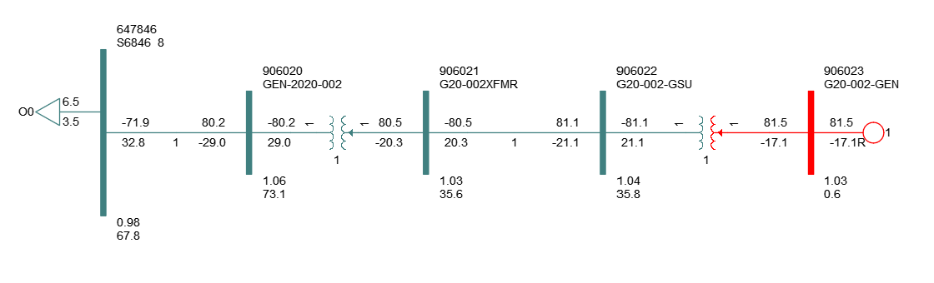
*based on the DISIS-2017-002 stability models
This Study has been requested by the Interconnection Customer to evaluate the modification of GEN-2020-002 dynamic model. The generating capacity for GEN-2020-002 (82.4 MW) and the total capability (82.4 MW) exceed its Generator Interconnection Agreement (GIA) Interconnection Service amount, 81 MW, as listed in Appendix A of the GIA. As a result, the customer must ensure that the amount of power injected at the POI does not exceed the Interconnection Service amount listed in its GIA.
In addition, the modification request included changes to the collection system, generator step-up transformer, generation interconnection line, main substation transformer, and reactive power devices. Figure 2 shows the powerflow model single line diagram for the GEN-2020-002 modification. The existing and modified configurations for GEN-2020-002 are shown in Table 1-2.
Figure 2: GEN-2020-002 Single Line Diagram (Modification Configuration)
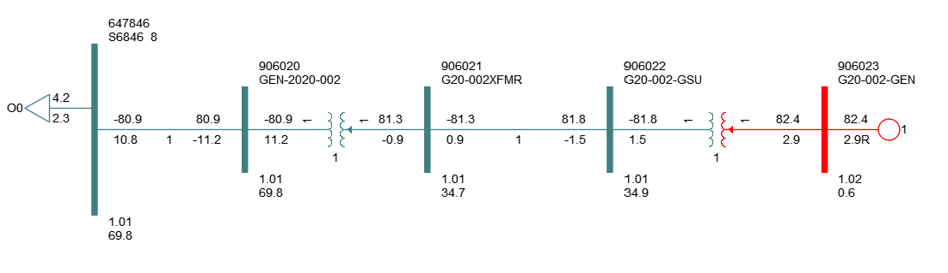

Table 1-2: GEN-2020-002 Modification Request
Facility | Existing Generating Facility Configuration | Modification Generating Facility Configuration
Point of Interconnection | S6846 Substation 69 kV (647846) | S6846 Substation 69 kV (647846)
Configuration/Capacity | 27 x 4.53 MW Solar Inverters | 26 x Sungrow SG3600UD 3.6 MVA Solar Inverters
Generation Interconnection Line | Length = 0.5 miles | Length = 0.5 miles
 | R = 0.129000 pu | R = 0.000000 pu
 | X = 0.065100 pu | X = 0.000100 pu
 | B = 0.004000 pu | B = 0.004000 pu
Main Substation Transformer¹ | R = 0.002332 pu | R = 0.002998 pu
 | X = 0.069961 pu | X = 0.089950 pu
 | Winding MVA = 52 MVA | Winding MVA = 57 MVA
 | Rating MVA = 87 MVA | Rating MVA = 95 MVA
Equivalent Collector Line² | R = 0.010000 pu | R = 0.007308 pu
 | X = 0.011700 pu | X = 0.010145 pu
 | B = 0.014400 pu | B = 0.013090 pu
GSU Transformer¹ | Gen Equivalent Qty: 26 | Gen Equivalent Qty: 26
 | R = 0.005472 pu | R = 0.008688 pu
 | X = 0.054727 pu | X = 0.060814 pu
 | Winding MVA = 90 MVA | Winding MVA = 90 MVA
 | Rating MVA = 90 MVA | Rating MVA = 90 MVA
Generator Dynamic Model³  & Power Factor | REGCAU1³  Leading and Lagging: ±0.8988 | REGCA1³  Leading and Lagging: ±0.8803
Reactive Power Devices | N/A | N/A
1) X/R based on Winding MVA, 2) All pu are on 100 MVA Base 3) DYR stability model name

Existing Versus Modification Comparison
To determine which analyses are required for the Study, the differences between the existing configuration and the requested modification were evaluated. SPP performed this comparison and the resulting analyses using a set of modified study models developed based on the modification request data and the DISIS-2017-002 study models.
The methodology and results of the comparisons are described below. The analysis was completed using PSS/E version 34.8.0 software.

Stability Model Parameters Comparison
SPP determined that short circuit and dynamic stability analyses were required because of the change in dynamic models. This is because the short circuit contribution and stability responses of the existing configuration and the requested modification’s configuration may differ. The generator dynamic model for the modification can be found in Appendix A.
As short circuit and dynamic stability analyses were required, a turbine parameters comparison was not needed for the determination of the scope of the study.

Equivalent Impedance Comparison Calculation
As the inverter change determined that short circuit and dynamic stability analyses were required, an equivalent impedance comparison was not needed for the determination of the scope of the study.

Short Circuit Analysis
A short circuit study was performed using the 25SP model for GEN-2020-002. The detailed results of the short circuit analysis are provided in Appendix B.

Methodology
The short circuit analysis included applying a three-phase fault on buses up to 5 levels away from the 69 kV POI bus. The PSS/E “Automatic Sequence Fault Calculation (ASCC)” fault analysis module was used to calculate the fault current levels in the transmission system with and without GEN-2020-002 online.
SPP created a short circuit model using the 25SP DISIS-2017-002 stability study model by adjusting the GEN-2020-002 short circuit parameters consistent with the modification data. The adjusted parameters are shown in Table 2-1 below.
Table 2-1: Short Circuit Model Parameters*
Parameter | Value by Generator Bus#
 | 906023
Machine  MVA Base | 93.60
R (pu) | 0.0
X’’ (pu) | 0.9426
*pu values based on Machine MVA Base

Results
The results of the short circuit analysis for the 25SP model are summarized in Table 2-2 and Table 2-3. The GEN-2020-002 POI bus (S6846 Substation 69 kV - 647846) fault current magnitudes are provided in Table 2-2 showing a maximum fault current of 8.0408 kA with the GEN-2020-002 project online. Table 2-3 shows the maximum fault current magnitudes and fault current increases with the GEN-2020-002 project online.
There was one bus with a pre-existing maximum three-phase fault current over 40 kA. This bus is highlighted in Appendix B. The maximum GEN-2020-002 contribution to three-phase fault current was about 9.534% and 0.6999 kA.

Table 2-2: POI Short Circuit Results
Case | GEN-OFF Current (kA) | GEN-ON Current (kA) | Max kA Change | Max %Change
25SP | 7.3409 | 8.0408 | 0.6999 | 9.534%

Table 2-3: 25SP Short Circuit Results
Voltage (kV) | Max. Current (kA) | Max kA Change | Max %Change
69 | 26.8244 | 0.6999 | 9.534%
115 | 26.7996 | 0.0146 | 0.057%
161 | 45.1699 | 0.0931 | 0.666%
Max | 45.1699 | 0.6999 | 9.534%

Dynamic Stability Analysis
SPP performed a dynamic stability analysis to identify the impact of the inverter configuration change and other modifications to GEN-2020-002. The analysis was performed according to SPP’s Disturbance Performance Requirements. The modification details are described in the Project and Modification Request section and the dynamic modeling data is provided in Appendix A. The existing original case issues and simulation plots can be found in Appendix E.

Methodology and Criteria
The dynamic stability analysis was performed using models developed with the requested GEN-2020-002 configuration of 26 x Sungrow SG3600UD 3.6 MVA Inverters (REGCA1). This stability analysis was performed using PTI’s PSS/E version 34.8.0 software.
The modifications requested for the GEN-2020-002 project were used to create modified stability models for this impact study based on the DISIS-2017-002 stability study models:
- 2025 Summer Peak (25SP),
- 2025 Winter Peak (25WP)

The modified dynamic model data for the GEN-2020-002 project is provided in Appendix A. The modified powerflow models and associated dynamic database were initialized (no-fault test) to confirm that there were no errors in the initial conditions of the system and the dynamic data.
During the fault simulations, the monitored areas include all buses and radially connected facilities within five buses of the Request’s POI as well as three buses from each regional or tie-line facility. The active power (PELEC), reactive power (QELEC), and terminal voltage (ETERM) were monitored for GEN-2020-002 and other current and prior queued projects in their cluster group within the monitored area. The machine rotor angle for synchronous machines and speed for asynchronous machines within the studied area were monitored. In addition, the voltages of all 69 kV and above buses within the study area were monitored.

Fault Definitions
SPP developed and simulated faults for GEN-2020-002 using the modified study models. The new set of faults was simulated using the modified study models. The fault events included three-phase faults and single-line-to-ground stuck breaker faults. Single-line-to-ground faults are approximated by applying a fault impedance to bring the faulted bus positive sequence voltage to 0.6 pu. The simulated faults are listed and described in Appendix C. These contingencies were applied to the modified 25SP and 25WP models.

Results
Appendix D includes the relevant results of the fault events simulated for each of the modified cases. Existing original case issues are documented separately in Appendix E. The associated stability plots are also provided in Appendix E.
The results of the dynamic stability analysis showed that there were several existing original case issues found in the original Annual Interim 2022 case and the case with the GEN-2020-002 modification. These issues were not attributed to the GEN-2020-002 modification request and detailed in Appendix E.
There were no damping or voltage recovery violations attributed to the GEN-2020-002 modification request observed during the simulated faults. Additionally, the project was found to stay connected during the contingencies that were studied and, therefore, will meet the Low Voltage Ride Through (LVRT) requirements of FERC Order #661A.

Modified Capacity Exceeds GIA Capacity
Under FERC Order 845, Interconnection Customers are allowed to request Interconnection Service that is lower than the full generating capacity of their planned generating facilities. The Interconnection Customers must install acceptable control and protection devices that prevent the injection above their requested Interconnection Service amount measured at the POI.
As such, Interconnection Customers are allowed to increase the generating capacity of a generating facility without increasing its Interconnection Service amount stated in its GIA. This is allowable as long as they install the proper control and protection devices, and the requested modification is not determined to be a Material Modification.

Results
The modified generating capacity of GEN-2020-002 (81 MW) and the total capability (82.4 MW) exceed the GIA Interconnection Service amount, 81 MW, as listed in Appendix A of the GIA. The GEN-2020-002 inverters are rated at 3.17 MW and use a Power Plant Controller (PPC) to limit the total power injected into the POI.
The customer must install monitoring and control equipment as needed to ensure that the amount of power injected at the POI does not exceed the Interconnection Service amount listed in its GIA.

Material Modification Determination
In accordance with Attachment V of SPP’s Open Access Transmission Tariff, for modifications other than those specifically permitted by Attachment V, SPP shall evaluate the proposed modifications prior to making them and inform the Interconnection Customer in writing of whether the modifications would constitute a Material Modification. Material Modification shall mean (1) modification to an Interconnection Request in the queue that has a material adverse impact on the cost or timing of any other Interconnection Request with a later Queue priority date; or (2) planned modification to an Existing Generating Facility that is undergoing evaluation for a Generating Facility Modification or Generating Facility Replacement, and has a material adverse impact on the Transmission System with respect to: i) steady-state thermal or voltage limits, ii) dynamic system stability and response, or iii) short-circuit capability limit; compared to the impacts of the Existing Generating Facility prior to the modification or replacement.

Results
SPP determined the requested modification is not a Material Modification based on the results of this Modification Request Impact Study performed by SPP. SPP evaluated the impact of the requested modification on the prior study results. SPP determined that the requested modification did not negatively impact the prior study dynamic stability and short circuit results, and the modifications to the project were not enough to change the previously studied powerflow conclusions.
This determination implies that any network upgrades already required by GEN-2020-002 would not be negatively impacted and that no new upgrades are required due to the requested modification, thus not resulting in a material adverse impact on the cost or timing of any other Interconnection Request with a later Queue priority date.

Appendix A: GEN-2020-002 Generator Dynamic Model
906023 'REGCA1' 1 0
0.20000E-01 10.000 0.90000 0.50000 1.0000
1.1000 0.10000E-01 0.0000 -1.0000 0.10000E-01
0.0000 99.000 -99.000 0.70000 /
906023 'REECA1' 1
0 0 1 0 0 0
0.85000 1.2000 0.10000E-01 -0.10000 0.10000
2.0000 1.0000 -1.0000 0.0000 0.0000
0.0000 0.0000 0.10000E-01 0.60000 -0.60000
1.1000 0.90000 0.30000 5.0000 0.50000
0.0000 0.0000 0.10000E-01 99.000 -99.000
1.0000 0.0000 1.0000 0.10000E-01 0.0000
1.0000 0.50000 1.0000 0.85000 1.0000
1.2000 1.0000 0.0000 1.0000 0.50000
1.0000 0.85000 1.0000 1.2000 1.0000 /
906023 'REPCA1' 1
906020 906020 647846 '1 ' 0 1 1
0.50000E-01 0.50000 10.000 0.0000 0.50000E-01
0.85000 0.0000 0.0000 0.30000E-01 0.50000E-01
-0.50000E-01 0.0000 0.0000 0.47500 -0.47500
0.50000 0.25000 0.25000 -0.60000E-03 0.60000E-03
999.00 -999.00 0.88000 0.0000 0.50000
20.000 20.000 /
90602301 'VTGTPAT' 906023 906023 '1 ' -1.0000 1.3000 0.50000E-01 0.0000 /
90602302 'VTGTPAT' 906023 906023 '1 ' -1.0000 1.2000 0.16000 0.0000 /
90602303 'VTGTPAT' 906023 906023 '1 ' -1.0000 1.1000 10.000 0.0000 /
90602304 'VTGTPAT' 906023 906023 '1 ' 0.50000 5.0000 2.0000 0.0000 /
90602305 'VTGTPAT' 906023 906023 '1 ' 0.70000 5.0000 10.000 0.0000 /
90602306 'VTGTPAT' 906023 906023 '1 ' 0.88000 5.0000 20.000 0.0000 /
90602307 'FRQTPAT' 906023 906023 '1 ' 57.000 100.00 0.50000 0.0000 /
90602308 'FRQTPAT' 906023 906023 '1 ' 58.300 100.00 600.00 0.0000 /
90602309 'FRQTPAT' 906023 906023 '1 ' -100.00 62.000 0.50000 0.0000 /
90602310 'FRQTPAT' 906023 906023 '1 ' -100.00 60.700 600.00 0.0000 /

Appendix B: GEN-2020-002 Short Circuit Results
Group | Bus Number | Bus Name | Bus Voltage (kV) | Request Not In Service 25SP Fault Current 3-Phase (kA) | Request In Service 25SP Fault Current 3-Phase (kA) | Change in Fault Current (kA)
02 NEBRASKA | 640155 | DAVEY 7 | 115 | 11.3682 | 11.3709 | 0.0027
02 NEBRASKA | 640320 | PLTSMTH8 | 69 | 5.4597 | 5.4622 | 0.0025
02 NEBRASKA | 646209 | S1209 5 | 161 | 45.1111 | 45.1699 | 0.0588
02 NEBRASKA | 646214 | S1214 5 | 161 | 12.3845 | 12.467 | 0.0825
02 NEBRASKA | 646254 | S1254 5 | 161 | 31.4386 | 31.4861 | 0.0475
02 NEBRASKA | 646281 | S1281 5 | 161 | 33.9653 | 34.0463 | 0.081
02 NEBRASKA | 646287 | S1287 5 | 161 | 21.3937 | 21.4621 | 0.0684
02 NEBRASKA | 646361 | S1361 5 | 161 | 39.0098 | 39.0805 | 0.0707
02 NEBRASKA | 646363 | S1363 5 | 161 | 30.7818 | 30.8274 | 0.0456
02 NEBRASKA | 647014 | S914A 8 | 69 | 11.2893 | 11.6431 | 0.3538
02 NEBRASKA | 647079 | 979TP 8 | 69 | 6.9927 | 7.005 | 0.0123
02 NEBRASKA | 647091 | 991TP 8 | 69 | 11.5394 | 11.577 | 0.0376
02 NEBRASKA | 647100 | ASH GRV8 | 69 | 6.908 | 6.9283 | 0.0203
02 NEBRASKA | 647104 | MUD LNG8 | 69 | 14.5792 | 14.5928 | 0.0136
02 NEBRASKA | 647427 | FREM G 8 | 69 | 14.0135 | 14.048 | 0.0345
02 NEBRASKA | 647846 | S6846 8 | 69 | 7.3409 | 8.0408 | 0.6999
02 NEBRASKA | 647900 | S900 8 | 69 | 8.0437 | 8.0713 | 0.0276
02 NEBRASKA | 647902 | S902 8 | 69 | 8.9396 | 9.1659 | 0.2263
02 NEBRASKA | 647904 | S904 8 | 69 | 8.7142 | 8.7199 | 0.0057
02 NEBRASKA | 647909 | S909 8 | 69 | 26.7659 | 26.8244 | 0.0585
02 NEBRASKA | 647914 | S914 8 | 69 | 7.7571 | 7.8747 | 0.1176
02 NEBRASKA | 647918 | S918 8 | 69 | 22.7286 | 22.7541 | 0.0255
02 NEBRASKA | 647921 | S921 8 | 69 | 26.1751 | 26.1963 | 0.0212
02 NEBRASKA | 647937 | S937 8 | 69 | 8.9982 | 9.114 | 0.1158
02 NEBRASKA | 647939 | S939 8 | 69 | 19.9675 | 19.9932 | 0.0257
02 NEBRASKA | 647960 | S960 8 | 69 | 7.4311 | 7.4407 | 0.0096
02 NEBRASKA | 647972 | S972 8 | 69 | 4.275 | 4.2801 | 0.0051
02 NEBRASKA | 647979 | S979 8 | 69 | 6.8447 | 6.8565 | 0.0118
02 NEBRASKA | 647982 | S982 8 | 69 | 3.8279 | 3.8303 | 0.0024
02 NEBRASKA | 647983 | S983 8 | 69 | 7.1468 | 7.6092 | 0.4624
02 NEBRASKA | 647984 | S984 8 | 69 | 7.8351 | 7.957 | 0.1219
02 NEBRASKA | 647985 | S985 8 | 69 | 8.1264 | 8.1327 | 0.0063
02 NEBRASKA | 647988 | S988 8 | 69 | 2.8817 | 2.9043 | 0.0226
02 NEBRASKA | 647991 | S991 8 | 69 | 9.7231 | 9.7497 | 0.0266
02 NEBRASKA | 650169 | 70&BLUFF 5 | 161 | 8.813 | 8.8293 | 0.0163
02 NEBRASKA | 650261 | 56&I80 7 | 115 | 22.823 | 22.8337 | 0.0107
02 NEBRASKA | 650269 | 70&BLUFF 7 | 115 | 25.4472 | 25.4618 | 0.0146
02 NEBRASKA | 650275 | 84&BLUFF 7 | 115 | 26.786 | 26.7996 | 0.0136
02 NEBRASKA | 650277 | TBGS_A 7 | 115 | 25.499 | 25.5112 | 0.0122
02 NEBRASKA | 650278 | TBGS_B 7 | 115 | 25.6786 | 25.691 | 0.0124
02 NEBRASKA | 906020 | GEN-2020-002 | 69 | 7.3409 | 8.0408 | 0.6999

Appendix C: Fault Definitions
Fault ID | Planning Event | Fault Description
GROUP2_FAULT_1_P1 | P1 | 3 Phase fault on 56&I80 7 115.00 (650261) 115 kV Bus  a. Apply fault at the 56&I80 7 115.00 (650261) 115 kV Bus  b. Clear fault after 7 cycles and trip the faulted elements:  b.1. 19&ALVO 7 (650215) 115.0 kV to 56&I80 7 (650261) 115.0 kV Transmission Circuit #1  b.2. 56&I80 7 (650261) 115.0 kV to 70&BLUFF 7 (650269) 115.0 kV Transmission Circuit #1  b.3. 56&I80 7 (650261) 115.0 kV to 56&I80 9 (650361) 12.5 kV to 611TERTIARY (650561) 7.2 kV Three Winding #1
GROUP2_FAULT_2_P1 | P1 | 3 Phase fault on 84FLETCHER7 115.00 (650284) 115 kV Bus  a. Apply fault at the 84FLETCHER7 115.00 (650284) 115 kV Bus  b. Clear fault after 7 cycles and trip the faulted elements:  b.1. 84LEIGHTON7 (650267) 115.0 kV to 84FLETCHER7 (650284) 115.0 kV Transmission Circuit #1  b.2. 84&BLUFF 7 (650275) 115.0 kV to 84FLETCHER7 (650284) 115.0 kV Transmission Circuit #1  b.3. 84FLETCHER7 (650284) 115.0 kV to 84&FL 9 (650384) 13.2 kV to 841TERTIARY (650584) 7.2 kV Three Winding #1
GROUP2_FAULT_3_P1 | P1 | 3 Phase fault on 70&BLUFF 7 115.00 (650269) 115 kV Bus  a. Apply fault at the 70&BLUFF 7 115.00 (650269) 115 kV Bus  b. Clear fault after 7 cycles and trip the faulted elements:  b.1. 70&BLUFF 7 (650269) 115.0 kV to 84&BLUFF 7 (650275) 115.0 kV Transmission Circuit #1  c. Wait 20 cycles, and then reclose the faulted elements in (b) back into the Fault  d. Leave Fault on for 7 cycles, then trip the faulted elements in (b) and clear the fault
GROUP2_FAULT_4_P1 | P1 | 3 Phase fault on 84&BLUFF 7 115.00 (650275) 115 kV Bus  a. Apply fault at the 84&BLUFF 7 115.00 (650275) 115 kV Bus  b. Clear fault after 7 cycles and trip the faulted elements:  b.1. 84&BLUFF 7 (650275) 115.0 kV to WAVERLY 7 (650283) 115.0 kV Transmission Circuit #1  c. Wait 20 cycles, and then reclose the faulted elements in (b) back into the Fault  d. Leave Fault on for 7 cycles, then trip the faulted elements in (b) and clear the fault
GROUP2_FAULT_5_P1 | P1 | 3 Phase fault on 70&BLUFF 5 161.00 (650169) 161 kV Bus  a. Apply fault at the 70&BLUFF 5 161.00 (650169) 161 kV Bus  b. Clear fault after 7 cycles and trip the faulted elements:  b.1. S1214 5 (646214) 161.0 kV to 70&BLUFF 5 (650169) 161.0 kV Transmission Circuit #1  b.2. 70&BLUFF 5 (650169) 161.0 kV to 70&BLUFF 7 (650269) 115.0 kV to 70&BLUFF 9 (650369) 13.8 kV Three Winding #1  b.4. 70&BLUFF 9 (650369) 13.8 kV to 70&BLUFF 7 (650269) 115.0 kV to 70&BLUFF 5 (650169) 161.0 kV Three Winding #1
GROUP2_FAULT_6_P1 | P1 | 3 Phase fault on S3454 3 345.00 (645454) 345 kV Bus  a. Apply fault at the S3454 3 345.00 (645454) 345 kV Bus  b. Clear fault after 6 cycles and trip the faulted elements:  b.1. S3454 3 (645454) 345.0 kV to WAGENER 3 (650185) 345.0 kV Transmission Circuit #1  c. Wait 20 cycles, and then reclose the faulted elements in (b) back into the Fault  d. Leave Fault on for 6 cycles, then trip the faulted elements in (b) and clear the fault
GROUP2_FAULT_7_P1 | P1 | 3 Phase fault on 120&ALVO 7 115.00 (650279) 115 kV Bus  a. Apply fault at the 120&ALVO 7 115.00 (650279) 115 kV Bus  b. Clear fault after 7 cycles and trip the faulted elements:  b.1. 120&ALVO 7 (650279) 115.0 kV to WAVERLY 7 (650283) 115.0 kV Transmission Circuit #1  c. Wait 20 cycles, and then reclose the faulted elements in (b) back into the Fault  d. Leave Fault on for 7 cycles, then trip the faulted elements in (b) and clear the fault
GROUP2_FAULT_8_P1 | P1 | 3 Phase fault on DAVEY 7 115.00 (640155) 115 kV Bus  a. Apply fault at the DAVEY 7 115.00 (640155) 115 kV Bus  b. Clear fault after 7 cycles and trip the faulted elements:  b.1. DAVEY 7 (640155) 115.0 kV to WAHOO 7 (640402) 115.0 kV Transmission Circuit #1  b.2. DAVEY 7 (640155) 115.0 kV to 70&BLUFF 7 (650269) 115.0 kV Transmission Circuit #1  c. Wait 20 cycles, and then reclose the faulted elements in (b) back into the Fault  d. Leave Fault on for 7 cycles, then trip the faulted elements in (b) and clear the fault
GROUP2_FAULT_9_P1 | P1 | 3 Phase fault on S3451 3 345.00 (645451) 345 kV Bus  a. Apply fault at the S3451 3 345.00 (645451) 345 kV Bus  b. Clear fault after 6 cycles and trip the faulted elements:  b.1. S3451 3 (645451) 345.0 kV to S3454 3 (645454) 345.0 kV Transmission Circuit #1  c. Wait 20 cycles, and then reclose the faulted elements in (b) back into the Fault  d. Leave Fault on for 6 cycles, then trip the faulted elements in (b) and clear the fault
GROUP2_FAULT_10_P1 | P1 | 3 Phase fault on S3454 3 345.00 (645454) 345 kV Bus  a. Apply fault at the S3454 3 345.00 (645454) 345 kV Bus  b. Clear fault after 6 cycles and trip the faulted elements:  b.1. S3454 3 (645454) 345.0 kV to S3455 3 (645455) 345.0 kV Transmission Circuit #1  c. Wait 20 cycles, and then reclose the faulted elements in (b) back into the Fault  d. Leave Fault on for 6 cycles, then trip the faulted elements in (b) and clear the fault
GROUP2_FAULT_11_P1 | P1 | 3 Phase fault on S3455 3 345.00 (645455) 345 kV Bus  a. Apply fault at the S3455 3 345.00 (645455) 345 kV Bus  b. Clear fault after 6 cycles and trip the faulted elements:  b.1. S3455 3 (645455) 345.0 kV to S3456 3 (645456) 345.0 kV Transmission Circuit #1  c. Wait 20 cycles, and then reclose the faulted elements in (b) back into the Fault  d. Leave Fault on for 6 cycles, then trip the faulted elements in (b) and clear the fault
GROUP2_FAULT_12_P1 | P1 | 3 Phase fault on S3455 3 345.00 (645455) 345 kV Bus  a. Apply fault at the S3455 3 345.00 (645455) 345 kV Bus  b. Clear fault after 6 cycles and trip the faulted elements:  b.1. S3455 3 (645455) 345.0 kV to S3740 3 (645740) 345.0 kV Transmission Circuit #1  c. Wait 20 cycles, and then reclose the faulted elements in (b) back into the Fault  d. Leave Fault on for 6 cycles, then trip the faulted elements in (b) and clear the fault
GROUP2_FAULT_13_P1 | P1 | 3 Phase fault on S3455 3 345.00 (645455) 345 kV Bus  a. Apply fault at the S3455 3 345.00 (645455) 345 kV Bus  b. Clear fault after 6 cycles and trip the faulted elements:  b.1. S3455 3 (645455) 345.0 kV to S3761 3 (645761) 345.0 kV Transmission Circuit #1  c. Wait 20 cycles, and then reclose the faulted elements in (b) back into the Fault  d. Leave Fault on for 6 cycles, then trip the faulted elements in (b) and clear the fault
GROUP2_FAULT_14_P1 | P1 | 3 Phase fault on S1214 5 161.00 (646214) 161 kV Bus  a. Apply fault at the S1214 5 161.00 (646214) 161 kV Bus  b. Clear fault after 7 cycles and trip the faulted elements:  b.1. S1214 5 (646214) 161.0 kV to S1287 5 (646287) 161.0 kV Transmission Circuit #1  c. Wait 20 cycles, and then reclose the faulted elements in (b) back into the Fault  d. Leave Fault on for 7 cycles, then trip the faulted elements in (b) and clear the fault
GROUP2_FAULT_15_P1 | P1 | 3 Phase fault on S1221 5 161.00 (646221) 161 kV Bus  a. Apply fault at the S1221 5 161.00 (646221) 161 kV Bus  b. Clear fault after 7 cycles and trip the faulted elements:  b.1. S1221 5 (646221) 161.0 kV to S1255 5 (646255) 161.0 kV Transmission Circuit #1  c. Wait 20 cycles, and then reclose the faulted elements in (b) back into the Fault  d. Leave Fault on for 7 cycles, then trip the faulted elements in (b) and clear the fault
GROUP2_FAULT_16_P1 | P1 | 3 Phase fault on S1233 5 161.00 (646233) 161 kV Bus  a. Apply fault at the S1233 5 161.00 (646233) 161 kV Bus  b. Clear fault after 7 cycles and trip the faulted elements:  b.1. S1233 5 (646233) 161.0 kV to S1255 5 (646255) 161.0 kV Transmission Circuit #1  c. Wait 20 cycles, and then reclose the faulted elements in (b) back into the Fault  d. Leave Fault on for 7 cycles, then trip the faulted elements in (b) and clear the fault
GROUP2_FAULT_17_P1 | P1 | 3 Phase fault on S1249 5 161.00 (646249) 161 kV Bus  a. Apply fault at the S1249 5 161.00 (646249) 161 kV Bus  b. Clear fault after 7 cycles and trip the faulted elements:  b.1. S1249 5 (646249) 161.0 kV to S1256 5 (646256) 161.0 kV Transmission Circuit #1  c. Wait 20 cycles, and then reclose the faulted elements in (b) back into the Fault  d. Leave Fault on for 7 cycles, then trip the faulted elements in (b) and clear the fault
GROUP2_FAULT_18_P1 | P1 | 3 Phase fault on S1254 5 161.00 (646254) 161 kV Bus  a. Apply fault at the S1254 5 161.00 (646254) 161 kV Bus  b. Clear fault after 7 cycles and trip the faulted elements:  b.1. S1254 5 (646254) 161.0 kV to S1281 5 (646281) 161.0 kV Transmission Circuit #1  c. Wait 20 cycles, and then reclose the faulted elements in (b) back into the Fault  d. Leave Fault on for 7 cycles, then trip the faulted elements in (b) and clear the fault
GROUP2_FAULT_19_P1 | P1 | 3 Phase fault on S1255 5 161.00 (646255) 161 kV Bus  a. Apply fault at the S1255 5 161.00 (646255) 161 kV Bus  b. Clear fault after 7 cycles and trip the faulted elements:  b.1. S1255 5 (646255) 161.0 kV to S1259 5 (646259) 161.0 kV Transmission Circuit #1  c. Wait 20 cycles, and then reclose the faulted elements in (b) back into the Fault  d. Leave Fault on for 7 cycles, then trip the faulted elements in (b) and clear the fault
GROUP2_FAULT_20_P1 | P1 | 3 Phase fault on S1255 5 161.00 (646255) 161 kV Bus  a. Apply fault at the S1255 5 161.00 (646255) 161 kV Bus  b. Clear fault after 7 cycles and trip the faulted elements:  b.1. S1255 5 (646255) 161.0 kV to S1361 5 (646361) 161.0 kV Transmission Circuit #1  c. Wait 20 cycles, and then reclose the faulted elements in (b) back into the Fault  d. Leave Fault on for 7 cycles, then trip the faulted elements in (b) and clear the fault
GROUP2_FAULT_21_P1 | P1 | 3 Phase fault on S1259 5 161.00 (646259) 161 kV Bus  a. Apply fault at the S1259 5 161.00 (646259) 161 kV Bus  b. Clear fault after 7 cycles and trip the faulted elements:  b.1. S1259 5 (646259) 161.0 kV to S1278 5 (646278) 161.0 kV Transmission Circuit #1  c. Wait 20 cycles, and then reclose the faulted elements in (b) back into the Fault  d. Leave Fault on for 7 cycles, then trip the faulted elements in (b) and clear the fault
GROUP2_FAULT_22_P1 | P1 | 3 Phase fault on S1260 5 161.00 (646260) 161 kV Bus  a. Apply fault at the S1260 5 161.00 (646260) 161 kV Bus  b. Clear fault after 7 cycles and trip the faulted elements:  b.1. S1260 5 (646260) 161.0 kV to S1361 5 (646361) 161.0 kV Transmission Circuit #1  c. Wait 20 cycles, and then reclose the faulted elements in (b) back into the Fault  d. Leave Fault on for 7 cycles, then trip the faulted elements in (b) and clear the fault
GROUP2_FAULT_23_P1 | P1 | 3 Phase fault on S1281 5 161.00 (646281) 161 kV Bus  a. Apply fault at the S1281 5 161.00 (646281) 161 kV Bus  b. Clear fault after 7 cycles and trip the faulted elements:  b.1. S1254 5 (646254) 161.0 kV to S1281 5 (646281) 161.0 kV Transmission Circuit #1  b.2. S1281 5 (646281) 161.0 kV to S1287 5 (646287) 161.0 kV Transmission Circuit #1  b.3. S1281 5 (646281) 161.0 kV to S1361 5 (646361) 161.0 kV Transmission Circuit #1  b.4. S1281 5 (646281) 161.0 kV to S1363 5 (646363) 161.0 kV Transmission Circuit #1  c. Wait 20 cycles, and then reclose the faulted elements in (b) back into the Fault  d. Leave Fault on for 7 cycles, then trip the faulted elements in (b) and clear the fault
GROUP2_FAULT_24_P1 | P1 | 3 Phase fault on S1259 5 161.00 (646259) 161 kV Bus  a. Apply fault at the S1259 5 161.00 (646259) 161 kV Bus  b. Clear fault after 7 cycles and trip the faulted elements:  b.1. S1259 5 (646259) 161.0 kV to S1260 5 (646260) 161.0 kV Transmission Circuit #1  c. Wait 20 cycles, and then reclose the faulted elements in (b) back into the Fault  d. Leave Fault on for 7 cycles, then trip the faulted elements in (b) and clear the fault
GROUP2_FAULT_25_P1 | P1 | 3 Phase fault on PLTSMTH8 69.000 (640320) 69 kV Bus  a. Apply fault at the PLTSMTH8 69.000 (640320) 69 kV Bus  b. Clear fault after 7 cycles and trip the faulted elements:  b.1. PLTSMTH8 (640320) 69.0 kV to S985 8 (647985) 69.0 kV Transmission Circuit #1  c. Wait 20 cycles, and then reclose the faulted elements in (b) back into the Fault  d. Leave Fault on for 7 cycles, then trip the faulted elements in (b) and clear the fault
GROUP2_FAULT_26_P1 | P1 | 3 Phase fault on S914A 8 69.000 (647014) 69 kV Bus  a. Apply fault at the S914A 8 69.000 (647014) 69 kV Bus  b. Clear fault after 7 cycles and trip the faulted elements:  b.1. S914A 8 (647014) 69.0 kV to S6846 8 (647846) 69.0 kV Transmission Circuit #1  c. Wait 20 cycles, and then reclose the faulted elements in (b) back into the Fault  d. Leave Fault on for 7 cycles, then trip the faulted elements in (b) and clear the fault
GROUP2_FAULT_27_P1 | P1 | 3 Phase fault on S914A 8 69.000 (647014) 69 kV Bus  a. Apply fault at the S914A 8 69.000 (647014) 69 kV Bus  b. Clear fault after 7 cycles and trip the faulted elements:  b.1. S914A 8 (647014) 69.0 kV to S914 8 (647914) 69.0 kV Transmission Circuit #1  c. Wait 20 cycles, and then reclose the faulted elements in (b) back into the Fault  d. Leave Fault on for 7 cycles, then trip the faulted elements in (b) and clear the fault
GROUP2_FAULT_28_P1 | P1 | 3 Phase fault on 991TP 8 69.000 (647091) 69 kV Bus  a. Apply fault at the 991TP 8 69.000 (647091) 69 kV Bus  b. Clear fault after 7 cycles and trip the faulted elements:  b.1. 991TP 8 (647091) 69.0 kV to FREM G 8 (647427) 69.0 kV Transmission Circuit #1  b.2. 991TP 8 (647091) 69.0 kV to S984 8 (647984) 69.0 kV Transmission Circuit #1  b.3. 991TP 8 (647091) 69.0 kV to S991 8 (647991) 69.0 kV Transmission Circuit #1  c. Wait 20 cycles, and then reclose the faulted elements in (b) back into the Fault  d. Leave Fault on for 7 cycles, then trip the faulted elements in (b) and clear the fault
GROUP2_FAULT_29_P1 | P1 | 3 Phase fault on S6846 8 69.000 (647846) 69 kV Bus  a. Apply fault at the S6846 8 69.000 (647846) 69 kV Bus  b. Clear fault after 7 cycles and trip the faulted elements:  b.1. S6846 8 (647846) 69.0 kV to S983 8 (647983) 69.0 kV Transmission Circuit #1  c. Wait 20 cycles, and then reclose the faulted elements in (b) back into the Fault  d. Leave Fault on for 7 cycles, then trip the faulted elements in (b) and clear the fault
GROUP2_FAULT_30_P1 | P1 | 3 Phase fault on S900 8 69.000 (647900) 69 kV Bus  a. Apply fault at the S900 8 69.000 (647900) 69 kV Bus  b. Clear fault after 7 cycles and trip the faulted elements:  b.1. S900 8 (647900) 69.0 kV to S914 8 (647914) 69.0 kV Transmission Circuit #1  c. Wait 20 cycles, and then reclose the faulted elements in (b) back into the Fault  d. Leave Fault on for 7 cycles, then trip the faulted elements in (b) and clear the fault
GROUP2_FAULT_31_P1 | P1 | 3 Phase fault on S900 8 69.000 (647900) 69 kV Bus  a. Apply fault at the S900 8 69.000 (647900) 69 kV Bus  b. Clear fault after 7 cycles and trip the faulted elements:  b.1. S900 8 (647900) 69.0 kV to S972 8 (647972) 69.0 kV Transmission Circuit #1  c. Wait 20 cycles, and then reclose the faulted elements in (b) back into the Fault  d. Leave Fault on for 7 cycles, then trip the faulted elements in (b) and clear the fault
GROUP2_FAULT_32_P1 | P1 | 3 Phase fault on S900 8 69.000 (647900) 69 kV Bus  a. Apply fault at the S900 8 69.000 (647900) 69 kV Bus  b. Clear fault after 7 cycles and trip the faulted elements:  b.1. S900 8 (647900) 69.0 kV to S985 8 (647985) 69.0 kV Transmission Circuit #1  c. Wait 20 cycles, and then reclose the faulted elements in (b) back into the Fault  d. Leave Fault on for 7 cycles, then trip the faulted elements in (b) and clear the fault
GROUP2_FAULT_33_P1 | P1 | 3 Phase fault on S937 8 69.000 (647937) 69 kV Bus  a. Apply fault at the S937 8 69.000 (647937) 69 kV Bus  b. Clear fault after 7 cycles and trip the faulted elements:  b.1. S902 8 (647902) 69.0 kV to S937 8 (647937) 69.0 kV Transmission Circuit #1  b.2. S909 8 (647909) 69.0 kV to S937 8 (647937) 69.0 kV Transmission Circuit #1  b.3. S937 8 (647937) 69.0 kV Generator #1  c. Wait 20 cycles, and then reclose the faulted elements in (b) back into the Fault  d. Leave Fault on for 7 cycles, then trip the faulted elements in (b) and clear the fault
GROUP2_FAULT_34_P1 | P1 | 3 Phase fault on S902 8 69.000 (647902) 69 kV Bus  a. Apply fault at the S902 8 69.000 (647902) 69 kV Bus  b. Clear fault after 7 cycles and trip the faulted elements:  b.1. S902 8 (647902) 69.0 kV to S983 8 (647983) 69.0 kV Transmission Circuit #1  c. Wait 20 cycles, and then reclose the faulted elements in (b) back into the Fault  d. Leave Fault on for 7 cycles, then trip the faulted elements in (b) and clear the fault
GROUP2_FAULT_35_P1 | P1 | 3 Phase fault on S902 8 69.000 (647902) 69 kV Bus  a. Apply fault at the S902 8 69.000 (647902) 69 kV Bus  b. Clear fault after 7 cycles and trip the faulted elements:  b.1. S902 8 (647902) 69.0 kV to S984 8 (647984) 69.0 kV Transmission Circuit #1  c. Wait 20 cycles, and then reclose the faulted elements in (b) back into the Fault  d. Leave Fault on for 7 cycles, then trip the faulted elements in (b) and clear the fault
GROUP2_FAULT_36_P1 | P1 | 3 Phase fault on S904 8 69.000 (647904) 69 kV Bus  a. Apply fault at the S904 8 69.000 (647904) 69 kV Bus  b. Clear fault after 7 cycles and trip the faulted elements:  b.1. S904 8 (647904) 69.0 kV to S906 S 8 (647906) 69.0 kV Transmission Circuit #1  c. Wait 20 cycles, and then reclose the faulted elements in (b) back into the Fault  d. Leave Fault on for 7 cycles, then trip the faulted elements in (b) and clear the fault
GROUP2_FAULT_37_P1 | P1 | 3 Phase fault on S904 8 69.000 (647904) 69 kV Bus  a. Apply fault at the S904 8 69.000 (647904) 69 kV Bus  b. Clear fault after 7 cycles and trip the faulted elements:  b.1. S904 8 (647904) 69.0 kV to S985 8 (647985) 69.0 kV Transmission Circuit #1  c. Wait 20 cycles, and then reclose the faulted elements in (b) back into the Fault  d. Leave Fault on for 7 cycles, then trip the faulted elements in (b) and clear the fault
GROUP2_FAULT_38_P1 | P1 | 3 Phase fault on S972 8 69.000 (647972) 69 kV Bus  a. Apply fault at the S972 8 69.000 (647972) 69 kV Bus  b. Clear fault after 7 cycles and trip the faulted elements:  b.1. S972 8 (647972) 69.0 kV to S982 8 (647982) 69.0 kV Transmission Circuit #1  c. Wait 20 cycles, and then reclose the faulted elements in (b) back into the Fault  d. Leave Fault on for 7 cycles, then trip the faulted elements in (b) and clear the fault
GROUP2_FAULT_39_P1 | P1 | 3 Phase fault on FREM F 8 69.000 (647426) 69 kV Bus  a. Apply fault at the FREM F 8 69.000 (647426) 69 kV Bus  b. Clear fault after 7 cycles and trip the faulted elements:  b.1. FREM F 8 (647426) 69.0 kV to S992 8 (647992) 69.0 kV Transmission Circuit #1  c. Wait 20 cycles, and then reclose the faulted elements in (b) back into the Fault  d. Leave Fault on for 7 cycles, then trip the faulted elements in (b) and clear the fault
GROUP2_FAULT_40_P1 | P1 | 3 Phase fault on FREM A 8 69.000 (647421) 69 kV Bus  a. Apply fault at the FREM A 8 69.000 (647421) 69 kV Bus  b. Clear fault after 7 cycles and trip the faulted elements:  b.1. FREM A 8 (647421) 69.0 kV to FREM G 8 (647427) 69.0 kV Transmission Circuit #1  c. Wait 20 cycles, and then reclose the faulted elements in (b) back into the Fault  d. Leave Fault on for 7 cycles, then trip the faulted elements in (b) and clear the fault
GROUP2_FAULT_41_P1 | P1 | 3 Phase fault on FREM A 8 69.000 (647421) 69 kV Bus  a. Apply fault at the FREM A 8 69.000 (647421) 69 kV Bus  b. Clear fault after 7 cycles and trip the faulted elements:  b.1. FREM A 8 (647421) 69.0 kV to FREM B 8 (647422) 69.0 kV Transmission Circuit #1  c. Wait 20 cycles, and then reclose the faulted elements in (b) back into the Fault  d. Leave Fault on for 7 cycles, then trip the faulted elements in (b) and clear the fault
GROUP2_FAULT_42_P1 | P1 | 3 Phase fault on FREM A 8 69.000 (647421) 69 kV Bus  a. Apply fault at the FREM A 8 69.000 (647421) 69 kV Bus  b. Clear fault after 7 cycles and trip the faulted elements:  b.1. FREM A 8 (647421) 69.0 kV to FREM F 8 (647426) 69.0 kV Transmission Circuit #1  c. Wait 20 cycles, and then reclose the faulted elements in (b) back into the Fault  d. Leave Fault on for 7 cycles, then trip the faulted elements in (b) and clear the fault
GROUP2_FAULT_43_P1 | P1 | 3 Phase fault on FREM B 8 69.000 (647422) 69 kV Bus  a. Apply fault at the FREM B 8 69.000 (647422) 69 kV Bus  b. Clear fault after 7 cycles and trip the faulted elements:  b.1. FREM B 8 (647422) 69.0 kV to FREM C 8 (647423) 69.0 kV Transmission Circuit #1  c. Wait 20 cycles, and then reclose the faulted elements in (b) back into the Fault  d. Leave Fault on for 7 cycles, then trip the faulted elements in (b) and clear the fault
GROUP2_FAULT_44_P1 | P1 | 3 Phase fault on FREM B 8 69.000 (647422) 69 kV Bus  a. Apply fault at the FREM B 8 69.000 (647422) 69 kV Bus  b. Clear fault after 7 cycles and trip the faulted elements:  b.1. FREM B 8 (647422) 69.0 kV to FREM D 8 (647424) 69.0 kV Transmission Circuit #1  c. Wait 20 cycles, and then reclose the faulted elements in (b) back into the Fault  d. Leave Fault on for 7 cycles, then trip the faulted elements in (b) and clear the fault
GROUP2_FAULT_45_P1 | P1 | 3 Phase fault on FREM B 8 69.000 (647422) 69 kV Bus  a. Apply fault at the FREM B 8 69.000 (647422) 69 kV Bus  b. Clear fault after 7 cycles and trip the faulted elements:  b.1. FREM B 8 (647422) 69.0 kV to FREM G 8 (647427) 69.0 kV Transmission Circuit #1  c. Wait 20 cycles, and then reclose the faulted elements in (b) back into the Fault  d. Leave Fault on for 7 cycles, then trip the faulted elements in (b) and clear the fault
GROUP2_FAULT_46_P1 | P1 | 3 Phase fault on FREM E 8 69.000 (647425) 69 kV Bus  a. Apply fault at the FREM E 8 69.000 (647425) 69 kV Bus  b. Clear fault after 7 cycles and trip the faulted elements:  b.1. FREM E 8 (647425) 69.0 kV to FREM F 8 (647426) 69.0 kV Transmission Circuit #1  c. Wait 20 cycles, and then reclose the faulted elements in (b) back into the Fault  d. Leave Fault on for 7 cycles, then trip the faulted elements in (b) and clear the fault
GROUP2_FAULT_47_P1 | P1 | 3 Phase fault on S1291 5 161.00 (646291) 161 kV Bus  a. Apply fault at the S1291 5 161.00 (646291) 161 kV Bus  b. Clear fault after 7 cycles and trip the faulted elements:  b.1. S991 E 8 (647291) 69.0 kV to FREM B 8 (647422) 69.0 kV Transmission Circuit #1  b.2. S991 E 8 (647291) 69.0 kV to S1291 5 (646291) 161.0 kV to S1291T29 (648291) 13.8 kV Three Winding #1
GROUP2_FAULT_48_P1 | P1 | 3 Phase fault on ASH GRV8 69.000 (647100) 69 kV Bus  a. Apply fault at the ASH GRV8 69.000 (647100) 69 kV Bus  b. Clear fault after 7 cycles and trip the faulted elements:  b.1. ASH GRV8 (647100) 69.0 kV to S900 8 (647900) 69.0 kV Transmission Circuit #1  c. Wait 20 cycles, and then reclose the faulted elements in (b) back into the Fault  d. Leave Fault on for 7 cycles, then trip the faulted elements in (b) and clear the fault
GROUP2_FAULT_49_P1 | P1 | 3 Phase fault on 979TP 8 69.000 (647079) 69 kV Bus  a. Apply fault at the 979TP 8 69.000 (647079) 69 kV Bus  b. Clear fault after 7 cycles and trip the faulted elements:  b.1. 979TP 8 (647079) 69.0 kV to S900 8 (647900) 69.0 kV Transmission Circuit #1  b.2. 979TP 8 (647079) 69.0 kV to S960 8 (647960) 69.0 kV Transmission Circuit #1  b.3. 979TP 8 (647079) 69.0 kV to S979 8 (647979) 69.0 kV Transmission Circuit #1  c. Wait 20 cycles, and then reclose the faulted elements in (b) back into the Fault  d. Leave Fault on for 7 cycles, then trip the faulted elements in (b) and clear the fault
GROUP2_FAULT_50_P1 | P1 | 3 Phase fault on S914A 8 69.000 (647014) 69 kV Bus  a. Apply fault at the S914A 8 69.000 (647014) 69 kV Bus  b. Clear fault after 7 cycles and trip the faulted elements:  b.1. S914A 8 (647014) 69.0 kV to S988 8 (647988) 69.0 kV Transmission Circuit #1  c. Wait 20 cycles, and then reclose the faulted elements in (b) back into the Fault  d. Leave Fault on for 7 cycles, then trip the faulted elements in (b) and clear the fault
GROUP2_FAULT_51_P1 | P1 | 3 Phase fault on S3454 3 345.00 (645454) 345 kV Bus  a. Apply fault at the S3454 3 345.00 (645454) 345 kV Bus  b. Clear fault after 6 cycles and trip the faulted elements:  b.1. S1249 5 (646249) 161.0 kV to S1254 5 (646254) 161.0 kV Transmission Circuit #1  b.2. S3454 3 (645454) 345.0 kV to S1254 5 (646254) 161.0 kV to S1254T19 (648254) 13.8 kV Three Winding #1
GROUP2_FAULT_52_P1 | P1 | 3 Phase fault on S3455 3 345.00 (645455) 345 kV Bus  a. Apply fault at the S3455 3 345.00 (645455) 345 kV Bus  b. Clear fault after 6 cycles and trip the faulted elements:  b.1. S3455 3 (645455) 345.0 kV to S1255 5 (646255) 161.0 kV to S3455T19 (648255) 13.8 kV Three Winding #1
GROUP2_FAULT_53_P1 | P1 | 3 Phase fault on S3455 3 345.00 (645455) 345 kV Bus  a. Apply fault at the S3455 3 345.00 (645455) 345 kV Bus  b. Clear fault after 6 cycles and trip the faulted elements:  b.1. S3455 3 (645455) 345.0 kV to S1255 5 (646255) 161.0 kV to S3455T39 (648355) 13.8 kV Three Winding #1
GROUP2_FAULT_54_P1 | P1 | 3 Phase fault on S3761 3 345.00 (645761) 345 kV Bus  a. Apply fault at the S3761 3 345.00 (645761) 345 kV Bus  b. Clear fault after 6 cycles and trip the faulted elements:  b.1. S3761 3 (645761) 345.0 kV to S1361 5 (646361) 161.0 kV to S3761T19 (648261) 13.8 kV Three Winding #1
GROUP2_FAULT_55_P1 | P1 | 3 Phase fault on S1214 5 161.00 (646214) 161 kV Bus  a. Apply fault at the S1214 5 161.00 (646214) 161 kV Bus  b. Clear fault after 7 cycles and trip the faulted elements:  b.1. S1214 5 (646214) 161.0 kV to S914A 8 (647014) 69.0 kV to S1214T19 (648214) 13.8 kV Three Winding #1
GROUP2_FAULT_56_P1 | P1 | 3 Phase fault on S1260 5 161.00 (646260) 161 kV Bus  a. Apply fault at the S1260 5 161.00 (646260) 161 kV Bus  b. Clear fault after 7 cycles and trip the faulted elements:  b.1. S1260 5 (646260) 161.0 kV to S960 8 (647960) 69.0 kV to S1260T29 (648260) 7.6 kV Three Winding #1
GROUP2_FAULT_57_P1 | P1 | 3 Phase fault on S900 8 69.000 (647900) 69 kV Bus  a. Apply fault at the S900 8 69.000 (647900) 69 kV Bus  b. Clear fault after 7 cycles and trip the faulted elements:  b.1. S900 8 (647900) 69.0 kV Fixed Shunt Device #1  c. Wait 20 cycles, and then reclose the faulted elements in (b) back into the Fault  d. Leave Fault on for 7 cycles, then trip the faulted elements in (b) and clear the fault
GROUP2_FAULT_58_P1 | P1 | 3 Phase fault on S1260 5 161.00 (646260) 161 kV Bus  a. Apply fault at the S1260 5 161.00 (646260) 161 kV Bus  b. Clear fault after 7 cycles and trip the faulted elements:  b.1. S1260 5 (646260) 161.0 kV to S1362 5 (646362) 161.0 kV Transmission Circuit #1  c. Wait 20 cycles, and then reclose the faulted elements in (b) back into the Fault  d. Leave Fault on for 7 cycles, then trip the faulted elements in (b) and clear the fault
GROUP2_FAULT_59_P1 | P1 | 3 Phase fault on S1362 5 161.00 (646362) 161 kV Bus  a. Apply fault at the S1362 5 161.00 (646362) 161 kV Bus  b. Clear fault after 7 cycles and trip the faulted elements:  b.1. S1362 5 (646362) 161.0 kV to S1363 5 (646363) 161.0 kV Transmission Circuit #1  c. Wait 20 cycles, and then reclose the faulted elements in (b) back into the Fault  d. Leave Fault on for 7 cycles, then trip the faulted elements in (b) and clear the fault
GROUP2_FAULT_60_P1 | P1 | 3 Phase fault on S1362 5 161.00 (646362) 161 kV Bus  a. Apply fault at the S1362 5 161.00 (646362) 161 kV Bus  b. Clear fault after 7 cycles and trip the faulted elements:  b.1. S1362 5 (646362) 161.0 kV to S1363 5 (646363) 161.0 kV Transmission Circuit #2  c. Wait 20 cycles, and then reclose the faulted elements in (b) back into the Fault  d. Leave Fault on for 7 cycles, then trip the faulted elements in (b) and clear the fault
GROUP2_FAULT_1_P4 | P4 | Single Phase Fault with Stuck Breaker on S1281 5 161.00 (646281) 161 kV Bus  a. Apply Fault at the S1281 5 161.00 (646281) 161 kV Bus  b. Clear Fault after 16 cycles and trip the following elements:  b.1. S1254 5 (646254) 161.0 kV to S1281 5 (646281) 161.0 kV Transmission Circuit #1  b.2. S1281 5 (646281) 161.0 kV to S1287 5 (646287) 161.0 kV Transmission Circuit #1  b.3. S1281 5 (646281) 161.0 kV to S1361 5 (646361) 161.0 kV Transmission Circuit #1  b.4. S1281 5 (646281) 161.0 kV to S1363 5 (646363) 161.0 kV Transmission Circuit #1
GROUP2_FAULT_2_P4 | P4 | Single Phase Fault with Stuck Breaker on S1214 5 161.00 (646214) 161 kV Bus  a. Apply Fault at the S1214 5 161.00 (646214) 161 kV Bus  b. Clear Fault after 16 cycles and trip the following elements:  b.1. S1214 5 (646214) 161.0 kV to 70&BLUFF 5 (650169) 161.0 kV Transmission Circuit #1
GROUP2_FAULT_3_P4 | P4 | Single Phase Fault with Stuck Breaker on S1214 5 161.00 (646214) 161 kV Bus  a. Apply Fault at the S1214 5 161.00 (646214) 161 kV Bus  b. Clear Fault after 16 cycles and trip the following elements:  b.1. S1214 5 (646214) 161.0 kV to S914A 8 (647014) 69.0 kV to S1214T19 (648214) 13.8 kV Three Winding #1
GROUP2_FAULT_4_P4 | P4 | Single Phase Fault with Stuck Breaker on S1214 5 161.00 (646214) 161 kV Bus  a. Apply Fault at the S1214 5 161.00 (646214) 161 kV Bus  b. Clear Fault after 16 cycles and trip the following elements:  b.1. S1214 5 (646214) 161.0 kV to S1287 5 (646287) 161.0 kV Transmission Circuit #1
GROUP2_FAULT_5_P4 | P4 | Single Phase Fault with Stuck Breaker on S1254 5 161.00 (646254) 161 kV Bus  a. Apply Fault at the S1254 5 161.00 (646254) 161 kV Bus  b. Clear Fault after 16 cycles and trip the following elements:  b.1. S1254 5 (646254) 161.0 kV to S1281 5 (646281) 161.0 kV Transmission Circuit #1
GROUP2_FAULT_6_P4 | P4 | Single Phase Fault with Stuck Breaker on S1254 5 161.00 (646254) 161 kV Bus  a. Apply Fault at the S1254 5 161.00 (646254) 161 kV Bus  b. Clear Fault after 16 cycles and trip the following elements:  b.1. S1254 5 (646254) 161.0 kV to S1281 5 (646281) 161.0 kV Transmission Circuit #1
GROUP2_FAULT_7_P4 | P4 | Single Phase Fault with Stuck Breaker on S1281 5 161.00 (646281) 161 kV Bus  a. Apply Fault at the S1281 5 161.00 (646281) 161 kV Bus  b. Clear Fault after 16 cycles and trip the following elements:  b.1. S1281 5 (646281) 161.0 kV to S1287 5 (646287) 161.0 kV Transmission Circuit #1
GROUP2_FAULT_8_P4 | P4 | Single Phase Fault with Stuck Breaker on S1254 5 161.00 (646254) 161 kV Bus  a. Apply Fault at the S1254 5 161.00 (646254) 161 kV Bus  b. Clear Fault after 16 cycles and trip the following elements:  b.1. S3454 3 (645454) 345.0 kV to S1254 5 (646254) 161.0 kV to S1254T19 (648254) 13.8 kV Three Winding #1  b.4. S1249 5 (646249) 161.0 kV to S1254 5 (646254) 161.0 kV Transmission Circuit #1  b.5. S1254 5 (646254) 161.0 kV to S1281 5 (646281) 161.0 kV Transmission Circuit #1  b.6. S3451 3 (645451) 345.0 kV to S3454 3 (645454) 345.0 kV Transmission Circuit #1
GROUP2_FAULT_9_P4 | P4 | Single Phase Fault with Stuck Breaker on S1254 5 161.00 (646254) 161 kV Bus  a. Apply Fault at the S1254 5 161.00 (646254) 161 kV Bus  b. Clear Fault after 16 cycles and trip the following elements:  b.1. S3454 3 (645454) 345.0 kV to S1254 5 (646254) 161.0 kV to S1254T19 (648254) 13.8 kV Three Winding #1  b.4. S1249 5 (646249) 161.0 kV to S1254 5 (646254) 161.0 kV Transmission Circuit #1  b.5. S1254 5 (646254) 161.0 kV to S1281 5 (646281) 161.0 kV Transmission Circuit #1  b.6. S3454 3 (645454) 345.0 kV to S3455 3 (645455) 345.0 kV Transmission Circuit #1
GROUP2_FAULT_10_P4 | P4 | Single Phase Fault with Stuck Breaker on S1214 5 161.00 (646214) 161 kV Bus  a. Apply Fault at the S1214 5 161.00 (646214) 161 kV Bus  b. Clear Fault after 16 cycles and trip the following elements:  b.1. S1214 5 (646214) 161.0 kV to S1287 5 (646287) 161.0 kV Transmission Circuit #1  b.2. S1214 5 (646214) 161.0 kV to 70&BLUFF 5 (650169) 161.0 kV Transmission Circuit #1  b.3. S1214 5 (646214) 161.0 kV to S914A 8 (647014) 69.0 kV to S1214T19 (648214) 13.8 kV Three Winding #1
GROUP2_FAULT_11_P4 | P4 | Single Phase Fault with Stuck Breaker on S3454 3 345.00 (645454) 345 kV Bus  a. Apply Fault at the S3454 3 345.00 (645454) 345 kV Bus  b. Clear Fault after 16 cycles and trip the following elements:  b.1. S1249 5 (646249) 161.0 kV to S1254 5 (646254) 161.0 kV Transmission Circuit #1  b.2. S1254 5 (646254) 161.0 kV to S1281 5 (646281) 161.0 kV Transmission Circuit #1  b.3. S1254 5 (646254) 161.0 kV to S3454 3 (645454) 345.0 kV to S1254T19 (648254) 13.8 kV Three Winding #1
GROUP2_FAULT_12_P4 | P4 | Single Phase Fault with Stuck Breaker on S1260 5 161.00 (646260) 161 kV Bus  a. Apply Fault at the S1260 5 161.00 (646260) 161 kV Bus  b. Clear Fault after 16 cycles and trip the following elements:  b.1. S1254 5 (646254) 161.0 kV to S1281 5 (646281) 161.0 kV Transmission Circuit #1  b.2. S1281 5 (646281) 161.0 kV to S1287 5 (646287) 161.0 kV Transmission Circuit #1  b.3. S1281 5 (646281) 161.0 kV to S1361 5 (646361) 161.0 kV Transmission Circuit #1  b.4. S1281 5 (646281) 161.0 kV to S1363 5 (646363) 161.0 kV Transmission Circuit #1  b.5. S1260 5 (646260) 161.0 kV to S960 8 (647960) 69.0 kV to S1260T29 (648260) 7.6 kV Three Winding #1
GROUP2_FAULT_13_P4 | P4 | Single Phase Fault with Stuck Breaker on S1281 5 161.00 (646281) 161 kV Bus  a. Apply Fault at the S1281 5 161.00 (646281) 161 kV Bus  b. Clear Fault after 16 cycles and trip the following elements:  b.1. S1254 5 (646254) 161.0 kV to S1281 5 (646281) 161.0 kV Transmission Circuit #1  b.2. S1281 5 (646281) 161.0 kV to S1287 5 (646287) 161.0 kV Transmission Circuit #1  b.3. S1281 5 (646281) 161.0 kV to S1361 5 (646361) 161.0 kV Transmission Circuit #1  b.4. S1281 5 (646281) 161.0 kV to S1363 5 (646363) 161.0 kV Transmission Circuit #1  b.5. S1255 5 (646255) 161.0 kV to S1361 5 (646361) 161.0 kV Transmission Circuit #1
GROUP2_FAULT_14_P4 | P4 | Single Phase Fault with Stuck Breaker on S1287 5 161.00 (646287) 161 kV Bus  a. Apply Fault at the S1287 5 161.00 (646287) 161 kV Bus  b. Clear Fault after 16 cycles and trip the following elements:  b.1. S1214 5 (646214) 161.0 kV to S1287 5 (646287) 161.0 kV Transmission Circuit #1  b.2. S1281 5 (646281) 161.0 kV to S1287 5 (646287) 161.0 kV Transmission Circuit #1
GROUP2_FAULT_15_P4 | P4 | Single Phase Fault with Stuck Breaker on S6846 8 69.000 (647846) 69 kV Bus  a. Apply Fault at the S6846 8 69.000 (647846) 69 kV Bus  b. Clear Fault after 16 cycles and trip the following elements:  b.1. S914A 8 (647014) 69.0 kV to S6846 8 (647846) 69.0 kV Transmission Circuit #1  b.2. S6846 8 (647846) 69.0 kV to S983 8 (647983) 69.0 kV Transmission Circuit #1  b.3. S6846 8 (647846) 69.0 kV to GEN-2020-002 (906020) 69.0 kV Transmission Circuit #1
GROUP2_FAULT_16_P4 | P4 | Single Phase Fault with Stuck Breaker on 56&I80 7 115.00 (650261) 115 kV Bus  a. Apply Fault at the 56&I80 7 115.00 (650261) 115 kV Bus  b. Clear Fault after 16 cycles and trip the following elements:  b.1. 56&I80 7 (650261) 115.0 kV to 70&BLUFF 7 (650269) 115.0 kV Transmission Circuit #1  b.2. 19&ALVO 7 (650215) 115.0 kV to 56&I80 7 (650261) 115.0 kV Transmission Circuit #1  b.3. DAVEY 7 (640155) 115.0 kV to 70&BLUFF 7 (650269) 115.0 kV Transmission Circuit #1  b.4. 70&BLUFF 7 (650269) 115.0 kV to 84&BLUFF 7 (650275) 115.0 kV Transmission Circuit #1  b.5. 70&BLUFF 7 (650269) 115.0 kV to 70&BLUFF 5 (650169) 161.0 kV to 70&BLUFF 9 (650369) 13.8 kV Three Winding #1  b.8. 56&I80 7 (650261) 115.0 kV to 56&I80 9 (650361) 12.5 kV to 611TERTIARY (650561) 7.2 kV Three Winding #1
GROUP2_FAULT_17_P4 | P4 | Single Phase Fault with Stuck Breaker on S1254 5 161.00 (646254) 161 kV Bus  a. Apply Fault at the S1254 5 161.00 (646254) 161 kV Bus  b. Clear Fault after 16 cycles and trip the following elements:  b.1. S3454 3 (645454) 345.0 kV to S1254 5 (646254) 161.0 kV to S1254T19 (648254) 13.8 kV Three Winding #1  b.4. S1249 5 (646249) 161.0 kV to S1254 5 (646254) 161.0 kV Transmission Circuit #1  b.5. S1254 5 (646254) 161.0 kV to S1281 5 (646281) 161.0 kV Transmission Circuit #1  b.6. S3451 3 (645451) 345.0 kV to S3454 3 (645454) 345.0 kV Transmission Circuit #1
GROUP2_FAULT_18_P4 | P4 | Single Phase Fault with Stuck Breaker on S1254 5 161.00 (646254) 161 kV Bus  a. Apply Fault at the S1254 5 161.00 (646254) 161 kV Bus  b. Clear Fault after 16 cycles and trip the following elements:  b.1. S3454 3 (645454) 345.0 kV to S1254 5 (646254) 161.0 kV to S1254T19 (648254) 13.8 kV Three Winding #1  b.4. S1249 5 (646249) 161.0 kV to S1254 5 (646254) 161.0 kV Transmission Circuit #1  b.5. S1254 5 (646254) 161.0 kV to S1281 5 (646281) 161.0 kV Transmission Circuit #1  b.6. S3451 3 (645451) 345.0 kV to S3454 3 (645454) 345.0 kV Transmission Circuit #1
GROUP2_FAULT_19_P4 | P4 | Single Phase Fault with Stuck Breaker on S1254 5 161.00 (646254) 161 kV Bus  a. Apply Fault at the S1254 5 161.00 (646254) 161 kV Bus  b. Clear Fault after 16 cycles and trip the following elements:  b.1. S3454 3 (645454) 345.0 kV to S1254 5 (646254) 161.0 kV to S1254T19 (648254) 13.8 kV Three Winding #1  b.4. S1249 5 (646249) 161.0 kV to S1254 5 (646254) 161.0 kV Transmission Circuit #1  b.5. S1254 5 (646254) 161.0 kV to S1281 5 (646281) 161.0 kV Transmission Circuit #1  b.6. S3451 3 (645451) 345.0 kV to S3454 3 (645454) 345.0 kV Transmission Circuit #1
GROUP2_FAULT_20_P4 | P4 | Single Phase Fault with Stuck Breaker on S1254 5 161.00 (646254) 161 kV Bus  a. Apply Fault at the S1254 5 161.00 (646254) 161 kV Bus  b. Clear Fault after 16 cycles and trip the following elements:  b.1. S3454 3 (645454) 345.0 kV to S1254 5 (646254) 161.0 kV to S1254T19 (648254) 13.8 kV Three Winding #1  b.4. S1249 5 (646249) 161.0 kV to S1254 5 (646254) 161.0 kV Transmission Circuit #1  b.5. S1254 5 (646254) 161.0 kV to S1281 5 (646281) 161.0 kV Transmission Circuit #1  b.6. S3454 3 (645454) 345.0 kV to S3455 3 (645455) 345.0 kV Transmission Circuit #1
GROUP2_FAULT_21_P4 | P4 | Single Phase Fault with Stuck Breaker on S1254 5 161.00 (646254) 161 kV Bus  a. Apply Fault at the S1254 5 161.00 (646254) 161 kV Bus  b. Clear Fault after 16 cycles and trip the following elements:  b.1. S3454 3 (645454) 345.0 kV to S1254 5 (646254) 161.0 kV to S1254T19 (648254) 13.8 kV Three Winding #1  b.4. S1249 5 (646249) 161.0 kV to S1254 5 (646254) 161.0 kV Transmission Circuit #1  b.5. S1254 5 (646254) 161.0 kV to S1281 5 (646281) 161.0 kV Transmission Circuit #1  b.6. S3454 3 (645454) 345.0 kV to S3455 3 (645455) 345.0 kV Transmission Circuit #1
GROUP2_FAULT_22_P4 | P4 | Single Phase Fault with Stuck Breaker on S1254 5 161.00 (646254) 161 kV Bus  a. Apply Fault at the S1254 5 161.00 (646254) 161 kV Bus  b. Clear Fault after 16 cycles and trip the following elements:  b.1. S3454 3 (645454) 345.0 kV to S1254 5 (646254) 161.0 kV to S1254T19 (648254) 13.8 kV Three Winding #1  b.4. S1249 5 (646249) 161.0 kV to S1254 5 (646254) 161.0 kV Transmission Circuit #1  b.5. S1254 5 (646254) 161.0 kV to S1281 5 (646281) 161.0 kV Transmission Circuit #1  b.6. S3454 3 (645454) 345.0 kV to S3455 3 (645455) 345.0 kV Transmission Circuit #1
GROUP2_FAULT_23_P4 | P4 | Single Phase Fault with Stuck Breaker on S1214 5 161.00 (646214) 161 kV Bus  a. Apply Fault at the S1214 5 161.00 (646214) 161 kV Bus  b. Clear Fault after 16 cycles and trip the following elements:  b.1. S1214 5 (646214) 161.0 kV to S1287 5 (646287) 161.0 kV Transmission Circuit #1  b.2. S1214 5 (646214) 161.0 kV to 70&BLUFF 5 (650169) 161.0 kV Transmission Circuit #1  b.3. S1214 5 (646214) 161.0 kV to S914A 8 (647014) 69.0 kV to S1214T19 (648214) 13.8 kV Three Winding #1
GROUP2_FAULT_24_P4 | P4 | Single Phase Fault with Stuck Breaker on S1214 5 161.00 (646214) 161 kV Bus  a. Apply Fault at the S1214 5 161.00 (646214) 161 kV Bus  b. Clear Fault after 16 cycles and trip the following elements:  b.1. S1214 5 (646214) 161.0 kV to S1287 5 (646287) 161.0 kV Transmission Circuit #1  b.2. S1214 5 (646214) 161.0 kV to 70&BLUFF 5 (650169) 161.0 kV Transmission Circuit #1  b.3. S1214 5 (646214) 161.0 kV to S914A 8 (647014) 69.0 kV to S1214T19 (648214) 13.8 kV Three Winding #1
GROUP2_FAULT_25_P4 | P4 | Single Phase Fault with Stuck Breaker on S1214 5 161.00 (646214) 161 kV Bus  a. Apply Fault at the S1214 5 161.00 (646214) 161 kV Bus  b. Clear Fault after 16 cycles and trip the following elements:  b.1. S1214 5 (646214) 161.0 kV to S1287 5 (646287) 161.0 kV Transmission Circuit #1  b.2. S1214 5 (646214) 161.0 kV to 70&BLUFF 5 (650169) 161.0 kV Transmission Circuit #1  b.3. S1214 5 (646214) 161.0 kV to S914A 8 (647014) 69.0 kV to S1214T19 (648214) 13.8 kV Three Winding #1
GROUP2_FAULT_26_P4 | P4 | Single Phase Fault with Stuck Breaker on S3454 3 345.00 (645454) 345 kV Bus  a. Apply Fault at the S3454 3 345.00 (645454) 345 kV Bus  b. Clear Fault after 16 cycles and trip the following elements:  b.1. S1249 5 (646249) 161.0 kV to S1254 5 (646254) 161.0 kV Transmission Circuit #1  b.2. S1254 5 (646254) 161.0 kV to S1281 5 (646281) 161.0 kV Transmission Circuit #1  b.3. S1254 5 (646254) 161.0 kV to S3454 3 (645454) 345.0 kV to S1254T19 (648254) 13.8 kV Three Winding #1
GROUP2_FAULT_27_P4 | P4 | Single Phase Fault with Stuck Breaker on S3454 3 345.00 (645454) 345 kV Bus  a. Apply Fault at the S3454 3 345.00 (645454) 345 kV Bus  b. Clear Fault after 16 cycles and trip the following elements:  b.1. S1249 5 (646249) 161.0 kV to S1254 5 (646254) 161.0 kV Transmission Circuit #1  b.2. S1254 5 (646254) 161.0 kV to S1281 5 (646281) 161.0 kV Transmission Circuit #1  b.3. S1254 5 (646254) 161.0 kV to S3454 3 (645454) 345.0 kV to S1254T19 (648254) 13.8 kV Three Winding #1
GROUP2_FAULT_28_P4 | P4 | Single Phase Fault with Stuck Breaker on S3454 3 345.00 (645454) 345 kV Bus  a. Apply Fault at the S3454 3 345.00 (645454) 345 kV Bus  b. Clear Fault after 16 cycles and trip the following elements:  b.1. S1249 5 (646249) 161.0 kV to S1254 5 (646254) 161.0 kV Transmission Circuit #1  b.2. S1254 5 (646254) 161.0 kV to S1281 5 (646281) 161.0 kV Transmission Circuit #1  b.3. S1254 5 (646254) 161.0 kV to S3454 3 (645454) 345.0 kV to S1254T19 (648254) 13.8 kV Three Winding #1
GROUP2_FAULT_29_P4 | P4 | Single Phase Fault with Stuck Breaker on S1287 5 161.00 (646287) 161 kV Bus  a. Apply Fault at the S1287 5 161.00 (646287) 161 kV Bus  b. Clear Fault after 16 cycles and trip the following elements:  b.1. S1214 5 (646214) 161.0 kV to S1287 5 (646287) 161.0 kV Transmission Circuit #1  b.2. S1281 5 (646281) 161.0 kV to S1287 5 (646287) 161.0 kV Transmission Circuit #1
GROUP2_FAULT_30_P4 | P4 | Single Phase Fault with Stuck Breaker on S1287 5 161.00 (646287) 161 kV Bus  a. Apply Fault at the S1287 5 161.00 (646287) 161 kV Bus  b. Clear Fault after 16 cycles and trip the following elements:  b.1. S1214 5 (646214) 161.0 kV to S1287 5 (646287) 161.0 kV Transmission Circuit #1  b.2. S1281 5 (646281) 161.0 kV to S1287 5 (646287) 161.0 kV Transmission Circuit #1
GROUP2_FAULT_31_P4 | P4 | Single Phase Fault with Stuck Breaker on S1281 5 161.00 (646281) 161 kV Bus  a. Apply Fault at the S1281 5 161.00 (646281) 161 kV Bus  b. Clear Fault after 16 cycles and trip the following elements:  b.1. S1260 5 (646260) 161.0 kV to S1361 5 (646361) 161.0 kV Transmission Circuit #1  b.2. S1254 5 (646254) 161.0 kV to S1281 5 (646281) 161.0 kV Transmission Circuit #1  b.3. S1281 5 (646281) 161.0 kV to S1287 5 (646287) 161.0 kV Transmission Circuit #1  b.4. S1281 5 (646281) 161.0 kV to S1361 5 (646361) 161.0 kV Transmission Circuit #1  b.5. S1281 5 (646281) 161.0 kV to S1363 5 (646363) 161.0 kV Transmission Circuit #1
GROUP2_FAULT_32_P4 | P4 | Single Phase Fault with Stuck Breaker on S1260 5 161.00 (646260) 161 kV Bus  a. Apply Fault at the S1260 5 161.00 (646260) 161 kV Bus  b. Clear Fault after 16 cycles and trip the following elements:  b.1. S1254 5 (646254) 161.0 kV to S1281 5 (646281) 161.0 kV Transmission Circuit #1  b.2. S1281 5 (646281) 161.0 kV to S1287 5 (646287) 161.0 kV Transmission Circuit #1  b.3. S1281 5 (646281) 161.0 kV to S1361 5 (646361) 161.0 kV Transmission Circuit #1  b.4. S1281 5 (646281) 161.0 kV to S1363 5 (646363) 161.0 kV Transmission Circuit #1  b.5. S1260 5 (646260) 161.0 kV to S960 8 (647960) 69.0 kV to S1260T29 (648260) 7.6 kV Three Winding #1
GROUP2_FAULT_33_P4 | P4 | Single Phase Fault with Stuck Breaker on S1281 5 161.00 (646281) 161 kV Bus  a. Apply Fault at the S1281 5 161.00 (646281) 161 kV Bus  b. Clear Fault after 16 cycles and trip the following elements:  b.1. S1260 5 (646260) 161.0 kV to S1361 5 (646361) 161.0 kV Transmission Circuit #1  b.2. S1254 5 (646254) 161.0 kV to S1281 5 (646281) 161.0 kV Transmission Circuit #1  b.3. S1281 5 (646281) 161.0 kV to S1287 5 (646287) 161.0 kV Transmission Circuit #1  b.4. S1281 5 (646281) 161.0 kV to S1361 5 (646361) 161.0 kV Transmission Circuit #1  b.5. S1281 5 (646281) 161.0 kV to S1363 5 (646363) 161.0 kV Transmission Circuit #1
GROUP2_FAULT_34_P4 | P4 | Single Phase Fault with Stuck Breaker on S1281 5 161.00 (646281) 161 kV Bus  a. Apply Fault at the S1281 5 161.00 (646281) 161 kV Bus  b. Clear Fault after 16 cycles and trip the following elements:  b.1. S1260 5 (646260) 161.0 kV to S1361 5 (646361) 161.0 kV Transmission Circuit #1  b.2. S1254 5 (646254) 161.0 kV to S1281 5 (646281) 161.0 kV Transmission Circuit #1  b.3. S1281 5 (646281) 161.0 kV to S1287 5 (646287) 161.0 kV Transmission Circuit #1  b.4. S1281 5 (646281) 161.0 kV to S1361 5 (646361) 161.0 kV Transmission Circuit #1  b.5. S1281 5 (646281) 161.0 kV to S1363 5 (646363) 161.0 kV Transmission Circuit #1
GROUP2_FAULT_35_P4 | P4 | Single Phase Fault with Stuck Breaker on S1281 5 161.00 (646281) 161 kV Bus  a. Apply Fault at the S1281 5 161.00 (646281) 161 kV Bus  b. Clear Fault after 16 cycles and trip the following elements:  b.1. S1254 5 (646254) 161.0 kV to S1281 5 (646281) 161.0 kV Transmission Circuit #1  b.2. S1281 5 (646281) 161.0 kV to S1287 5 (646287) 161.0 kV Transmission Circuit #1  b.3. S1281 5 (646281) 161.0 kV to S1361 5 (646361) 161.0 kV Transmission Circuit #1  b.4. S1281 5 (646281) 161.0 kV to S1363 5 (646363) 161.0 kV Transmission Circuit #1
GROUP2_FAULT_36_P4 | P4 | Single Phase Fault with Stuck Breaker on S1281 5 161.00 (646281) 161 kV Bus  a. Apply Fault at the S1281 5 161.00 (646281) 161 kV Bus  b. Clear Fault after 16 cycles and trip the following elements:  b.1. S1254 5 (646254) 161.0 kV to S1281 5 (646281) 161.0 kV Transmission Circuit #1  b.2. S1281 5 (646281) 161.0 kV to S1287 5 (646287) 161.0 kV Transmission Circuit #1  b.3. S1281 5 (646281) 161.0 kV to S1361 5 (646361) 161.0 kV Transmission Circuit #1  b.4. S1281 5 (646281) 161.0 kV to S1363 5 (646363) 161.0 kV Transmission Circuit #1
GROUP2_FAULT_37_P4 | P4 | Single Phase Fault with Stuck Breaker on S900 8 69.000 (647900) 69 kV Bus  a. Apply Fault at the S900 8 69.000 (647900) 69 kV Bus  b. Clear Fault after 16 cycles and trip the following elements:  b.1. 979TP 8 (647079) 69.0 kV to S900 8 (647900) 69.0 kV Transmission Circuit #1  b.2. ASH GRV8 (647100) 69.0 kV to S900 8 (647900) 69.0 kV Transmission Circuit #1  b.3. S900 8 (647900) 69.0 kV to S914 8 (647914) 69.0 kV Transmission Circuit #1  b.4. S900 8 (647900) 69.0 kV to S972 8 (647972) 69.0 kV Transmission Circuit #1  b.5. S900 8 (647900) 69.0 kV to S985 8 (647985) 69.0 kV Transmission Circuit #1
GROUP2_FAULT_38_P4 | P4 | Single Phase Fault with Stuck Breaker on S900 8 69.000 (647900) 69 kV Bus  a. Apply Fault at the S900 8 69.000 (647900) 69 kV Bus  b. Clear Fault after 16 cycles and trip the following elements:  b.1. 979TP 8 (647079) 69.0 kV to S900 8 (647900) 69.0 kV Transmission Circuit #1  b.2. ASH GRV8 (647100) 69.0 kV to S900 8 (647900) 69.0 kV Transmission Circuit #1  b.3. S900 8 (647900) 69.0 kV to S914 8 (647914) 69.0 kV Transmission Circuit #1  b.4. S900 8 (647900) 69.0 kV to S972 8 (647972) 69.0 kV Transmission Circuit #1  b.5. S900 8 (647900) 69.0 kV to S985 8 (647985) 69.0 kV Transmission Circuit #1  b.6. 979TP 8 (647079) 69.0 kV to S960 8 (647960) 69.0 kV Transmission Circuit #1  b.7. 979TP 8 (647079) 69.0 kV to S979 8 (647979) 69.0 kV Transmission Circuit #1
GROUP2_FAULT_39_P4 | P4 | Single Phase Fault with Stuck Breaker on S902 8 69.000 (647902) 69 kV Bus  a. Apply Fault at the S902 8 69.000 (647902) 69 kV Bus  b. Clear Fault after 16 cycles and trip the following elements:  b.1. S902 8 (647902) 69.0 kV to S937 8 (647937) 69.0 kV Transmission Circuit #1  b.2. S902 8 (647902) 69.0 kV to S983 8 (647983) 69.0 kV Transmission Circuit #1  b.3. S902 8 (647902) 69.0 kV to S984 8 (647984) 69.0 kV Transmission Circuit #1
GROUP2_FAULT_40_P4 | P4 | Single Phase Fault with Stuck Breaker on S902 8 69.000 (647902) 69 kV Bus  a. Apply Fault at the S902 8 69.000 (647902) 69 kV Bus  b. Clear Fault after 16 cycles and trip the following elements:  b.1. S902 8 (647902) 69.0 kV to S937 8 (647937) 69.0 kV Transmission Circuit #1  b.2. S902 8 (647902) 69.0 kV to S983 8 (647983) 69.0 kV Transmission Circuit #1  b.3. S902 8 (647902) 69.0 kV to S984 8 (647984) 69.0 kV Transmission Circuit #1  b.4. S909 8 (647909) 69.0 kV to S937 8 (647937) 69.0 kV Transmission Circuit #1  b.5. S937 8 (647937) 69.0 kV to Generator #1
GROUP2_FAULT_41_P4 | P4 | Single Phase Fault with Stuck Breaker on S985 8 69.000 (647985) 69 kV Bus  a. Apply Fault at the S985 8 69.000 (647985) 69 kV Bus  b. Clear Fault after 16 cycles and trip the following elements:  b.1. S904 8 (647904) 69.0 kV to S906 S 8 (647906) 69.0 kV Transmission Circuit #1  b.2. S904 8 (647904) 69.0 kV to S985 8 (647985) 69.0 kV Transmission Circuit #1  b.3. PLTSMTH8 (640320) 69.0 kV to S985 8 (647985) 69.0 kV Transmission Circuit #1  b.4. S900 8 (647900) 69.0 kV to S985 8 (647985) 69.0 kV Transmission Circuit #1
GROUP2_FAULT_42_P4 | P4 | Single Phase Fault with Stuck Breaker on S909 8 69.000 (647909) 69 kV Bus  a. Apply Fault at the S909 8 69.000 (647909) 69 kV Bus  b. Clear Fault after 16 cycles and trip the following elements:  b.1. S909 8 (647909) 69.0 kV to S918 8 (647918) 69.0 kV Transmission Circuit #1  b.2. S909 8 (647909) 69.0 kV to S921 8 (647921) 69.0 kV Transmission Circuit #1  b.3. S909 8 (647909) 69.0 kV to S937 8 (647937) 69.0 kV Transmission Circuit #1  b.4. S909 8 (647909) 69.0 kV to S939 8 (647939) 69.0 kV Transmission Circuit #1  b.5. S909 8 (647909) 69.0 kV to S1209 5 (646209) 161.0 kV to S1209T19 (648209) 13.8 kV Three Winding #1  b.6. S902 8 (647902) 69.0 kV to S937 8 (647937) 69.0 kV Transmission Circuit #1  b.7. S937 8 (647937) 69.0 kV to Generator #1
GROUP2_FAULT_43_P4 | P4 | Single Phase Fault with Stuck Breaker on S914 8 69.000 (647914) 69 kV Bus  a. Apply Fault at the S914 8 69.000 (647914) 69 kV Bus  b. Clear Fault after 16 cycles and trip the following elements:  b.1. S914A 8 (647014) 69.0 kV to S914 8 (647914) 69.0 kV Transmission Circuit #1  b.2. S900 8 (647900) 69.0 kV to S914 8 (647914) 69.0 kV Transmission Circuit #1
GROUP2_FAULT_44_P4 | P4 | Single Phase Fault with Stuck Breaker on S1214 5 161.00 (646214) 161 kV Bus  a. Apply Fault at the S1214 5 161.00 (646214) 161 kV Bus  b. Clear Fault after 16 cycles and trip the following elements:  b.1. S914A 8 (647014) 69.0 kV to S988 8 (647988) 69.0 kV Transmission Circuit #1  b.2. S1214 5 (646214) 161.0 kV to S914A 8 (647014) 69.0 kV to S1214T19 (648214) 13.8 kV Three Winding #1
GROUP2_FAULT_45_P4 | P4 | Single Phase Fault with Stuck Breaker on S1214 5 161.00 (646214) 161 kV Bus  a. Apply Fault at the S1214 5 161.00 (646214) 161 kV Bus  b. Clear Fault after 16 cycles and trip the following elements:  b.1. S914A 8 (647014) 69.0 kV to S6846 8 (647846) 69.0 kV Transmission Circuit #1  b.2. S1214 5 (646214) 161.0 kV to S914A 8 (647014) 69.0 kV to S1214T19 (648214) 13.8 kV Three Winding #1
GROUP2_FAULT_46_P4 | P4 | Single Phase Fault with Stuck Breaker on S914A 8 69.000 (647014) 69 kV Bus  a. Apply Fault at the S914A 8 69.000 (647014) 69 kV Bus  b. Clear Fault after 16 cycles and trip the following elements:  b.1. S914A 8 (647014) 69.0 kV to S914 8 (647914) 69.0 kV Transmission Circuit #1  b.2. S914A 8 (647014) 69.0 kV to S6846 8 (647846) 69.0 kV Transmission Circuit #1
GROUP2_FAULT_47_P4 | P4 | Single Phase Fault with Stuck Breaker on S914A 8 69.000 (647014) 69 kV Bus  a. Apply Fault at the S914A 8 69.000 (647014) 69 kV Bus  b. Clear Fault after 16 cycles and trip the following elements:  b.1. S914A 8 (647014) 69.0 kV to S914 8 (647914) 69.0 kV Transmission Circuit #1  b.2. S914A 8 (647014) 69.0 kV to S988 8 (647988) 69.0 kV Transmission Circuit #1
GROUP2_FAULT_48_P4 | P4 | Single Phase Fault with Stuck Breaker on S972 8 69.000 (647972) 69 kV Bus  a. Apply Fault at the S972 8 69.000 (647972) 69 kV Bus  b. Clear Fault after 16 cycles and trip the following elements:  b.1. S900 8 (647900) 69.0 kV to S972 8 (647972) 69.0 kV Transmission Circuit #1  b.2. S972 8 (647972) 69.0 kV to S982 8 (647982) 69.0 kV Transmission Circuit #1
GROUP2_FAULT_49_P4 | P4 | Single Phase Fault with Stuck Breaker on S972 8 69.000 (647972) 69 kV Bus  a. Apply Fault at the S972 8 69.000 (647972) 69 kV Bus  b. Clear Fault after 16 cycles and trip the following elements:  b.1. S900 8 (647900) 69.0 kV to S972 8 (647972) 69.0 kV Transmission Circuit #1  b.2. S972 8 (647972) 69.0 kV to S982 8 (647982) 69.0 kV Transmission Circuit #1  b.3. 990TP 8 (647090) 69.0 kV to S982 8 (647982) 69.0 kV Transmission Circuit #1
GROUP2_FAULT_50_P4 | P4 | Single Phase Fault with Stuck Breaker on S983 8 69.000 (647983) 69 kV Bus  a. Apply Fault at the S983 8 69.000 (647983) 69 kV Bus  b. Clear Fault after 16 cycles and trip the following elements:  b.1. S6846 8 (647846) 69.0 kV to S983 8 (647983) 69.0 kV Transmission Circuit #1  b.2. S902 8 (647902) 69.0 kV to S983 8 (647983) 69.0 kV Transmission Circuit #1
GROUP2_FAULT_51_P4 | P4 | Single Phase Fault with Stuck Breaker on 991TP 8 69.000 (647091) 69 kV Bus  a. Apply Fault at the 991TP 8 69.000 (647091) 69 kV Bus  b. Clear Fault after 16 cycles and trip the following elements:  b.1. 991TP 8 (647091) 69.0 kV to S984 8 (647984) 69.0 kV Transmission Circuit #1  b.2. S902 8 (647902) 69.0 kV to S984 8 (647984) 69.0 kV Transmission Circuit #1  b.3. 991TP 8 (647091) 69.0 kV to FREM G 8 (647427) 69.0 kV Transmission Circuit #1  b.4. 991TP 8 (647091) 69.0 kV to S991 8 (647991) 69.0 kV Transmission Circuit #1
GROUP2_FAULT_52_P4 | P4 | Single Phase Fault with Stuck Breaker on S985 8 69.000 (647985) 69 kV Bus  a. Apply Fault at the S985 8 69.000 (647985) 69 kV Bus  b. Clear Fault after 16 cycles and trip the following elements:  b.1. PLTSMTH8 (640320) 69.0 kV to S985 8 (647985) 69.0 kV Transmission Circuit #1  b.2. S900 8 (647900) 69.0 kV to S985 8 (647985) 69.0 kV Transmission Circuit #1  b.3. S904 8 (647904) 69.0 kV to S985 8 (647985) 69.0 kV Transmission Circuit #1
GROUP2_FAULT_53_P4 | P4 | Single Phase Fault with Stuck Breaker on S1281 5 161.00 (646281) 161 kV Bus  a. Apply Fault at the S1281 5 161.00 (646281) 161 kV Bus  b. Clear Fault after 16 cycles and trip the following elements:  b.1. S1281 5 (646281) 161.0 kV to S1363 5 (646363) 161.0 kV Transmission Circuit #1  b.2. S1281 5 (646281) 161.0 kV to S1361 5 (646361) 161.0 kV Transmission Circuit #1
GROUP2_FAULT_54_P4 | P4 | Single Phase Fault with Stuck Breaker on S914A 8 69.000 (647014) 69 kV Bus  a. Apply Fault at the S914A 8 69.000 (647014) 69 kV Bus  b. Clear Fault after 16 cycles and trip the following elements:  b.1. S914A 8 (647014) 69.0 kV to S914 8 (647914) 69.0 kV Transmission Circuit #1  b.2. S914A 8 (647014) 69.0 kV to S6846 8 (647846) 69.0 kV Transmission Circuit #1
GROUP2_FAULT_55_P4 | P4 | Single Phase Fault with Stuck Breaker on 979TP 8 69.000 (647079) 69 kV Bus  a. Apply Fault at the 979TP 8 69.000 (647079) 69 kV Bus  b. Clear Fault after 16 cycles and trip the following elements:  b.1. 979TP 8 (647079) 69.0 kV to S960 8 (647960) 69.0 kV Transmission Circuit #1  b.2. 979TP 8 (647079) 69.0 kV to S900 8 (647900) 69.0 kV Transmission Circuit #1
GROUP2_FAULT_56_P4 | P4 | Single Phase Fault with Stuck Breaker on 991TP 8 69.000 (647091) 69 kV Bus  a. Apply Fault at the 991TP 8 69.000 (647091) 69 kV Bus  b. Clear Fault after 16 cycles and trip the following elements:  b.1. 991TP 8 (647091) 69.0 kV to S984 8 (647984) 69.0 kV Transmission Circuit #1  b.2. 991TP 8 (647091) 69.0 kV to FREM G 8 (647427) 69.0 kV Transmission Circuit #1
GROUP2_FAULT_57_P4 | P4 | Single Phase Fault with Stuck Breaker on S6846 8 69.000 (647846) 69 kV Bus  a. Apply Fault at the S6846 8 69.000 (647846) 69 kV Bus  b. Clear Fault after 16 cycles and trip the following elements:  b.1. S6846 8 (647846) 69.0 kV to S914A 8 (647014) 69.0 kV Transmission Circuit #1  b.2. S6846 8 (647846) 69.0 kV to S983 8 (647983) 69.0 kV Transmission Circuit #1
GROUP2_FAULT_58_P4 | P4 | Single Phase Fault with Stuck Breaker on S900 8 69.000 (647900) 69 kV Bus  a. Apply Fault at the S900 8 69.000 (647900) 69 kV Bus  b. Clear Fault after 16 cycles and trip the following elements:  b.1. S900 8 (647900) 69.0 kV to 979TP 8 (647079) 69.0 kV Transmission Circuit #1  b.2. S900 8 (647900) 69.0 kV to S914 8 (647914) 69.0 kV Transmission Circuit #1
GROUP2_FAULT_59_P4 | P4 | Single Phase Fault with Stuck Breaker on S902 8 69.000 (647902) 69 kV Bus  a. Apply Fault at the S902 8 69.000 (647902) 69 kV Bus  b. Clear Fault after 16 cycles and trip the following elements:  b.1. S902 8 (647902) 69.0 kV to S983 8 (647983) 69.0 kV Transmission Circuit #1  b.2. S902 8 (647902) 69.0 kV to S937 8 (647937) 69.0 kV Transmission Circuit #1
GROUP2_FAULT_60_P4 | P4 | Single Phase Fault with Stuck Breaker on 70&BLUFF 7 115.00 (650269) 115 kV Bus  a. Apply Fault at the 70&BLUFF 7 115.00 (650269) 115 kV Bus  b. Clear Fault after 16 cycles and trip the following elements:  b.1. 70&BLUFF 7 (650269) 115.0 kV to 84&BLUFF 7 (650275) 115.0 kV Transmission Circuit #1  b.2. 70&BLUFF 7 (650269) 115.0 kV to 56&I80 7 (650261) 115.0 kV Transmission Circuit #1
GROUP2_FAULT_61_P4 | P4 | Single Phase Fault with Stuck Breaker on S3761 3 345.00 (645761) 345 kV Bus  a. Apply Fault at the S3761 3 345.00 (645761) 345 kV Bus  b. Clear Fault after 16 cycles and trip the following elements:  b.1. S1361 5 (646361) 161.0 kV to S3761 3 (645761) 345.0 kV to S3761T19 (648261) 13.8 kV Three Winding #1  b.2. S1361 5 (646361) 161.0 kV to S1255 5 (646255) 161.0 kV Transmission Circuit #1
GROUP2_FAULT_62_P4 | P4 | Single Phase Fault with Stuck Breaker on S1363 5 161.00 (646363) 161 kV Bus  a. Apply Fault at the S1363 5 161.00 (646363) 161 kV Bus  b. Clear Fault after 16 cycles and trip the following elements:  b.1. S1363 5 (646363) 161.0 kV to S1362 5 (646362) 161.0 kV Transmission Circuit #1  b.2. S1363 5 (646363) 161.0 kV to S1362 5 (646362) 161.0 kV Transmission Circuit #2
GROUP2_FAULT_63_P4 | P4 | Single Phase Fault with Stuck Breaker on S914 8 69.000 (647914) 69 kV Bus  a. Apply Fault at the S914 8 69.000 (647914) 69 kV Bus  b. Clear Fault after 16 cycles and trip the following elements:  b.1. S914 8 (647914) 69.0 kV to S914A 8 (647014) 69.0 kV Transmission Circuit #1  b.2. S914 8 (647914) 69.0 kV to S900 8 (647900) 69.0 kV Transmission Circuit #1
GROUP2_FAULT_64_P4 | P4 | Single Phase Fault with Stuck Breaker on S984 8 69.000 (647984) 69 kV Bus  a. Apply Fault at the S984 8 69.000 (647984) 69 kV Bus  b. Clear Fault after 16 cycles and trip the following elements:  b.1. S984 8 (647984) 69.0 kV to 991TP 8 (647091) 69.0 kV Transmission Circuit #1  b.2. S984 8 (647984) 69.0 kV to S902 8 (647902) 69.0 kV Transmission Circuit #1
GROUP2_FAULT_65_P4 | P4 | Single Phase Fault with Stuck Breaker on S983 8 69.000 (647983) 69 kV Bus  a. Apply Fault at the S983 8 69.000 (647983) 69 kV Bus  b. Clear Fault after 16 cycles and trip the following elements:  b.1. S983 8 (647983) 69.0 kV to S6846 8 (647846) 69.0 kV Transmission Circuit #1  b.2. S983 8 (647983) 69.0 kV to S902 8 (647902) 69.0 kV Transmission Circuit #1
GROUP2_FAULT_66_P4 | P4 | Single Phase Fault with Stuck Breaker on S972 8 69.000 (647972) 69 kV Bus  a. Apply Fault at the S972 8 69.000 (647972) 69 kV Bus  b. Clear Fault after 16 cycles and trip the following elements:  b.1. S972 8 (647972) 69.0 kV to S900 8 (647900) 69.0 kV Transmission Circuit #1  b.2. S972 8 (647972) 69.0 kV to S982 8 (647982) 69.0 kV Transmission Circuit #1
GROUP2_FAULT_67_P4 | P4 | Single Phase Fault with Stuck Breaker on S985 8 69.000 (647985) 69 kV Bus  a. Apply Fault at the S985 8 69.000 (647985) 69 kV Bus  b. Clear Fault after 16 cycles and trip the following elements:  b.1. S985 8 (647985) 69.0 kV to S904 8 (647904) 69.0 kV Transmission Circuit #1  b.2. S985 8 (647985) 69.0 kV to PLTSMTH8 (640320) 69.0 kV Transmission Circuit #1
GROUP2_FAULT_68_P4 | P4 | Single Phase Fault with Stuck Breaker on S937 8 69.000 (647937) 69 kV Bus  a. Apply Fault at the S937 8 69.000 (647937) 69 kV Bus  b. Clear Fault after 16 cycles and trip the following elements:  b.1. S937 8 (647937) 69.0 kV to S902 8 (647902) 69.0 kV Transmission Circuit #1  b.2. S937 8 (647937) 69.0 kV to S909 8 (647909) 69.0 kV Transmission Circuit #1  b.3. S937 8 (647937) 69.0 kV to Generator #1
GROUP2_FAULT_69_P4 | P4 | Single Phase Fault with Stuck Breaker on 70&BLUFF 5 161.00 (650169) 161 kV Bus  a. Apply Fault at the 70&BLUFF 5 161.00 (650169) 161 kV Bus  b. Clear Fault after 16 cycles and trip the following elements:  b.1. 70&BLUFF 5 (650169) 161.0 kV to S1214 5 (646214) 161.0 kV Transmission Circuit #1  b.2. 70&BLUFF 5 (650169) 161.0 kV to 70&BLUFF 7 (650269) 115.0 kV to 70&BLUFF 9 (650369) 13.8 kV Three Winding #1
GROUP2_FAULT_70_P4 | P4 | Single Phase Fault with Stuck Breaker on S3455 3 345.00 (645455) 345 kV Bus  a. Apply Fault at the S3455 3 345.00 (645455) 345 kV Bus  b. Clear Fault after 16 cycles and trip the following elements:  b.1. S3455 3 (645455) 345.0 kV to S3740 3 (645740) 345.0 kV Transmission Circuit #1  b.2. S3455 3 (645455) 345.0 kV to S1255 5 (646255) 161.0 kV to S3455T39 (648355) 13.8 kV Three Winding #1
GROUP2_FAULT_71_P4 | P4 | Single Phase Fault with Stuck Breaker on WAGENER 3 345.00 (650185) 345 kV Bus  a. Apply Fault at the WAGENER 3 345.00 (650185) 345 kV Bus  b. Clear Fault after 16 cycles and trip the following elements:  b.1. S3454 3 (645454) 345.0 kV to WAGENER 3 (650185) 345.0 kV Transmission Circuit #1  b.2. WAGENER 3 (650185) 345.0 kV to WAGENER 7 (650285) 115.0 kV to WAGENER2 9 (650485) 13.8 kV Three Winding #2
GROUP2_FAULT_72_P4 | P4 | Single Phase Fault with Stuck Breaker on WAGENER 3 345.00 (650185) 345 kV Bus  a. Apply Fault at the WAGENER 3 345.00 (650185) 345 kV Bus  b. Clear Fault after 16 cycles and trip the following elements:  b.1. S3454 3 (645454) 345.0 kV to WAGENER 3 (650185) 345.0 kV Transmission Circuit #1  b.2. NW68HOLDRG3 (650114) 345.0 kV to WAGENER 3 (650185) 345.0 kV Transmission Circuit #1
GROUP2_FAULT_73_P4 | P4 | Single Phase Fault with Stuck Breaker on 56&I80 7 115.00 (650261) 115 kV Bus  a. Apply Fault at the 56&I80 7 115.00 (650261) 115 kV Bus  b. Clear Fault after 16 cycles and trip the following elements:  b.1. 19&ALVO 7 (650215) 115.0 kV to 27FLETCHER7 (650228) 115.0 kV Transmission Circuit #1  b.2. 19&ALVO 7 (650215) 115.0 kV to 56&I80 7 (650261) 115.0 kV Transmission Circuit #1  b.3. 27FLETCHER7 (650228) 115.0 kV to 33SUPERIOR7 (650233) 115.0 kV Transmission Circuit #1  b.4. 56&I80 7 (650261) 115.0 kV to 70&BLUFF 7 (650269) 115.0 kV Transmission Circuit #1  b.5. 27FLETCHER7 (650228) 115.0 kV to 27&FL 9 (650328) 12.5 kV to 281TERTIARY (650528) 9.2 kV Three Winding #1  b.6. 56&I80 7 (650261) 115.0 kV to 56&I80 9 (650361) 12.5 kV to 611TERTIARY (650561) 7.2 kV Three Winding #1
GROUP2_FAULT_74_P4 | P4 | Single Phase Fault with Stuck Breaker on 84FLETCHER7 115.00 (650284) 115 kV Bus  a. Apply Fault at the 84FLETCHER7 115.00 (650284) 115 kV Bus  b. Clear Fault after 16 cycles and trip the following elements:  b.1. 57&GARLAND7 (650262) 115.0 kV to 84LEIGHTON7 (650267) 115.0 kV Transmission Circuit #1  b.2. 84LEIGHTON7 (650267) 115.0 kV to 84FLETCHER7 (650284) 115.0 kV Transmission Circuit #1  b.3. 84&BLUFF 7 (650275) 115.0 kV to 84FLETCHER7 (650284) 115.0 kV Transmission Circuit #1  b.4. 84FLETCHER7 (650284) 115.0 kV to 84&FL 9 (650384) 13.2 kV to 841TERTIARY (650584) 7.2 kV Three Winding #1
GROUP2_FAULT_75_P4 | P4 | Single Phase Fault with Stuck Breaker on 84FLETCHER7 115.00 (650284) 115 kV Bus  a. Apply Fault at the 84FLETCHER7 115.00 (650284) 115 kV Bus  b. Clear Fault after 16 cycles and trip the following elements:  b.1. 84LEIGHTON7 (650267) 115.0 kV to 84FLETCHER7 (650284) 115.0 kV Transmission Circuit #1  b.2. 84LEIGHTON7 (650267) 115.0 kV to WAGENER 7 (650285) 115.0 kV Transmission Circuit #1  b.3. 84&BLUFF 7 (650275) 115.0 kV to 84FLETCHER7 (650284) 115.0 kV Transmission Circuit #1  b.4. 84FLETCHER7 (650284) 115.0 kV to 84&FL 9 (650384) 13.2 kV to 841TERTIARY (650584) 7.2 kV Three Winding #1
GROUP2_FAULT_76_P4 | P4 | Single Phase Fault with Stuck Breaker on 84&BLUFF 7 115.00 (650275) 115 kV Bus  a. Apply Fault at the 84&BLUFF 7 115.00 (650275) 115 kV Bus  b. Clear Fault after 16 cycles and trip the following elements:  b.1. 70&BLUFF 7 (650269) 115.0 kV to 84&BLUFF 7 (650275) 115.0 kV Transmission Circuit #1  b.2. 84&BLUFF 7 (650275) 115.0 kV to WAVERLY 7 (650283) 115.0 kV Transmission Circuit #1
GROUP2_FAULT_77_P4 | P4 | Single Phase Fault with Stuck Breaker on 84FLETCHER7 115.00 (650284) 115 kV Bus  a. Apply Fault at the 84FLETCHER7 115.00 (650284) 115 kV Bus  b. Clear Fault after 16 cycles and trip the following elements:  b.1. 84LEIGHTON7 (650267) 115.0 kV to 84FLETCHER7 (650284) 115.0 kV Transmission Circuit #1  b.2. 70&BLUFF 7 (650269) 115.0 kV to 84&BLUFF 7 (650275) 115.0 kV Transmission Circuit #1  b.3. 84&BLUFF 7 (650275) 115.0 kV to 84FLETCHER7 (650284) 115.0 kV Transmission Circuit #1  b.4. 84FLETCHER7 (650284) 115.0 kV to 84&FL 9 (650384) 13.2 kV to 841TERTIARY (650584) 7.2 kV Three Winding #1
GROUP2_FAULT_78_P4 | P4 | Single Phase Fault with Stuck Breaker on TBGS_A 7 115.00 (650277) 115 kV Bus  a. Apply Fault at the TBGS_A 7 115.00 (650277) 115 kV Bus  b. Clear Fault after 16 cycles and trip the following elements:  b.1. TBGS 4G (650004) 13.8 kV to TBGS LFG G (650010) 4.2 kV Two Winding #1  b.2. 84&BLUFF 7 (650275) 115.0 kV to TBGS_A 7 (650277) 115.0 kV Transmission Circuit #1  b.3. 84&BLUFF 7 (650275) 115.0 kV to WAVERLY 7 (650283) 115.0 kV Transmission Circuit #1  b.4. TBGS_A 7 (650277) 115.0 kV to TBGS 4G (650004) 13.8 kV Two Winding #1
GROUP2_FAULT_79_P4 | P4 | Single Phase Fault with Stuck Breaker on TBGS_B 7 115.00 (650278) 115 kV Bus  a. Apply Fault at the TBGS_B 7 115.00 (650278) 115 kV Bus  b. Clear Fault after 16 cycles and trip the following elements:  b.1. TBGS 4G (650004) 13.8 kV to TBGS LFG G (650010) 4.2 kV Two Winding #1  b.2. 84&BLUFF 7 (650275) 115.0 kV to TBGS_A 7 (650277) 115.0 kV Transmission Circuit #1  b.3. 84&BLUFF 7 (650275) 115.0 kV to TBGS_B 7 (650278) 115.0 kV Transmission Circuit #1  b.4. TBGS_A 7 (650277) 115.0 kV to TBGS 4G (650004) 13.8 kV Two Winding #1  b.5. TBGS_B 7 (650278) 115.0 kV to TBGS 1G (650001) 13.8 kV Two Winding #1  b.6. TBGS_B 7 (650278) 115.0 kV to TBGS 2G (650002) 13.8 kV Two Winding #1  b.7. TBGS_B 7 (650278) 115.0 kV to TBGS 3G (650003) 13.8 kV Two Winding #1
GROUP2_FAULT_80_P4 | P4 | Single Phase Fault with Stuck Breaker on 84FLETCHER7 115.00 (650284) 115 kV Bus  a. Apply Fault at the 84FLETCHER7 115.00 (650284) 115 kV Bus  b. Clear Fault after 16 cycles and trip the following elements:  b.1. 84LEIGHTON7 (650267) 115.0 kV to 84FLETCHER7 (650284) 115.0 kV Transmission Circuit #1  b.2. 84&BLUFF 7 (650275) 115.0 kV to TBGS_B 7 (650278) 115.0 kV Transmission Circuit #1  b.3. 84&BLUFF 7 (650275) 115.0 kV to 84FLETCHER7 (650284) 115.0 kV Transmission Circuit #1  b.4. TBGS_B 7 (650278) 115.0 kV to TBGS 1G (650001) 13.8 kV Two Winding #1  b.5. TBGS_B 7 (650278) 115.0 kV to TBGS 2G (650002) 13.8 kV Two Winding #1  b.6. TBGS_B 7 (650278) 115.0 kV to TBGS 3G (650003) 13.8 kV Two Winding #1  b.7. 84FLETCHER7 (650284) 115.0 kV to 84&FL 9 (650384) 13.2 kV to 841TERTIARY (650584) 7.2 kV Three Winding #1
GROUP2_FAULT_81_P4 | P4 | Single Phase Fault with Stuck Breaker on WAVERLY 7 115.00 (650283) 115 kV Bus  a. Apply Fault at the WAVERLY 7 115.00 (650283) 115 kV Bus  b. Clear Fault after 16 cycles and trip the following elements:  b.1. 84&BLUFF 7 (650275) 115.0 kV to WAVERLY 7 (650283) 115.0 kV Transmission Circuit #1  b.2. 120&ALVO 7 (650279) 115.0 kV to WAVERLY 7 (650283) 115.0 kV Transmission Circuit #1  b.3. WAVERLY 7 (650283) 115.0 kV to WAVERLY A9 (650383) 13.2 kV to 831TERTIARY (650583) 7.2 kV Three Winding #1  b.4. WAVERLY 7 (650283) 115.0 kV to WAVERLY B9 (650483) 12.5 kV to 832TERTIARY (650683) 7.2 kV Three Winding #1
GROUP2_FAULT_82_P4 | P4 | Single Phase Fault with Stuck Breaker on 120&ALVO 7 115.00 (650279) 115 kV Bus  a. Apply Fault at the 120&ALVO 7 115.00 (650279) 115 kV Bus  b. Clear Fault after 16 cycles and trip the following elements:  b.1. 120&ALVO 7 (650279) 115.0 kV to WAVERLY 7 (650283) 115.0 kV Transmission Circuit #1  b.2. 120&ALVO 7 (650279) 115.0 kV to WAGENER 7 (650285) 115.0 kV Transmission Circuit #1  b.3. 120&ALVO 7 (650279) 115.0 kV to 120&ALVO 9 (650379) 12.5 kV to 791TERTIARY (650579) 7.2 kV Three Winding #1
GROUP2_FAULT_83_P4 | P4 | Single Phase Fault with Stuck Breaker on 56&I80 7 115.00 (650261) 115 kV Bus  a. Apply Fault at the 56&I80 7 115.00 (650261) 115 kV Bus  b. Clear Fault after 16 cycles and trip the following elements:  b.1. NW56&MORTN7 (650207) 115.0 kV to NW12&ARBOR7 (650226) 115.0 kV Transmission Circuit #1  b.2. 19&ALVO 7 (650215) 115.0 kV to NW12&ARBOR7 (650226) 115.0 kV Transmission Circuit #1  b.3. 19&ALVO 7 (650215) 115.0 kV to 56&I80 7 (650261) 115.0 kV Transmission Circuit #1  b.4. 56&I80 7 (650261) 115.0 kV to 70&BLUFF 7 (650269) 115.0 kV Transmission Circuit #1  b.5. NW12&ARBOR7 (650226) 115.0 kV to NW12&AR 9 (650326) 12.5 kV to 261TERTIARY (650526) 7.2 kV Three Winding #1  b.6. 56&I80 7 (650261) 115.0 kV to 56&I80 9 (650361) 12.5 kV to 611TERTIARY (650561) 7.2 kV Three Winding #1
GROUP2_FAULT_84_P4 | P4 | Single Phase Fault with Stuck Breaker on S3454 3 345.00 (645454) 345 kV Bus  a. Apply Fault at the S3454 3 345.00 (645454) 345 kV Bus  b. Clear Fault after 16 cycles and trip the following elements:  b.1. S3451 3 (645451) 345.0 kV to S3454 3 (645454) 345.0 kV Transmission Circuit #1  b.2. S3454 3 (645454) 345.0 kV to WAGENER 3 (650185) 345.0 kV Transmission Circuit #1
GROUP2_FAULT_85_P4 | P4 | Single Phase Fault with Stuck Breaker on S3454 3 345.00 (645454) 345 kV Bus  a. Apply Fault at the S3454 3 345.00 (645454) 345 kV Bus  b. Clear Fault after 16 cycles and trip the following elements:  b.1. S3454 3 (645454) 345.0 kV to S3455 3 (645455) 345.0 kV Transmission Circuit #1  b.2. S3454 3 (645454) 345.0 kV to WAGENER 3 (650185) 345.0 kV Transmission Circuit #1
GROUP2_FAULT_86_P4 | P4 | Single Phase Fault with Stuck Breaker on S3455 3 345.00 (645455) 345 kV Bus  a. Apply Fault at the S3455 3 345.00 (645455) 345 kV Bus  b. Clear Fault after 16 cycles and trip the following elements:  b.1. S3455 3 (645455) 345.0 kV to S3456 3 (645456) 345.0 kV Transmission Circuit #1  b.2. S3455 3 (645455) 345.0 kV to S1255 5 (646255) 161.0 kV to S3455T19 (648255) 13.8 kV Three Winding #1
GROUP2_FAULT_87_P4 | P4 | Single Phase Fault with Stuck Breaker on S3455 3 345.00 (645455) 345 kV Bus  a. Apply Fault at the S3455 3 345.00 (645455) 345 kV Bus  b. Clear Fault after 16 cycles and trip the following elements:  b.1. S3455 3 (645455) 345.0 kV to S3761 3 (645761) 345.0 kV Transmission Circuit #1  b.2. S3455 3 (645455) 345.0 kV to S1255 5 (646255) 161.0 kV to S3455T39 (648355) 13.8 kV Three Winding #1
GROUP2_FAULT_88_P4 | P4 | Single Phase Fault with Stuck Breaker on S3456 3 345.00 (645456) 345 kV Bus  a. Apply Fault at the S3456 3 345.00 (645456) 345 kV Bus  b. Clear Fault after 16 cycles and trip the following elements:  b.1. CBLUFFS3 (635000) 345.0 kV to S3456 3 (645456) 345.0 kV Transmission Circuit #1  b.2. S3455 3 (645455) 345.0 kV to S3456 3 (645456) 345.0 kV Transmission Circuit #1
GROUP2_FAULT_89_P4 | P4 | Single Phase Fault with Stuck Breaker on S3740 3 345.00 (645740) 345 kV Bus  a. Apply Fault at the S3740 3 345.00 (645740) 345 kV Bus  b. Clear Fault after 16 cycles and trip the following elements:  b.1. S3455 3 (645455) 345.0 kV to S3740 3 (645740) 345.0 kV Transmission Circuit #1  b.2. S3740 3 (645740) 345.0 kV to CASS 2G (645042) 15.0 kV Two Winding #1
GROUP2_FAULT_90_P4 | P4 | Single Phase Fault with Stuck Breaker on S3761 3 345.00 (645761) 345 kV Bus  a. Apply Fault at the S3761 3 345.00 (645761) 345 kV Bus  b. Clear Fault after 16 cycles and trip the following elements:  b.1. S3455 3 (645455) 345.0 kV to S3761 3 (645761) 345.0 kV Transmission Circuit #1  b.2. S3761 3 (645761) 345.0 kV to S1361 5 (646361) 161.0 kV to S3761T19 (648261) 13.8 kV Three Winding #1
GROUP2_FAULT_91_P4 | P4 | Single Phase Fault with Stuck Breaker on S1221 5 161.00 (646221) 161 kV Bus  a. Apply Fault at the S1221 5 161.00 (646221) 161 kV Bus  b. Clear Fault after 16 cycles and trip the following elements:  b.1. S1221 5 (646221) 161.0 kV to S1255 5 (646255) 161.0 kV Transmission Circuit #1  b.2. S1221 5 (646221) 161.0 kV to S921 8 (647921) 69.0 kV to S1221T99 (648221) 13.8 kV Three Winding #1
GROUP2_FAULT_92_P4 | P4 | Single Phase Fault with Stuck Breaker on S1233 5 161.00 (646233) 161 kV Bus  a. Apply Fault at the S1233 5 161.00 (646233) 161 kV Bus  b. Clear Fault after 16 cycles and trip the following elements:  b.1. S1233 5 (646233) 161.0 kV to S1234 5 (646234) 161.0 kV Transmission Circuit #1  b.2. S1233 5 (646233) 161.0 kV to S1255 5 (646255) 161.0 kV Transmission Circuit #1
GROUP2_FAULT_93_P4 | P4 | Single Phase Fault with Stuck Breaker on S1249 5 161.00 (646249) 161 kV Bus  a. Apply Fault at the S1249 5 161.00 (646249) 161 kV Bus  b. Clear Fault after 16 cycles and trip the following elements:  b.1. S1249 5 (646249) 161.0 kV to S1254 5 (646254) 161.0 kV Transmission Circuit #1  b.2. S1249 5 (646249) 161.0 kV to S1256 5 (646256) 161.0 kV Transmission Circuit #1
GROUP2_FAULT_94_P4 | P4 | Single Phase Fault with Stuck Breaker on S1253 5 161.00 (646253) 161 kV Bus  a. Apply Fault at the S1253 5 161.00 (646253) 161 kV Bus  b. Clear Fault after 16 cycles and trip the following elements:  b.1. S1235 5 (646235) 161.0 kV to S1253 5 (646253) 161.0 kV Transmission Circuit #1  b.2. S1249 5 (646249) 161.0 kV to S1256 5 (646256) 161.0 kV Transmission Circuit #1  b.3. S1253 5 (646253) 161.0 kV to S1256 5 (646256) 161.0 kV Transmission Circuit #1  b.4. S1253 5 (646253) 161.0 kV to S1367 5 (646367) 161.0 kV Transmission Circuit #1
GROUP2_FAULT_95_P4 | P4 | Single Phase Fault with Stuck Breaker on S3455 3 345.00 (645455) 345 kV Bus  a. Apply Fault at the S3455 3 345.00 (645455) 345 kV Bus  b. Clear Fault after 16 cycles and trip the following elements:  b.1. S1221 5 (646221) 161.0 kV to S1255 5 (646255) 161.0 kV Transmission Circuit #1  b.2. S3455 3 (645455) 345.0 kV to S1255 5 (646255) 161.0 kV to S3455T19 (648255) 13.8 kV Three Winding #1
GROUP2_FAULT_96_P4 | P4 | Single Phase Fault with Stuck Breaker on S3455 3 345.00 (645455) 345 kV Bus  a. Apply Fault at the S3455 3 345.00 (645455) 345 kV Bus  b. Clear Fault after 16 cycles and trip the following elements:  b.1. S1255 5 (646255) 161.0 kV to S1259 5 (646259) 161.0 kV Transmission Circuit #1  b.2. S3455 3 (645455) 345.0 kV to S1255 5 (646255) 161.0 kV to S3455T39 (648355) 13.8 kV Three Winding #1
GROUP2_FAULT_97_P4 | P4 | Single Phase Fault with Stuck Breaker on S1259 5 161.00 (646259) 161 kV Bus  a. Apply Fault at the S1259 5 161.00 (646259) 161 kV Bus  b. Clear Fault after 16 cycles and trip the following elements:  b.1. S1255 5 (646255) 161.0 kV to S1259 5 (646259) 161.0 kV Transmission Circuit #1  b.2. S1259 5 (646259) 161.0 kV to S1260 5 (646260) 161.0 kV Transmission Circuit #1
GROUP2_FAULT_98_P4 | P4 | Single Phase Fault with Stuck Breaker on S1278 5 161.00 (646278) 161 kV Bus  a. Apply Fault at the S1278 5 161.00 (646278) 161 kV Bus  b. Clear Fault after 16 cycles and trip the following elements:  b.1. S1255 5 (646255) 161.0 kV to S1259 5 (646259) 161.0 kV Transmission Circuit #1  b.2. S1259 5 (646259) 161.0 kV to S1278 5 (646278) 161.0 kV Transmission Circuit #1
GROUP2_FAULT_99_P4 | P4 | Single Phase Fault with Stuck Breaker on S1278 5 161.00 (646278) 161 kV Bus  a. Apply Fault at the S1278 5 161.00 (646278) 161 kV Bus  b. Clear Fault after 16 cycles and trip the following elements:  b.1. S1259 5 (646259) 161.0 kV to S1260 5 (646260) 161.0 kV Transmission Circuit #1  b.2. S1259 5 (646259) 161.0 kV to S1278 5 (646278) 161.0 kV Transmission Circuit #1
GROUP2_FAULT_100_P4 | P4 | Single Phase Fault with Stuck Breaker on S1278 5 161.00 (646278) 161 kV Bus  a. Apply Fault at the S1278 5 161.00 (646278) 161 kV Bus  b. Clear Fault after 16 cycles and trip the following elements:  b.1. S1232 5 (646232) 161.0 kV to S1278 5 (646278) 161.0 kV Transmission Circuit #1  b.2. S1259 5 (646259) 161.0 kV to S1278 5 (646278) 161.0 kV Transmission Circuit #1
GROUP2_FAULT_101_P4 | P4 | Single Phase Fault with Stuck Breaker on 990TP 8 69.000 (647090) 69 kV Bus  a. Apply Fault at the 990TP 8 69.000 (647090) 69 kV Bus  b. Clear Fault after 16 cycles and trip the following elements:  b.1. 990TP 8 (647090) 69.0 kV to S971 8 (647971) 69.0 kV Transmission Circuit #1  b.2. 990TP 8 (647090) 69.0 kV to S982 8 (647982) 69.0 kV Transmission Circuit #1  b.3. 990TP 8 (647090) 69.0 kV to S990 8 (647990) 69.0 kV Transmission Circuit #1  b.4. S972 8 (647972) 69.0 kV to S982 8 (647982) 69.0 kV Transmission Circuit #1
GROUP2_FAULT_102_P4 | P4 | Single Phase Fault with Stuck Breaker on FREM A 8 69.000 (647421) 69 kV Bus  a. Apply Fault at the FREM A 8 69.000 (647421) 69 kV Bus  b. Clear Fault after 16 cycles and trip the following elements:  b.1. FREM A 8 (647421) 69.0 kV to FREM 6G (647416) 13.8 kV Two Winding #1  b.2. FREM A 8 (647421) 69.0 kV to FREM 7G (647417) 13.8 kV Two Winding #1  b.3. FREM A 8 (647421) 69.0 kV to FREM 8G (647418) 13.8 kV Two Winding #1  b.4. FREM A 8 (647421) 69.0 kV to FREM B 8 (647422) 69.0 kV Transmission Circuit #1  b.5. FREM A 8 (647421) 69.0 kV to FREM F 8 (647426) 69.0 kV Transmission Circuit #1  b.6. FREM A 8 (647421) 69.0 kV to FREM G 8 (647427) 69.0 kV Transmission Circuit #1  b.7. FREM A 8 (647421) 69.0 kV to FR67FAN9 (647487) 4.2 kV to FR67FNT9 (647497) 2.4 kV Three Winding #1  b.8. FREM A 8 (647421) 69.0 kV to FR8 AUX9 (647488) 4.2 kV to FR8 AXT9 (647498) 2.4 kV Three Winding #1
GROUP2_FAULT_103_P4 | P4 | Single Phase Fault with Stuck Breaker on FREM B 8 69.000 (647422) 69 kV Bus  a. Apply Fault at the FREM B 8 69.000 (647422) 69 kV Bus  b. Clear Fault after 16 cycles and trip the following elements:  b.1. S991 E 8 (647291) 69.0 kV to FREM B 8 (647422) 69.0 kV Transmission Circuit #1  b.2. FREM A 8 (647421) 69.0 kV to FREM B 8 (647422) 69.0 kV Transmission Circuit #1  b.3. FREM B 8 (647422) 69.0 kV to FREM C 8 (647423) 69.0 kV Transmission Circuit #1  b.4. FREM B 8 (647422) 69.0 kV to FREM D 8 (647424) 69.0 kV Transmission Circuit #1  b.5. FREM B 8 (647422) 69.0 kV to FREM G 8 (647427) 69.0 kV Transmission Circuit #1
GROUP2_FAULT_104_P4 | P4 | Single Phase Fault with Stuck Breaker on FREM C 8 69.000 (647423) 69 kV Bus  a. Apply Fault at the FREM C 8 69.000 (647423) 69 kV Bus  b. Clear Fault after 16 cycles and trip the following elements:  b.1. FREM B 8 (647422) 69.0 kV to FREM C 8 (647423) 69.0 kV Transmission Circuit #1  b.2. FREM C 8 (647423) 69.0 kV to FREM D 8 (647424) 69.0 kV Transmission Circuit #1
GROUP2_FAULT_105_P4 | P4 | Single Phase Fault with Stuck Breaker on FREM D 8 69.000 (647424) 69 kV Bus  a. Apply Fault at the FREM D 8 69.000 (647424) 69 kV Bus  b. Clear Fault after 16 cycles and trip the following elements:  b.1. FREM B 8 (647422) 69.0 kV to FREM D 8 (647424) 69.0 kV Transmission Circuit #1  b.2. FREM C 8 (647423) 69.0 kV to FREM D 8 (647424) 69.0 kV Transmission Circuit #1  b.3. FREM D 8 (647424) 69.0 kV to FREM E 8 (647425) 69.0 kV Transmission Circuit #1  b.4. FREM D 8 (647424) 69.0 kV to S976 8 (647976) 69.0 kV Transmission Circuit #1
GROUP2_FAULT_106_P4 | P4 | Single Phase Fault with Stuck Breaker on FREM E 8 69.000 (647425) 69 kV Bus  a. Apply Fault at the FREM E 8 69.000 (647425) 69 kV Bus  b. Clear Fault after 16 cycles and trip the following elements:  b.1. FREM D 8 (647424) 69.0 kV to FREM E 8 (647425) 69.0 kV Transmission Circuit #1  b.2. FREM E 8 (647425) 69.0 kV to FREM F 8 (647426) 69.0 kV Transmission Circuit #1
GROUP2_FAULT_107_P4 | P4 | Single Phase Fault with Stuck Breaker on FREM F 8 69.000 (647426) 69 kV Bus  a. Apply Fault at the FREM F 8 69.000 (647426) 69 kV Bus  b. Clear Fault after 16 cycles and trip the following elements:  b.1. FREM A 8 (647421) 69.0 kV to FREM F 8 (647426) 69.0 kV Transmission Circuit #1  b.2. FREM E 8 (647425) 69.0 kV to FREM F 8 (647426) 69.0 kV Transmission Circuit #1  b.3. FREM F 8 (647426) 69.0 kV to S992 8 (647992) 69.0 kV Transmission Circuit #1
GROUP2_FAULT_108_P4 | P4 | Single Phase Fault with Stuck Breaker on FREM G 8 69.000 (647427) 69 kV Bus  a. Apply Fault at the FREM G 8 69.000 (647427) 69 kV Bus  b. Clear Fault after 16 cycles and trip the following elements:  b.1. 991TP 8 (647091) 69.0 kV to FREM G 8 (647427) 69.0 kV Transmission Circuit #1  b.2. FREM A 8 (647421) 69.0 kV to FREM G 8 (647427) 69.0 kV Transmission Circuit #1  b.3. FREM B 8 (647422) 69.0 kV to FREM G 8 (647427) 69.0 kV Transmission Circuit #1  b.4. FREM G 8 (647427) 69.0 kV to FREM 1G (647411) 13.8 kV Two Winding #1
GROUP2_FAULT_109_P4 | P4 | Single Phase Fault with Stuck Breaker on S906 S 8 69.000 (647906) 69 kV Bus  a. Apply Fault at the S906 S 8 69.000 (647906) 69 kV Bus  b. Clear Fault after 16 cycles and trip the following elements:  b.1. 6815TP38 (647016) 69.0 kV to S906 S 8 (647906) 69.0 kV Transmission Circuit #1  b.2. S904 8 (647904) 69.0 kV to S906 S 8 (647906) 69.0 kV Transmission Circuit #1  b.3. S906 S 8 (647906) 69.0 kV to SARPY 2G (645032) 13.8 kV Two Winding #1  b.4. S906 S 8 (647906) 69.0 kV to S924 8 (647924) 69.0 kV Transmission Circuit #1  b.5. S906 S 8 (647906) 69.0 kV to S938 8 (647938) 69.0 kV Transmission Circuit #1  b.6. S1206 5 (646206) 161.0 kV to S906 S 8 (647906) 69.0 kV to S1206T19 (648206) 13.8 kV Three Winding #1  b.9. S906 S 8 (647906) 69.0 kV to Switched Shunt Device #1
GROUP2_FAULT_110_P4 | P4 | Single Phase Fault with Stuck Breaker on WAHOO 7 115.00 (640402) 115 kV Bus  a. Apply Fault at the WAHOO 7 115.00 (640402) 115 kV Bus  b. Clear Fault after 16 cycles and trip the following elements:  b.1. DAVEY 7 (640155) 115.0 kV to WAHOO 7 (640402) 115.0 kV Transmission Circuit #1  b.2. DAVIDCY7 (640157) 115.0 kV to WAHOO 7 (640402) 115.0 kV Transmission Circuit #1  b.3. WAHOO 29 (648402) 13.8 kV to WAHOO 7 (640402) 115.0 kV Two Winding #1  b.4. WAHOO 7 (640402) 115.0 kV to WAHOO G (640403) 34.5 kV to WAHOO T1 9 (643163) 13.8 kV Three Winding #1
REGIONAL_FAULT_1_P1 | P1 | 3 Phase fault on FTRANDL4 230.00 (652509) 230 kV Bus  a. Apply fault at the FTRANDL4 230.00 (652509) 230 kV Bus  b. Clear fault after 7 cycles and trip the faulted elements:  b.1. FTRANDL4 (652509) 230.0 kV to FTRANDL7 (652510) 115.0 kV Two Winding #1  b.2. FTRANDL4 (652509) 230.0 kV to FTRANDL7 (652510) 115.0 kV Two Winding #2
REGIONAL_FAULT_2_P1 | P1 | 3 Phase fault on FTTHOMP4 230.00 (652507) 230 kV Bus  a. Apply fault at the FTTHOMP4 230.00 (652507) 230 kV Bus  b. Clear fault after 7 cycles and trip the faulted elements:  b.1. FTTHOMP4 (652507) 230.0 kV to FTRANDL4 (652509) 230.0 kV Transmission Circuit #1  c. Wait 20 cycles, and then reclose the faulted elements in (b) back into the Fault  d. Leave Fault on for 7 cycles, then trip the faulted elements in (b) and clear the fault
REGIONAL_FAULT_3_P1 | P1 | 3 Phase fault on RAUN 3 345.00 (635200) 345 kV Bus  a. Apply fault at the RAUN 3 345.00 (635200) 345 kV Bus  b. Clear fault after 6 cycles and trip the faulted elements:  b.1. RAUN 3 (635200) 345.0 kV Fixed Shunt Device #1  c. Wait 20 cycles, and then reclose the faulted elements in (b) back into the Fault  d. Leave Fault on for 6 cycles, then trip the faulted elements in (b) and clear the fault
REGIONAL_FAULT_4_P1 | P1 | 3 Phase fault on CBLUFFS3 345.00 (635000) 345 kV Bus  a. Apply fault at the CBLUFFS3 345.00 (635000) 345 kV Bus  b. Clear fault after 6 cycles and trip the faulted elements:  b.1. CBLUFFS3 (635000) 345.0 kV to PNYCRK 3 (635013) 345.0 kV Transmission Circuit #1  c. Wait 20 cycles, and then reclose the faulted elements in (b) back into the Fault  d. Leave Fault on for 6 cycles, then trip the faulted elements in (b) and clear the fault
REGIONAL_FAULT_5_P1 | P1 | 3 Phase fault on CBLUFFS3 345.00 (635000) 345 kV Bus  a. Apply fault at the CBLUFFS3 345.00 (635000) 345 kV Bus  b. Clear fault after 6 cycles and trip the faulted elements:  b.1. CBLUFFS3 (635000) 345.0 kV to OVRLND 3 (635014) 345.0 kV Transmission Circuit #1  c. Wait 20 cycles, and then reclose the faulted elements in (b) back into the Fault  d. Leave Fault on for 6 cycles, then trip the faulted elements in (b) and clear the fault
REGIONAL_FAULT_6_P1 | P1 | 3 Phase fault on CBLUFFS3 345.00 (635000) 345 kV Bus  a. Apply fault at the CBLUFFS3 345.00 (635000) 345 kV Bus  b. Clear fault after 6 cycles and trip the faulted elements:  b.1. CBLUFFS3 (635000) 345.0 kV to STHLND 3 (635016) 345.0 kV Transmission Circuit #1  c. Wait 20 cycles, and then reclose the faulted elements in (b) back into the Fault  d. Leave Fault on for 6 cycles, then trip the faulted elements in (b) and clear the fault
REGIONAL_FAULT_7_P1 | P1 | 3 Phase fault on CBLUFFS3 345.00 (635000) 345 kV Bus  a. Apply fault at the CBLUFFS3 345.00 (635000) 345 kV Bus  b. Clear fault after 6 cycles and trip the faulted elements:  b.1. CBLUFFS3 (635000) 345.0 kV to S3456 3 (645456) 345.0 kV Transmission Circuit #1  c. Wait 20 cycles, and then reclose the faulted elements in (b) back into the Fault  d. Leave Fault on for 6 cycles, then trip the faulted elements in (b) and clear the fault
REGIONAL_FAULT_8_P1 | P1 | 3 Phase fault on PNYCRK 3 345.00 (635013) 345 kV Bus  a. Apply fault at the PNYCRK 3 345.00 (635013) 345 kV Bus  b. Clear fault after 6 cycles and trip the faulted elements:  b.1. PNYCRK 3 (635013) 345.0 kV to STHLND 3 (635016) 345.0 kV Transmission Circuit #1  c. Wait 20 cycles, and then reclose the faulted elements in (b) back into the Fault  d. Leave Fault on for 6 cycles, then trip the faulted elements in (b) and clear the fault
REGIONAL_FAULT_9_P1 | P1 | 3 Phase fault on PNYCRK 3 345.00 (635013) 345 kV Bus  a. Apply fault at the PNYCRK 3 345.00 (635013) 345 kV Bus  b. Clear fault after 6 cycles and trip the faulted elements:  b.1. PNYCRK 3 (635013) 345.0 kV to STHLND 3 (635016) 345.0 kV Transmission Circuit #2  c. Wait 20 cycles, and then reclose the faulted elements in (b) back into the Fault  d. Leave Fault on for 6 cycles, then trip the faulted elements in (b) and clear the fault
REGIONAL_FAULT_10_P1 | P1 | 3 Phase fault on PNYCRK 3 345.00 (635013) 345 kV Bus  a. Apply fault at the PNYCRK 3 345.00 (635013) 345 kV Bus  b. Clear fault after 6 cycles and trip the faulted elements:  b.1. PNYCRK 3 (635013) 345.0 kV to RLHILLS3 (635100) 345.0 kV Transmission Circuit #1  c. Wait 20 cycles, and then reclose the faulted elements in (b) back into the Fault  d. Leave Fault on for 6 cycles, then trip the faulted elements in (b) and clear the fault
REGIONAL_FAULT_11_P1 | P1 | 3 Phase fault on OVRLND 3 345.00 (635014) 345 kV Bus  a. Apply fault at the OVRLND 3 345.00 (635014) 345 kV Bus  b. Clear fault after 6 cycles and trip the faulted elements:  b.1. OVRLND 3 (635014) 345.0 kV to FALLOW 3 (635590) 345.0 kV Transmission Circuit #1  c. Wait 20 cycles, and then reclose the faulted elements in (b) back into the Fault  d. Leave Fault on for 6 cycles, then trip the faulted elements in (b) and clear the fault
REGIONAL_FAULT_12_P1 | P1 | 3 Phase fault on ATCHSN 3 345.00 (635017) 345 kV Bus  a. Apply fault at the ATCHSN 3 345.00 (635017) 345 kV Bus  b. Clear fault after 6 cycles and trip the faulted elements:  b.1. ATCHSN 3 (635017) 345.0 kV to COOPER 3 (640139) 345.0 kV Transmission Circuit #1  c. Wait 20 cycles, and then reclose the faulted elements in (b) back into the Fault  d. Leave Fault on for 6 cycles, then trip the faulted elements in (b) and clear the fault
REGIONAL_FAULT_13_P1 | P1 | 3 Phase fault on RAUN 3 345.00 (635200) 345 kV Bus  a. Apply fault at the RAUN 3 345.00 (635200) 345 kV Bus  b. Clear fault after 6 cycles and trip the faulted elements:  b.1. RAUN 3 (635200) 345.0 kV to HOSKINS3 (640226) 345.0 kV Transmission Circuit #1  c. Wait 20 cycles, and then reclose the faulted elements in (b) back into the Fault  d. Leave Fault on for 6 cycles, then trip the faulted elements in (b) and clear the fault
REGIONAL_FAULT_14_P1 | P1 | 3 Phase fault on RAUN 3 345.00 (635200) 345 kV Bus  a. Apply fault at the RAUN 3 345.00 (635200) 345 kV Bus  b. Clear fault after 6 cycles and trip the faulted elements:  b.1. RAUN 3 (635200) 345.0 kV to S3451 3 (645451) 345.0 kV Transmission Circuit #1  c. Wait 20 cycles, and then reclose the faulted elements in (b) back into the Fault  d. Leave Fault on for 6 cycles, then trip the faulted elements in (b) and clear the fault
REGIONAL_FAULT_15_P1 | P1 | 3 Phase fault on RAUN 3 345.00 (635200) 345 kV Bus  a. Apply fault at the RAUN 3 345.00 (635200) 345 kV Bus  b. Clear fault after 6 cycles and trip the faulted elements:  b.1. RAUN 3 (635200) 345.0 kV to SIOUXCY3 (652564) 345.0 kV Transmission Circuit #1  c. Wait 20 cycles, and then reclose the faulted elements in (b) back into the Fault  d. Leave Fault on for 6 cycles, then trip the faulted elements in (b) and clear the fault
REGIONAL_FAULT_16_P1 | P1 | 3 Phase fault on OVRLND 3 345.00 (635014) 345 kV Bus  a. Apply fault at the OVRLND 3 345.00 (635014) 345 kV Bus  b. Clear fault after 6 cycles and trip the faulted elements:  b.1. OVRLND 3 (635014) 345.0 kV to OVRLND 5 (635015) 161.0 kV Two Winding #1
REGIONAL_FAULT_17_P1 | P1 | 3 Phase fault on RAUN 3 345.00 (635200) 345 kV Bus  a. Apply fault at the RAUN 3 345.00 (635200) 345 kV Bus  b. Clear fault after 6 cycles and trip the faulted elements:  b.1. RAUN 3 (635200) 345.0 kV to RAUN 5 (635201) 161.0 kV Two Winding #2
REGIONAL_FAULT_18_P1 | P1 | 3 Phase fault on CBLUFFS3 345.00 (635000) 345 kV Bus  a. Apply fault at the CBLUFFS3 345.00 (635000) 345 kV Bus  b. Clear fault after 6 cycles and trip the faulted elements:  b.1. CBLUFFS3 (635000) 345.0 kV to CBLUFFS5 (635001) 161.0 kV to CBLF1XT9 (635025) 13.8 kV Three Winding #1
REGIONAL_FAULT_19_P1 | P1 | 3 Phase fault on CBLUFFS3 345.00 (635000) 345 kV Bus  a. Apply fault at the CBLUFFS3 345.00 (635000) 345 kV Bus  b. Clear fault after 6 cycles and trip the faulted elements:  b.1. CBLUFFS3 (635000) 345.0 kV to CBLUFFS5 (635001) 161.0 kV to CBLF2XT9 (635026) 13.8 kV Three Winding #2
REGIONAL_FAULT_20_P1 | P1 | 3 Phase fault on RAUN 3 345.00 (635200) 345 kV Bus  a. Apply fault at the RAUN 3 345.00 (635200) 345 kV Bus  b. Clear fault after 6 cycles and trip the faulted elements:  b.1. RAUN 3 (635200) 345.0 kV to RAUN 5 (635201) 161.0 kV to RAUN1XT9 (635205) 13.8 kV Three Winding #1
REGIONAL_FAULT_21_P1 | P1 | 3 Phase fault on FTRANDL4 230.00 (652509) 230 kV Bus  a. Apply fault at the FTRANDL4 230.00 (652509) 230 kV Bus  b. Clear fault after 7 cycles and trip the faulted elements:  b.1. FTRANDL4 (652509) 230.0 kV to SIOUXCY4 (652565) 230.0 kV Transmission Circuit #1  c. Wait 20 cycles, and then reclose the faulted elements in (b) back into the Fault  d. Leave Fault on for 7 cycles, then trip the faulted elements in (b) and clear the fault
REGIONAL_FAULT_22_P1 | P1 | 3 Phase fault on AXTELL 3 345.00 (640065) 345 kV Bus  a. Apply fault at the AXTELL 3 345.00 (640065) 345 kV Bus  b. Clear fault after 6 cycles and trip the faulted elements:  b.1. AXTELL 7 (640066) 115.0 kV to AXTELL 3 (640065) 345.0 kV to AXTELL 9 (640067) 13.8 kV Three Winding #1
REGIONAL_FAULT_23_P1 | P1 | 3 Phase fault on COOPER 3 345.00 (640139) 345 kV Bus  a. Apply fault at the COOPER 3 345.00 (640139) 345 kV Bus  b. Clear fault after 6 cycles and trip the faulted elements:  b.1. COOPER 5 (640140) 161.0 kV to COOPER 3 (640139) 345.0 kV to COOPER T2 9 (640142) 13.8 kV Three Winding #1
REGIONAL_FAULT_24_P1 | P1 | 3 Phase fault on COOPER 3 345.00 (640139) 345 kV Bus  a. Apply fault at the COOPER 3 345.00 (640139) 345 kV Bus  b. Clear fault after 6 cycles and trip the faulted elements:  b.1. COOPER 5 (640140) 161.0 kV to COOPER 3 (640139) 345.0 kV to COOPER T5 9 (643172) 13.8 kV Three Winding #1
REGIONAL_FAULT_25_P1 | P1 | 3 Phase fault on GENTLMN3 345.00 (640183) 345 kV Bus  a. Apply fault at the GENTLMN3 345.00 (640183) 345 kV Bus  b. Clear fault after 6 cycles and trip the faulted elements:  b.1. GENTLMN4 (640184) 230.0 kV to GENTLMN3 (640183) 345.0 kV to G.GENT19 (640185) 13.8 kV Three Winding #1
REGIONAL_FAULT_26_P1 | P1 | 3 Phase fault on GENTLMN3 345.00 (640183) 345 kV Bus  a. Apply fault at the GENTLMN3 345.00 (640183) 345 kV Bus  b. Clear fault after 6 cycles and trip the faulted elements:  b.1. GENTLMN4 (640184) 230.0 kV to GENTLMN3 (640183) 345.0 kV to GENTLEMANT29 (643066) 13.8 kV Three Winding #2
REGIONAL_FAULT_27_P1 | P1 | 3 Phase fault on REDWILO3 345.00 (640325) 345 kV Bus  a. Apply fault at the REDWILO3 345.00 (640325) 345 kV Bus  b. Clear fault after 6 cycles and trip the faulted elements:  b.1. REDWILO7 (640326) 115.0 kV to REDWILO3 (640325) 345.0 kV to REDWILO9 (640327) 13.8 kV Three Winding #1
REGIONAL_FAULT_28_P1 | P1 | 3 Phase fault on 7FAIRPT 345.00 (300039) 345 kV Bus  a. Apply fault at the 7FAIRPT 345.00 (300039) 345 kV Bus  b. Clear fault after 6 cycles and trip the faulted elements:  b.1. 7FAIRPT (300039) 345.0 kV to ST JOE 7 (541199) 345.0 kV Transmission Circuit #1  b.2. 7FAIRPT (300039) 345.0 kV to COOPER 3 (640139) 345.0 kV Transmission Circuit #1  b.3. 5FAIRPTB2 (300076) 161.0 kV to 5FAIRPTXF3 (301559) 161.0 kV Transmission Circuit #1  b.4. 5FAIRPTXF3 (301559) 161.0 kV to 7FAIRPT (300039) 345.0 kV Two Winding #3
REGIONAL_FAULT_29_P1 | P1 | 3 Phase fault on COOPER 3 345.00 (640139) 345 kV Bus  a. Apply fault at the COOPER 3 345.00 (640139) 345 kV Bus  b. Clear fault after 6 cycles and trip the faulted elements:  b.1. COOPER 3 (640139) 345.0 kV to S3458 3 (645458) 345.0 kV Transmission Circuit #1  c. Wait 20 cycles, and then reclose the faulted elements in (b) back into the Fault  d. Leave Fault on for 6 cycles, then trip the faulted elements in (b) and clear the fault
REGIONAL_FAULT_30_P1 | P1 | 3 Phase fault on MEADOWGROVE4230.00 (640540) 230 kV Bus  a. Apply fault at the MEADOWGROVE4230.00 (640540) 230 kV Bus  b. Clear fault after 7 cycles and trip the faulted elements:  b.1. MEADOWGROVE4 (640540) 230.0 kV to FTRANDL4 (652509) 230.0 kV Transmission Circuit #1  c. Wait 20 cycles, and then reclose the faulted elements in (b) back into the Fault  d. Leave Fault on for 7 cycles, then trip the faulted elements in (b) and clear the fault
REGIONAL_FAULT_31_P1 | P1 | 3 Phase fault on FTRANDL4 230.00 (652509) 230 kV Bus  a. Apply fault at the FTRANDL4 230.00 (652509) 230 kV Bus  b. Clear fault after 7 cycles and trip the faulted elements:  b.1. FTRANDL4 (652509) 230.0 kV to LAKPLAT-ER4 (655475) 230.0 kV Transmission Circuit #1  c. Wait 20 cycles, and then reclose the faulted elements in (b) back into the Fault  d. Leave Fault on for 7 cycles, then trip the faulted elements in (b) and clear the fault
REGIONAL_FAULT_32_P1 | P1 | 3 Phase fault on FTRANDL4 230.00 (652509) 230 kV Bus  a. Apply fault at the FTRANDL4 230.00 (652509) 230 kV Bus  b. Clear fault after 7 cycles and trip the faulted elements:  b.1. FTRANDL4 (652509) 230.0 kV to UTICAJC4 (652526) 230.0 kV Transmission Circuit #1  c. Wait 20 cycles, and then reclose the faulted elements in (b) back into the Fault  d. Leave Fault on for 7 cycles, then trip the faulted elements in (b) and clear the fault
REGIONAL_FAULT_33_P1 | P1 | 3 Phase fault on MINGO 7 345.00 (531451) 345 kV Bus  a. Apply fault at the MINGO 7 345.00 (531451) 345 kV Bus  b. Clear fault after 6 cycles and trip the faulted elements:  b.1. MINGO 7 (531451) 345.0 kV to REDWILO3 (640325) 345.0 kV Transmission Circuit #1  c. Wait 20 cycles, and then reclose the faulted elements in (b) back into the Fault  d. Leave Fault on for 6 cycles, then trip the faulted elements in (b) and clear the fault
REGIONAL_FAULT_34_P1 | P1 | 3 Phase fault on J748POI 345.00 (87487) 345 kV Bus  a. Apply fault at the J748POI 345.00 (87487) 345 kV Bus  b. Clear fault after 6 cycles and trip the faulted elements:  b.1. J748POI (87487) 345.0 kV to RAUN 3 (635200) 345.0 kV Transmission Circuit #1  c. Wait 20 cycles, and then reclose the faulted elements in (b) back into the Fault  d. Leave Fault on for 6 cycles, then trip the faulted elements in (b) and clear the fault
REGIONAL_FAULT_35_P1 | P1 | 3 Phase fault on ST JOE 7 345.00 (541199) 345 kV Bus  a. Apply fault at the ST JOE 7 345.00 (541199) 345 kV Bus  b. Clear fault after 6 cycles and trip the faulted elements:  b.1. ST JOE 7 (541199) 345.0 kV to EASTOWN7 (541400) 345.0 kV Transmission Circuit #1  c. Wait 20 cycles, and then reclose the faulted elements in (b) back into the Fault  d. Leave Fault on for 6 cycles, then trip the faulted elements in (b) and clear the fault
REGIONAL_FAULT_36_P1 | P1 | 3 Phase fault on ST JOE 7 345.00 (541199) 345 kV Bus  a. Apply fault at the ST JOE 7 345.00 (541199) 345 kV Bus  b. Clear fault after 6 cycles and trip the faulted elements:  b.1. ST JOE 7 (541199) 345.0 kV to COOPER 3 (640139) 345.0 kV Transmission Circuit #1  c. Wait 20 cycles, and then reclose the faulted elements in (b) back into the Fault  d. Leave Fault on for 6 cycles, then trip the faulted elements in (b) and clear the fault
REGIONAL_FAULT_37_P1 | P1 | 3 Phase fault on ST JOE 7 345.00 (541199) 345 kV Bus  a. Apply fault at the ST JOE 7 345.00 (541199) 345 kV Bus  b. Clear fault after 6 cycles and trip the faulted elements:  b.1. ST JOE 7 (541199) 345.0 kV to G17-183-TAP (761383) 345.0 kV Transmission Circuit #1  c. Wait 20 cycles, and then reclose the faulted elements in (b) back into the Fault  d. Leave Fault on for 6 cycles, then trip the faulted elements in (b) and clear the fault
REGIONAL_FAULT_38_P1 | P1 | 3 Phase fault on G16-050-TAP 345.00 (560082) 345 kV Bus  a. Apply fault at the G16-050-TAP 345.00 (560082) 345 kV Bus  b. Clear fault after 6 cycles and trip the faulted elements:  b.1. G16-050-TAP (560082) 345.0 kV to AXTELL 3 (640065) 345.0 kV Transmission Circuit #1  c. Wait 20 cycles, and then reclose the faulted elements in (b) back into the Fault  d. Leave Fault on for 6 cycles, then trip the faulted elements in (b) and clear the fault
REGIONAL_FAULT_39_P1 | P1 | 3 Phase fault on RAUN 3 345.00 (635200) 345 kV Bus  a. Apply fault at the RAUN 3 345.00 (635200) 345 kV Bus  b. Clear fault after 6 cycles and trip the faulted elements:  b.1. RAUN 3 (635200) 345.0 kV to J412 POI 3 (635252) 345.0 kV Transmission Circuit #1  c. Wait 20 cycles, and then reclose the faulted elements in (b) back into the Fault  d. Leave Fault on for 6 cycles, then trip the faulted elements in (b) and clear the fault
REGIONAL_FAULT_40_P1 | P1 | 3 Phase fault on AXTELL 3 345.00 (640065) 345 kV Bus  a. Apply fault at the AXTELL 3 345.00 (640065) 345 kV Bus  b. Clear fault after 6 cycles and trip the faulted elements:  b.1. AXTELL 3 (640065) 345.0 kV to PAULINE3 (640312) 345.0 kV Transmission Circuit #1  c. Wait 20 cycles, and then reclose the faulted elements in (b) back into the Fault  d. Leave Fault on for 6 cycles, then trip the faulted elements in (b) and clear the fault
REGIONAL_FAULT_41_P1 | P1 | 3 Phase fault on AXTELL 3 345.00 (640065) 345 kV Bus  a. Apply fault at the AXTELL 3 345.00 (640065) 345 kV Bus  b. Clear fault after 6 cycles and trip the faulted elements:  b.1. AXTELL 3 (640065) 345.0 kV to SWEET W3 (640374) 345.0 kV Transmission Circuit #1  c. Wait 20 cycles, and then reclose the faulted elements in (b) back into the Fault  d. Leave Fault on for 6 cycles, then trip the faulted elements in (b) and clear the fault
REGIONAL_FAULT_42_P1 | P1 | 3 Phase fault on COOPER 3 345.00 (640139) 345 kV Bus  a. Apply fault at the COOPER 3 345.00 (640139) 345 kV Bus  b. Clear fault after 6 cycles and trip the faulted elements:  b.1. COOPER 3 (640139) 345.0 kV to MONOLITH 3 (640590) 345.0 kV Transmission Circuit #1  c. Wait 20 cycles, and then reclose the faulted elements in (b) back into the Fault  d. Leave Fault on for 6 cycles, then trip the faulted elements in (b) and clear the fault
REGIONAL_FAULT_43_P1 | P1 | 3 Phase fault on GENTLMN3 345.00 (640183) 345 kV Bus  a. Apply fault at the GENTLMN3 345.00 (640183) 345 kV Bus  b. Clear fault after 6 cycles and trip the faulted elements:  b.1. GENTLMN3 (640183) 345.0 kV to KEYSTON3 (640252) 345.0 kV Transmission Circuit #1  c. Wait 20 cycles, and then reclose the faulted elements in (b) back into the Fault  d. Leave Fault on for 6 cycles, then trip the faulted elements in (b) and clear the fault
REGIONAL_FAULT_44_P1 | P1 | 3 Phase fault on GENTLMN3 345.00 (640183) 345 kV Bus  a. Apply fault at the GENTLMN3 345.00 (640183) 345 kV Bus  b. Clear fault after 6 cycles and trip the faulted elements:  b.1. GENTLMN3 (640183) 345.0 kV to REDWILO3 (640325) 345.0 kV Transmission Circuit #1  c. Wait 20 cycles, and then reclose the faulted elements in (b) back into the Fault  d. Leave Fault on for 6 cycles, then trip the faulted elements in (b) and clear the fault
REGIONAL_FAULT_45_P1 | P1 | 3 Phase fault on GENTLMN3 345.00 (640183) 345 kV Bus  a. Apply fault at the GENTLMN3 345.00 (640183) 345 kV Bus  b. Clear fault after 6 cycles and trip the faulted elements:  b.1. GENTLMN3 (640183) 345.0 kV to SWEET W3 (640374) 345.0 kV Transmission Circuit #1  c. Wait 20 cycles, and then reclose the faulted elements in (b) back into the Fault  d. Leave Fault on for 6 cycles, then trip the faulted elements in (b) and clear the fault
REGIONAL_FAULT_46_P1 | P1 | 3 Phase fault on GENTLMN3 345.00 (640183) 345 kV Bus  a. Apply fault at the GENTLMN3 345.00 (640183) 345 kV Bus  b. Clear fault after 6 cycles and trip the faulted elements:  b.1. GENTLMN3 (640183) 345.0 kV to SWEET W3 (640374) 345.0 kV Transmission Circuit #2  c. Wait 20 cycles, and then reclose the faulted elements in (b) back into the Fault  d. Leave Fault on for 6 cycles, then trip the faulted elements in (b) and clear the fault
REGIONAL_FAULT_47_P1 | P1 | 3 Phase fault on GENTLMN3 345.00 (640183) 345 kV Bus  a. Apply fault at the GENTLMN3 345.00 (640183) 345 kV Bus  b. Clear fault after 6 cycles and trip the faulted elements:  b.1. GENTLMN3 (640183) 345.0 kV to THEDFRD3 (640500) 345.0 kV Transmission Circuit #1  c. Wait 20 cycles, and then reclose the faulted elements in (b) back into the Fault  d. Leave Fault on for 6 cycles, then trip the faulted elements in (b) and clear the fault
REGIONAL_FAULT_48_P1 | P1 | 3 Phase fault on ST JOE 7 345.00 (541199) 345 kV Bus  a. Apply fault at the ST JOE 7 345.00 (541199) 345 kV Bus  b. Clear fault after 6 cycles and trip the faulted elements:  b.1. ST JOE 7 (541199) 345.0 kV to ST JOE 5 (541253) 161.0 kV to STJOE 1T (541370) 13.8 kV Three Winding #22
REGIONAL_FAULT_49_P1 | P1 | 3 Phase fault on ST JOE 7 345.00 (541199) 345 kV Bus  a. Apply fault at the ST JOE 7 345.00 (541199) 345 kV Bus  b. Clear fault after 6 cycles and trip the faulted elements:  b.1. ST JOE 7 (541199) 345.0 kV to ST JOE 5 (541253) 161.0 kV to STJOE 2T (541371) 13.8 kV Three Winding #33
REGIONAL_FAULT_1_P4 | P4 | Single Phase Fault with Stuck Breaker on CBLUFFS3 345.00 (635000) 345 kV Bus  a. Apply Fault at the CBLUFFS3 345.00 (635000) 345 kV Bus  b. Clear Fault after 16 cycles and trip the following elements:  b.1. CBLUFFS3 (635000) 345.0 kV to WSEC 4G (635024) 26.0 kV Two Winding #1  b.2. CBLUFFS3 (635000) 345.0 kV to OVRLND 3 (635014) 345.0 kV Transmission Circuit #1
REGIONAL_FAULT_2_P4 | P4 | Single Phase Fault with Stuck Breaker on CBLUFFS3 345.00 (635000) 345 kV Bus  a. Apply Fault at the CBLUFFS3 345.00 (635000) 345 kV Bus  b. Clear Fault after 16 cycles and trip the following elements:  b.1. CBLUFFS3 (635000) 345.0 kV to WSEC 3G (635023) 24.0 kV Two Winding #1  b.2. CBLUFFS3 (635000) 345.0 kV to PNYCRK 3 (635013) 345.0 kV Transmission Circuit #1
REGIONAL_FAULT_3_P4 | P4 | Single Phase Fault with Stuck Breaker on CBLUFFS3 345.00 (635000) 345 kV Bus  a. Apply Fault at the CBLUFFS3 345.00 (635000) 345 kV Bus  b. Clear Fault after 16 cycles and trip the following elements:  b.1. CBLUFFS3 (635000) 345.0 kV to STHLND 3 (635016) 345.0 kV Transmission Circuit #1  b.2. CBLUFFS3 (635000) 345.0 kV to CBLUFFS5 (635001) 161.0 kV to CBLF1XT9 (635025) 13.8 kV Three Winding #1
REGIONAL_FAULT_4_P4 | P4 | Single Phase Fault with Stuck Breaker on RLHILLS3 345.00 (635100) 345 kV Bus  a. Apply Fault at the RLHILLS3 345.00 (635100) 345 kV Bus  b. Clear Fault after 16 cycles and trip the following elements:  b.1. PNYCRK 3 (635013) 345.0 kV to RLHILLS3 (635100) 345.0 kV Transmission Circuit #1  b.2. RLHILLS3 (635100) 345.0 kV to RLHILLS B1 9 (635101) 34.5 kV Two Winding #1
REGIONAL_FAULT_5_P4 | P4 | Single Phase Fault with Stuck Breaker on RLHILLS3 345.00 (635100) 345 kV Bus  a. Apply Fault at the RLHILLS3 345.00 (635100) 345 kV Bus  b. Clear Fault after 16 cycles and trip the following elements:  b.1. PNYCRK 3 (635013) 345.0 kV to RLHILLS3 (635100) 345.0 kV Transmission Circuit #1  b.2. RLHILLS3 (635100) 345.0 kV to RLHILLS B3 9 (635105) 34.5 kV Two Winding #1
REGIONAL_FAULT_6_P4 | P4 | Single Phase Fault with Stuck Breaker on ATCHSN 3 345.00 (635017) 345 kV Bus  a. Apply Fault at the ATCHSN 3 345.00 (635017) 345 kV Bus  b. Clear Fault after 16 cycles and trip the following elements:  b.1. ATCHSN 3 (635017) 345.0 kV to COOPER 3 (640139) 345.0 kV Transmission Circuit #1  b.2. ATCHSN 3 (635017) 345.0 kV to FRMRCTY B1 9 (635019) 34.5 kV Two Winding #1
REGIONAL_FAULT_7_P4 | P4 | Single Phase Fault with Stuck Breaker on OVRLND 3 345.00 (635014) 345 kV Bus  a. Apply Fault at the OVRLND 3 345.00 (635014) 345 kV Bus  b. Clear Fault after 16 cycles and trip the following elements:  b.1. OVRLND 3 (635014) 345.0 kV to FALLOW 3 (635590) 345.0 kV Transmission Circuit #1  b.2. OVRLND 3 (635014) 345.0 kV to OVRLND 5 (635015) 161.0 kV Two Winding #1
REGIONAL_FAULT_8_P4 | P4 | Single Phase Fault with Stuck Breaker on OVRLND 3 345.00 (635014) 345 kV Bus  a. Apply Fault at the OVRLND 3 345.00 (635014) 345 kV Bus  b. Clear Fault after 16 cycles and trip the following elements:  b.1. OVRLND 3 (635014) 345.0 kV to FALLOW 3 (635590) 345.0 kV Transmission Circuit #1  b.2. CBLUFFS3 (635000) 345.0 kV to OVRLND 3 (635014) 345.0 kV Transmission Circuit #1
REGIONAL_FAULT_9_P4 | P4 | Single Phase Fault with Stuck Breaker on OVRLND 3 345.00 (635014) 345 kV Bus  a. Apply Fault at the OVRLND 3 345.00 (635014) 345 kV Bus  b. Clear Fault after 16 cycles and trip the following elements:  b.1. CBLUFFS3 (635000) 345.0 kV to OVRLND 3 (635014) 345.0 kV Transmission Circuit #1  b.2. OVRLND 3 (635014) 345.0 kV to OVRLND 5 (635015) 161.0 kV Two Winding #1
REGIONAL_FAULT_10_P4 | P4 | Single Phase Fault with Stuck Breaker on CBLUFFS3 345.00 (635000) 345 kV Bus  a. Apply Fault at the CBLUFFS3 345.00 (635000) 345 kV Bus  b. Clear Fault after 16 cycles and trip the following elements:  b.1. CBLUFFS5 (635001) 161.0 kV to INDNCRK5 (635011) 161.0 kV Transmission Circuit #1  b.2. CBLUFFS3 (635000) 345.0 kV to CBLUFFS5 (635001) 161.0 kV to CBLF1XT9 (635025) 13.8 kV Three Winding #1
REGIONAL_FAULT_11_P4 | P4 | Single Phase Fault with Stuck Breaker on OVRLND 3 345.00 (635014) 345 kV Bus  a. Apply Fault at the OVRLND 3 345.00 (635014) 345 kV Bus  b. Clear Fault after 16 cycles and trip the following elements:  b.1. OVRLND 3 (635014) 345.0 kV to OVRLND 5 (635015) 161.0 kV Two Winding #1  b.2. QUICK 5 (635012) 161.0 kV to OVRLND 5 (635015) 161.0 kV Transmission Circuit #1
REGIONAL_FAULT_12_P4 | P4 | Single Phase Fault with Stuck Breaker on OVRLND 3 345.00 (635014) 345 kV Bus  a. Apply Fault at the OVRLND 3 345.00 (635014) 345 kV Bus  b. Clear Fault after 16 cycles and trip the following elements:  b.1. OVRLND 3 (635014) 345.0 kV to OVRLND 5 (635015) 161.0 kV Two Winding #1  b.2. CBLUFFS5 (635001) 161.0 kV to OVRLND 5 (635015) 161.0 kV Transmission Circuit #1
REGIONAL_FAULT_13_P4 | P4 | Single Phase Fault with Stuck Breaker on FALLOW 3 345.00 (635590) 345 kV Bus  a. Apply Fault at the FALLOW 3 345.00 (635590) 345 kV Bus  b. Clear Fault after 16 cycles and trip the following elements:  b.1. OVRLND 3 (635014) 345.0 kV to FALLOW 3 (635590) 345.0 kV Transmission Circuit #1  b.2. FALLOW 3 (635590) 345.0 kV to MRNLGHT B1 9 (635595) 34.5 kV Two Winding #1
REGIONAL_FAULT_14_P4 | P4 | Single Phase Fault with Stuck Breaker on RAUN 3 345.00 (635200) 345 kV Bus  a. Apply Fault at the RAUN 3 345.00 (635200) 345 kV Bus  b. Clear Fault after 16 cycles and trip the following elements:  b.1. RAUN 3 (635200) 345.0 kV to NEAL 3G (635213) 22.0 kV Two Winding #1  b.2. RAUN 3 (635200) 345.0 kV to RAUN 5 (635201) 161.0 kV Two Winding #2
REGIONAL_FAULT_15_P4 | P4 | Single Phase Fault with Stuck Breaker on RAUN 3 345.00 (635200) 345 kV Bus  a. Apply Fault at the RAUN 3 345.00 (635200) 345 kV Bus  b. Clear Fault after 16 cycles and trip the following elements:  b.1. RAUN 3 (635200) 345.0 kV to NEAL 4G (635214) 24.0 kV Two Winding #1  b.2. RAUN 3 (635200) 345.0 kV to RAUN 5 (635201) 161.0 kV to RAUN1XT9 (635205) 13.8 kV Three Winding #1
REGIONAL_FAULT_16_P4 | P4 | Single Phase Fault with Stuck Breaker on RAUN 3 345.00 (635200) 345 kV Bus  a. Apply Fault at the RAUN 3 345.00 (635200) 345 kV Bus  b. Clear Fault after 16 cycles and trip the following elements:  b.1. RAUN 3 (635200) 345.0 kV to S3451 3 (645451) 345.0 kV Transmission Circuit #1  b.2. RAUN 3 (635200) 345.0 kV to HOSKINS3 (640226) 345.0 kV Transmission Circuit #1
REGIONAL_FAULT_17_P4 | P4 | Single Phase Fault with Stuck Breaker on RAUN 3 345.00 (635200) 345 kV Bus  a. Apply Fault at the RAUN 3 345.00 (635200) 345 kV Bus  b. Clear Fault after 16 cycles and trip the following elements:  b.1. RAUN 5 (635201) 161.0 kV to INTCHG 5 (635220) 161.0 kV Transmission Circuit #1  b.2. RAUN 3 (635200) 345.0 kV to RAUN 5 (635201) 161.0 kV Two Winding #2
REGIONAL_FAULT_18_P4 | P4 | Single Phase Fault with Stuck Breaker on RAUN 3 345.00 (635200) 345 kV Bus  a. Apply Fault at the RAUN 3 345.00 (635200) 345 kV Bus  b. Clear Fault after 16 cycles and trip the following elements:  b.1. RAUN 5 (635201) 161.0 kV to NEAL S 5 (635202) 161.0 kV Transmission Circuit #1  b.2. RAUN 3 (635200) 345.0 kV to RAUN 5 (635201) 161.0 kV to RAUN1XT9 (635205) 13.8 kV Three Winding #1
REGIONAL_FAULT_19_P4 | P4 | Single Phase Fault with Stuck Breaker on SIOUXCY3 345.00 (652564) 345 kV Bus  a. Apply Fault at the SIOUXCY3 345.00 (652564) 345 kV Bus  b. Clear Fault after 16 cycles and trip the following elements:  b.1. RAUN 3 (635200) 345.0 kV to SIOUXCY3 (652564) 345.0 kV Transmission Circuit #1  b.2. SIOUXCY3 (652564) 345.0 kV to SIOUXCY-LNX3 (652864) 345.0 kV Transmission Circuit #z  b.3. SIOUXCY3 (652564) 345.0 kV to SIOUXCY2 (652552) 230.0 kV to SIOUXC19 (652304) 13.8 kV Three Winding #1  b.4. SIOUXCY3 (652564) 345.0 kV to SIOUXCY2 (652552) 230.0 kV to SIOUXC29 (652305) 13.8 kV Three Winding #1
REGIONAL_FAULT_20_P4 | P4 | Single Phase Fault with Stuck Breaker on SIOUXCY3 345.00 (652564) 345 kV Bus  a. Apply Fault at the SIOUXCY3 345.00 (652564) 345 kV Bus  b. Clear Fault after 16 cycles and trip the following elements:  b.1. RAUN 3 (635200) 345.0 kV to SIOUXCY3 (652564) 345.0 kV Transmission Circuit #1  b.2. SIOUXCY3 (652564) 345.0 kV to SIOUXCY-LNX3 (652864) 345.0 kV Transmission Circuit #z  b.3. SIOUXCY3 (652564) 345.0 kV to SIOUXCY2 (652552) 230.0 kV to SIOUXC19 (652304) 13.8 kV Three Winding #1  b.4. SIOUXCY3 (652564) 345.0 kV to SIOUXCY2 (652552) 230.0 kV to SIOUXC29 (652305) 13.8 kV Three Winding #1  b.5. SPLT RK3 (601006) 345.0 kV to SIOUXCY-LNX3 (652864) 345.0 kV Transmission Circuit #1
REGIONAL_FAULT_21_P4 | P4 | Single Phase Fault with Stuck Breaker on SIOUXCY4 230.00 (652565) 230 kV Bus  a. Apply Fault at the SIOUXCY4 230.00 (652565) 230 kV Bus  b. Clear Fault after 16 cycles and trip the following elements:  b.1. TWIN CH4 (640386) 230.0 kV to SIOUXCY4 (652565) 230.0 kV Transmission Circuit #1  b.2. FTRANDL4 (652509) 230.0 kV to SIOUXCY4 (652565) 230.0 kV Transmission Circuit #1  b.3. SIOUXCY2 (652552) 230.0 kV to SIOUXCY4 (652565) 230.0 kV Transmission Circuit #z1  b.4. SIOUXCY2 (652552) 230.0 kV to SIOUXCY4 (652565) 230.0 kV Transmission Circuit #z2  b.5. SIOUXCY4 (652565) 230.0 kV to DENISON4 (652567) 230.0 kV Transmission Circuit #1  b.6. SIOUXCY4 (652565) 230.0 kV to RASMUSN-ER4 (655484) 230.0 kV Transmission Circuit #1  b.7. SIOUXCY4 (652565) 230.0 kV to SIOUXCY5 (652566) 161.0 kV to SIOUXC39 (652308) 13.8 kV Three Winding #1  b.8. SIOUXCY4 (652565) 230.0 kV to SIOUXCY5 (652566) 161.0 kV to SIOUXC49 (652310) 13.8 kV Three Winding #1
REGIONAL_FAULT_22_P4 | P4 | Single Phase Fault with Stuck Breaker on EASTOWN7 345.00 (541400) 345 kV Bus  a. Apply Fault at the EASTOWN7 345.00 (541400) 345 kV Bus  b. Clear Fault after 16 cycles and trip the following elements:  b.1. ST JOE 7 (541199) 345.0 kV to EASTOWN7 (541400) 345.0 kV Transmission Circuit #1  b.2. EASTOWN7 (541400) 345.0 kV to IATAN 7 (542982) 345.0 kV Transmission Circuit #1
REGIONAL_FAULT_23_P4 | P4 | Single Phase Fault with Stuck Breaker on ST JOE 7 345.00 (541199) 345 kV Bus  a. Apply Fault at the ST JOE 7 345.00 (541199) 345 kV Bus  b. Clear Fault after 16 cycles and trip the following elements:  b.1. ST JOE 7 (541199) 345.0 kV to EASTOWN7 (541400) 345.0 kV Transmission Circuit #1  b.2. 7FAIRPT (300039) 345.0 kV to ST JOE 7 (541199) 345.0 kV Transmission Circuit #1
REGIONAL_FAULT_24_P4 | P4 | Single Phase Fault with Stuck Breaker on ST JOE 7 345.00 (541199) 345 kV Bus  a. Apply Fault at the ST JOE 7 345.00 (541199) 345 kV Bus  b. Clear Fault after 16 cycles and trip the following elements:  b.1. ST JOE 7 (541199) 345.0 kV to COOPER 3 (640139) 345.0 kV Transmission Circuit #1  b.2. ST JOE 7 (541199) 345.0 kV to G17-183-TAP (761383) 345.0 kV Transmission Circuit #1
REGIONAL_FAULT_25_P4 | P4 | Single Phase Fault with Stuck Breaker on EASTOWN7 345.00 (541400) 345 kV Bus  a. Apply Fault at the EASTOWN7 345.00 (541400) 345 kV Bus  b. Clear Fault after 16 cycles and trip the following elements:  b.1. ST JOE 7 (541199) 345.0 kV to EASTOWN7 (541400) 345.0 kV Transmission Circuit #1  b.2. EASTOWN7 (541400) 345.0 kV to EASTOWN5 (541401) 161.0 kV to EASTOWN1 (541402) 13.8 kV Three Winding #11
REGIONAL_FAULT_26_P4 | P4 | Single Phase Fault with Stuck Breaker on ST JOE 7 345.00 (541199) 345 kV Bus  a. Apply Fault at the ST JOE 7 345.00 (541199) 345 kV Bus  b. Clear Fault after 16 cycles and trip the following elements:  b.1. ST JOE 7 (541199) 345.0 kV to EASTOWN7 (541400) 345.0 kV Transmission Circuit #1  b.2. ST JOE 7 (541199) 345.0 kV to ST JOE 5 (541253) 161.0 kV to STJOE 1T (541370) 13.8 kV Three Winding #22
REGIONAL_FAULT_27_P4 | P4 | Single Phase Fault with Stuck Breaker on ST JOE 7 345.00 (541199) 345 kV Bus  a. Apply Fault at the ST JOE 7 345.00 (541199) 345 kV Bus  b. Clear Fault after 16 cycles and trip the following elements:  b.1. 7FAIRPT (300039) 345.0 kV to ST JOE 7 (541199) 345.0 kV Transmission Circuit #1  b.2. ST JOE 7 (541199) 345.0 kV to ST JOE 5 (541253) 161.0 kV to STJOE 2T (541371) 13.8 kV Three Winding #33
REGIONAL_FAULT_28_P4 | P4 | Single Phase Fault with Stuck Breaker on ST JOE 7 345.00 (541199) 345 kV Bus  a. Apply Fault at the ST JOE 7 345.00 (541199) 345 kV Bus  b. Clear Fault after 16 cycles and trip the following elements:  b.1. ST JOE 7 (541199) 345.0 kV to ST JOE 5 (541253) 161.0 kV to STJOE 2T (541371) 13.8 kV Three Winding #33  b.2. ST JOE 7 (541199) 345.0 kV to G17-183-TAP (761383) 345.0 kV Transmission Circuit #1
REGIONAL_FAULT_29_P4 | P4 | Single Phase Fault with Stuck Breaker on ST JOE 7 345.00 (541199) 345 kV Bus  a. Apply Fault at the ST JOE 7 345.00 (541199) 345 kV Bus  b. Clear Fault after 16 cycles and trip the following elements:  b.1. ST JOE 7 (541199) 345.0 kV to COOPER 3 (640139) 345.0 kV Transmission Circuit #1  b.2. ST JOE 7 (541199) 345.0 kV to ST JOE 5 (541253) 161.0 kV to STJOE 1T (541370) 13.8 kV Three Winding #22
REGIONAL_FAULT_30_P4 | P4 | Single Phase Fault with Stuck Breaker on MINGO 7 345.00 (531451) 345 kV Bus  a. Apply Fault at the MINGO 7 345.00 (531451) 345 kV Bus  b. Clear Fault after 16 cycles and trip the following elements:  b.1. MINGO 7 (531451) 345.0 kV to REDWILO3 (640325) 345.0 kV Transmission Circuit #1  b.2. MINGTER1 (531452) 13.8 kV to MINGO 3 (531429) 115.0 kV to MINGO 7 (531451) 345.0 kV Three Winding #1
REGIONAL_FAULT_31_P4 | P4 | Single Phase Fault with Stuck Breaker on ST JOE 7 345.00 (541199) 345 kV Bus  a. Apply Fault at the ST JOE 7 345.00 (541199) 345 kV Bus  b. Clear Fault after 16 cycles and trip the following elements:  b.1. ST JOE 7 (541199) 345.0 kV to EASTOWN7 (541400) 345.0 kV Transmission Circuit #1  b.2. 7FAIRPT (300039) 345.0 kV to ST JOE 7 (541199) 345.0 kV Transmission Circuit #1
REGIONAL_FAULT_32_P4 | P4 | Single Phase Fault with Stuck Breaker on ST JOE 7 345.00 (541199) 345 kV Bus  a. Apply Fault at the ST JOE 7 345.00 (541199) 345 kV Bus  b. Clear Fault after 16 cycles and trip the following elements:  b.1. 7FAIRPT (300039) 345.0 kV to ST JOE 7 (541199) 345.0 kV Transmission Circuit #1  b.2. ST JOE 7 (541199) 345.0 kV to ST JOE 5 (541253) 161.0 kV to STJOE 2T (541371) 13.8 kV Three Winding #33
REGIONAL_FAULT_33_P4 | P4 | Single Phase Fault with Stuck Breaker on ST JOE 7 345.00 (541199) 345 kV Bus  a. Apply Fault at the ST JOE 7 345.00 (541199) 345 kV Bus  b. Clear Fault after 16 cycles and trip the following elements:  b.1. ST JOE 7 (541199) 345.0 kV to ST JOE 5 (541253) 161.0 kV to STJOE 2T (541371) 13.8 kV Three Winding #33  b.2. ST JOE 7 (541199) 345.0 kV to G17-183-TAP (761383) 345.0 kV Transmission Circuit #1
REGIONAL_FAULT_34_P4 | P4 | Single Phase Fault with Stuck Breaker on ST JOE 7 345.00 (541199) 345 kV Bus  a. Apply Fault at the ST JOE 7 345.00 (541199) 345 kV Bus  b. Clear Fault after 16 cycles and trip the following elements:  b.1. ST JOE 7 (541199) 345.0 kV to COOPER 3 (640139) 345.0 kV Transmission Circuit #1  b.2. ST JOE 7 (541199) 345.0 kV to G17-183-TAP (761383) 345.0 kV Transmission Circuit #1
REGIONAL_FAULT_35_P4 | P4 | Single Phase Fault with Stuck Breaker on ST JOE 7 345.00 (541199) 345 kV Bus  a. Apply Fault at the ST JOE 7 345.00 (541199) 345 kV Bus  b. Clear Fault after 16 cycles and trip the following elements:  b.1. ST JOE 7 (541199) 345.0 kV to COOPER 3 (640139) 345.0 kV Transmission Circuit #1  b.2. ST JOE 7 (541199) 345.0 kV to ST JOE 5 (541253) 161.0 kV to STJOE 1T (541370) 13.8 kV Three Winding #22
REGIONAL_FAULT_36_P4 | P4 | Single Phase Fault with Stuck Breaker on ST JOE 7 345.00 (541199) 345 kV Bus  a. Apply Fault at the ST JOE 7 345.00 (541199) 345 kV Bus  b. Clear Fault after 16 cycles and trip the following elements:  b.1. ST JOE 7 (541199) 345.0 kV to EASTOWN7 (541400) 345.0 kV Transmission Circuit #1  b.2. ST JOE 7 (541199) 345.0 kV to ST JOE 5 (541253) 161.0 kV to STJOE 1T (541370) 13.8 kV Three Winding #22
REGIONAL_FAULT_37_P4 | P4 | Single Phase Fault with Stuck Breaker on EASTOWN7 345.00 (541400) 345 kV Bus  a. Apply Fault at the EASTOWN7 345.00 (541400) 345 kV Bus  b. Clear Fault after 16 cycles and trip the following elements:  b.1. ST JOE 7 (541199) 345.0 kV to EASTOWN7 (541400) 345.0 kV Transmission Circuit #1  b.2. EASTOWN7 (541400) 345.0 kV to EASTOWN5 (541401) 161.0 kV to EASTOWN1 (541402) 13.8 kV Three Winding #11
REGIONAL_FAULT_38_P4 | P4 | Single Phase Fault with Stuck Breaker on EASTOWN7 345.00 (541400) 345 kV Bus  a. Apply Fault at the EASTOWN7 345.00 (541400) 345 kV Bus  b. Clear Fault after 16 cycles and trip the following elements:  b.1. ST JOE 7 (541199) 345.0 kV to EASTOWN7 (541400) 345.0 kV Transmission Circuit #1  b.2. EASTOWN7 (541400) 345.0 kV to IATAN 7 (542982) 345.0 kV Transmission Circuit #1
REGIONAL_FAULT_39_P4 | P4 | Single Phase Fault with Stuck Breaker on ST JOE 7 345.00 (541199) 345 kV Bus  a. Apply Fault at the ST JOE 7 345.00 (541199) 345 kV Bus  b. Clear Fault after 16 cycles and trip the following elements:  b.1. 7FAIRPT (300039) 345.0 kV to ST JOE 7 (541199) 345.0 kV Transmission Circuit #1  b.2. ST JOE 7 (541199) 345.0 kV to ST JOE 5 (541253) 161.0 kV to STJOE 2T (541371) 13.8 kV Three Winding #33
REGIONAL_FAULT_40_P4 | P4 | Single Phase Fault with Stuck Breaker on ST JOE 7 345.00 (541199) 345 kV Bus  a. Apply Fault at the ST JOE 7 345.00 (541199) 345 kV Bus  b. Clear Fault after 16 cycles and trip the following elements:  b.1. ST JOE 7 (541199) 345.0 kV to ST JOE 5 (541253) 161.0 kV to STJOE 2T (541371) 13.8 kV Three Winding #33  b.2. ST JOE 7 (541199) 345.0 kV to G17-183-TAP (761383) 345.0 kV Transmission Circuit #1
REGIONAL_FAULT_41_P4 | P4 | Single Phase Fault with Stuck Breaker on ST JOE 7 345.00 (541199) 345 kV Bus  a. Apply Fault at the ST JOE 7 345.00 (541199) 345 kV Bus  b. Clear Fault after 16 cycles and trip the following elements:  b.1. ST JOE 7 (541199) 345.0 kV to COOPER 3 (640139) 345.0 kV Transmission Circuit #1  b.2. ST JOE 7 (541199) 345.0 kV to ST JOE 5 (541253) 161.0 kV to STJOE 1T (541370) 13.8 kV Three Winding #22
REGIONAL_FAULT_42_P4 | P4 | Single Phase Fault with Stuck Breaker on EASTOWN7 345.00 (541400) 345 kV Bus  a. Apply Fault at the EASTOWN7 345.00 (541400) 345 kV Bus  b. Clear Fault after 16 cycles and trip the following elements:  b.1. ST JOE 7 (541199) 345.0 kV to EASTOWN7 (541400) 345.0 kV Transmission Circuit #1  b.2. EASTOWN7 (541400) 345.0 kV to EASTOWN5 (541401) 161.0 kV to EASTOWN1 (541402) 13.8 kV Three Winding #11
REGIONAL_FAULT_43_P4 | P4 | Single Phase Fault with Stuck Breaker on ST JOE 7 345.00 (541199) 345 kV Bus  a. Apply Fault at the ST JOE 7 345.00 (541199) 345 kV Bus  b. Clear Fault after 16 cycles and trip the following elements:  b.1. ST JOE 7 (541199) 345.0 kV to EASTOWN7 (541400) 345.0 kV Transmission Circuit #1  b.2. ST JOE 7 (541199) 345.0 kV to ST JOE 5 (541253) 161.0 kV to STJOE 1T (541370) 13.8 kV Three Winding #22
REGIONAL_FAULT_44_P4 | P4 | Single Phase Fault with Stuck Breaker on ST JOE 7 345.00 (541199) 345 kV Bus  a. Apply Fault at the ST JOE 7 345.00 (541199) 345 kV Bus  b. Clear Fault after 16 cycles and trip the following elements:  b.1. ST JOE 7 (541199) 345.0 kV to EASTOWN7 (541400) 345.0 kV Transmission Circuit #1  b.2. 7FAIRPT (300039) 345.0 kV to ST JOE 7 (541199) 345.0 kV Transmission Circuit #1
REGIONAL_FAULT_45_P4 | P4 | Single Phase Fault with Stuck Breaker on ST JOE 7 345.00 (541199) 345 kV Bus  a. Apply Fault at the ST JOE 7 345.00 (541199) 345 kV Bus  b. Clear Fault after 16 cycles and trip the following elements:  b.1. ST JOE 7 (541199) 345.0 kV to COOPER 3 (640139) 345.0 kV Transmission Circuit #1  b.2. ST JOE 7 (541199) 345.0 kV to G17-183-TAP (761383) 345.0 kV Transmission Circuit #1
REGIONAL_FAULT_46_P4 | P4 | Single Phase Fault with Stuck Breaker on EASTOWN7 345.00 (541400) 345 kV Bus  a. Apply Fault at the EASTOWN7 345.00 (541400) 345 kV Bus  b. Clear Fault after 16 cycles and trip the following elements:  b.1. ST JOE 7 (541199) 345.0 kV to EASTOWN7 (541400) 345.0 kV Transmission Circuit #1  b.2. EASTOWN7 (541400) 345.0 kV to IATAN 7 (542982) 345.0 kV Transmission Circuit #1
REGIONAL_FAULT_47_P4 | P4 | Single Phase Fault with Stuck Breaker on RAUN 3 345.00 (635200) 345 kV Bus  a. Apply Fault at the RAUN 3 345.00 (635200) 345 kV Bus  b. Clear Fault after 16 cycles and trip the following elements:  b.1. RAUN 3 (635200) 345.0 kV to S3451 3 (645451) 345.0 kV Transmission Circuit #1
REGIONAL_FAULT_48_P4 | P4 | Single Phase Fault with Stuck Breaker on CBLUFFS3 345.00 (635000) 345 kV Bus  a. Apply Fault at the CBLUFFS3 345.00 (635000) 345 kV Bus  b. Clear Fault after 16 cycles and trip the following elements:  b.1. CBLUFFS3 (635000) 345.0 kV to S3456 3 (645456) 345.0 kV Transmission Circuit #1
REGIONAL_FAULT_49_P4 | P4 | Single Phase Fault with Stuck Breaker on COOPER 3 345.00 (640139) 345 kV Bus  a. Apply Fault at the COOPER 3 345.00 (640139) 345 kV Bus  b. Clear Fault after 16 cycles and trip the following elements:  b.1. COOPER 3 (640139) 345.0 kV to S3458 3 (645458) 345.0 kV Transmission Circuit #1
REGIONAL_FAULT_50_P4 | P4 | Single Phase Fault with Stuck Breaker on RAUN 3 345.00 (635200) 345 kV Bus  a. Apply Fault at the RAUN 3 345.00 (635200) 345 kV Bus  b. Clear Fault after 16 cycles and trip the following elements:  b.1. RAUN 3 (635200) 345.0 kV to S3451 3 (645451) 345.0 kV Transmission Circuit #1
REGIONAL_FAULT_51_P4 | P4 | Single Phase Fault with Stuck Breaker on S3451 3 345.00 (645451) 345 kV Bus  a. Apply Fault at the S3451 3 345.00 (645451) 345 kV Bus  b. Clear Fault after 16 cycles and trip the following elements:  b.1. RAUN 3 (635200) 345.0 kV to S3451 3 (645451) 345.0 kV Transmission Circuit #1  b.2. S3451 3 (645451) 345.0 kV to S1251 5 (646251) 161.0 kV to S3451T49 (648351) 13.8 kV Three Winding #1
REGIONAL_FAULT_52_P4 | P4 | Single Phase Fault with Stuck Breaker on S3456 3 345.00 (645456) 345 kV Bus  a. Apply Fault at the S3456 3 345.00 (645456) 345 kV Bus  b. Clear Fault after 16 cycles and trip the following elements:  b.1. CBLUFFS3 (635000) 345.0 kV to S3456 3 (645456) 345.0 kV Transmission Circuit #1  b.2. S3455 3 (645455) 345.0 kV to S3456 3 (645456) 345.0 kV Transmission Circuit #1
REGIONAL_FAULT_53_P4 | P4 | Single Phase Fault with Stuck Breaker on S3456 3 345.00 (645456) 345 kV Bus  a. Apply Fault at the S3456 3 345.00 (645456) 345 kV Bus  b. Clear Fault after 16 cycles and trip the following elements:  b.1. S3456 3 (645456) 345.0 kV to S3458 3 (645458) 345.0 kV Transmission Circuit #1  b.2. CBLUFFS3 (635000) 345.0 kV to S3456 3 (645456) 345.0 kV Transmission Circuit #1
REGIONAL_FAULT_54_P4 | P4 | Single Phase Fault with Stuck Breaker on COOPER 3 345.00 (640139) 345 kV Bus  a. Apply Fault at the COOPER 3 345.00 (640139) 345 kV Bus  b. Clear Fault after 16 cycles and trip the following elements:  b.1. COOPER 3 (640139) 345.0 kV to S3458 3 (645458) 345.0 kV Transmission Circuit #1
REGIONAL_FAULT_55_P4 | P4 | Single Phase Fault with Stuck Breaker on LAKPLAT-ER4 230.00 (655475) 230 kV Bus  a. Apply Fault at the LAKPLAT-ER4 230.00 (655475) 230 kV Bus  b. Clear Fault after 16 cycles and trip the following elements:  b.1. FTTHOMP4 (652507) 230.0 kV to LAKPLAT-ER4 (655475) 230.0 kV Transmission Circuit #1  b.2. FTRANDL4 (652509) 230.0 kV to LAKPLAT-ER4 (655475) 230.0 kV Transmission Circuit #1  b.3. LAKPLAT-ER4 (655475) 230.0 kV to LAKPLAT-ER8 (655476) 69.0 kV Two Winding #1
REGIONAL_FAULT_56_P4 | P4 | Single Phase Fault with Stuck Breaker on SIOUXCY4 230.00 (652565) 230 kV Bus  a. Apply Fault at the SIOUXCY4 230.00 (652565) 230 kV Bus  b. Clear Fault after 16 cycles and trip the following elements:  b.1. TWIN CH4 (640386) 230.0 kV to SIOUXCY4 (652565) 230.0 kV Transmission Circuit #1  b.2. FTRANDL4 (652509) 230.0 kV to SIOUXCY4 (652565) 230.0 kV Transmission Circuit #1  b.3. SIOUXCY4 (652565) 230.0 kV to DENISON4 (652567) 230.0 kV Transmission Circuit #1  b.4. SIOUXCY4 (652565) 230.0 kV to SIOUXCY5 (652566) 161.0 kV to SIOUXC49 (652310) 13.8 kV Three Winding #1
REGIONAL_FAULT_57_P4 | P4 | Single Phase Fault with Stuck Breaker on LAKPLAT-ER4 230.00 (655475) 230 kV Bus  a. Apply Fault at the LAKPLAT-ER4 230.00 (655475) 230 kV Bus  b. Clear Fault after 16 cycles and trip the following elements:  b.1. FTTHOMP4 (652507) 230.0 kV to LAKPLAT-ER4 (655475) 230.0 kV Transmission Circuit #1  b.2. FTRANDL4 (652509) 230.0 kV to LAKPLAT-ER4 (655475) 230.0 kV Transmission Circuit #1  b.3. LAKPLAT-ER4 (655475) 230.0 kV to LAKPLAT-ER8 (655476) 69.0 kV Two Winding #1
REGIONAL_FAULT_58_P4 | P4 | Single Phase Fault with Stuck Breaker on FTTHOMP4 230.00 (652507) 230 kV Bus  a. Apply Fault at the FTTHOMP4 230.00 (652507) 230 kV Bus  b. Clear Fault after 16 cycles and trip the following elements:  b.1. FTTHOMP4 (652507) 230.0 kV to BIGBND14 (652540) 230.0 kV Transmission Circuit #1  b.2. FTTHOMP4 (652507) 230.0 kV to FTRANDL4 (652509) 230.0 kV Transmission Circuit #1
REGIONAL_FAULT_59_P4 | P4 | Single Phase Fault with Stuck Breaker on UTICAJC4 230.00 (652526) 230 kV Bus  a. Apply Fault at the UTICAJC4 230.00 (652526) 230 kV Bus  b. Clear Fault after 16 cycles and trip the following elements:  b.1. FTRANDL4 (652509) 230.0 kV to UTICAJC4 (652526) 230.0 kV Transmission Circuit #1  b.2. UTICAJC4 (652526) 230.0 kV to UTICAJC7 (652626) 115.0 kV to UTICAJC9 (652627) 13.2 kV Three Winding #1
REGIONAL_FAULT_60_P4 | P4 | Single Phase Fault with Stuck Breaker on UTICAJC4 230.00 (652526) 230 kV Bus  a. Apply Fault at the UTICAJC4 230.00 (652526) 230 kV Bus  b. Clear Fault after 16 cycles and trip the following elements:  b.1. FTRANDL4 (652509) 230.0 kV to UTICAJC4 (652526) 230.0 kV Transmission Circuit #1  b.2. UTICAJC4 (652526) 230.0 kV to RASMUSN-ER4 (655484) 230.0 kV Transmission Circuit #1
REGIONAL_FAULT_61_P4 | P4 | Single Phase Fault with Stuck Breaker on SIOUXCY3 345.00 (652564) 345 kV Bus  a. Apply Fault at the SIOUXCY3 345.00 (652564) 345 kV Bus  b. Clear Fault after 16 cycles and trip the following elements:  b.1. RAUN 3 (635200) 345.0 kV to SIOUXCY3 (652564) 345.0 kV Transmission Circuit #1  b.2. SIOUXCY3 (652564) 345.0 kV to SIOUXCY-LNX3 (652864) 345.0 kV Transmission Circuit #z  b.3. SIOUXCY3 (652564) 345.0 kV to SIOUXCY2 (652552) 230.0 kV to SIOUXC19 (652304) 13.8 kV Three Winding #1  b.4. SIOUXCY3 (652564) 345.0 kV to SIOUXCY2 (652552) 230.0 kV to SIOUXC29 (652305) 13.8 kV Three Winding #1  b.7. SPLT RK3 (601006) 345.0 kV to SIOUXCY-LNX3 (652864) 345.0 kV Transmission Circuit #1
REGIONAL_FAULT_62_P4 | P4 | Single Phase Fault with Stuck Breaker on SIOUXCY4 230.00 (652565) 230 kV Bus  a. Apply Fault at the SIOUXCY4 230.00 (652565) 230 kV Bus  b. Clear Fault after 16 cycles and trip the following elements:  b.1. TWIN CH4 (640386) 230.0 kV to SIOUXCY4 (652565) 230.0 kV Transmission Circuit #1  b.2. FTRANDL4 (652509) 230.0 kV to SIOUXCY4 (652565) 230.0 kV Transmission Circuit #1  b.3. SIOUXCY2 (652552) 230.0 kV to SIOUXCY4 (652565) 230.0 kV Transmission Circuit #z1  b.4. SIOUXCY2 (652552) 230.0 kV to SIOUXCY4 (652565) 230.0 kV Transmission Circuit #z2  b.5. SIOUXCY4 (652565) 230.0 kV to DENISON4 (652567) 230.0 kV Transmission Circuit #1  b.6. SIOUXCY4 (652565) 230.0 kV to RASMUSN-ER4 (655484) 230.0 kV Transmission Circuit #1  b.7. SIOUXCY4 (652565) 230.0 kV to SIOUXCY5 (652566) 161.0 kV to SIOUXC39 (652308) 13.8 kV Three Winding #1  b.8. SIOUXCY4 (652565) 230.0 kV to SIOUXCY5 (652566) 161.0 kV to SIOUXC49 (652310) 13.8 kV Three Winding #1  b.9. SIOUXC19 (652304) 13.8 kV to SIOUXCY3 (652564) 345.0 kV to SIOUXCY2 (652552) 230.0 kV Three Winding #1  b.10. SIOUXC29 (652305) 13.8 kV to SIOUXCY3 (652564) 345.0 kV to SIOUXCY2 (652552) 230.0 kV Three Winding #1
REGIONAL_FAULT_63_P4 | P4 | Single Phase Fault with Stuck Breaker on SIOUXCY4 230.00 (652565) 230 kV Bus  a. Apply Fault at the SIOUXCY4 230.00 (652565) 230 kV Bus  b. Clear Fault after 16 cycles and trip the following elements:  b.1. TWIN CH4 (640386) 230.0 kV to SIOUXCY4 (652565) 230.0 kV Transmission Circuit #1  b.2. FTRANDL4 (652509) 230.0 kV to SIOUXCY4 (652565) 230.0 kV Transmission Circuit #1  b.3. SIOUXCY4 (652565) 230.0 kV to DENISON4 (652567) 230.0 kV Transmission Circuit #1  b.4. SIOUXCY4 (652565) 230.0 kV to SIOUXCY5 (652566) 161.0 kV to SIOUXC49 (652310) 13.8 kV Three Winding #1
REGIONAL_FAULT_64_P4 | P4 | Single Phase Fault with Stuck Breaker on FTTHOMP4 230.00 (652507) 230 kV Bus  a. Apply Fault at the FTTHOMP4 230.00 (652507) 230 kV Bus  b. Clear Fault after 16 cycles and trip the following elements:  b.1. FTTHOMP4 (652507) 230.0 kV to FTTHOMP8 (652276) 69.0 kV to FTTHOMP9 (652277) 13.8 kV Three Winding #1  b.4. FTTHOMP4 (652507) 230.0 kV to FTRANDL4 (652509) 230.0 kV Transmission Circuit #1
REGIONAL_FAULT_65_P4 | P4 | Single Phase Fault with Stuck Breaker on FTRANDL4 230.00 (652509) 230 kV Bus  a. Apply Fault at the FTRANDL4 230.00 (652509) 230 kV Bus  b. Clear Fault after 16 cycles and trip the following elements:  b.1. FTRANDL4 (652509) 230.0 kV to FTRANDL7 (652510) 115.0 kV Two Winding #1  b.2. BONESTL7 (652475) 115.0 kV to GREGORY7 (652478) 115.0 kV Transmission Circuit #1  b.3. BONESTL7 (652475) 115.0 kV to FTRANDL7 (652510) 115.0 kV Transmission Circuit #1  b.4. FTRANDL4 (652509) 230.0 kV to FTRANDL7 (652510) 115.0 kV Two Winding #2
REGIONAL_FAULT_66_P4 | P4 | Single Phase Fault with Stuck Breaker on FTRANDL4 230.00 (652509) 230 kV Bus  a. Apply Fault at the FTRANDL4 230.00 (652509) 230 kV Bus  b. Clear Fault after 16 cycles and trip the following elements:  b.1. FTRANDL4 (652509) 230.0 kV to FTRANDL7 (652510) 115.0 kV Two Winding #1  b.2. FTRANDL7 (652510) 115.0 kV to FTRDL12G (652546) 13.8 kV Two Winding #1  b.3. FTRANDL4 (652509) 230.0 kV to FTRANDL7 (652510) 115.0 kV Two Winding #2
REGIONAL_FAULT_67_P4 | P4 | Single Phase Fault with Stuck Breaker on FTRANDL4 230.00 (652509) 230 kV Bus  a. Apply Fault at the FTRANDL4 230.00 (652509) 230 kV Bus  b. Clear Fault after 16 cycles and trip the following elements:  b.1. FTRANDL4 (652509) 230.0 kV to FTRANDL7 (652510) 115.0 kV Two Winding #1  b.2. ARMOUR 7 (652501) 115.0 kV to FTRANDL7 (652510) 115.0 kV Transmission Circuit #1  b.3. ARMOUR 7 (652501) 115.0 kV to MTVERN 7 (652518) 115.0 kV Transmission Circuit #1  b.4. ARMOUR 9 (652246) 34.5 kV to ARMOUR 7 (652501) 115.0 kV Two Winding #1  b.5. ARMOUR 8 (652249) 69.0 kV to ARMOUR 7 (652501) 115.0 kV Two Winding #1  b.6. FTRANDL4 (652509) 230.0 kV to FTRANDL7 (652510) 115.0 kV Two Winding #2
REGIONAL_FAULT_68_P4 | P4 | Single Phase Fault with Stuck Breaker on FTRANDL4 230.00 (652509) 230 kV Bus  a. Apply Fault at the FTRANDL4 230.00 (652509) 230 kV Bus  b. Clear Fault after 16 cycles and trip the following elements:  b.1. FTRANDL4 (652509) 230.0 kV to FTRANDL7 (652510) 115.0 kV Two Winding #1  b.2. SPENCER7 (640349) 115.0 kV to FTRANDL7 (652510) 115.0 kV Transmission Circuit #1  b.3. FTRANDL4 (652509) 230.0 kV to FTRANDL7 (652510) 115.0 kV Two Winding #2
REGIONAL_FAULT_69_P4 | P4 | Single Phase Fault with Stuck Breaker on FTRANDL4 230.00 (652509) 230 kV Bus  a. Apply Fault at the FTRANDL4 230.00 (652509) 230 kV Bus  b. Clear Fault after 16 cycles and trip the following elements:  b.1. FTRANDL4 (652509) 230.0 kV to FTRANDL7 (652510) 115.0 kV Two Winding #1  b.2. FTRANDL7 (652510) 115.0 kV to WHTSWAN-ER7 (655490) 115.0 kV Transmission Circuit #1  b.3. TYNDALL7 (652525) 115.0 kV to WHTSWAN-ER7 (655490) 115.0 kV Transmission Circuit #1  b.4. FTRANDL4 (652509) 230.0 kV to FTRANDL7 (652510) 115.0 kV Two Winding #2
REGIONAL_FAULT_70_P4 | P4 | Single Phase Fault with Stuck Breaker on FTRANDL4 230.00 (652509) 230 kV Bus  a. Apply Fault at the FTRANDL4 230.00 (652509) 230 kV Bus  b. Clear Fault after 16 cycles and trip the following elements:  b.1. FTRANDL4 (652509) 230.0 kV to FTRANDL7 (652510) 115.0 kV Two Winding #1  b.2. BONESTL7 (652475) 115.0 kV to GREGORY7 (652478) 115.0 kV Transmission Circuit #1  b.3. BONESTL7 (652475) 115.0 kV to FTRANDL7 (652510) 115.0 kV Transmission Circuit #1  b.4. FTRANDL4 (652509) 230.0 kV to FTRANDL7 (652510) 115.0 kV Two Winding #2
REGIONAL_FAULT_71_P4 | P4 | Single Phase Fault with Stuck Breaker on FTRANDL4 230.00 (652509) 230 kV Bus  a. Apply Fault at the FTRANDL4 230.00 (652509) 230 kV Bus  b. Clear Fault after 16 cycles and trip the following elements:  b.1. FTRANDL4 (652509) 230.0 kV to FTRANDL7 (652510) 115.0 kV Two Winding #1  b.2. FTRANDL7 (652510) 115.0 kV to FTRDL12G (652546) 13.8 kV Two Winding #1  b.3. FTRANDL4 (652509) 230.0 kV to FTRANDL7 (652510) 115.0 kV Two Winding #2
REGIONAL_FAULT_72_P4 | P4 | Single Phase Fault with Stuck Breaker on FTRANDL4 230.00 (652509) 230 kV Bus  a. Apply Fault at the FTRANDL4 230.00 (652509) 230 kV Bus  b. Clear Fault after 16 cycles and trip the following elements:  b.1. FTRANDL4 (652509) 230.0 kV to FTRANDL7 (652510) 115.0 kV Two Winding #1  b.2. ARMOUR 7 (652501) 115.0 kV to FTRANDL7 (652510) 115.0 kV Transmission Circuit #1  b.3. ARMOUR 7 (652501) 115.0 kV to MTVERN 7 (652518) 115.0 kV Transmission Circuit #1  b.4. ARMOUR 9 (652246) 34.5 kV to ARMOUR 7 (652501) 115.0 kV Two Winding #1  b.5. ARMOUR 8 (652249) 69.0 kV to ARMOUR 7 (652501) 115.0 kV Two Winding #1  b.6. FTRANDL4 (652509) 230.0 kV to FTRANDL7 (652510) 115.0 kV Two Winding #2
REGIONAL_FAULT_73_P4 | P4 | Single Phase Fault with Stuck Breaker on FTRANDL4 230.00 (652509) 230 kV Bus  a. Apply Fault at the FTRANDL4 230.00 (652509) 230 kV Bus  b. Clear Fault after 16 cycles and trip the following elements:  b.1. FTRANDL4 (652509) 230.0 kV to FTRANDL7 (652510) 115.0 kV Two Winding #1  b.2. SPENCER7 (640349) 115.0 kV to FTRANDL7 (652510) 115.0 kV Transmission Circuit #1  b.3. FTRANDL4 (652509) 230.0 kV to FTRANDL7 (652510) 115.0 kV Two Winding #2
REGIONAL_FAULT_74_P4 | P4 | Single Phase Fault with Stuck Breaker on FTRANDL4 230.00 (652509) 230 kV Bus  a. Apply Fault at the FTRANDL4 230.00 (652509) 230 kV Bus  b. Clear Fault after 16 cycles and trip the following elements:  b.1. FTRANDL4 (652509) 230.0 kV to FTRANDL7 (652510) 115.0 kV Two Winding #1  b.2. FTRANDL7 (652510) 115.0 kV to WHTSWAN-ER7 (655490) 115.0 kV Transmission Circuit #1  b.3. TYNDALL7 (652525) 115.0 kV to WHTSWAN-ER7 (655490) 115.0 kV Transmission Circuit #1  b.4. FTRANDL4 (652509) 230.0 kV to FTRANDL7 (652510) 115.0 kV Two Winding #2
REGIONAL_FAULT_75_P4 | P4 | Single Phase Fault with Stuck Breaker on FTRANDL4 230.00 (652509) 230 kV Bus  a. Apply Fault at the FTRANDL4 230.00 (652509) 230 kV Bus  b. Clear Fault after 16 cycles and trip the following elements:  b.1. FTRANDL4 (652509) 230.0 kV to FTRANDL7 (652510) 115.0 kV Two Winding #1  b.2. FTRANDL4 (652509) 230.0 kV to SIOUXCY4 (652565) 230.0 kV Transmission Circuit #1  b.3. FTRANDL4 (652509) 230.0 kV to FTRANDL7 (652510) 115.0 kV Two Winding #2
REGIONAL_FAULT_76_P4 | P4 | Single Phase Fault with Stuck Breaker on FTRANDL4 230.00 (652509) 230 kV Bus  a. Apply Fault at the FTRANDL4 230.00 (652509) 230 kV Bus  b. Clear Fault after 16 cycles and trip the following elements:  b.1. FTRANDL4 (652509) 230.0 kV to FTRANDL7 (652510) 115.0 kV Two Winding #1  b.2. FTRANDL4 (652509) 230.0 kV to UTICAJC4 (652526) 230.0 kV Transmission Circuit #1  b.3. FTRANDL4 (652509) 230.0 kV to FTRANDL7 (652510) 115.0 kV Two Winding #2
REGIONAL_FAULT_77_P4 | P4 | Single Phase Fault with Stuck Breaker on FTRANDL4 230.00 (652509) 230 kV Bus  a. Apply Fault at the FTRANDL4 230.00 (652509) 230 kV Bus  b. Clear Fault after 16 cycles and trip the following elements:  b.1. FTRANDL4 (652509) 230.0 kV to FTRANDL7 (652510) 115.0 kV Two Winding #1  b.2. FTRANDL4 (652509) 230.0 kV to FTRDL78G (652549) 13.8 kV Two Winding #1  b.3. FTRANDL4 (652509) 230.0 kV to FTRANDL7 (652510) 115.0 kV Two Winding #2
REGIONAL_FAULT_78_P4 | P4 | Single Phase Fault with Stuck Breaker on FTRANDL4 230.00 (652509) 230 kV Bus  a. Apply Fault at the FTRANDL4 230.00 (652509) 230 kV Bus  b. Clear Fault after 16 cycles and trip the following elements:  b.1. FTRANDL4 (652509) 230.0 kV to FTRANDL7 (652510) 115.0 kV Two Winding #1  b.2. FTTHOMP4 (652507) 230.0 kV to FTRANDL4 (652509) 230.0 kV Transmission Circuit #1  b.3. FTRANDL4 (652509) 230.0 kV to FTRANDL7 (652510) 115.0 kV Two Winding #2
REGIONAL_FAULT_79_P4 | P4 | Single Phase Fault with Stuck Breaker on FTRANDL4 230.00 (652509) 230 kV Bus  a. Apply Fault at the FTRANDL4 230.00 (652509) 230 kV Bus  b. Clear Fault after 16 cycles and trip the following elements:  b.1. FTRANDL4 (652509) 230.0 kV to FTRANDL7 (652510) 115.0 kV Two Winding #1  b.2. MEADOWGROVE4 (640540) 230.0 kV to FTRANDL4 (652509) 230.0 kV Transmission Circuit #1  b.3. FTRANDL4 (652509) 230.0 kV to FTRANDL7 (652510) 115.0 kV Two Winding #2
REGIONAL_FAULT_80_P4 | P4 | Single Phase Fault with Stuck Breaker on FTRANDL4 230.00 (652509) 230 kV Bus  a. Apply Fault at the FTRANDL4 230.00 (652509) 230 kV Bus  b. Clear Fault after 16 cycles and trip the following elements:  b.1. FTRANDL4 (652509) 230.0 kV to FTRANDL7 (652510) 115.0 kV Two Winding #1  b.2. FTRANDL4 (652509) 230.0 kV to FTRDL56G (652548) 13.8 kV Two Winding #1  b.3. FTRANDL4 (652509) 230.0 kV to FTRANDL7 (652510) 115.0 kV Two Winding #2
REGIONAL_FAULT_81_P4 | P4 | Single Phase Fault with Stuck Breaker on FTRANDL4 230.00 (652509) 230 kV Bus  a. Apply Fault at the FTRANDL4 230.00 (652509) 230 kV Bus  b. Clear Fault after 16 cycles and trip the following elements:  b.1. FTRANDL4 (652509) 230.0 kV to FTRANDL7 (652510) 115.0 kV Two Winding #1  b.2. FTRANDL4 (652509) 230.0 kV to LAKPLAT-ER4 (655475) 230.0 kV Transmission Circuit #1  b.3. FTRANDL4 (652509) 230.0 kV to FTRANDL7 (652510) 115.0 kV Two Winding #2
REGIONAL_FAULT_82_P4 | P4 | Single Phase Fault with Stuck Breaker on FTRANDL4 230.00 (652509) 230 kV Bus  a. Apply Fault at the FTRANDL4 230.00 (652509) 230 kV Bus  b. Clear Fault after 16 cycles and trip the following elements:  b.1. FTRANDL4 (652509) 230.0 kV to FTRANDL7 (652510) 115.0 kV Two Winding #1  b.2. FTRANDL4 (652509) 230.0 kV to FTRDL34G (652547) 13.8 kV Two Winding #1  b.3. FTRANDL4 (652509) 230.0 kV to FTRANDL7 (652510) 115.0 kV Two Winding #2
REGIONAL_FAULT_83_P4 | P4 | Single Phase Fault with Stuck Breaker on FTRANDL4 230.00 (652509) 230 kV Bus  a. Apply Fault at the FTRANDL4 230.00 (652509) 230 kV Bus  b. Clear Fault after 16 cycles and trip the following elements:  b.1. FTRANDL4 (652509) 230.0 kV to FTRANDL7 (652510) 115.0 kV Two Winding #1  b.2. FTRANDL4 (652509) 230.0 kV to SIOUXCY4 (652565) 230.0 kV Transmission Circuit #1  b.3. FTRANDL4 (652509) 230.0 kV to FTRANDL7 (652510) 115.0 kV Two Winding #2
REGIONAL_FAULT_84_P4 | P4 | Single Phase Fault with Stuck Breaker on FTRANDL4 230.00 (652509) 230 kV Bus  a. Apply Fault at the FTRANDL4 230.00 (652509) 230 kV Bus  b. Clear Fault after 16 cycles and trip the following elements:  b.1. FTRANDL4 (652509) 230.0 kV to FTRANDL7 (652510) 115.0 kV Two Winding #1  b.2. FTRANDL4 (652509) 230.0 kV to UTICAJC4 (652526) 230.0 kV Transmission Circuit #1  b.3. FTRANDL4 (652509) 230.0 kV to FTRANDL7 (652510) 115.0 kV Two Winding #2
REGIONAL_FAULT_85_P4 | P4 | Single Phase Fault with Stuck Breaker on FTRANDL4 230.00 (652509) 230 kV Bus  a. Apply Fault at the FTRANDL4 230.00 (652509) 230 kV Bus  b. Clear Fault after 16 cycles and trip the following elements:  b.1. FTRANDL4 (652509) 230.0 kV to FTRANDL7 (652510) 115.0 kV Two Winding #1  b.2. FTRANDL4 (652509) 230.0 kV to FTRDL78G (652549) 13.8 kV Two Winding #1  b.3. FTRANDL4 (652509) 230.0 kV to FTRANDL7 (652510) 115.0 kV Two Winding #2
REGIONAL_FAULT_86_P4 | P4 | Single Phase Fault with Stuck Breaker on FTRANDL4 230.00 (652509) 230 kV Bus  a. Apply Fault at the FTRANDL4 230.00 (652509) 230 kV Bus  b. Clear Fault after 16 cycles and trip the following elements:  b.1. FTRANDL4 (652509) 230.0 kV to FTRANDL7 (652510) 115.0 kV Two Winding #1  b.2. FTTHOMP4 (652507) 230.0 kV to FTRANDL4 (652509) 230.0 kV Transmission Circuit #1  b.3. FTRANDL4 (652509) 230.0 kV to FTRANDL7 (652510) 115.0 kV Two Winding #2
REGIONAL_FAULT_87_P4 | P4 | Single Phase Fault with Stuck Breaker on FTRANDL4 230.00 (652509) 230 kV Bus  a. Apply Fault at the FTRANDL4 230.00 (652509) 230 kV Bus  b. Clear Fault after 16 cycles and trip the following elements:  b.1. FTRANDL4 (652509) 230.0 kV to FTRANDL7 (652510) 115.0 kV Two Winding #1  b.2. MEADOWGROVE4 (640540) 230.0 kV to FTRANDL4 (652509) 230.0 kV Transmission Circuit #1  b.3. FTRANDL4 (652509) 230.0 kV to FTRANDL7 (652510) 115.0 kV Two Winding #2
REGIONAL_FAULT_88_P4 | P4 | Single Phase Fault with Stuck Breaker on FTRANDL4 230.00 (652509) 230 kV Bus  a. Apply Fault at the FTRANDL4 230.00 (652509) 230 kV Bus  b. Clear Fault after 16 cycles and trip the following elements:  b.1. FTRANDL4 (652509) 230.0 kV to FTRANDL7 (652510) 115.0 kV Two Winding #1  b.2. FTRANDL4 (652509) 230.0 kV to FTRDL56G (652548) 13.8 kV Two Winding #1  b.3. FTRANDL4 (652509) 230.0 kV to FTRANDL7 (652510) 115.0 kV Two Winding #2
REGIONAL_FAULT_89_P4 | P4 | Single Phase Fault with Stuck Breaker on FTRANDL4 230.00 (652509) 230 kV Bus  a. Apply Fault at the FTRANDL4 230.00 (652509) 230 kV Bus  b. Clear Fault after 16 cycles and trip the following elements:  b.1. FTRANDL4 (652509) 230.0 kV to FTRANDL7 (652510) 115.0 kV Two Winding #1  b.2. FTRANDL4 (652509) 230.0 kV to LAKPLAT-ER4 (655475) 230.0 kV Transmission Circuit #1  b.3. FTRANDL4 (652509) 230.0 kV to FTRANDL7 (652510) 115.0 kV Two Winding #2
REGIONAL_FAULT_90_P4 | P4 | Single Phase Fault with Stuck Breaker on FTRANDL4 230.00 (652509) 230 kV Bus  a. Apply Fault at the FTRANDL4 230.00 (652509) 230 kV Bus  b. Clear Fault after 16 cycles and trip the following elements:  b.1. FTRANDL4 (652509) 230.0 kV to FTRANDL7 (652510) 115.0 kV Two Winding #1  b.2. FTRANDL4 (652509) 230.0 kV to FTRDL34G (652547) 13.8 kV Two Winding #1  b.3. FTRANDL4 (652509) 230.0 kV to FTRANDL7 (652510) 115.0 kV Two Winding #2
REGIONAL_FAULT_91_P4 | P4 | Single Phase Fault with Stuck Breaker on FTRANDL4 230.00 (652509) 230 kV Bus  a. Apply Fault at the FTRANDL4 230.00 (652509) 230 kV Bus  b. Clear Fault after 16 cycles and trip the following elements:  b.1. FTRANDL4 (652509) 230.0 kV to FTRANDL7 (652510) 115.0 kV Two Winding #1  b.2. FTRANDL4 (652509) 230.0 kV to FTRANDL7 (652510) 115.0 kV Two Winding #2
REGIONAL_FAULT_92_P4 | P4 | Single Phase Fault with Stuck Breaker on FTRANDL4 230.00 (652509) 230 kV Bus  a. Apply Fault at the FTRANDL4 230.00 (652509) 230 kV Bus  b. Clear Fault after 16 cycles and trip the following elements:  b.1. FTRANDL4 (652509) 230.0 kV to FTRANDL7 (652510) 115.0 kV Two Winding #1  b.2. FTRANDL4 (652509) 230.0 kV to FTRANDL7 (652510) 115.0 kV Two Winding #2
REGIONAL_FAULT_93_P4 | P4 | Single Phase Fault with Stuck Breaker on FTRANDL4 230.00 (652509) 230 kV Bus  a. Apply Fault at the FTRANDL4 230.00 (652509) 230 kV Bus  b. Clear Fault after 16 cycles and trip the following elements:  b.1. FTRANDL4 (652509) 230.0 kV to FTRANDL7 (652510) 115.0 kV Two Winding #1  b.2. FTRANDL4 (652509) 230.0 kV to FTRANDL7 (652510) 115.0 kV Two Winding #2
REGIONAL_FAULT_94_P4 | P4 | Single Phase Fault with Stuck Breaker on FTRANDL4 230.00 (652509) 230 kV Bus  a. Apply Fault at the FTRANDL4 230.00 (652509) 230 kV Bus  b. Clear Fault after 16 cycles and trip the following elements:  b.1. FTRANDL4 (652509) 230.0 kV to FTRANDL7 (652510) 115.0 kV Two Winding #1  b.2. FTRANDL4 (652509) 230.0 kV to FTRANDL7 (652510) 115.0 kV Two Winding #2
REGIONAL_FAULT_95_P4 | P4 | Single Phase Fault with Stuck Breaker on FTRANDL4 230.00 (652509) 230 kV Bus  a. Apply Fault at the FTRANDL4 230.00 (652509) 230 kV Bus  b. Clear Fault after 16 cycles and trip the following elements:  b.1. FTRANDL4 (652509) 230.0 kV to FTRANDL7 (652510) 115.0 kV Two Winding #1  b.2. FTRANDL4 (652509) 230.0 kV to FTRANDL7 (652510) 115.0 kV Two Winding #2
REGIONAL_FAULT_96_P4 | P4 | Single Phase Fault with Stuck Breaker on FTRANDL4 230.00 (652509) 230 kV Bus  a. Apply Fault at the FTRANDL4 230.00 (652509) 230 kV Bus  b. Clear Fault after 16 cycles and trip the following elements:  b.1. FTRANDL4 (652509) 230.0 kV to FTRANDL7 (652510) 115.0 kV Two Winding #1  b.2. FTRANDL4 (652509) 230.0 kV to FTRANDL7 (652510) 115.0 kV Two Winding #2
REGIONAL_FAULT_97_P4 | P4 | Single Phase Fault with Stuck Breaker on FTRANDL4 230.00 (652509) 230 kV Bus  a. Apply Fault at the FTRANDL4 230.00 (652509) 230 kV Bus  b. Clear Fault after 16 cycles and trip the following elements:  b.1. FTRANDL4 (652509) 230.0 kV to FTRANDL7 (652510) 115.0 kV Two Winding #1  b.2. FTRANDL4 (652509) 230.0 kV to FTRANDL7 (652510) 115.0 kV Two Winding #2
REGIONAL_FAULT_98_P4 | P4 | Single Phase Fault with Stuck Breaker on FTRANDL4 230.00 (652509) 230 kV Bus  a. Apply Fault at the FTRANDL4 230.00 (652509) 230 kV Bus  b. Clear Fault after 16 cycles and trip the following elements:  b.1. FTRANDL4 (652509) 230.0 kV to FTRANDL7 (652510) 115.0 kV Two Winding #1  b.2. FTRANDL4 (652509) 230.0 kV to FTRANDL7 (652510) 115.0 kV Two Winding #2
REGIONAL_FAULT_99_P4 | P4 | Single Phase Fault with Stuck Breaker on FTRANDL4 230.00 (652509) 230 kV Bus  a. Apply Fault at the FTRANDL4 230.00 (652509) 230 kV Bus  b. Clear Fault after 16 cycles and trip the following elements:  b.1. FTRANDL4 (652509) 230.0 kV to FTRANDL7 (652510) 115.0 kV Two Winding #1  b.2. FTRANDL4 (652509) 230.0 kV to FTRANDL7 (652510) 115.0 kV Two Winding #2
REGIONAL_FAULT_100_P4 | P4 | Single Phase Fault with Stuck Breaker on FTRANDL4 230.00 (652509) 230 kV Bus  a. Apply Fault at the FTRANDL4 230.00 (652509) 230 kV Bus  b. Clear Fault after 16 cycles and trip the following elements:  b.1. FTRANDL4 (652509) 230.0 kV to FTRANDL7 (652510) 115.0 kV Two Winding #1  b.2. FTRANDL4 (652509) 230.0 kV to FTRANDL7 (652510) 115.0 kV Two Winding #2
REGIONAL_FAULT_101_P4 | P4 | Single Phase Fault with Stuck Breaker on MINGO 7 345.00 (531451) 345 kV Bus  a. Apply Fault at the MINGO 7 345.00 (531451) 345 kV Bus  b. Clear Fault after 16 cycles and trip the following elements:  b.1. MINGTER (531453) 13.8 kV to MINGO 3 (531429) 115.0 kV to MINGO 7 (531451) 345.0 kV Three Winding #1  b.2. MINGO 7 (531451) 345.0 kV to REDWILO3 (640325) 345.0 kV Transmission Circuit #1
REGIONAL_FAULT_102_P4 | P4 | Single Phase Fault with Stuck Breaker on GENTLMN3 345.00 (640183) 345 kV Bus  a. Apply Fault at the GENTLMN3 345.00 (640183) 345 kV Bus  b. Clear Fault after 16 cycles and trip the following elements:  b.1. GENTLMN3 (640183) 345.0 kV to SWEET W3 (640374) 345.0 kV Transmission Circuit #1  b.2. GENTLMN3 (640183) 345.0 kV to THEDFRD3 (640500) 345.0 kV Transmission Circuit #1
REGIONAL_FAULT_103_P4 | P4 | Single Phase Fault with Stuck Breaker on SIOUXCY4 230.00 (652565) 230 kV Bus  a. Apply Fault at the SIOUXCY4 230.00 (652565) 230 kV Bus  b. Clear Fault after 16 cycles and trip the following elements:  b.1. SIOUXCY4 (652565) 230.0 kV to SIOUXCY5 (652566) 161.0 kV to SIOUXC49 (652310) 13.8 kV Three Winding #1  b.4. SIOUXCY3 (652564) 345.0 kV to SIOUXCY2 (652552) 230.0 kV to SIOUXC19 (652304) 13.8 kV Three Winding #1  b.7. SIOUXCY3 (652564) 345.0 kV to SIOUXCY2 (652552) 230.0 kV to SIOUXC29 (652305) 13.8 kV Three Winding #1  b.10. SIOUXCY4 (652565) 230.0 kV to SIOUXCY5 (652566) 161.0 kV to SIOUXC39 (652308) 13.8 kV Three Winding #1  b.13. TWIN CH4 (640386) 230.0 kV to SIOUXCY4 (652565) 230.0 kV Transmission Circuit #1  b.14. FTRANDL4 (652509) 230.0 kV to SIOUXCY4 (652565) 230.0 kV Transmission Circuit #1  b.15. SIOUXCY2 (652552) 230.0 kV to SIOUXCY4 (652565) 230.0 kV Transmission Circuit #z1  b.16. SIOUXCY2 (652552) 230.0 kV to SIOUXCY4 (652565) 230.0 kV Transmission Circuit #z2  b.17. SIOUXCY4 (652565) 230.0 kV to DENISON4 (652567) 230.0 kV Transmission Circuit #1  b.18. SIOUXCY4 (652565) 230.0 kV to RASMUSN-ER4 (655484) 230.0 kV Transmission Circuit #1
REGIONAL_FAULT_104_P4 | P4 | Single Phase Fault with Stuck Breaker on GENTLMN3 345.00 (640183) 345 kV Bus  a. Apply Fault at the GENTLMN3 345.00 (640183) 345 kV Bus  b. Clear Fault after 16 cycles and trip the following elements:  b.1. GENTLMN3 (640183) 345.0 kV to SWEET W3 (640374) 345.0 kV Transmission Circuit #2  b.2. GENTLMN3 (640183) 345.0 kV to REDWILO3 (640325) 345.0 kV Transmission Circuit #1
REGIONAL_FAULT_105_P4 | P4 | Single Phase Fault with Stuck Breaker on GENTLMN3 345.00 (640183) 345 kV Bus  a. Apply Fault at the GENTLMN3 345.00 (640183) 345 kV Bus  b. Clear Fault after 16 cycles and trip the following elements:  b.1. GENTLMN3 (640183) 345.0 kV to KEYSTON3 (640252) 345.0 kV Transmission Circuit #1  b.2. GENTLMN4 (640184) 230.0 kV to GENTLMN3 (640183) 345.0 kV to GENTLEMANT29 (643066) 13.8 kV Three Winding #2
REGIONAL_FAULT_106_P4 | P4 | Single Phase Fault with Stuck Breaker on GENTLMN3 345.00 (640183) 345 kV Bus  a. Apply Fault at the GENTLMN3 345.00 (640183) 345 kV Bus  b. Clear Fault after 16 cycles and trip the following elements:  b.1. GENTLMN3 (640183) 345.0 kV to GENTLM2G (640011) 24.0 kV Two Winding #1  b.2. GENTLMN4 (640184) 230.0 kV to GENTLMN3 (640183) 345.0 kV to G.GENT19 (640185) 13.8 kV Three Winding #1
REGIONAL_FAULT_107_P4 | P4 | Single Phase Fault with Stuck Breaker on GENTLMN3 345.00 (640183) 345 kV Bus  a. Apply Fault at the GENTLMN3 345.00 (640183) 345 kV Bus  b. Clear Fault after 16 cycles and trip the following elements:  b.1. GENTLMN4 (640184) 230.0 kV to OGALALA4 (640302) 230.0 kV Transmission Circuit #1  b.2. GENTLMN4 (640184) 230.0 kV to GENTLMN3 (640183) 345.0 kV to GENTLEMANT29 (643066) 13.8 kV Three Winding #2
REGIONAL_FAULT_108_P4 | P4 | Single Phase Fault with Stuck Breaker on SWEET W3 345.00 (640374) 345 kV Bus  a. Apply Fault at the SWEET W3 345.00 (640374) 345 kV Bus  b. Clear Fault after 16 cycles and trip the following elements:  b.1. SWEET W3 (640374) 345.0 kV to GR ISLD3 (653571) 345.0 kV Transmission Circuit #1  b.2. GENTLMN3 (640183) 345.0 kV to SWEET W3 (640374) 345.0 kV Transmission Circuit #1
REGIONAL_FAULT_109_P4 | P4 | Single Phase Fault with Stuck Breaker on KEYSTON3 345.00 (640252) 345 kV Bus  a. Apply Fault at the KEYSTON3 345.00 (640252) 345 kV Bus  b. Clear Fault after 16 cycles and trip the following elements:  b.1. GENTLMN3 (640183) 345.0 kV to KEYSTON3 (640252) 345.0 kV Transmission Circuit #1  b.2. KEYSTON3 (640252) 345.0 kV to SD.LS-KS-MB3 (659425) 345.0 kV Transmission Circuit #1  b.3. SIDNEY__-MB3 (659133) 345.0 kV to SD.LS-KS-MB3 (659425) 345.0 kV Transmission Circuit #z  b.4. KEYSTON7 (640253) 115.0 kV to KEYSTON3 (640252) 345.0 kV to KEYSTON9 (640254) 13.8 kV Three Winding #1
REGIONAL_FAULT_110_P4 | P4 | Single Phase Fault with Stuck Breaker on SWEET W3 345.00 (640374) 345 kV Bus  a. Apply Fault at the SWEET W3 345.00 (640374) 345 kV Bus  b. Clear Fault after 16 cycles and trip the following elements:  b.1. AXTELL 3 (640065) 345.0 kV to SWEET W3 (640374) 345.0 kV Transmission Circuit #1  b.2. GENTLMN3 (640183) 345.0 kV to SWEET W3 (640374) 345.0 kV Transmission Circuit #2
REGIONAL_FAULT_111_P4 | P4 | Single Phase Fault with Stuck Breaker on SWEET W3 345.00 (640374) 345 kV Bus  a. Apply Fault at the SWEET W3 345.00 (640374) 345 kV Bus  b. Clear Fault after 16 cycles and trip the following elements:  b.1. SWEET W3 (640374) 345.0 kV to GR ISLD3 (653571) 345.0 kV Transmission Circuit #1  b.2. GENTLMN3 (640183) 345.0 kV to SWEET W3 (640374) 345.0 kV Transmission Circuit #2
REGIONAL_FAULT_112_P4 | P4 | Single Phase Fault with Stuck Breaker on SWEET W3 345.00 (640374) 345 kV Bus  a. Apply Fault at the SWEET W3 345.00 (640374) 345 kV Bus  b. Clear Fault after 16 cycles and trip the following elements:  b.1. AXTELL 3 (640065) 345.0 kV to SWEET W3 (640374) 345.0 kV Transmission Circuit #1  b.2. GENTLMN3 (640183) 345.0 kV to SWEET W3 (640374) 345.0 kV Transmission Circuit #1
REGIONAL_FAULT_113_P4 | P4 | Single Phase Fault with Stuck Breaker on REDWILO3 345.00 (640325) 345 kV Bus  a. Apply Fault at the REDWILO3 345.00 (640325) 345 kV Bus  b. Clear Fault after 16 cycles and trip the following elements:  b.1. GENTLMN3 (640183) 345.0 kV to REDWILO3 (640325) 345.0 kV Transmission Circuit #1  b.2. MINGO 7 (531451) 345.0 kV to REDWILO3 (640325) 345.0 kV Transmission Circuit #1  b.3. REDWILO7 (640326) 115.0 kV to REDWILO3 (640325) 345.0 kV to REDWILO9 (640327) 13.8 kV Three Winding #1
REGIONAL_FAULT_114_P4 | P4 | Single Phase Fault with Stuck Breaker on AXTELL 3 345.00 (640065) 345 kV Bus  a. Apply Fault at the AXTELL 3 345.00 (640065) 345 kV Bus  b. Clear Fault after 16 cycles and trip the following elements:  b.1. AXTELL 3 (640065) 345.0 kV to SWEET W3 (640374) 345.0 kV Transmission Circuit #1  b.2. AXTELL 7 (640066) 115.0 kV to AXTELL 3 (640065) 345.0 kV to AXTELL 9 (640067) 13.8 kV Three Winding #1
REGIONAL_FAULT_115_P4 | P4 | Single Phase Fault with Stuck Breaker on AXTELL 3 345.00 (640065) 345 kV Bus  a. Apply Fault at the AXTELL 3 345.00 (640065) 345 kV Bus  b. Clear Fault after 16 cycles and trip the following elements:  b.1. AXTELL 7 (640066) 115.0 kV to AXTELL 3 (640065) 345.0 kV to AXTELL 9 (640067) 13.8 kV Three Winding #1  b.2. G16-050-TAP (560082) 345.0 kV to AXTELL 3 (640065) 345.0 kV Transmission Circuit #1
REGIONAL_FAULT_116_P4 | P4 | Single Phase Fault with Stuck Breaker on AXTELL 3 345.00 (640065) 345 kV Bus  a. Apply Fault at the AXTELL 3 345.00 (640065) 345 kV Bus  b. Clear Fault after 16 cycles and trip the following elements:  b.1. AXTELL 3 (640065) 345.0 kV to PAULINE3 (640312) 345.0 kV Transmission Circuit #1  b.2. G16-050-TAP (560082) 345.0 kV to AXTELL 3 (640065) 345.0 kV Transmission Circuit #1
REGIONAL_FAULT_117_P4 | P4 | Single Phase Fault with Stuck Breaker on AXTELL 3 345.00 (640065) 345 kV Bus  a. Apply Fault at the AXTELL 3 345.00 (640065) 345 kV Bus  b. Clear Fault after 16 cycles and trip the following elements:  b.1. AXTELL 3 (640065) 345.0 kV to PAULINE3 (640312) 345.0 kV Transmission Circuit #1  b.2. AXTELL 3 (640065) 345.0 kV to SWEET W3 (640374) 345.0 kV Transmission Circuit #1
REGIONAL_FAULT_118_P4 | P4 | Single Phase Fault with Stuck Breaker on COOPER 3 345.00 (640139) 345 kV Bus  a. Apply Fault at the COOPER 3 345.00 (640139) 345 kV Bus  b. Clear Fault after 16 cycles and trip the following elements:  b.1. ST JOE 7 (541199) 345.0 kV to COOPER 3 (640139) 345.0 kV Transmission Circuit #1  b.2. ATCHSN 3 (635017) 345.0 kV to COOPER 3 (640139) 345.0 kV Transmission Circuit #1
REGIONAL_FAULT_119_P4 | P4 | Single Phase Fault with Stuck Breaker on COOPER 3 345.00 (640139) 345 kV Bus  a. Apply Fault at the COOPER 3 345.00 (640139) 345 kV Bus  b. Clear Fault after 16 cycles and trip the following elements:  b.1. COOPER 3 (640139) 345.0 kV to MONOLITH 3 (640590) 345.0 kV Transmission Circuit #1  b.2. COOPER 3 (640139) 345.0 kV to COOPER1G (640009) 22.0 kV Two Winding #1
REGIONAL_FAULT_120_P4 | P4 | Single Phase Fault with Stuck Breaker on COOPER 3 345.00 (640139) 345 kV Bus  a. Apply Fault at the COOPER 3 345.00 (640139) 345 kV Bus  b. Clear Fault after 16 cycles and trip the following elements:  b.1. COOPER 3 (640139) 345.0 kV to S3458 3 (645458) 345.0 kV Transmission Circuit #1  b.2. COOPER 5 (640140) 161.0 kV to COOPER 3 (640139) 345.0 kV to COOPER T2 9 (640142) 13.8 kV Three Winding #1
REGIONAL_FAULT_121_P4 | P4 | Single Phase Fault with Stuck Breaker on COOPER 3 345.00 (640139) 345 kV Bus  a. Apply Fault at the COOPER 3 345.00 (640139) 345 kV Bus  b. Clear Fault after 16 cycles and trip the following elements:  b.1. 7FAIRPT (300039) 345.0 kV to COOPER 3 (640139) 345.0 kV Transmission Circuit #1  b.2. COOPER 5 (640140) 161.0 kV to COOPER 3 (640139) 345.0 kV to COOPER T5 9 (643172) 13.8 kV Three Winding #1
REGIONAL_FAULT_122_P4 | P4 | Single Phase Fault with Stuck Breaker on COOPER 3 345.00 (640139) 345 kV Bus  a. Apply Fault at the COOPER 3 345.00 (640139) 345 kV Bus  b. Clear Fault after 16 cycles and trip the following elements:  b.1. COOPER 5 (640140) 161.0 kV to S1280 5 (646280) 161.0 kV Transmission Circuit #1  b.2. COOPER 5 (640140) 161.0 kV to COOPER 3 (640139) 345.0 kV to COOPER T2 9 (640142) 13.8 kV Three Winding #1
REGIONAL_FAULT_123_P4 | P4 | Single Phase Fault with Stuck Breaker on HOSKINS3 345.00 (640226) 345 kV Bus  a. Apply Fault at the HOSKINS3 345.00 (640226) 345 kV Bus  b. Clear Fault after 16 cycles and trip the following elements:  b.1. RAUN 3 (635200) 345.0 kV to HOSKINS3 (640226) 345.0 kV Transmission Circuit #1  b.2. HOSKINS4 (640227) 230.0 kV to HOSKINS3 (640226) 345.0 kV to HOSKINS T2 9 (643082) 13.8 kV Three Winding #1
REGIONAL_FAULT_124_P4 | P4 | Single Phase Fault with Stuck Breaker on HOSKINS3 345.00 (640226) 345 kV Bus  a. Apply Fault at the HOSKINS3 345.00 (640226) 345 kV Bus  b. Clear Fault after 16 cycles and trip the following elements:  b.1. RAUN 3 (635200) 345.0 kV to HOSKINS3 (640226) 345.0 kV Transmission Circuit #1  b.2. HOSKINS7 (640228) 115.0 kV to HOSKINS3 (640226) 345.0 kV to HOSKNS19 (640231) 13.8 kV Three Winding #1
REGIONAL_FAULT_125_P4 | P4 | Single Phase Fault with Stuck Breaker on MONOLITH 3 345.00 (640590) 345 kV Bus  a. Apply Fault at the MONOLITH 3 345.00 (640590) 345 kV Bus  b. Clear Fault after 16 cycles and trip the following elements:  b.1. COOPER 3 (640139) 345.0 kV to MONOLITH 3 (640590) 345.0 kV Transmission Circuit #1  b.2. MONOLITH 7 (640591) 115.0 kV to MONOLITH 3 (640590) 345.0 kV to MONOLITHT2 9 (640597) 13.8 kV Three Winding #1
REGIONAL_FAULT_126_P4 | P4 | Single Phase Fault with Stuck Breaker on PAULINE3 345.00 (640312) 345 kV Bus  a. Apply Fault at the PAULINE3 345.00 (640312) 345 kV Bus  b. Clear Fault after 16 cycles and trip the following elements:  b.1. AXTELL 3 (640065) 345.0 kV to PAULINE3 (640312) 345.0 kV Transmission Circuit #1  b.2. PAULINE3 (640312) 345.0 kV to TOBIAS 3 (640525) 345.0 kV Transmission Circuit #1  b.3. PAULINE7 (640313) 115.0 kV to PAULINE3 (640312) 345.0 kV to PAULINE9 (640315) 13.8 kV Three Winding #1
REGIONAL_FAULT_127_P4 | P4 | Single Phase Fault with Stuck Breaker on 7FAIRPT 345.00 (300039) 345 kV Bus  a. Apply Fault at the 7FAIRPT 345.00 (300039) 345 kV Bus  b. Clear Fault after 16 cycles and trip the following elements:  b.1. COOPER 5 (640140) 161.0 kV to COOPER 3 (640139) 345.0 kV to COOPER T5 9 (643172) 13.8 kV Three Winding #1  b.4. 7FAIRPT (300039) 345.0 kV to COOPER 3 (640139) 345.0 kV Transmission Circuit #1  b.5. 7FAIRPT (300039) 345.0 kV to ST JOE 7 (541199) 345.0 kV Transmission Circuit #1  b.6. 5FAIRPTXF3 (301559) 161.0 kV to 7FAIRPT (300039) 345.0 kV Two Winding #3  b.7. 5FAIRPTB2 (300076) 161.0 kV to 5FAIRPTXF3 (301559) 161.0 kV Transmission Circuit #1
REGIONAL_FAULT_128_P4 | P4 | Single Phase Fault with Stuck Breaker on S3451 3 345.00 (645451) 345 kV Bus  a. Apply Fault at the S3451 3 345.00 (645451) 345 kV Bus  b. Clear Fault after 16 cycles and trip the following elements:  b.1. RAUN 3 (635200) 345.0 kV to S3451 3 (645451) 345.0 kV Transmission Circuit #1  b.2. S3451 3 (645451) 345.0 kV to S1251 5 (646251) 161.0 kV to S3451T49 (648351) 13.8 kV Three Winding #1
REGIONAL_FAULT_129_P4 | P4 | Single Phase Fault with Stuck Breaker on S3451 3 345.00 (645451) 345 kV Bus  a. Apply Fault at the S3451 3 345.00 (645451) 345 kV Bus  b. Clear Fault after 16 cycles and trip the following elements:  b.1. RAUN 3 (635200) 345.0 kV to S3451 3 (645451) 345.0 kV Transmission Circuit #1  b.2. S3451 3 (645451) 345.0 kV to S1251 5 (646251) 161.0 kV to S3451T49 (648351) 13.8 kV Three Winding #1
REGIONAL_FAULT_130_P4 | P4 | Single Phase Fault with Stuck Breaker on S3451 3 345.00 (645451) 345 kV Bus  a. Apply Fault at the S3451 3 345.00 (645451) 345 kV Bus  b. Clear Fault after 16 cycles and trip the following elements:  b.1. RAUN 3 (635200) 345.0 kV to S3451 3 (645451) 345.0 kV Transmission Circuit #1  b.2. S3451 3 (645451) 345.0 kV to S1251 5 (646251) 161.0 kV to S3451T49 (648351) 13.8 kV Three Winding #1
REGIONAL_FAULT_131_P4 | P4 | Single Phase Fault with Stuck Breaker on S3451 3 345.00 (645451) 345 kV Bus  a. Apply Fault at the S3451 3 345.00 (645451) 345 kV Bus  b. Clear Fault after 16 cycles and trip the following elements:  b.1. RAUN 3 (635200) 345.0 kV to S3451 3 (645451) 345.0 kV Transmission Circuit #1  b.2. S3451 3 (645451) 345.0 kV to S1251 5 (646251) 161.0 kV to S3451T49 (648351) 13.8 kV Three Winding #1
REGIONAL_FAULT_132_P4 | P4 | Single Phase Fault with Stuck Breaker on S3456 3 345.00 (645456) 345 kV Bus  a. Apply Fault at the S3456 3 345.00 (645456) 345 kV Bus  b. Clear Fault after 16 cycles and trip the following elements:  b.1. CBLUFFS3 (635000) 345.0 kV to S3456 3 (645456) 345.0 kV Transmission Circuit #1  b.2. S3455 3 (645455) 345.0 kV to S3456 3 (645456) 345.0 kV Transmission Circuit #1
REGIONAL_FAULT_133_P4 | P4 | Single Phase Fault with Stuck Breaker on S3456 3 345.00 (645456) 345 kV Bus  a. Apply Fault at the S3456 3 345.00 (645456) 345 kV Bus  b. Clear Fault after 16 cycles and trip the following elements:  b.1. CBLUFFS3 (635000) 345.0 kV to S3456 3 (645456) 345.0 kV Transmission Circuit #1  b.2. S3455 3 (645455) 345.0 kV to S3456 3 (645456) 345.0 kV Transmission Circuit #1
REGIONAL_FAULT_134_P4 | P4 | Single Phase Fault with Stuck Breaker on S3456 3 345.00 (645456) 345 kV Bus  a. Apply Fault at the S3456 3 345.00 (645456) 345 kV Bus  b. Clear Fault after 16 cycles and trip the following elements:  b.1. S3456 3 (645456) 345.0 kV to S3458 3 (645458) 345.0 kV Transmission Circuit #1  b.2. CBLUFFS3 (635000) 345.0 kV to S3456 3 (645456) 345.0 kV Transmission Circuit #1
REGIONAL_FAULT_135_P4 | P4 | Single Phase Fault with Stuck Breaker on S3456 3 345.00 (645456) 345 kV Bus  a. Apply Fault at the S3456 3 345.00 (645456) 345 kV Bus  b. Clear Fault after 16 cycles and trip the following elements:  b.1. S3456 3 (645456) 345.0 kV to S3458 3 (645458) 345.0 kV Transmission Circuit #1  b.2. CBLUFFS3 (635000) 345.0 kV to S3456 3 (645456) 345.0 kV Transmission Circuit #1
REGIONAL_FAULT_136_P4 | P4 | Single Phase Fault with Stuck Breaker on COOPER 3 345.00 (640139) 345 kV Bus  a. Apply Fault at the COOPER 3 345.00 (640139) 345 kV Bus  b. Clear Fault after 16 cycles and trip the following elements:  b.1. COOPER 5 (640140) 161.0 kV to S1280 5 (646280) 161.0 kV Transmission Circuit #1  b.2. COOPER 5 (640140) 161.0 kV to COOPER 3 (640139) 345.0 kV to COOPER T2 9 (640142) 13.8 kV Three Winding #1
REGIONAL_FAULT_137_P4 | P4 | Single Phase Fault with Stuck Breaker on COOPER 3 345.00 (640139) 345 kV Bus  a. Apply Fault at the COOPER 3 345.00 (640139) 345 kV Bus  b. Clear Fault after 16 cycles and trip the following elements:  b.1. COOPER 5 (640140) 161.0 kV to S1280 5 (646280) 161.0 kV Transmission Circuit #1  b.2. COOPER 5 (640140) 161.0 kV to COOPER 3 (640139) 345.0 kV to COOPER T2 9 (640142) 13.8 kV Three Winding #1
REGIONAL_FAULT_138_P4 | P4 | Single Phase Fault with Stuck Breaker on COOPER 3 345.00 (640139) 345 kV Bus  a. Apply Fault at the COOPER 3 345.00 (640139) 345 kV Bus  b. Clear Fault after 16 cycles and trip the following elements:  b.1. COOPER 5 (640140) 161.0 kV to S1280 5 (646280) 161.0 kV Transmission Circuit #1  b.2. COOPER 5 (640140) 161.0 kV to COOPER 3 (640139) 345.0 kV to COOPER T2 9 (640142) 13.8 kV Three Winding #1
REGIONAL_FAULT_139_P4 | P4 | Single Phase Fault with Stuck Breaker on SIOUXCY4 230.00 (652565) 230 kV Bus  a. Apply Fault at the SIOUXCY4 230.00 (652565) 230 kV Bus  b. Clear Fault after 16 cycles and trip the following elements:  b.1. SIOUXCY4 (652565) 230.0 kV to SIOUXCY5 (652566) 161.0 kV to SIOUXC49 (652310) 13.8 kV Three Winding #1  b.4. SIOUXCY3 (652564) 345.0 kV to SIOUXCY2 (652552) 230.0 kV to SIOUXC19 (652304) 13.8 kV Three Winding #1  b.7. SIOUXCY3 (652564) 345.0 kV to SIOUXCY2 (652552) 230.0 kV to SIOUXC29 (652305) 13.8 kV Three Winding #1  b.10. SIOUXCY4 (652565) 230.0 kV to SIOUXCY5 (652566) 161.0 kV to SIOUXC39 (652308) 13.8 kV Three Winding #1  b.13. TWIN CH4 (640386) 230.0 kV to SIOUXCY4 (652565) 230.0 kV Transmission Circuit #1  b.14. FTRANDL4 (652509) 230.0 kV to SIOUXCY4 (652565) 230.0 kV Transmission Circuit #1  b.15. SIOUXCY2 (652552) 230.0 kV to SIOUXCY4 (652565) 230.0 kV Transmission Circuit #z1  b.16. SIOUXCY2 (652552) 230.0 kV to SIOUXCY4 (652565) 230.0 kV Transmission Circuit #z2  b.17. SIOUXCY4 (652565) 230.0 kV to DENISON4 (652567) 230.0 kV Transmission Circuit #1  b.18. SIOUXCY4 (652565) 230.0 kV to RASMUSN-ER4 (655484) 230.0 kV Transmission Circuit #1
REGIONAL_FAULT_140_P4 | P4 | Single Phase Fault with Stuck Breaker on SIOUXCY4 230.00 (652565) 230 kV Bus  a. Apply Fault at the SIOUXCY4 230.00 (652565) 230 kV Bus  b. Clear Fault after 16 cycles and trip the following elements:  b.1. TWIN CH4 (640386) 230.0 kV to SIOUXCY4 (652565) 230.0 kV Transmission Circuit #1  b.2. FTRANDL4 (652509) 230.0 kV to SIOUXCY4 (652565) 230.0 kV Transmission Circuit #1  b.3. SIOUXCY4 (652565) 230.0 kV to DENISON4 (652567) 230.0 kV Transmission Circuit #1  b.4. SIOUXCY4 (652565) 230.0 kV to SIOUXCY5 (652566) 161.0 kV to SIOUXC49 (652310) 13.8 kV Three Winding #1
REGIONAL_FAULT_141_P4 | P4 | Single Phase Fault with Stuck Breaker on SIOUXCY3 345.00 (652564) 345 kV Bus  a. Apply Fault at the SIOUXCY3 345.00 (652564) 345 kV Bus  b. Clear Fault after 16 cycles and trip the following elements:  b.1. RAUN 3 (635200) 345.0 kV to SIOUXCY3 (652564) 345.0 kV Transmission Circuit #1  b.2. SIOUXCY3 (652564) 345.0 kV to SIOUXCY-LNX3 (652864) 345.0 kV Transmission Circuit #z  b.3. SIOUXCY3 (652564) 345.0 kV to SIOUXCY2 (652552) 230.0 kV to SIOUXC19 (652304) 13.8 kV Three Winding #1  b.4. SIOUXCY3 (652564) 345.0 kV to SIOUXCY2 (652552) 230.0 kV to SIOUXC29 (652305) 13.8 kV Three Winding #1  b.7. SPLT RK3 (601006) 345.0 kV to SIOUXCY-LNX3 (652864) 345.0 kV Transmission Circuit #1
REGIONAL_FAULT_142_P4 | P4 | Single Phase Fault with Stuck Breaker on UTICAJC4 230.00 (652526) 230 kV Bus  a. Apply Fault at the UTICAJC4 230.00 (652526) 230 kV Bus  b. Clear Fault after 16 cycles and trip the following elements:  b.1. FTRANDL4 (652509) 230.0 kV to UTICAJC4 (652526) 230.0 kV Transmission Circuit #1  b.2. UTICAJC4 (652526) 230.0 kV to UTICAJC7 (652626) 115.0 kV to UTICAJC9 (652627) 13.2 kV Three Winding #1
REGIONAL_FAULT_143_P4 | P4 | Single Phase Fault with Stuck Breaker on UTICAJC4 230.00 (652526) 230 kV Bus  a. Apply Fault at the UTICAJC4 230.00 (652526) 230 kV Bus  b. Clear Fault after 16 cycles and trip the following elements:  b.1. FTRANDL4 (652509) 230.0 kV to UTICAJC4 (652526) 230.0 kV Transmission Circuit #1  b.2. UTICAJC4 (652526) 230.0 kV to RASMUSN-ER4 (655484) 230.0 kV Transmission Circuit #1
REGIONAL_FAULT_144_P4 | P4 | Single Phase Fault with Stuck Breaker on SIOUXCY4 230.00 (652565) 230 kV Bus  a. Apply Fault at the SIOUXCY4 230.00 (652565) 230 kV Bus  b. Clear Fault after 16 cycles and trip the following elements:  b.1. TWIN CH4 (640386) 230.0 kV to SIOUXCY4 (652565) 230.0 kV Transmission Circuit #1  b.2. FTRANDL4 (652509) 230.0 kV to SIOUXCY4 (652565) 230.0 kV Transmission Circuit #1  b.3. SIOUXCY4 (652565) 230.0 kV to DENISON4 (652567) 230.0 kV Transmission Circuit #1  b.4. SIOUXCY4 (652565) 230.0 kV to SIOUXCY5 (652566) 161.0 kV to SIOUXC49 (652310) 13.8 kV Three Winding #1
REGIONAL_FAULT_145_P4 | P4 | Single Phase Fault with Stuck Breaker on SIOUXCY3 345.00 (652564) 345 kV Bus  a. Apply Fault at the SIOUXCY3 345.00 (652564) 345 kV Bus  b. Clear Fault after 16 cycles and trip the following elements:  b.1. RAUN 3 (635200) 345.0 kV to SIOUXCY3 (652564) 345.0 kV Transmission Circuit #1  b.2. SIOUXCY3 (652564) 345.0 kV to SIOUXCY-LNX3 (652864) 345.0 kV Transmission Circuit #z  b.3. SIOUXCY3 (652564) 345.0 kV to SIOUXCY2 (652552) 230.0 kV to SIOUXC19 (652304) 13.8 kV Three Winding #1  b.4. SIOUXCY3 (652564) 345.0 kV to SIOUXCY2 (652552) 230.0 kV to SIOUXC29 (652305) 13.8 kV Three Winding #1  b.7. SPLT RK3 (601006) 345.0 kV to SIOUXCY-LNX3 (652864) 345.0 kV Transmission Circuit #1
REGIONAL_FAULT_146_P4 | P4 | Single Phase Fault with Stuck Breaker on UTICAJC4 230.00 (652526) 230 kV Bus  a. Apply Fault at the UTICAJC4 230.00 (652526) 230 kV Bus  b. Clear Fault after 16 cycles and trip the following elements:  b.1. FTRANDL4 (652509) 230.0 kV to UTICAJC4 (652526) 230.0 kV Transmission Circuit #1  b.2. UTICAJC4 (652526) 230.0 kV to UTICAJC7 (652626) 115.0 kV to UTICAJC9 (652627) 13.2 kV Three Winding #1
REGIONAL_FAULT_147_P4 | P4 | Single Phase Fault with Stuck Breaker on SIOUXCY4 230.00 (652565) 230 kV Bus  a. Apply Fault at the SIOUXCY4 230.00 (652565) 230 kV Bus  b. Clear Fault after 16 cycles and trip the following elements:  b.1. TWIN CH4 (640386) 230.0 kV to SIOUXCY4 (652565) 230.0 kV Transmission Circuit #1  b.2. FTRANDL4 (652509) 230.0 kV to SIOUXCY4 (652565) 230.0 kV Transmission Circuit #1  b.3. SIOUXCY4 (652565) 230.0 kV to DENISON4 (652567) 230.0 kV Transmission Circuit #1  b.4. SIOUXCY4 (652565) 230.0 kV to SIOUXCY5 (652566) 161.0 kV to SIOUXC49 (652310) 13.8 kV Three Winding #1
REGIONAL_FAULT_148_P4 | P4 | Single Phase Fault with Stuck Breaker on FTTHOMP4 230.00 (652507) 230 kV Bus  a. Apply Fault at the FTTHOMP4 230.00 (652507) 230 kV Bus  b. Clear Fault after 16 cycles and trip the following elements:  b.1. FTTHOMP4 (652507) 230.0 kV to FTTHOMP8 (652276) 69.0 kV to FTTHOMP9 (652277) 13.8 kV Three Winding #1  b.4. FTTHOMP4 (652507) 230.0 kV to FTRANDL4 (652509) 230.0 kV Transmission Circuit #1
REGIONAL_FAULT_149_P4 | P4 | Single Phase Fault with Stuck Breaker on FTTHOMP4 230.00 (652507) 230 kV Bus  a. Apply Fault at the FTTHOMP4 230.00 (652507) 230 kV Bus  b. Clear Fault after 16 cycles and trip the following elements:  b.1. FTTHOMP4 (652507) 230.0 kV to BIGBND14 (652540) 230.0 kV Transmission Circuit #1  b.2. FTTHOMP4 (652507) 230.0 kV to FTRANDL4 (652509) 230.0 kV Transmission Circuit #1
REGIONAL_FAULT_150_P4 | P4 | Single Phase Fault with Stuck Breaker on FTTHOMP4 230.00 (652507) 230 kV Bus  a. Apply Fault at the FTTHOMP4 230.00 (652507) 230 kV Bus  b. Clear Fault after 16 cycles and trip the following elements:  b.1. FTTHOMP4 (652507) 230.0 kV to BIGBND14 (652540) 230.0 kV Transmission Circuit #1  b.2. FTTHOMP4 (652507) 230.0 kV to FTRANDL4 (652509) 230.0 kV Transmission Circuit #1
REGIONAL_FAULT_151_P4 | P4 | Single Phase Fault with Stuck Breaker on FTRANDL4 230.00 (652509) 230 kV Bus  a. Apply Fault at the FTRANDL4 230.00 (652509) 230 kV Bus  b. Clear Fault after 16 cycles and trip the following elements:  b.1. FTRANDL4 (652509) 230.0 kV to FTRANDL7 (652510) 115.0 kV Two Winding #1  b.2. BONESTL7 (652475) 115.0 kV to GREGORY7 (652478) 115.0 kV Transmission Circuit #1  b.3. BONESTL7 (652475) 115.0 kV to FTRANDL7 (652510) 115.0 kV Transmission Circuit #1  b.4. FTRANDL4 (652509) 230.0 kV to FTRANDL7 (652510) 115.0 kV Two Winding #2
REGIONAL_FAULT_152_P4 | P4 | Single Phase Fault with Stuck Breaker on FTRANDL4 230.00 (652509) 230 kV Bus  a. Apply Fault at the FTRANDL4 230.00 (652509) 230 kV Bus  b. Clear Fault after 16 cycles and trip the following elements:  b.1. FTRANDL4 (652509) 230.0 kV to FTRANDL7 (652510) 115.0 kV Two Winding #1  b.2. ARMOUR 7 (652501) 115.0 kV to FTRANDL7 (652510) 115.0 kV Transmission Circuit #1  b.3. ARMOUR 7 (652501) 115.0 kV to MTVERN 7 (652518) 115.0 kV Transmission Circuit #1  b.4. ARMOUR 9 (652246) 34.5 kV to ARMOUR 7 (652501) 115.0 kV Two Winding #1  b.5. ARMOUR 8 (652249) 69.0 kV to ARMOUR 7 (652501) 115.0 kV Two Winding #1  b.6. FTRANDL4 (652509) 230.0 kV to FTRANDL7 (652510) 115.0 kV Two Winding #2
REGIONAL_FAULT_153_P4 | P4 | Single Phase Fault with Stuck Breaker on FTRANDL4 230.00 (652509) 230 kV Bus  a. Apply Fault at the FTRANDL4 230.00 (652509) 230 kV Bus  b. Clear Fault after 16 cycles and trip the following elements:  b.1. FTRANDL4 (652509) 230.0 kV to FTRANDL7 (652510) 115.0 kV Two Winding #1  b.2. SPENCER7 (640349) 115.0 kV to FTRANDL7 (652510) 115.0 kV Transmission Circuit #1  b.3. FTRANDL4 (652509) 230.0 kV to FTRANDL7 (652510) 115.0 kV Two Winding #2
REGIONAL_FAULT_154_P4 | P4 | Single Phase Fault with Stuck Breaker on FTRANDL4 230.00 (652509) 230 kV Bus  a. Apply Fault at the FTRANDL4 230.00 (652509) 230 kV Bus  b. Clear Fault after 16 cycles and trip the following elements:  b.1. FTRANDL4 (652509) 230.0 kV to FTRANDL7 (652510) 115.0 kV Two Winding #1  b.2. FTRANDL7 (652510) 115.0 kV to WHTSWAN-ER7 (655490) 115.0 kV Transmission Circuit #1  b.3. TYNDALL7 (652525) 115.0 kV to WHTSWAN-ER7 (655490) 115.0 kV Transmission Circuit #1  b.4. FTRANDL4 (652509) 230.0 kV to FTRANDL7 (652510) 115.0 kV Two Winding #2
REGIONAL_FAULT_155_P4 | P4 | Single Phase Fault with Stuck Breaker on FTRANDL4 230.00 (652509) 230 kV Bus  a. Apply Fault at the FTRANDL4 230.00 (652509) 230 kV Bus  b. Clear Fault after 16 cycles and trip the following elements:  b.1. FTRANDL4 (652509) 230.0 kV to FTRANDL7 (652510) 115.0 kV Two Winding #1  b.2. FTRANDL4 (652509) 230.0 kV to SIOUXCY4 (652565) 230.0 kV Transmission Circuit #1  b.3. FTRANDL4 (652509) 230.0 kV to FTRANDL7 (652510) 115.0 kV Two Winding #2
REGIONAL_FAULT_156_P4 | P4 | Single Phase Fault with Stuck Breaker on FTRANDL4 230.00 (652509) 230 kV Bus  a. Apply Fault at the FTRANDL4 230.00 (652509) 230 kV Bus  b. Clear Fault after 16 cycles and trip the following elements:  b.1. FTRANDL4 (652509) 230.0 kV to FTRANDL7 (652510) 115.0 kV Two Winding #1  b.2. FTRANDL4 (652509) 230.0 kV to UTICAJC4 (652526) 230.0 kV Transmission Circuit #1  b.3. FTRANDL4 (652509) 230.0 kV to FTRANDL7 (652510) 115.0 kV Two Winding #2
REGIONAL_FAULT_157_P4 | P4 | Single Phase Fault with Stuck Breaker on FTRANDL4 230.00 (652509) 230 kV Bus  a. Apply Fault at the FTRANDL4 230.00 (652509) 230 kV Bus  b. Clear Fault after 16 cycles and trip the following elements:  b.1. FTRANDL4 (652509) 230.0 kV to FTRANDL7 (652510) 115.0 kV Two Winding #1  b.2. FTTHOMP4 (652507) 230.0 kV to FTRANDL4 (652509) 230.0 kV Transmission Circuit #1  b.3. FTRANDL4 (652509) 230.0 kV to FTRANDL7 (652510) 115.0 kV Two Winding #2
REGIONAL_FAULT_158_P4 | P4 | Single Phase Fault with Stuck Breaker on FTRANDL4 230.00 (652509) 230 kV Bus  a. Apply Fault at the FTRANDL4 230.00 (652509) 230 kV Bus  b. Clear Fault after 16 cycles and trip the following elements:  b.1. FTRANDL4 (652509) 230.0 kV to FTRANDL7 (652510) 115.0 kV Two Winding #1  b.2. MEADOWGROVE4 (640540) 230.0 kV to FTRANDL4 (652509) 230.0 kV Transmission Circuit #1  b.3. FTRANDL4 (652509) 230.0 kV to FTRANDL7 (652510) 115.0 kV Two Winding #2
REGIONAL_FAULT_159_P4 | P4 | Single Phase Fault with Stuck Breaker on FTRANDL4 230.00 (652509) 230 kV Bus  a. Apply Fault at the FTRANDL4 230.00 (652509) 230 kV Bus  b. Clear Fault after 16 cycles and trip the following elements:  b.1. FTRANDL4 (652509) 230.0 kV to FTRANDL7 (652510) 115.0 kV Two Winding #1  b.2. FTRANDL4 (652509) 230.0 kV to LAKPLAT-ER4 (655475) 230.0 kV Transmission Circuit #1  b.3. FTRANDL4 (652509) 230.0 kV to FTRANDL7 (652510) 115.0 kV Two Winding #2
REGIONAL_FAULT_160_P4 | P4 | Single Phase Fault with Stuck Breaker on FTRANDL4 230.00 (652509) 230 kV Bus  a. Apply Fault at the FTRANDL4 230.00 (652509) 230 kV Bus  b. Clear Fault after 16 cycles and trip the following elements:  b.1. FTRANDL4 (652509) 230.0 kV to FTRANDL7 (652510) 115.0 kV Two Winding #1  b.2. BONESTL7 (652475) 115.0 kV to GREGORY7 (652478) 115.0 kV Transmission Circuit #1  b.3. BONESTL7 (652475) 115.0 kV to FTRANDL7 (652510) 115.0 kV Transmission Circuit #1  b.4. FTRANDL4 (652509) 230.0 kV to FTRANDL7 (652510) 115.0 kV Two Winding #2
REGIONAL_FAULT_161_P4 | P4 | Single Phase Fault with Stuck Breaker on FTRANDL4 230.00 (652509) 230 kV Bus  a. Apply Fault at the FTRANDL4 230.00 (652509) 230 kV Bus  b. Clear Fault after 16 cycles and trip the following elements:  b.1. FTRANDL4 (652509) 230.0 kV to FTRANDL7 (652510) 115.0 kV Two Winding #1  b.2. ARMOUR 7 (652501) 115.0 kV to FTRANDL7 (652510) 115.0 kV Transmission Circuit #1  b.3. ARMOUR 7 (652501) 115.0 kV to MTVERN 7 (652518) 115.0 kV Transmission Circuit #1  b.4. ARMOUR 9 (652246) 34.5 kV to ARMOUR 7 (652501) 115.0 kV Two Winding #1  b.5. ARMOUR 8 (652249) 69.0 kV to ARMOUR 7 (652501) 115.0 kV Two Winding #1  b.6. FTRANDL4 (652509) 230.0 kV to FTRANDL7 (652510) 115.0 kV Two Winding #2
REGIONAL_FAULT_162_P4 | P4 | Single Phase Fault with Stuck Breaker on FTRANDL4 230.00 (652509) 230 kV Bus  a. Apply Fault at the FTRANDL4 230.00 (652509) 230 kV Bus  b. Clear Fault after 16 cycles and trip the following elements:  b.1. FTRANDL4 (652509) 230.0 kV to FTRANDL7 (652510) 115.0 kV Two Winding #1  b.2. SPENCER7 (640349) 115.0 kV to FTRANDL7 (652510) 115.0 kV Transmission Circuit #1  b.3. FTRANDL4 (652509) 230.0 kV to FTRANDL7 (652510) 115.0 kV Two Winding #2
REGIONAL_FAULT_163_P4 | P4 | Single Phase Fault with Stuck Breaker on FTRANDL4 230.00 (652509) 230 kV Bus  a. Apply Fault at the FTRANDL4 230.00 (652509) 230 kV Bus  b. Clear Fault after 16 cycles and trip the following elements:  b.1. FTRANDL4 (652509) 230.0 kV to FTRANDL7 (652510) 115.0 kV Two Winding #1  b.2. FTRANDL7 (652510) 115.0 kV to WHTSWAN-ER7 (655490) 115.0 kV Transmission Circuit #1  b.3. TYNDALL7 (652525) 115.0 kV to WHTSWAN-ER7 (655490) 115.0 kV Transmission Circuit #1  b.4. FTRANDL4 (652509) 230.0 kV to FTRANDL7 (652510) 115.0 kV Two Winding #2
REGIONAL_FAULT_164_P4 | P4 | Single Phase Fault with Stuck Breaker on FTRANDL4 230.00 (652509) 230 kV Bus  a. Apply Fault at the FTRANDL4 230.00 (652509) 230 kV Bus  b. Clear Fault after 16 cycles and trip the following elements:  b.1. FTRANDL4 (652509) 230.0 kV to FTRANDL7 (652510) 115.0 kV Two Winding #1  b.2. FTRANDL4 (652509) 230.0 kV to SIOUXCY4 (652565) 230.0 kV Transmission Circuit #1  b.3. FTRANDL4 (652509) 230.0 kV to FTRANDL7 (652510) 115.0 kV Two Winding #2
REGIONAL_FAULT_165_P4 | P4 | Single Phase Fault with Stuck Breaker on FTRANDL4 230.00 (652509) 230 kV Bus  a. Apply Fault at the FTRANDL4 230.00 (652509) 230 kV Bus  b. Clear Fault after 16 cycles and trip the following elements:  b.1. FTRANDL4 (652509) 230.0 kV to FTRANDL7 (652510) 115.0 kV Two Winding #1  b.2. FTRANDL4 (652509) 230.0 kV to UTICAJC4 (652526) 230.0 kV Transmission Circuit #1  b.3. FTRANDL4 (652509) 230.0 kV to FTRANDL7 (652510) 115.0 kV Two Winding #2
REGIONAL_FAULT_166_P4 | P4 | Single Phase Fault with Stuck Breaker on FTRANDL4 230.00 (652509) 230 kV Bus  a. Apply Fault at the FTRANDL4 230.00 (652509) 230 kV Bus  b. Clear Fault after 16 cycles and trip the following elements:  b.1. FTRANDL4 (652509) 230.0 kV to FTRANDL7 (652510) 115.0 kV Two Winding #1  b.2. FTTHOMP4 (652507) 230.0 kV to FTRANDL4 (652509) 230.0 kV Transmission Circuit #1  b.3. FTRANDL4 (652509) 230.0 kV to FTRANDL7 (652510) 115.0 kV Two Winding #2
REGIONAL_FAULT_167_P4 | P4 | Single Phase Fault with Stuck Breaker on FTRANDL4 230.00 (652509) 230 kV Bus  a. Apply Fault at the FTRANDL4 230.00 (652509) 230 kV Bus  b. Clear Fault after 16 cycles and trip the following elements:  b.1. FTRANDL4 (652509) 230.0 kV to FTRANDL7 (652510) 115.0 kV Two Winding #1  b.2. MEADOWGROVE4 (640540) 230.0 kV to FTRANDL4 (652509) 230.0 kV Transmission Circuit #1  b.3. FTRANDL4 (652509) 230.0 kV to FTRANDL7 (652510) 115.0 kV Two Winding #2
REGIONAL_FAULT_168_P4 | P4 | Single Phase Fault with Stuck Breaker on FTRANDL4 230.00 (652509) 230 kV Bus  a. Apply Fault at the FTRANDL4 230.00 (652509) 230 kV Bus  b. Clear Fault after 16 cycles and trip the following elements:  b.1. FTRANDL4 (652509) 230.0 kV to FTRANDL7 (652510) 115.0 kV Two Winding #1  b.2. FTRANDL4 (652509) 230.0 kV to LAKPLAT-ER4 (655475) 230.0 kV Transmission Circuit #1  b.3. FTRANDL4 (652509) 230.0 kV to FTRANDL7 (652510) 115.0 kV Two Winding #2
REGIONAL_FAULT_169_P4 | P4 | Single Phase Fault with Stuck Breaker on FTRANDL4 230.00 (652509) 230 kV Bus  a. Apply Fault at the FTRANDL4 230.00 (652509) 230 kV Bus  b. Clear Fault after 16 cycles and trip the following elements:  b.1. FTRANDL4 (652509) 230.0 kV to FTRANDL7 (652510) 115.0 kV Two Winding #1  b.2. FTRANDL7 (652510) 115.0 kV to FTRDL12G (652546) 13.8 kV Two Winding #1  b.3. FTRANDL4 (652509) 230.0 kV to FTRANDL7 (652510) 115.0 kV Two Winding #2
REGIONAL_FAULT_170_P4 | P4 | Single Phase Fault with Stuck Breaker on FTRANDL4 230.00 (652509) 230 kV Bus  a. Apply Fault at the FTRANDL4 230.00 (652509) 230 kV Bus  b. Clear Fault after 16 cycles and trip the following elements:  b.1. FTRANDL4 (652509) 230.0 kV to FTRANDL7 (652510) 115.0 kV Two Winding #1  b.2. FTRANDL4 (652509) 230.0 kV to FTRDL34G (652547) 13.8 kV Two Winding #1  b.3. FTRANDL4 (652509) 230.0 kV to FTRANDL7 (652510) 115.0 kV Two Winding #2
REGIONAL_FAULT_171_P4 | P4 | Single Phase Fault with Stuck Breaker on FTRANDL4 230.00 (652509) 230 kV Bus  a. Apply Fault at the FTRANDL4 230.00 (652509) 230 kV Bus  b. Clear Fault after 16 cycles and trip the following elements:  b.1. FTRANDL4 (652509) 230.0 kV to FTRANDL7 (652510) 115.0 kV Two Winding #1  b.2. FTRANDL4 (652509) 230.0 kV to FTRDL56G (652548) 13.8 kV Two Winding #1  b.3. FTRANDL4 (652509) 230.0 kV to FTRANDL7 (652510) 115.0 kV Two Winding #2
REGIONAL_FAULT_172_P4 | P4 | Single Phase Fault with Stuck Breaker on FTRANDL4 230.00 (652509) 230 kV Bus  a. Apply Fault at the FTRANDL4 230.00 (652509) 230 kV Bus  b. Clear Fault after 16 cycles and trip the following elements:  b.1. FTRANDL4 (652509) 230.0 kV to FTRANDL7 (652510) 115.0 kV Two Winding #1  b.2. FTRANDL4 (652509) 230.0 kV to FTRDL78G (652549) 13.8 kV Two Winding #1  b.3. FTRANDL4 (652509) 230.0 kV to FTRANDL7 (652510) 115.0 kV Two Winding #2
REGIONAL_FAULT_173_P4 | P4 | Single Phase Fault with Stuck Breaker on FTRANDL4 230.00 (652509) 230 kV Bus  a. Apply Fault at the FTRANDL4 230.00 (652509) 230 kV Bus  b. Clear Fault after 16 cycles and trip the following elements:  b.1. FTRANDL4 (652509) 230.0 kV to FTRANDL7 (652510) 115.0 kV Two Winding #1  b.2. FTRANDL4 (652509) 230.0 kV to FTRANDL7 (652510) 115.0 kV Two Winding #2
REGIONAL_FAULT_174_P4 | P4 | Single Phase Fault with Stuck Breaker on FTRANDL4 230.00 (652509) 230 kV Bus  a. Apply Fault at the FTRANDL4 230.00 (652509) 230 kV Bus  b. Clear Fault after 16 cycles and trip the following elements:  b.1. FTRANDL4 (652509) 230.0 kV to FTRANDL7 (652510) 115.0 kV Two Winding #1  b.2. FTRANDL4 (652509) 230.0 kV to FTRANDL7 (652510) 115.0 kV Two Winding #2
REGIONAL_FAULT_175_P4 | P4 | Single Phase Fault with Stuck Breaker on FTRANDL4 230.00 (652509) 230 kV Bus  a. Apply Fault at the FTRANDL4 230.00 (652509) 230 kV Bus  b. Clear Fault after 16 cycles and trip the following elements:  b.1. FTRANDL4 (652509) 230.0 kV to FTRANDL7 (652510) 115.0 kV Two Winding #1  b.2. FTRANDL7 (652510) 115.0 kV to FTRDL12G (652546) 13.8 kV Two Winding #1  b.3. FTRANDL4 (652509) 230.0 kV to FTRANDL7 (652510) 115.0 kV Two Winding #2
REGIONAL_FAULT_176_P4 | P4 | Single Phase Fault with Stuck Breaker on FTRANDL4 230.00 (652509) 230 kV Bus  a. Apply Fault at the FTRANDL4 230.00 (652509) 230 kV Bus  b. Clear Fault after 16 cycles and trip the following elements:  b.1. FTRANDL4 (652509) 230.0 kV to FTRANDL7 (652510) 115.0 kV Two Winding #1  b.2. FTRANDL4 (652509) 230.0 kV to FTRDL34G (652547) 13.8 kV Two Winding #1  b.3. FTRANDL4 (652509) 230.0 kV to FTRANDL7 (652510) 115.0 kV Two Winding #2
REGIONAL_FAULT_177_P4 | P4 | Single Phase Fault with Stuck Breaker on FTRANDL4 230.00 (652509) 230 kV Bus  a. Apply Fault at the FTRANDL4 230.00 (652509) 230 kV Bus  b. Clear Fault after 16 cycles and trip the following elements:  b.1. FTRANDL4 (652509) 230.0 kV to FTRANDL7 (652510) 115.0 kV Two Winding #1  b.2. FTRANDL4 (652509) 230.0 kV to FTRDL56G (652548) 13.8 kV Two Winding #1  b.3. FTRANDL4 (652509) 230.0 kV to FTRANDL7 (652510) 115.0 kV Two Winding #2
REGIONAL_FAULT_178_P4 | P4 | Single Phase Fault with Stuck Breaker on FTRANDL4 230.00 (652509) 230 kV Bus  a. Apply Fault at the FTRANDL4 230.00 (652509) 230 kV Bus  b. Clear Fault after 16 cycles and trip the following elements:  b.1. FTRANDL4 (652509) 230.0 kV to FTRANDL7 (652510) 115.0 kV Two Winding #1  b.2. FTRANDL4 (652509) 230.0 kV to FTRDL78G (652549) 13.8 kV Two Winding #1  b.3. FTRANDL4 (652509) 230.0 kV to FTRANDL7 (652510) 115.0 kV Two Winding #2
REGIONAL_FAULT_179_P4 | P4 | Single Phase Fault with Stuck Breaker on FTRANDL4 230.00 (652509) 230 kV Bus  a. Apply Fault at the FTRANDL4 230.00 (652509) 230 kV Bus  b. Clear Fault after 16 cycles and trip the following elements:  b.1. FTRANDL4 (652509) 230.0 kV to FTRANDL7 (652510) 115.0 kV Two Winding #1  b.2. FTRANDL4 (652509) 230.0 kV to FTRANDL7 (652510) 115.0 kV Two Winding #2
REGIONAL_FAULT_180_P4 | P4 | Single Phase Fault with Stuck Breaker on FTRANDL4 230.00 (652509) 230 kV Bus  a. Apply Fault at the FTRANDL4 230.00 (652509) 230 kV Bus  b. Clear Fault after 16 cycles and trip the following elements:  b.1. FTRANDL4 (652509) 230.0 kV to FTRANDL7 (652510) 115.0 kV Two Winding #1  b.2. FTRANDL4 (652509) 230.0 kV to FTRANDL7 (652510) 115.0 kV Two Winding #2
REGIONAL_FAULT_181_P4 | P4 | Single Phase Fault with Stuck Breaker on FTRANDL4 230.00 (652509) 230 kV Bus  a. Apply Fault at the FTRANDL4 230.00 (652509) 230 kV Bus  b. Clear Fault after 16 cycles and trip the following elements:  b.1. FTRANDL4 (652509) 230.0 kV to FTRANDL7 (652510) 115.0 kV Two Winding #1  b.2. BONESTL7 (652475) 115.0 kV to GREGORY7 (652478) 115.0 kV Transmission Circuit #1  b.3. BONESTL7 (652475) 115.0 kV to FTRANDL7 (652510) 115.0 kV Transmission Circuit #1  b.4. FTRANDL4 (652509) 230.0 kV to FTRANDL7 (652510) 115.0 kV Two Winding #2
REGIONAL_FAULT_182_P4 | P4 | Single Phase Fault with Stuck Breaker on FTRANDL4 230.00 (652509) 230 kV Bus  a. Apply Fault at the FTRANDL4 230.00 (652509) 230 kV Bus  b. Clear Fault after 16 cycles and trip the following elements:  b.1. FTRANDL4 (652509) 230.0 kV to FTRANDL7 (652510) 115.0 kV Two Winding #1  b.2. FTRANDL7 (652510) 115.0 kV to FTRDL12G (652546) 13.8 kV Two Winding #1  b.3. FTRANDL4 (652509) 230.0 kV to FTRANDL7 (652510) 115.0 kV Two Winding #2
REGIONAL_FAULT_183_P4 | P4 | Single Phase Fault with Stuck Breaker on FTRANDL4 230.00 (652509) 230 kV Bus  a. Apply Fault at the FTRANDL4 230.00 (652509) 230 kV Bus  b. Clear Fault after 16 cycles and trip the following elements:  b.1. FTRANDL4 (652509) 230.0 kV to FTRANDL7 (652510) 115.0 kV Two Winding #1  b.2. ARMOUR 7 (652501) 115.0 kV to FTRANDL7 (652510) 115.0 kV Transmission Circuit #1  b.3. ARMOUR 7 (652501) 115.0 kV to MTVERN 7 (652518) 115.0 kV Transmission Circuit #1  b.4. ARMOUR 9 (652246) 34.5 kV to ARMOUR 7 (652501) 115.0 kV Two Winding #1  b.5. ARMOUR 8 (652249) 69.0 kV to ARMOUR 7 (652501) 115.0 kV Two Winding #1  b.6. FTRANDL4 (652509) 230.0 kV to FTRANDL7 (652510) 115.0 kV Two Winding #2
REGIONAL_FAULT_184_P4 | P4 | Single Phase Fault with Stuck Breaker on FTRANDL4 230.00 (652509) 230 kV Bus  a. Apply Fault at the FTRANDL4 230.00 (652509) 230 kV Bus  b. Clear Fault after 16 cycles and trip the following elements:  b.1. FTRANDL4 (652509) 230.0 kV to FTRANDL7 (652510) 115.0 kV Two Winding #1  b.2. SPENCER7 (640349) 115.0 kV to FTRANDL7 (652510) 115.0 kV Transmission Circuit #1  b.3. FTRANDL4 (652509) 230.0 kV to FTRANDL7 (652510) 115.0 kV Two Winding #2
REGIONAL_FAULT_185_P4 | P4 | Single Phase Fault with Stuck Breaker on FTRANDL4 230.00 (652509) 230 kV Bus  a. Apply Fault at the FTRANDL4 230.00 (652509) 230 kV Bus  b. Clear Fault after 16 cycles and trip the following elements:  b.1. FTRANDL4 (652509) 230.0 kV to FTRANDL7 (652510) 115.0 kV Two Winding #1  b.2. FTRANDL7 (652510) 115.0 kV to WHTSWAN-ER7 (655490) 115.0 kV Transmission Circuit #1  b.3. TYNDALL7 (652525) 115.0 kV to WHTSWAN-ER7 (655490) 115.0 kV Transmission Circuit #1  b.4. FTRANDL4 (652509) 230.0 kV to FTRANDL7 (652510) 115.0 kV Two Winding #2
REGIONAL_FAULT_186_P4 | P4 | Single Phase Fault with Stuck Breaker on FTRANDL4 230.00 (652509) 230 kV Bus  a. Apply Fault at the FTRANDL4 230.00 (652509) 230 kV Bus  b. Clear Fault after 16 cycles and trip the following elements:  b.1. FTRANDL4 (652509) 230.0 kV to FTRANDL7 (652510) 115.0 kV Two Winding #1  b.2. FTRANDL4 (652509) 230.0 kV to FTRANDL7 (652510) 115.0 kV Two Winding #2
REGIONAL_FAULT_187_P4 | P4 | Single Phase Fault with Stuck Breaker on FTRANDL4 230.00 (652509) 230 kV Bus  a. Apply Fault at the FTRANDL4 230.00 (652509) 230 kV Bus  b. Clear Fault after 16 cycles and trip the following elements:  b.1. FTRANDL4 (652509) 230.0 kV to FTRANDL7 (652510) 115.0 kV Two Winding #1  b.2. BONESTL7 (652475) 115.0 kV to GREGORY7 (652478) 115.0 kV Transmission Circuit #1  b.3. BONESTL7 (652475) 115.0 kV to FTRANDL7 (652510) 115.0 kV Transmission Circuit #1  b.4. FTRANDL4 (652509) 230.0 kV to FTRANDL7 (652510) 115.0 kV Two Winding #2
REGIONAL_FAULT_188_P4 | P4 | Single Phase Fault with Stuck Breaker on FTRANDL4 230.00 (652509) 230 kV Bus  a. Apply Fault at the FTRANDL4 230.00 (652509) 230 kV Bus  b. Clear Fault after 16 cycles and trip the following elements:  b.1. FTRANDL4 (652509) 230.0 kV to FTRANDL7 (652510) 115.0 kV Two Winding #1  b.2. FTRANDL7 (652510) 115.0 kV to FTRDL12G (652546) 13.8 kV Two Winding #1  b.3. FTRANDL4 (652509) 230.0 kV to FTRANDL7 (652510) 115.0 kV Two Winding #2
REGIONAL_FAULT_189_P4 | P4 | Single Phase Fault with Stuck Breaker on FTRANDL4 230.00 (652509) 230 kV Bus  a. Apply Fault at the FTRANDL4 230.00 (652509) 230 kV Bus  b. Clear Fault after 16 cycles and trip the following elements:  b.1. FTRANDL4 (652509) 230.0 kV to FTRANDL7 (652510) 115.0 kV Two Winding #1  b.2. ARMOUR 7 (652501) 115.0 kV to FTRANDL7 (652510) 115.0 kV Transmission Circuit #1  b.3. ARMOUR 7 (652501) 115.0 kV to MTVERN 7 (652518) 115.0 kV Transmission Circuit #1  b.4. ARMOUR 9 (652246) 34.5 kV to ARMOUR 7 (652501) 115.0 kV Two Winding #1  b.5. ARMOUR 8 (652249) 69.0 kV to ARMOUR 7 (652501) 115.0 kV Two Winding #1  b.6. FTRANDL4 (652509) 230.0 kV to FTRANDL7 (652510) 115.0 kV Two Winding #2
REGIONAL_FAULT_190_P4 | P4 | Single Phase Fault with Stuck Breaker on FTRANDL4 230.00 (652509) 230 kV Bus  a. Apply Fault at the FTRANDL4 230.00 (652509) 230 kV Bus  b. Clear Fault after 16 cycles and trip the following elements:  b.1. FTRANDL4 (652509) 230.0 kV to FTRANDL7 (652510) 115.0 kV Two Winding #1  b.2. SPENCER7 (640349) 115.0 kV to FTRANDL7 (652510) 115.0 kV Transmission Circuit #1  b.3. FTRANDL4 (652509) 230.0 kV to FTRANDL7 (652510) 115.0 kV Two Winding #2
REGIONAL_FAULT_191_P4 | P4 | Single Phase Fault with Stuck Breaker on FTRANDL4 230.00 (652509) 230 kV Bus  a. Apply Fault at the FTRANDL4 230.00 (652509) 230 kV Bus  b. Clear Fault after 16 cycles and trip the following elements:  b.1. FTRANDL4 (652509) 230.0 kV to FTRANDL7 (652510) 115.0 kV Two Winding #1  b.2. FTRANDL7 (652510) 115.0 kV to WHTSWAN-ER7 (655490) 115.0 kV Transmission Circuit #1  b.3. TYNDALL7 (652525) 115.0 kV to WHTSWAN-ER7 (655490) 115.0 kV Transmission Circuit #1  b.4. FTRANDL4 (652509) 230.0 kV to FTRANDL7 (652510) 115.0 kV Two Winding #2
REGIONAL_FAULT_192_P4 | P4 | Single Phase Fault with Stuck Breaker on FTRANDL4 230.00 (652509) 230 kV Bus  a. Apply Fault at the FTRANDL4 230.00 (652509) 230 kV Bus  b. Clear Fault after 16 cycles and trip the following elements:  b.1. FTRANDL4 (652509) 230.0 kV to FTRANDL7 (652510) 115.0 kV Two Winding #1  b.2. FTRANDL4 (652509) 230.0 kV to FTRANDL7 (652510) 115.0 kV Two Winding #2
REGIONAL_FAULT_193_P4 | P4 | Single Phase Fault with Stuck Breaker on FTRANDL4 230.00 (652509) 230 kV Bus  a. Apply Fault at the FTRANDL4 230.00 (652509) 230 kV Bus  b. Clear Fault after 16 cycles and trip the following elements:  b.1. FTRANDL4 (652509) 230.0 kV to FTRANDL7 (652510) 115.0 kV Two Winding #1  b.2. FTRANDL4 (652509) 230.0 kV to SIOUXCY4 (652565) 230.0 kV Transmission Circuit #1  b.3. FTRANDL4 (652509) 230.0 kV to FTRANDL7 (652510) 115.0 kV Two Winding #2
REGIONAL_FAULT_194_P4 | P4 | Single Phase Fault with Stuck Breaker on FTRANDL4 230.00 (652509) 230 kV Bus  a. Apply Fault at the FTRANDL4 230.00 (652509) 230 kV Bus  b. Clear Fault after 16 cycles and trip the following elements:  b.1. FTRANDL4 (652509) 230.0 kV to FTRANDL7 (652510) 115.0 kV Two Winding #1  b.2. FTRANDL4 (652509) 230.0 kV to UTICAJC4 (652526) 230.0 kV Transmission Circuit #1  b.3. FTRANDL4 (652509) 230.0 kV to FTRANDL7 (652510) 115.0 kV Two Winding #2
REGIONAL_FAULT_195_P4 | P4 | Single Phase Fault with Stuck Breaker on FTRANDL4 230.00 (652509) 230 kV Bus  a. Apply Fault at the FTRANDL4 230.00 (652509) 230 kV Bus  b. Clear Fault after 16 cycles and trip the following elements:  b.1. FTRANDL4 (652509) 230.0 kV to FTRANDL7 (652510) 115.0 kV Two Winding #1  b.2. FTRANDL4 (652509) 230.0 kV to FTRDL78G (652549) 13.8 kV Two Winding #1  b.3. FTRANDL4 (652509) 230.0 kV to FTRANDL7 (652510) 115.0 kV Two Winding #2
REGIONAL_FAULT_196_P4 | P4 | Single Phase Fault with Stuck Breaker on FTRANDL4 230.00 (652509) 230 kV Bus  a. Apply Fault at the FTRANDL4 230.00 (652509) 230 kV Bus  b. Clear Fault after 16 cycles and trip the following elements:  b.1. FTRANDL4 (652509) 230.0 kV to FTRANDL7 (652510) 115.0 kV Two Winding #1  b.2. FTTHOMP4 (652507) 230.0 kV to FTRANDL4 (652509) 230.0 kV Transmission Circuit #1  b.3. FTRANDL4 (652509) 230.0 kV to FTRANDL7 (652510) 115.0 kV Two Winding #2
REGIONAL_FAULT_197_P4 | P4 | Single Phase Fault with Stuck Breaker on FTRANDL4 230.00 (652509) 230 kV Bus  a. Apply Fault at the FTRANDL4 230.00 (652509) 230 kV Bus  b. Clear Fault after 16 cycles and trip the following elements:  b.1. FTRANDL4 (652509) 230.0 kV to FTRANDL7 (652510) 115.0 kV Two Winding #1  b.2. MEADOWGROVE4 (640540) 230.0 kV to FTRANDL4 (652509) 230.0 kV Transmission Circuit #1  b.3. FTRANDL4 (652509) 230.0 kV to FTRANDL7 (652510) 115.0 kV Two Winding #2
REGIONAL_FAULT_198_P4 | P4 | Single Phase Fault with Stuck Breaker on FTRANDL4 230.00 (652509) 230 kV Bus  a. Apply Fault at the FTRANDL4 230.00 (652509) 230 kV Bus  b. Clear Fault after 16 cycles and trip the following elements:  b.1. FTRANDL4 (652509) 230.0 kV to FTRANDL7 (652510) 115.0 kV Two Winding #1  b.2. FTRANDL4 (652509) 230.0 kV to FTRDL56G (652548) 13.8 kV Two Winding #1  b.3. FTRANDL4 (652509) 230.0 kV to FTRANDL7 (652510) 115.0 kV Two Winding #2
REGIONAL_FAULT_199_P4 | P4 | Single Phase Fault with Stuck Breaker on FTRANDL4 230.00 (652509) 230 kV Bus  a. Apply Fault at the FTRANDL4 230.00 (652509) 230 kV Bus  b. Clear Fault after 16 cycles and trip the following elements:  b.1. FTRANDL4 (652509) 230.0 kV to FTRANDL7 (652510) 115.0 kV Two Winding #1  b.2. FTRANDL4 (652509) 230.0 kV to LAKPLAT-ER4 (655475) 230.0 kV Transmission Circuit #1  b.3. FTRANDL4 (652509) 230.0 kV to FTRANDL7 (652510) 115.0 kV Two Winding #2
REGIONAL_FAULT_200_P4 | P4 | Single Phase Fault with Stuck Breaker on FTRANDL4 230.00 (652509) 230 kV Bus  a. Apply Fault at the FTRANDL4 230.00 (652509) 230 kV Bus  b. Clear Fault after 16 cycles and trip the following elements:  b.1. FTRANDL4 (652509) 230.0 kV to FTRANDL7 (652510) 115.0 kV Two Winding #1  b.2. FTRANDL4 (652509) 230.0 kV to FTRDL34G (652547) 13.8 kV Two Winding #1  b.3. FTRANDL4 (652509) 230.0 kV to FTRANDL7 (652510) 115.0 kV Two Winding #2
REGIONAL_FAULT_201_P4 | P4 | Single Phase Fault with Stuck Breaker on FTRANDL4 230.00 (652509) 230 kV Bus  a. Apply Fault at the FTRANDL4 230.00 (652509) 230 kV Bus  b. Clear Fault after 16 cycles and trip the following elements:  b.1. FTRANDL4 (652509) 230.0 kV to FTRANDL7 (652510) 115.0 kV Two Winding #1  b.2. FTRANDL4 (652509) 230.0 kV to FTRANDL7 (652510) 115.0 kV Two Winding #2
REGIONAL_FAULT_202_P4 | P4 | Single Phase Fault with Stuck Breaker on FTRANDL4 230.00 (652509) 230 kV Bus  a. Apply Fault at the FTRANDL4 230.00 (652509) 230 kV Bus  b. Clear Fault after 16 cycles and trip the following elements:  b.1. FTRANDL4 (652509) 230.0 kV to FTRANDL7 (652510) 115.0 kV Two Winding #1  b.2. FTRANDL4 (652509) 230.0 kV to SIOUXCY4 (652565) 230.0 kV Transmission Circuit #1  b.3. FTRANDL4 (652509) 230.0 kV to FTRANDL7 (652510) 115.0 kV Two Winding #2
REGIONAL_FAULT_203_P4 | P4 | Single Phase Fault with Stuck Breaker on FTRANDL4 230.00 (652509) 230 kV Bus  a. Apply Fault at the FTRANDL4 230.00 (652509) 230 kV Bus  b. Clear Fault after 16 cycles and trip the following elements:  b.1. FTRANDL4 (652509) 230.0 kV to FTRANDL7 (652510) 115.0 kV Two Winding #1  b.2. FTRANDL4 (652509) 230.0 kV to UTICAJC4 (652526) 230.0 kV Transmission Circuit #1  b.3. FTRANDL4 (652509) 230.0 kV to FTRANDL7 (652510) 115.0 kV Two Winding #2
REGIONAL_FAULT_204_P4 | P4 | Single Phase Fault with Stuck Breaker on FTRANDL4 230.00 (652509) 230 kV Bus  a. Apply Fault at the FTRANDL4 230.00 (652509) 230 kV Bus  b. Clear Fault after 16 cycles and trip the following elements:  b.1. FTRANDL4 (652509) 230.0 kV to FTRANDL7 (652510) 115.0 kV Two Winding #1  b.2. FTRANDL4 (652509) 230.0 kV to FTRDL78G (652549) 13.8 kV Two Winding #1  b.3. FTRANDL4 (652509) 230.0 kV to FTRANDL7 (652510) 115.0 kV Two Winding #2
REGIONAL_FAULT_205_P4 | P4 | Single Phase Fault with Stuck Breaker on FTRANDL4 230.00 (652509) 230 kV Bus  a. Apply Fault at the FTRANDL4 230.00 (652509) 230 kV Bus  b. Clear Fault after 16 cycles and trip the following elements:  b.1. FTRANDL4 (652509) 230.0 kV to FTRANDL7 (652510) 115.0 kV Two Winding #1  b.2. FTTHOMP4 (652507) 230.0 kV to FTRANDL4 (652509) 230.0 kV Transmission Circuit #1  b.3. FTRANDL4 (652509) 230.0 kV to FTRANDL7 (652510) 115.0 kV Two Winding #2
REGIONAL_FAULT_206_P4 | P4 | Single Phase Fault with Stuck Breaker on FTRANDL4 230.00 (652509) 230 kV Bus  a. Apply Fault at the FTRANDL4 230.00 (652509) 230 kV Bus  b. Clear Fault after 16 cycles and trip the following elements:  b.1. FTRANDL4 (652509) 230.0 kV to FTRANDL7 (652510) 115.0 kV Two Winding #1  b.2. MEADOWGROVE4 (640540) 230.0 kV to FTRANDL4 (652509) 230.0 kV Transmission Circuit #1  b.3. FTRANDL4 (652509) 230.0 kV to FTRANDL7 (652510) 115.0 kV Two Winding #2
REGIONAL_FAULT_207_P4 | P4 | Single Phase Fault with Stuck Breaker on FTRANDL4 230.00 (652509) 230 kV Bus  a. Apply Fault at the FTRANDL4 230.00 (652509) 230 kV Bus  b. Clear Fault after 16 cycles and trip the following elements:  b.1. FTRANDL4 (652509) 230.0 kV to FTRANDL7 (652510) 115.0 kV Two Winding #1  b.2. FTRANDL4 (652509) 230.0 kV to FTRDL56G (652548) 13.8 kV Two Winding #1  b.3. FTRANDL4 (652509) 230.0 kV to FTRANDL7 (652510) 115.0 kV Two Winding #2
REGIONAL_FAULT_208_P4 | P4 | Single Phase Fault with Stuck Breaker on FTRANDL4 230.00 (652509) 230 kV Bus  a. Apply Fault at the FTRANDL4 230.00 (652509) 230 kV Bus  b. Clear Fault after 16 cycles and trip the following elements:  b.1. FTRANDL4 (652509) 230.0 kV to FTRANDL7 (652510) 115.0 kV Two Winding #1  b.2. FTRANDL4 (652509) 230.0 kV to LAKPLAT-ER4 (655475) 230.0 kV Transmission Circuit #1  b.3. FTRANDL4 (652509) 230.0 kV to FTRANDL7 (652510) 115.0 kV Two Winding #2
REGIONAL_FAULT_209_P4 | P4 | Single Phase Fault with Stuck Breaker on FTRANDL4 230.00 (652509) 230 kV Bus  a. Apply Fault at the FTRANDL4 230.00 (652509) 230 kV Bus  b. Clear Fault after 16 cycles and trip the following elements:  b.1. FTRANDL4 (652509) 230.0 kV to FTRANDL7 (652510) 115.0 kV Two Winding #1  b.2. FTRANDL4 (652509) 230.0 kV to FTRDL34G (652547) 13.8 kV Two Winding #1  b.3. FTRANDL4 (652509) 230.0 kV to FTRANDL7 (652510) 115.0 kV Two Winding #2
REGIONAL_FAULT_210_P4 | P4 | Single Phase Fault with Stuck Breaker on FTRANDL4 230.00 (652509) 230 kV Bus  a. Apply Fault at the FTRANDL4 230.00 (652509) 230 kV Bus  b. Clear Fault after 16 cycles and trip the following elements:  b.1. FTRANDL4 (652509) 230.0 kV to FTRANDL7 (652510) 115.0 kV Two Winding #1  b.2. FTRANDL4 (652509) 230.0 kV to FTRANDL7 (652510) 115.0 kV Two Winding #2
REGIONAL_FAULT_211_P4 | P4 | Single Phase Fault with Stuck Breaker on J748POI 345.00 (87487) 345 kV Bus  a. Apply Fault at the J748POI 345.00 (87487) 345 kV Bus  b. Clear Fault after 16 cycles and trip the following elements:  b.1. J748POI (87487) 345.0 kV to CHEROKEE 3 (635399) 345.0 kV Transmission Circuit #1  b.2. J748POI (87487) 345.0 kV to RAUN 3 (635200) 345.0 kV Transmission Circuit #1
REGIONAL_FAULT_212_P4 | P4 | Single Phase Fault with Stuck Breaker on 7FAIRPT 345.00 (300039) 345 kV Bus  a. Apply Fault at the 7FAIRPT 345.00 (300039) 345 kV Bus  b. Clear Fault after 16 cycles and trip the following elements:  b.1. 7FAIRPT (300039) 345.0 kV to COOPER 3 (640139) 345.0 kV Transmission Circuit #1  b.2. 7FAIRPT (300039) 345.0 kV to 5FAIRPTXF3 (301559) 161.0 kV Two Winding #3
REGIONAL_FAULT_213_P4 | P4 | Single Phase Fault with Stuck Breaker on MINGO 7 345.00 (531451) 345 kV Bus  a. Apply Fault at the MINGO 7 345.00 (531451) 345 kV Bus  b. Clear Fault after 16 cycles and trip the following elements:  b.1. MINGO 7 (531451) 345.0 kV to REDWILO3 (640325) 345.0 kV Transmission Circuit #1  b.2. MINGO 7 (531451) 345.0 kV to SETAB 7 (531465) 345.0 kV Transmission Circuit #1
REGIONAL_FAULT_214_P4 | P4 | Single Phase Fault with Stuck Breaker on ST JOE 7 345.00 (541199) 345 kV Bus  a. Apply Fault at the ST JOE 7 345.00 (541199) 345 kV Bus  b. Clear Fault after 16 cycles and trip the following elements:  b.1. ST JOE 7 (541199) 345.0 kV to COOPER 3 (640139) 345.0 kV Transmission Circuit #1  b.2. ST JOE 7 (541199) 345.0 kV to G17-183-TAP (761383) 345.0 kV Transmission Circuit #1
REGIONAL_FAULT_215_P4 | P4 | Single Phase Fault with Stuck Breaker on G16-050-TAP 345.00 (560082) 345 kV Bus  a. Apply Fault at the G16-050-TAP 345.00 (560082) 345 kV Bus  b. Clear Fault after 16 cycles and trip the following elements:  b.1. G16-050-TAP (560082) 345.0 kV to POSTROCK7 (530583) 345.0 kV Transmission Circuit #1  b.2. G16-050-TAP (560082) 345.0 kV to AXTELL 3 (640065) 345.0 kV Transmission Circuit #1
REGIONAL_FAULT_216_P4 | P4 | Single Phase Fault with Stuck Breaker on CBLUFFS3 345.00 (635000) 345 kV Bus  a. Apply Fault at the CBLUFFS3 345.00 (635000) 345 kV Bus  b. Clear Fault after 16 cycles and trip the following elements:  b.1. CBLUFFS3 (635000) 345.0 kV to OVRLND 3 (635014) 345.0 kV Transmission Circuit #1  b.2. CBLUFFS3 (635000) 345.0 kV to S3456 3 (645456) 345.0 kV Transmission Circuit #1
REGIONAL_FAULT_217_P4 | P4 | Single Phase Fault with Stuck Breaker on PNYCRK 3 345.00 (635013) 345 kV Bus  a. Apply Fault at the PNYCRK 3 345.00 (635013) 345 kV Bus  b. Clear Fault after 16 cycles and trip the following elements:  b.1. PNYCRK 3 (635013) 345.0 kV to CBLUFFS3 (635000) 345.0 kV Transmission Circuit #1  b.2. PNYCRK 3 (635013) 345.0 kV to RLHILLS3 (635100) 345.0 kV Transmission Circuit #1
REGIONAL_FAULT_218_P4 | P4 | Single Phase Fault with Stuck Breaker on OVRLND 3 345.00 (635014) 345 kV Bus  a. Apply Fault at the OVRLND 3 345.00 (635014) 345 kV Bus  b. Clear Fault after 16 cycles and trip the following elements:  b.1. OVRLND 3 (635014) 345.0 kV to CBLUFFS3 (635000) 345.0 kV Transmission Circuit #1  b.2. OVRLND 3 (635014) 345.0 kV to FALLOW 3 (635590) 345.0 kV Transmission Circuit #1
REGIONAL_FAULT_219_P4 | P4 | Single Phase Fault with Stuck Breaker on ATCHSN 3 345.00 (635017) 345 kV Bus  a. Apply Fault at the ATCHSN 3 345.00 (635017) 345 kV Bus  b. Clear Fault after 16 cycles and trip the following elements:  b.1. ATCHSN 3 (635017) 345.0 kV to WESTBORO 3 (635018) 345.0 kV Transmission Circuit #1  b.2. ATCHSN 3 (635017) 345.0 kV to COOPER 3 (640139) 345.0 kV Transmission Circuit #1
REGIONAL_FAULT_220_P4 | P4 | Single Phase Fault with Stuck Breaker on RAUN 3 345.00 (635200) 345 kV Bus  a. Apply Fault at the RAUN 3 345.00 (635200) 345 kV Bus  b. Clear Fault after 16 cycles and trip the following elements:  b.1. RAUN 3 (635200) 345.0 kV to SIOUXCY3 (652564) 345.0 kV Transmission Circuit #1  b.2. RAUN 3 (635200) 345.0 kV to RAUN 5 (635201) 161.0 kV Two Winding #2
REGIONAL_FAULT_221_P4 | P4 | Single Phase Fault with Stuck Breaker on AXTELL 3 345.00 (640065) 345 kV Bus  a. Apply Fault at the AXTELL 3 345.00 (640065) 345 kV Bus  b. Clear Fault after 16 cycles and trip the following elements:  b.1. AXTELL 3 (640065) 345.0 kV to SWEET W3 (640374) 345.0 kV Transmission Circuit #1  b.2. AXTELL 3 (640065) 345.0 kV to G16-050-TAP (560082) 345.0 kV Transmission Circuit #1
REGIONAL_FAULT_222_P4 | P4 | Single Phase Fault with Stuck Breaker on COOPER 3 345.00 (640139) 345 kV Bus  a. Apply Fault at the COOPER 3 345.00 (640139) 345 kV Bus  b. Clear Fault after 16 cycles and trip the following elements:  b.1. COOPER 3 (640139) 345.0 kV to ST JOE 7 (541199) 345.0 kV Transmission Circuit #1  b.2. COOPER 3 (640139) 345.0 kV to 7FAIRPT (300039) 345.0 kV Transmission Circuit #1
REGIONAL_FAULT_223_P4 | P4 | Single Phase Fault with Stuck Breaker on GENTLMN3 345.00 (640183) 345 kV Bus  a. Apply Fault at the GENTLMN3 345.00 (640183) 345 kV Bus  b. Clear Fault after 16 cycles and trip the following elements:  b.1. GENTLMN3 (640183) 345.0 kV to REDWILO3 (640325) 345.0 kV Transmission Circuit #1  b.2. GENTLMN3 (640183) 345.0 kV to SWEET W3 (640374) 345.0 kV Transmission Circuit #1
REGIONAL_FAULT_224_P4 | P4 | Single Phase Fault with Stuck Breaker on MEADOWGROVE4230.00 (640540) 230 kV Bus  a. Apply Fault at the MEADOWGROVE4230.00 (640540) 230 kV Bus  b. Clear Fault after 16 cycles and trip the following elements:  b.1. MEADOWGROVE4 (640540) 230.0 kV to COLMBUS4 (640133) 230.0 kV Transmission Circuit #1  b.2. MEADOWGROVE4 (640540) 230.0 kV to FTRANDL4 (652509) 230.0 kV Transmission Circuit #1
REGIONAL_FAULT_225_P4 | P4 | Single Phase Fault with Stuck Breaker on FTTHOMP4 230.00 (652507) 230 kV Bus  a. Apply Fault at the FTTHOMP4 230.00 (652507) 230 kV Bus  b. Clear Fault after 16 cycles and trip the following elements:  b.1. FTTHOMP4 (652507) 230.0 kV to LETCHER4 (652606) 230.0 kV Transmission Circuit #1  b.2. FTTHOMP4 (652507) 230.0 kV to WESSINGTON 4 (652607) 230.0 kV Transmission Circuit #1
REGIONAL_FAULT_226_P4 | P4 | Single Phase Fault with Stuck Breaker on FTRANDL4 230.00 (652509) 230 kV Bus  a. Apply Fault at the FTRANDL4 230.00 (652509) 230 kV Bus  b. Clear Fault after 16 cycles and trip the following elements:  b.1. FTRANDL4 (652509) 230.0 kV to UTICAJC4 (652526) 230.0 kV Transmission Circuit #1  b.2. FTRANDL4 (652509) 230.0 kV to FTTHOMP4 (652507) 230.0 kV Transmission Circuit #1
REGIONAL_FAULT_227_P4 | P4 | Single Phase Fault with Stuck Breaker on AXTELL 3 345.00 (640065) 345 kV Bus  a. Apply Fault at the AXTELL 3 345.00 (640065) 345 kV Bus  b. Clear Fault after 16 cycles and trip the following elements:  b.1. AXTELL 7 (640066) 115.0 kV to AXTELL 3 (640065) 345.0 kV to AXTELL 9 (640067) 13.8 kV Three Winding #1  b.2. AXTELL 7 (640066) 115.0 kV to KEARNEY7 (640250) 115.0 kV Transmission Circuit #1
REGIONAL_FAULT_228_P4 | P4 | Single Phase Fault with Stuck Breaker on COOPER 3 345.00 (640139) 345 kV Bus  a. Apply Fault at the COOPER 3 345.00 (640139) 345 kV Bus  b. Clear Fault after 16 cycles and trip the following elements:  b.1. COOPER 5 (640140) 161.0 kV to S1280 5 (646280) 161.0 kV Transmission Circuit #1  b.2. COOPER 5 (640140) 161.0 kV to COOPER 3 (640139) 345.0 kV to COOPER T2 9 (640142) 13.8 kV Three Winding #1
REGIONAL_FAULT_229_P4 | P4 | Single Phase Fault with Stuck Breaker on GENTLMN4 230.00 (640184) 230 kV Bus  a. Apply Fault at the GENTLMN4 230.00 (640184) 230 kV Bus  b. Clear Fault after 16 cycles and trip the following elements:  b.1. GENTLMN4 (640184) 230.0 kV to N.PLATT4 (640286) 230.0 kV Transmission Circuit #1  b.2. GENTLMN4 (640184) 230.0 kV to N.PLATT4 (640286) 230.0 kV Transmission Circuit #2
REGIONAL_FAULT_230_P4 | P4 | Single Phase Fault with Stuck Breaker on REDWILO3 345.00 (640325) 345 kV Bus  a. Apply Fault at the REDWILO3 345.00 (640325) 345 kV Bus  b. Clear Fault after 16 cycles and trip the following elements:  b.1. REDWILO7 (640326) 115.0 kV to REDWILO3 (640325) 345.0 kV to REDWILO9 (640327) 13.8 kV Three Winding #1  b.2. REDWILO7 (640326) 115.0 kV to BEVERLY7 (640082) 115.0 kV Transmission Circuit #1
REGIONAL_FAULT_231_P4 | P4 | Single Phase Fault with Stuck Breaker on REDWILO3 345.00 (640325) 345 kV Bus  a. Apply Fault at the REDWILO3 345.00 (640325) 345 kV Bus  b. Clear Fault after 16 cycles and trip the following elements:  b.1. REDWILO3 (640325) 345.0 kV to GENTLMN3 (640183) 345.0 kV Transmission Circuit #1  b.2. REDWILO3 (640325) 345.0 kV to MINGO 7 (531451) 345.0 kV Transmission Circuit #1
REGIONAL_FAULT_232_P4 | P4 | Single Phase Fault with Stuck Breaker on EASTOWN7 345.00 (541400) 345 kV Bus  a. Apply Fault at the EASTOWN7 345.00 (541400) 345 kV Bus  b. Clear Fault after 16 cycles and trip the following elements:  b.1. EASTOWN7 (541400) 345.0 kV to IATAN 7 (542982) 345.0 kV Transmission Circuit #1  b.2. EASTOWN7 (541400) 345.0 kV to ST JOE 7 (541199) 345.0 kV Transmission Circuit #1
REGIONAL_FAULT_233_P4 | P4 | Single Phase Fault with Stuck Breaker on G17-183-TAP 345.00 (761383) 345 kV Bus  a. Apply Fault at the G17-183-TAP 345.00 (761383) 345 kV Bus  b. Clear Fault after 16 cycles and trip the following elements:  b.1. G17-183-TAP (761383) 345.0 kV to NASHUA 7 (542980) 345.0 kV Transmission Circuit #1  b.2. G17-183-TAP (761383) 345.0 kV to ST JOE 7 (541199) 345.0 kV Transmission Circuit #1
REGIONAL_FAULT_234_P4 | P4 | Single Phase Fault with Stuck Breaker on STHLND 3 345.00 (635016) 345 kV Bus  a. Apply Fault at the STHLND 3 345.00 (635016) 345 kV Bus  b. Clear Fault after 16 cycles and trip the following elements:  b.1. STHLND 3 (635016) 345.0 kV to CBLUFFS3 (635000) 345.0 kV Transmission Circuit #1  b.2. STHLND 3 (635016) 345.0 kV to PNYCRK 3 (635013) 345.0 kV Transmission Circuit #1
REGIONAL_FAULT_235_P4 | P4 | Single Phase Fault with Stuck Breaker on RLHILLS3 345.00 (635100) 345 kV Bus  a. Apply Fault at the RLHILLS3 345.00 (635100) 345 kV Bus  b. Clear Fault after 16 cycles and trip the following elements:  b.1. RLHILLS3 (635100) 345.0 kV to ORIENT 3 (635570) 345.0 kV Transmission Circuit #1  b.2. RLHILLS3 (635100) 345.0 kV to PNYCRK 3 (635013) 345.0 kV Transmission Circuit #1
REGIONAL_FAULT_236_P4 | P4 | Single Phase Fault with Stuck Breaker on FALLOW 3 345.00 (635590) 345 kV Bus  a. Apply Fault at the FALLOW 3 345.00 (635590) 345 kV Bus  b. Clear Fault after 16 cycles and trip the following elements:  b.1. FALLOW 3 (635590) 345.0 kV to ARBR HL 3 (635580) 345.0 kV Transmission Circuit #1  b.2. FALLOW 3 (635590) 345.0 kV to OVRLND 3 (635014) 345.0 kV Transmission Circuit #1
REGIONAL_FAULT_237_P4 | P4 | Single Phase Fault with Stuck Breaker on J412 POI 3 345.00 (635252) 345 kV Bus  a. Apply Fault at the J412 POI 3 345.00 (635252) 345 kV Bus  b. Clear Fault after 16 cycles and trip the following elements:  b.1. J412 POI 3 (635252) 345.0 kV to IDA CO 3 (635206) 345.0 kV Transmission Circuit #1  b.2. J412 POI 3 (635252) 345.0 kV to RAUN 3 (635200) 345.0 kV Transmission Circuit #1
REGIONAL_FAULT_238_P4 | P4 | Single Phase Fault with Stuck Breaker on HOSKINS3 345.00 (640226) 345 kV Bus  a. Apply Fault at the HOSKINS3 345.00 (640226) 345 kV Bus  b. Clear Fault after 16 cycles and trip the following elements:  b.1. HOSKINS3 (640226) 345.0 kV to HOSKINS7 (640228) 115.0 kV to HOSKNS19 (640231) 13.8 kV Three Winding #1  b.2. HOSKINS3 (640226) 345.0 kV to HOSKINS4 (640227) 230.0 kV to HOSKINS T2 9 (643082) 13.8 kV Three Winding #1
REGIONAL_FAULT_239_P4 | P4 | Single Phase Fault with Stuck Breaker on SIOUXCY3 345.00 (652564) 345 kV Bus  a. Apply Fault at the SIOUXCY3 345.00 (652564) 345 kV Bus  b. Clear Fault after 16 cycles and trip the following elements:  b.1. SIOUXCY3 (652564) 345.0 kV to RAUN 3 (635200) 345.0 kV Transmission Circuit #1  b.2. SIOUXCY3 (652564) 345.0 kV to SIOUXCY2 (652552) 230.0 kV to SIOUXC19 (652304) 13.8 kV Three Winding #1
REGIONAL_FAULT_240_P4 | P4 | Single Phase Fault with Stuck Breaker on PAULINE3 345.00 (640312) 345 kV Bus  a. Apply Fault at the PAULINE3 345.00 (640312) 345 kV Bus  b. Clear Fault after 16 cycles and trip the following elements:  b.1. PAULINE3 (640312) 345.0 kV to AXTELL 3 (640065) 345.0 kV Transmission Circuit #1  b.2. PAULINE3 (640312) 345.0 kV to TOBIAS 3 (640525) 345.0 kV Transmission Circuit #1
REGIONAL_FAULT_241_P4 | P4 | Single Phase Fault with Stuck Breaker on SWEET W3 345.00 (640374) 345 kV Bus  a. Apply Fault at the SWEET W3 345.00 (640374) 345 kV Bus  b. Clear Fault after 16 cycles and trip the following elements:  b.1. SWEET W3 (640374) 345.0 kV to AXTELL 3 (640065) 345.0 kV Transmission Circuit #1  b.2. SWEET W3 (640374) 345.0 kV to GENTLMN3 (640183) 345.0 kV Transmission Circuit #1
REGIONAL_FAULT_242_P4 | P4 | Single Phase Fault with Stuck Breaker on MONOLITH 3 345.00 (640590) 345 kV Bus  a. Apply Fault at the MONOLITH 3 345.00 (640590) 345 kV Bus  b. Clear Fault after 16 cycles and trip the following elements:  b.1. MONOLITH 3 (640590) 345.0 kV to MOORE 3 (640277) 345.0 kV Transmission Circuit #1  b.2. MONOLITH 3 (640590) 345.0 kV to MONOLITH 7 (640591) 115.0 kV to MONOLITHT2 9 (640597) 13.8 kV Three Winding #1
REGIONAL_FAULT_243_P4 | P4 | Single Phase Fault with Stuck Breaker on KEYSTON3 345.00 (640252) 345 kV Bus  a. Apply Fault at the KEYSTON3 345.00 (640252) 345 kV Bus  b. Clear Fault after 16 cycles and trip the following elements:  b.1. KEYSTON3 (640252) 345.0 kV to SD.LS-KS-MB3 (659425) 345.0 kV Transmission Circuit #1  b.2. KEYSTON3 (640252) 345.0 kV to GENTLMN3 (640183) 345.0 kV Transmission Circuit #1
REGIONAL_FAULT_244_P4 | P4 | Single Phase Fault with Stuck Breaker on THEDFRD3 345.00 (640500) 345 kV Bus  a. Apply Fault at the THEDFRD3 345.00 (640500) 345 kV Bus  b. Clear Fault after 16 cycles and trip the following elements:  b.1. THEDFRD3 (640500) 345.0 kV to GENTLMN3 (640183) 345.0 kV Transmission Circuit #1  b.2. THEDFRD3 (640500) 345.0 kV to THEDFRD7 (640381) 115.0 kV to THEDFORD9 (640570) 13.8 kV Three Winding #1
REGIONAL_FAULT_245_P4 | P4 | Single Phase Fault with Stuck Breaker on UTICAJC4 230.00 (652526) 230 kV Bus  a. Apply Fault at the UTICAJC4 230.00 (652526) 230 kV Bus  b. Clear Fault after 16 cycles and trip the following elements:  b.1. UTICAJC4 (652526) 230.0 kV to FTRANDL4 (652509) 230.0 kV Transmission Circuit #1  b.2. UTICAJC4 (652526) 230.0 kV to G17-175TAP (762237) 230.0 kV Transmission Circuit #1
REGIONAL_FAULT_246_P4 | P4 | Single Phase Fault with Stuck Breaker on SIOUXCY4 230.00 (652565) 230 kV Bus  a. Apply Fault at the SIOUXCY4 230.00 (652565) 230 kV Bus  b. Clear Fault after 16 cycles and trip the following elements:  b.1. SIOUXCY4 (652565) 230.0 kV to SIOUXCY2 (652552) 230.0 kV Transmission Circuit #z1  b.2. SIOUXCY4 (652565) 230.0 kV to SIOUXCY5 (652566) 161.0 kV to SIOUXC49 (652310) 13.8 kV Three Winding #1
REGIONAL_FAULT_247_P4 | P4 | Single Phase Fault with Stuck Breaker on LAKPLAT-ER4 230.00 (655475) 230 kV Bus  a. Apply Fault at the LAKPLAT-ER4 230.00 (655475) 230 kV Bus  b. Clear Fault after 16 cycles and trip the following elements:  b.1. LAKPLAT-ER4 (655475) 230.0 kV to FTTHOMP4 (652507) 230.0 kV Transmission Circuit #1  b.2. LAKPLAT-ER4 (655475) 230.0 kV to FTRANDL4 (652509) 230.0 kV Transmission Circuit #1
REGIONAL_FAULT_248_P4 | P4 | Single Phase Fault with Stuck Breaker on ST JOE 7 345.00 (541199) 345 kV Bus  a. Apply Fault at the ST JOE 7 345.00 (541199) 345 kV Bus  b. Clear Fault after 16 cycles and trip the following elements:  b.1. ST JOE 5 (541253) 161.0 kV to ST JOE 7 (541199) 345.0 kV to STJOE 2T (541371) 13.8 kV Three Winding #33  b.2. ST JOE 5 (541253) 161.0 kV to ST JOE 7 (541199) 345.0 kV to STJOE 1T (541370) 13.8 kV Three Winding #22
REGIONAL_FAULT_249_P4 | P4 | Single Phase Fault with Stuck Breaker on CBLUFFS3 345.00 (635000) 345 kV Bus  a. Apply Fault at the CBLUFFS3 345.00 (635000) 345 kV Bus  b. Clear Fault after 16 cycles and trip the following elements:  b.1. CBLUFFS5 (635001) 161.0 kV to CBLUFFS3 (635000) 345.0 kV to CBLF1XT9 (635025) 13.8 kV Three Winding #1  b.2. CBLUFFS5 (635001) 161.0 kV to CBLUFFS3 (635000) 345.0 kV to CBLF2XT9 (635026) 13.8 kV Three Winding #2
REGIONAL_FAULT_250_P4 | P4 | Single Phase Fault with Stuck Breaker on OVRLND 3 345.00 (635014) 345 kV Bus  a. Apply Fault at the OVRLND 3 345.00 (635014) 345 kV Bus  b. Clear Fault after 16 cycles and trip the following elements:  b.1. OVRLND 5 (635015) 161.0 kV to OVRLND 3 (635014) 345.0 kV Two Winding #1  b.2. OVRLND 5 (635015) 161.0 kV to QUICK 5 (635012) 161.0 kV Transmission Circuit #1
REGIONAL_FAULT_251_P4 | P4 | Single Phase Fault with Stuck Breaker on RAUN 3 345.00 (635200) 345 kV Bus  a. Apply Fault at the RAUN 3 345.00 (635200) 345 kV Bus  b. Clear Fault after 16 cycles and trip the following elements:  b.1. RAUN 5 (635201) 161.0 kV to RAUN 3 (635200) 345.0 kV Two Winding #2  b.2. RAUN 5 (635201) 161.0 kV to RAUN 3 (635200) 345.0 kV to RAUN1XT9 (635205) 13.8 kV Three Winding #1
REGIONAL_FAULT_252_P4 | P4 | Single Phase Fault with Stuck Breaker on FTRANDL7 115.00 (652510) 115 kV Bus  a. Apply Fault at the FTRANDL7 115.00 (652510) 115 kV Bus  b. Clear Fault after 16 cycles and trip the following elements:  b.1. FTRANDL7 (652510) 115.0 kV to SPENCER7 (640349) 115.0 kV Transmission Circuit #1  b.2. FTRANDL7 (652510) 115.0 kV to WHTSWAN-ER7 (655490) 115.0 kV Transmission Circuit #1

Appendix D: GEN-2020-002 Dynamic Stability Results
Fault ID | 25SP |  |  | 25WP
 | Volt Violation | Volt Recovery | Stable | Volt Violation | Volt Recovery | Stable
GROUP2_FAULT_1_P1 | Pass | Pass | Stable | Pass | Pass | Stable
GROUP2_FAULT_2_P1 | Pass | Pass | Stable | Pass | Pass | Stable
GROUP2_FAULT_3_P1 | Pass¹ | Pass¹ | Stable¹ | Pass | Pass | Stable
GROUP2_FAULT_4_P1 | Pass¹ | Pass¹ | Stable¹ | Pass¹ | Pass¹ | Stable¹
GROUP2_FAULT_5_P1 | Pass | Pass | Stable | Pass | Pass | Stable
GROUP2_FAULT_6_P1 | Pass | Pass | Stable | Pass | Pass | Stable
GROUP2_FAULT_7_P1 | Pass | Pass | Stable | Pass | Pass | Stable
GROUP2_FAULT_8_P1 | Pass | Pass | Stable | Pass | Pass | Stable
GROUP2_FAULT_9_P1 | Pass | Pass | Stable | Pass | Pass | Stable
GROUP2_FAULT_10_P1 | Pass | Pass | Stable | Pass | Pass | Stable
GROUP2_FAULT_11_P1 | Pass | Pass | Stable | Pass | Pass | Stable
GROUP2_FAULT_12_P1 | Pass | Pass | Stable | Pass | Pass | Stable
GROUP2_FAULT_13_P1 | Pass | Pass | Stable | Pass | Pass | Stable
GROUP2_FAULT_14_P1 | Pass | Pass | Stable | Pass | Pass | Stable
GROUP2_FAULT_15_P1 | Pass | Pass | Stable | Pass | Pass | Stable
GROUP2_FAULT_16_P1 | Pass | Pass | Stable | Pass | Pass | Stable
GROUP2_FAULT_17_P1 | Pass | Pass | Stable | Pass | Pass | Stable
GROUP2_FAULT_18_P1 | Pass | Pass | Stable | Pass | Pass | Stable
GROUP2_FAULT_19_P1 | Pass | Pass | Stable | Pass | Pass | Stable
GROUP2_FAULT_20_P1 | Pass | Pass | Stable | Pass | Pass | Stable
GROUP2_FAULT_21_P1 | Pass | Pass | Stable | Pass | Pass | Stable
GROUP2_FAULT_22_P1 | Pass | Pass | Stable | Pass | Pass | Stable
GROUP2_FAULT_23_P1 | Pass | Pass | Stable | Pass | Pass | Stable
GROUP2_FAULT_24_P1 | Pass | Pass | Stable | Pass | Pass | Stable
GROUP2_FAULT_25_P1 | Pass | Pass | Stable | Pass | Pass | Stable
GROUP2_FAULT_26_P1 | Pass | Pass | Stable | Pass | Pass | Stable
GROUP2_FAULT_27_P1 | Pass | Pass | Stable | Pass | Pass | Stable
GROUP2_FAULT_28_P1 | Pass | Pass | Stable | Pass | Pass | Stable
GROUP2_FAULT_29_P1 | Pass | Pass | Stable | Pass | Pass | Stable
GROUP2_FAULT_30_P1 | Pass | Pass | Stable | Pass | Pass | Stable
GROUP2_FAULT_31_P1 | Pass | Pass | Stable | Pass | Pass | Stable
GROUP2_FAULT_32_P1 | Pass | Pass | Stable | Pass | Pass | Stable
GROUP2_FAULT_33_P1 | Pass | Pass | Stable | Pass | Pass | Stable
GROUP2_FAULT_34_P1 | Pass | Pass | Stable | Pass | Pass | Stable
GROUP2_FAULT_35_P1 | Pass | Pass | Stable | Pass | Pass | Stable
GROUP2_FAULT_36_P1 | Pass | Pass | Stable | Pass | Pass | Stable
GROUP2_FAULT_37_P1 | Pass | Pass | Stable | Pass | Pass | Stable
GROUP2_FAULT_38_P1 | Pass | Pass | Stable | Pass | Pass | Stable
GROUP2_FAULT_39_P1 | Pass | Pass | Stable | Pass | Pass | Stable
GROUP2_FAULT_40_P1 | Pass | Pass | Stable | Pass | Pass | Stable
GROUP2_FAULT_41_P1 | Pass | Pass | Stable | Pass | Pass | Stable
GROUP2_FAULT_42_P1 | Pass | Pass | Stable | Pass | Pass | Stable
GROUP2_FAULT_43_P1 | Pass | Pass | Stable | Pass | Pass | Stable
GROUP2_FAULT_44_P1 | Pass | Pass | Stable | Pass | Pass | Stable
GROUP2_FAULT_45_P1 | Pass | Pass | Stable | Pass | Pass | Stable
GROUP2_FAULT_46_P1 | Pass | Pass | Stable | Pass | Pass | Stable
GROUP2_FAULT_47_P1 | Pass | Pass | Stable | Pass | Pass | Stable
GROUP2_FAULT_48_P1 | Pass | Pass | Stable | Pass | Pass | Stable
GROUP2_FAULT_49_P1 | Pass | Pass | Stable | Pass | Pass | Stable
GROUP2_FAULT_50_P1 | Pass | Pass | Stable | Pass | Pass | Stable
GROUP2_FAULT_51_P1 | Pass | Pass | Stable | Pass | Pass | Stable
GROUP2_FAULT_52_P1 | Pass | Pass | Stable | Pass | Pass | Stable
GROUP2_FAULT_53_P1 | Pass | Pass | Stable | Pass | Pass | Stable
GROUP2_FAULT_54_P1 | Pass | Pass | Stable | Pass | Pass | Stable
GROUP2_FAULT_55_P1 | Pass | Pass | Stable | Pass | Pass | Stable
GROUP2_FAULT_56_P1 | Pass | Pass | Stable | Pass | Pass | Stable
GROUP2_FAULT_57_P1 | Pass | Pass | Stable | Pass | Pass | Stable
GROUP2_FAULT_58_P1 | Pass | Pass | Stable | Pass | Pass | Stable
GROUP2_FAULT_59_P1 | Pass | Pass | Stable | Pass | Pass | Stable
GROUP2_FAULT_60_P1 | Pass | Pass | Stable | Pass | Pass | Stable
GROUP2_FAULT_1_P4 | Pass | Pass | Stable | Pass | Pass | Stable
GROUP2_FAULT_2_P4 | Pass | Pass | Stable | Pass | Pass | Stable
GROUP2_FAULT_3_P4 | Pass | Pass | Stable | Pass | Pass | Stable
GROUP2_FAULT_4_P4 | Pass | Pass | Stable | Pass | Pass | Stable
GROUP2_FAULT_5_P4 | Pass | Pass | Stable | Pass | Pass | Stable
GROUP2_FAULT_6_P4 | Pass | Pass | Stable | Pass | Pass | Stable
GROUP2_FAULT_7_P4 | Pass | Pass | Stable | Pass | Pass | Stable
GROUP2_FAULT_8_P4 | Pass | Pass | Stable | Pass | Pass | Stable
GROUP2_FAULT_9_P4 | Pass | Pass | Stable | Pass | Pass | Stable
GROUP2_FAULT_10_P4 | Pass | Pass | Stable | Pass | Pass | Stable
GROUP2_FAULT_11_P4 | Pass | Pass | Stable | Pass | Pass | Stable
GROUP2_FAULT_12_P4 | Pass | Pass | Stable | Pass | Pass | Stable
GROUP2_FAULT_13_P4 | Pass | Pass | Stable | Pass | Pass | Stable
GROUP2_FAULT_14_P4 | Pass | Pass | Stable | Pass | Pass | Stable
GROUP2_FAULT_15_P4 | Pass | Pass | Stable | Pass | Pass | Stable
GROUP2_FAULT_16_P4 | Pass | Pass | Stable | Pass | Pass | Stable
GROUP2_FAULT_17_P4 | Pass | Pass | Stable | Pass | Pass | Stable
GROUP2_FAULT_18_P4 | Pass | Pass | Stable | Pass | Pass | Stable
GROUP2_FAULT_19_P4 | Pass | Pass | Stable | Pass | Pass | Stable
GROUP2_FAULT_20_P4 | Pass | Pass | Stable | Pass | Pass | Stable
GROUP2_FAULT_21_P4 | Pass | Pass | Stable | Pass | Pass | Stable
GROUP2_FAULT_22_P4 | Pass | Pass | Stable | Pass | Pass | Stable
GROUP2_FAULT_23_P4 | Pass | Pass | Stable | Pass | Pass | Stable
GROUP2_FAULT_24_P4 | Pass | Pass | Stable | Pass | Pass | Stable
GROUP2_FAULT_25_P4 | Pass | Pass | Stable | Pass | Pass | Stable
GROUP2_FAULT_26_P4 | Pass | Pass | Stable | Pass | Pass | Stable
GROUP2_FAULT_27_P4 | Pass | Pass | Stable | Pass | Pass | Stable
GROUP2_FAULT_28_P4 | Pass | Pass | Stable | Pass | Pass | Stable
GROUP2_FAULT_29_P4 | Pass | Pass | Stable | Pass | Pass | Stable
GROUP2_FAULT_30_P4 | Pass | Pass | Stable | Pass | Pass | Stable
GROUP2_FAULT_31_P4 | Pass | Pass | Stable | Pass | Pass | Stable
GROUP2_FAULT_32_P4 | Pass | Pass | Stable | Pass | Pass | Stable
GROUP2_FAULT_33_P4 | Pass | Pass | Stable | Pass | Pass | Stable
GROUP2_FAULT_34_P4 | Pass | Pass | Stable | Pass | Pass | Stable
GROUP2_FAULT_35_P4 | Pass | Pass | Stable | Pass | Pass | Stable
GROUP2_FAULT_36_P4 | Pass | Pass | Stable | Pass | Pass | Stable
GROUP2_FAULT_37_P4 | Pass | Pass | Stable | Pass | Pass | Stable
GROUP2_FAULT_38_P4 | Pass | Pass | Stable | Pass | Pass | Stable
GROUP2_FAULT_39_P4 | Pass | Pass | Stable | Pass | Pass | Stable
GROUP2_FAULT_40_P4 | Pass | Pass | Stable | Pass | Pass | Stable
GROUP2_FAULT_41_P4 | Pass | Pass | Stable | Pass | Pass | Stable
GROUP2_FAULT_42_P4 | Pass | Pass | Stable | Pass | Pass | Stable
GROUP2_FAULT_43_P4 | Pass | Pass | Stable | Pass | Pass | Stable
GROUP2_FAULT_44_P4 | Pass | Pass | Stable | Pass | Pass | Stable
GROUP2_FAULT_45_P4 | Pass | Pass | Stable | Pass | Pass | Stable
GROUP2_FAULT_46_P4 | Pass | Pass | Stable | Pass | Pass | Stable
GROUP2_FAULT_47_P4 | Pass | Pass | Stable | Pass | Pass | Stable
GROUP2_FAULT_48_P4 | Pass | Pass | Stable | Pass | Pass | Stable
GROUP2_FAULT_49_P4 | Pass | Pass | Stable | Pass | Pass | Stable
GROUP2_FAULT_50_P4 | Pass | Pass | Stable | Pass | Pass | Stable
GROUP2_FAULT_51_P4 | Pass | Pass | Stable | Pass | Pass | Stable
GROUP2_FAULT_52_P4 | Pass | Pass | Stable | Pass | Pass | Stable
GROUP2_FAULT_53_P4 | Pass | Pass | Stable | Pass | Pass | Stable
GROUP2_FAULT_54_P4 | Pass | Pass | Stable | Pass | Pass | Stable
GROUP2_FAULT_55_P4 | Pass | Pass | Stable | Pass | Pass | Stable
GROUP2_FAULT_56_P4 | Pass | Pass | Stable | Pass | Pass | Stable
GROUP2_FAULT_57_P4 | Pass | Pass | Stable | Pass | Pass | Stable
GROUP2_FAULT_58_P4 | Pass | Pass | Stable | Pass | Pass | Stable
GROUP2_FAULT_59_P4 | Pass | Pass | Stable | Pass | Pass | Stable
GROUP2_FAULT_60_P4 | Pass | Pass | Stable | Pass | Pass | Stable
GROUP2_FAULT_61_P4 | Pass | Pass | Stable | Pass | Pass | Stable
GROUP2_FAULT_62_P4 | Pass | Pass | Stable | Pass | Pass | Stable
GROUP2_FAULT_63_P4 | Pass | Pass | Stable | Pass | Pass | Stable
GROUP2_FAULT_64_P4 | Pass | Pass | Stable | Pass | Pass | Stable
GROUP2_FAULT_65_P4 | Pass | Pass | Stable | Pass | Pass | Stable
GROUP2_FAULT_66_P4 | Pass | Pass | Stable | Pass | Pass | Stable
GROUP2_FAULT_67_P4 | Pass | Pass | Stable | Pass | Pass | Stable
GROUP2_FAULT_68_P4 | Pass | Pass | Stable | Pass | Pass | Stable
GROUP2_FAULT_69_P4 | Pass | Pass | Stable | Pass | Pass | Stable
GROUP2_FAULT_70_P4 | Pass | Pass | Stable | Pass | Pass | Stable
GROUP2_FAULT_71_P4 | Pass | Pass | Stable | Pass | Pass | Stable
GROUP2_FAULT_72_P4 | Pass | Pass | Stable | Pass | Pass | Stable
GROUP2_FAULT_73_P4 | Pass | Pass | Stable | Pass | Pass | Stable
GROUP2_FAULT_74_P4 | Pass | Pass | Stable | Pass | Pass | Stable
GROUP2_FAULT_75_P4 | Pass | Pass | Stable | Pass | Pass | Stable
GROUP2_FAULT_76_P4 | Pass | Pass | Stable | Pass | Pass | Stable
GROUP2_FAULT_77_P4 | Pass | Pass | Stable | Pass | Pass | Stable
GROUP2_FAULT_78_P4 | Pass | Pass | Stable | Pass | Pass | Stable
GROUP2_FAULT_79_P4 | Pass | Pass | Stable | Pass | Pass | Stable
GROUP2_FAULT_80_P4 | Pass | Pass | Stable | Pass | Pass | Stable
GROUP2_FAULT_81_P4 | Pass | Pass | Stable | Pass | Pass | Stable
GROUP2_FAULT_82_P4 | Pass | Pass | Stable | Pass | Pass | Stable
GROUP2_FAULT_83_P4 | Pass | Pass | Stable | Pass | Pass | Stable
GROUP2_FAULT_84_P4 | Pass | Pass | Stable | Pass | Pass | Stable
GROUP2_FAULT_85_P4 | Pass | Pass | Stable | Pass | Pass | Stable
GROUP2_FAULT_86_P4 | Pass | Pass | Stable | Pass | Pass | Stable
GROUP2_FAULT_87_P4 | Pass | Pass | Stable | Pass | Pass | Stable
GROUP2_FAULT_88_P4 | Pass | Pass | Stable | Pass | Pass | Stable
GROUP2_FAULT_89_P4 | Pass | Pass | Stable | Pass | Pass | Stable
GROUP2_FAULT_90_P4 | Pass | Pass | Stable | Pass | Pass | Stable
GROUP2_FAULT_91_P4 | Pass | Pass | Stable | Pass | Pass | Stable
GROUP2_FAULT_92_P4 | Pass | Pass | Stable | Pass | Pass | Stable
GROUP2_FAULT_93_P4 | Pass | Pass | Stable | Pass | Pass | Stable
GROUP2_FAULT_94_P4 | Pass | Pass | Stable | Pass | Pass | Stable
GROUP2_FAULT_95_P4 | Pass | Pass | Stable | Pass | Pass | Stable
GROUP2_FAULT_96_P4 | Pass | Pass | Stable | Pass | Pass | Stable
GROUP2_FAULT_97_P4 | Pass | Pass | Stable | Pass | Pass | Stable
GROUP2_FAULT_98_P4 | Pass | Pass | Stable | Pass | Pass | Stable
GROUP2_FAULT_99_P4 | Pass | Pass | Stable | Pass | Pass | Stable
GROUP2_FAULT_100_P4 | Pass | Pass | Stable | Pass | Pass | Stable
GROUP2_FAULT_101_P4 | Pass | Pass | Stable | Pass | Pass | Stable
GROUP2_FAULT_102_P4 | Pass | Pass | Stable | Pass | Pass | Stable
GROUP2_FAULT_103_P4 | Pass | Pass | Stable | Pass | Pass | Stable
GROUP2_FAULT_104_P4 | Pass | Pass | Stable | Pass | Pass | Stable
GROUP2_FAULT_105_P4 | Pass | Pass | Stable | Pass | Pass | Stable
GROUP2_FAULT_106_P4 | Pass | Pass | Stable | Pass | Pass | Stable
GROUP2_FAULT_107_P4 | Pass | Pass | Stable | Pass | Pass | Stable
GROUP2_FAULT_108_P4 | Pass | Pass | Stable | Pass | Pass | Stable
GROUP2_FAULT_109_P4 | Pass | Pass | Stable | Pass | Pass | Stable
GROUP2_FAULT_110_P4 | Pass | Pass | Stable | Pass | Pass | Stable
REGIONAL_FAULT_1_P1 | Pass | Pass | Stable | Pass | Pass | Stable
REGIONAL_FAULT_2_P1 | Pass | Pass | Stable | Pass | Pass | Stable
REGIONAL_FAULT_3_P1 | Pass | Pass | Stable | Pass | Pass | Stable
REGIONAL_FAULT_4_P1 | Pass | Pass | Stable | Pass | Pass | Stable
REGIONAL_FAULT_5_P1 | Pass | Pass | Stable | Pass | Pass | Stable
REGIONAL_FAULT_6_P1 | Pass | Pass | Stable | Pass | Pass | Stable
REGIONAL_FAULT_7_P1 | Pass | Pass | Stable | Pass | Pass | Stable
REGIONAL_FAULT_8_P1 | Pass | Pass | Stable | Pass | Pass | Stable
REGIONAL_FAULT_9_P1 | Pass | Pass | Stable | Pass | Pass | Stable
REGIONAL_FAULT_10_P1 | Pass | Pass | Stable | Pass | Pass | Stable
REGIONAL_FAULT_11_P1 | Pass | Pass | Stable | Pass | Pass | Stable
REGIONAL_FAULT_12_P1 | Pass | Pass | Stable | Pass | Pass | Stable
REGIONAL_FAULT_13_P1 | Pass | Pass | Stable | Pass | Pass | Stable
REGIONAL_FAULT_14_P1 | Pass | Pass | Stable | Pass | Pass | Stable
REGIONAL_FAULT_15_P1 | Pass | Pass | Stable | Pass | Pass | Stable
REGIONAL_FAULT_16_P1 | Pass | Pass | Stable | Pass | Pass | Stable
REGIONAL_FAULT_17_P1 | Pass | Pass | Stable | Pass | Pass | Stable
REGIONAL_FAULT_18_P1 | Pass | Pass | Stable | Pass | Pass | Stable
REGIONAL_FAULT_19_P1 | Pass | Pass | Stable | Pass | Pass | Stable
REGIONAL_FAULT_20_P1 | Pass | Pass | Stable | Pass | Pass | Stable
REGIONAL_FAULT_21_P1 | Pass | Pass | Stable | Pass | Pass | Stable
REGIONAL_FAULT_22_P1 | Pass | Pass | Stable | Pass | Pass | Stable
REGIONAL_FAULT_23_P1 | Pass | Pass | Stable | Pass | Pass | Stable
REGIONAL_FAULT_24_P1 | Pass | Pass | Stable | Pass | Pass | Stable
REGIONAL_FAULT_25_P1 | Pass | Pass | Stable | Pass | Pass | Stable
REGIONAL_FAULT_26_P1 | Pass | Pass | Stable | Pass | Pass | Stable
REGIONAL_FAULT_27_P1 | Pass | Pass | Stable | Pass | Pass | Stable
REGIONAL_FAULT_28_P1 | Pass | Pass | Stable | Pass | Pass | Stable
REGIONAL_FAULT_29_P1 | Pass | Pass | Stable | Pass | Pass | Stable
REGIONAL_FAULT_30_P1 | Pass | Pass | Stable | Pass | Pass | Stable
REGIONAL_FAULT_31_P1 | Pass | Pass | Stable | Pass | Pass | Stable
REGIONAL_FAULT_32_P1 | Pass | Pass | Stable | Pass | Pass | Stable
REGIONAL_FAULT_33_P1 | Pass | Pass | Stable | Pass | Pass | Stable
REGIONAL_FAULT_34_P1 | Pass | Pass | Stable | Pass | Pass | Stable
REGIONAL_FAULT_35_P1 | Pass | Pass | Stable | Pass | Pass | Stable
REGIONAL_FAULT_36_P1 | Pass | Pass | Stable | Pass | Pass | Stable
REGIONAL_FAULT_37_P1 | Pass | Pass | Stable | Pass | Pass | Stable
REGIONAL_FAULT_38_P1 | Pass | Pass | Stable | Pass | Pass | Stable
REGIONAL_FAULT_39_P1 | Pass | Pass | Stable | Pass | Pass | Stable
REGIONAL_FAULT_40_P1 | Pass | Pass | Stable | Pass | Pass | Stable
REGIONAL_FAULT_41_P1 | Pass | Pass | Stable | Pass | Pass | Stable
REGIONAL_FAULT_42_P1 | Pass | Pass | Stable | Pass | Pass | Stable
REGIONAL_FAULT_43_P1 | Pass | Pass | Stable | Pass | Pass | Stable
REGIONAL_FAULT_44_P1 | Pass | Pass | Stable | Pass | Pass | Stable
REGIONAL_FAULT_45_P1 | Pass | Pass | Stable | Pass | Pass | Stable
REGIONAL_FAULT_46_P1 | Pass | Pass | Stable | Pass | Pass | Stable
REGIONAL_FAULT_47_P1 | Pass | Pass | Stable | Pass | Pass | Stable
REGIONAL_FAULT_48_P1 | Pass | Pass | Stable | Pass | Pass | Stable
REGIONAL_FAULT_49_P1 | Pass | Pass | Stable | Pass | Pass | Stable
REGIONAL_FAULT_1_P4 | Pass | Pass | Stable | Pass | Pass | Stable
REGIONAL_FAULT_2_P4 | Pass | Pass | Stable | Pass | Pass | Stable
REGIONAL_FAULT_3_P4 | Pass | Pass | Stable | Pass | Pass | Stable
REGIONAL_FAULT_4_P4 | Pass | Pass | Stable | Pass | Pass | Stable
REGIONAL_FAULT_5_P4 | Pass | Pass | Stable | Pass | Pass | Stable
REGIONAL_FAULT_6_P4 | Pass | Pass | Stable | Pass | Pass | Stable
REGIONAL_FAULT_7_P4 | Pass | Pass | Stable | Pass | Pass | Stable
REGIONAL_FAULT_8_P4 | Pass | Pass | Stable | Pass | Pass | Stable
REGIONAL_FAULT_9_P4 | Pass | Pass | Stable | Pass | Pass | Stable
REGIONAL_FAULT_10_P4 | Pass | Pass | Stable | Pass | Pass | Stable
REGIONAL_FAULT_11_P4 | Pass | Pass | Stable | Pass | Pass | Stable
REGIONAL_FAULT_12_P4 | Pass | Pass | Stable | Pass | Pass | Stable
REGIONAL_FAULT_13_P4 | Pass | Pass | Stable | Pass | Pass | Stable
REGIONAL_FAULT_14_P4 | Pass | Pass | Stable | Pass | Pass | Stable
REGIONAL_FAULT_15_P4 | Pass | Pass | Stable | Pass | Pass | Stable
REGIONAL_FAULT_16_P4 | Pass | Pass | Stable | Pass | Pass | Stable
REGIONAL_FAULT_17_P4 | Pass | Pass | Stable | Pass | Pass | Stable
REGIONAL_FAULT_18_P4 | Pass | Pass | Stable | Pass | Pass | Stable
REGIONAL_FAULT_19_P4 | Pass | Pass | Stable | Pass | Pass | Stable
REGIONAL_FAULT_20_P4 | Pass | Pass | Stable | Pass | Pass | Stable
REGIONAL_FAULT_21_P4 | Pass | Pass | Stable | Pass | Pass | Stable
REGIONAL_FAULT_22_P4 | Pass | Pass | Stable | Pass | Pass | Stable
REGIONAL_FAULT_23_P4 | Pass | Pass | Stable | Pass | Pass | Stable
REGIONAL_FAULT_24_P4 | Pass | Pass | Stable | Pass | Pass | Stable
REGIONAL_FAULT_25_P4 | Pass | Pass | Stable | Pass | Pass | Stable
REGIONAL_FAULT_26_P4 | Pass | Pass | Stable | Pass | Pass | Stable
REGIONAL_FAULT_27_P4 | Pass | Pass | Stable | Pass | Pass | Stable
REGIONAL_FAULT_28_P4 | Pass | Pass | Stable | Pass | Pass | Stable
REGIONAL_FAULT_29_P4 | Pass | Pass | Stable | Pass | Pass | Stable
REGIONAL_FAULT_30_P4 | Pass | Pass | Stable | Pass | Pass | Stable
REGIONAL_FAULT_31_P4 | Pass | Pass | Stable | Pass | Pass | Stable
REGIONAL_FAULT_32_P4 | Pass | Pass | Stable | Pass | Pass | Stable
REGIONAL_FAULT_33_P4 | Pass | Pass | Stable | Pass | Pass | Stable
REGIONAL_FAULT_34_P4 | Pass | Pass | Stable | Pass | Pass | Stable
REGIONAL_FAULT_35_P4 | Pass | Pass | Stable | Pass | Pass | Stable
REGIONAL_FAULT_36_P4 | Pass | Pass | Stable | Pass | Pass | Stable
REGIONAL_FAULT_37_P4 | Pass | Pass | Stable | Pass | Pass | Stable
REGIONAL_FAULT_38_P4 | Pass | Pass | Stable | Pass | Pass | Stable
REGIONAL_FAULT_39_P4 | Pass | Pass | Stable | Pass | Pass | Stable
REGIONAL_FAULT_40_P4 | Pass | Pass | Stable | Pass | Pass | Stable
REGIONAL_FAULT_41_P4 | Pass | Pass | Stable | Pass | Pass | Stable
REGIONAL_FAULT_42_P4 | Pass | Pass | Stable | Pass | Pass | Stable
REGIONAL_FAULT_43_P4 | Pass | Pass | Stable | Pass | Pass | Stable
REGIONAL_FAULT_44_P4 | Pass | Pass | Stable | Pass | Pass | Stable
REGIONAL_FAULT_45_P4 | Pass | Pass | Stable | Pass | Pass | Stable
REGIONAL_FAULT_46_P4 | Pass | Pass | Stable | Pass | Pass | Stable
REGIONAL_FAULT_47_P4 | Pass | Pass | Stable | Pass | Pass | Stable
REGIONAL_FAULT_48_P4 | Pass | Pass | Stable | Pass | Pass | Stable
REGIONAL_FAULT_49_P4 | Pass | Pass | Stable | Pass | Pass | Stable
REGIONAL_FAULT_50_P4 | Pass | Pass | Stable | Pass | Pass | Stable
REGIONAL_FAULT_51_P4 | Pass | Pass | Stable | Pass | Pass | Stable
REGIONAL_FAULT_52_P4 | Pass | Pass | Stable | Pass | Pass | Stable
REGIONAL_FAULT_53_P4 | Pass | Pass | Stable | Pass | Pass | Stable
REGIONAL_FAULT_54_P4 | Pass | Pass | Stable | Pass | Pass | Stable
REGIONAL_FAULT_55_P4 | Pass | Pass | Stable | Pass | Pass | Stable
REGIONAL_FAULT_56_P4 | Pass | Pass | Stable | Pass | Pass | Stable
REGIONAL_FAULT_57_P4 | Pass | Pass | Stable | Pass | Pass | Stable
REGIONAL_FAULT_58_P4 | Pass | Pass | Stable | Pass | Pass | Stable
REGIONAL_FAULT_59_P4 | Pass | Pass | Stable | Pass | Pass | Stable
REGIONAL_FAULT_60_P4 | Pass | Pass | Stable | Pass | Pass | Stable
REGIONAL_FAULT_61_P4 | Pass | Pass | Stable | Pass | Pass | Stable
REGIONAL_FAULT_62_P4 | Pass | Pass | Stable | Pass | Pass | Stable
REGIONAL_FAULT_63_P4 | Pass | Pass | Stable | Pass | Pass | Stable
REGIONAL_FAULT_64_P4 | Pass | Pass | Stable | Pass | Pass | Stable
REGIONAL_FAULT_65_P4 | Pass | Pass | Stable | Pass | Pass | Stable
REGIONAL_FAULT_66_P4 | Pass | Pass | Stable | Pass | Pass | Stable
REGIONAL_FAULT_67_P4 | Pass | Pass | Stable | Pass | Pass | Stable
REGIONAL_FAULT_68_P4 | Pass | Pass | Stable | Pass | Pass | Stable
REGIONAL_FAULT_69_P4 | Pass | Pass | Stable | Pass | Pass | Stable
REGIONAL_FAULT_70_P4 | Pass | Pass | Stable | Pass | Pass | Stable
REGIONAL_FAULT_71_P4 | Pass | Pass | Stable | Pass | Pass | Stable
REGIONAL_FAULT_72_P4 | Pass | Pass | Stable | Pass | Pass | Stable
REGIONAL_FAULT_73_P4 | Pass | Pass | Stable | Pass | Pass | Stable
REGIONAL_FAULT_74_P4 | Pass | Pass | Stable | Pass | Pass | Stable
REGIONAL_FAULT_75_P4 | Pass | Pass | Stable | Pass | Pass | Stable
REGIONAL_FAULT_76_P4 | Pass | Pass | Stable | Pass | Pass | Stable
REGIONAL_FAULT_77_P4 | Pass | Pass | Stable | Pass | Pass | Stable
REGIONAL_FAULT_78_P4 | Pass | Pass | Stable | Pass | Pass | Stable
REGIONAL_FAULT_79_P4 | Pass | Pass | Stable | Pass | Pass | Stable
REGIONAL_FAULT_80_P4 | Pass | Pass | Stable | Pass | Pass | Stable
REGIONAL_FAULT_81_P4 | Pass | Pass | Stable | Pass | Pass | Stable
REGIONAL_FAULT_82_P4 | Pass | Pass | Stable | Pass | Pass | Stable
REGIONAL_FAULT_83_P4 | Pass | Pass | Stable | Pass | Pass | Stable
REGIONAL_FAULT_84_P4 | Pass | Pass | Stable | Pass | Pass | Stable
REGIONAL_FAULT_85_P4 | Pass | Pass | Stable | Pass | Pass | Stable
REGIONAL_FAULT_86_P4 | Pass | Pass | Stable | Pass | Pass | Stable
REGIONAL_FAULT_87_P4 | Pass | Pass | Stable | Pass | Pass | Stable
REGIONAL_FAULT_88_P4 | Pass | Pass | Stable | Pass | Pass | Stable
REGIONAL_FAULT_89_P4 | Pass | Pass | Stable | Pass | Pass | Stable
REGIONAL_FAULT_90_P4 | Pass | Pass | Stable | Pass | Pass | Stable
REGIONAL_FAULT_91_P4 | Pass | Pass | Stable | Pass | Pass | Stable
REGIONAL_FAULT_92_P4 | Pass | Pass | Stable | Pass | Pass | Stable
REGIONAL_FAULT_93_P4 | Pass | Pass | Stable | Pass | Pass | Stable
REGIONAL_FAULT_94_P4 | Pass | Pass | Stable | Pass | Pass | Stable
REGIONAL_FAULT_95_P4 | Pass | Pass | Stable | Pass | Pass | Stable
REGIONAL_FAULT_96_P4 | Pass | Pass | Stable | Pass | Pass | Stable
REGIONAL_FAULT_97_P4 | Pass | Pass | Stable | Pass | Pass | Stable
REGIONAL_FAULT_98_P4 | Pass | Pass | Stable | Pass | Pass | Stable
REGIONAL_FAULT_99_P4 | Pass | Pass | Stable | Pass | Pass | Stable
REGIONAL_FAULT_100_P4 | Pass | Pass | Stable | Pass | Pass | Stable
REGIONAL_FAULT_101_P4 | Pass | Pass | Stable | Pass | Pass | Stable
REGIONAL_FAULT_102_P4 | Pass | Pass | Stable | Pass | Pass | Stable
REGIONAL_FAULT_103_P4 | Pass | Pass | Stable | Pass | Pass | Stable
REGIONAL_FAULT_104_P4 | Pass | Pass | Stable | Pass | Pass | Stable
REGIONAL_FAULT_105_P4 | Pass | Pass | Stable | Pass | Pass | Stable
REGIONAL_FAULT_106_P4 | Pass | Pass | Stable | Pass | Pass | Stable
REGIONAL_FAULT_107_P4 | Pass | Pass | Stable | Pass | Pass | Stable
REGIONAL_FAULT_108_P4 | Pass | Pass | Stable | Pass | Pass | Stable
REGIONAL_FAULT_109_P4 | Pass | Pass | Stable | Pass | Pass | Stable
REGIONAL_FAULT_110_P4 | Pass | Pass | Stable | Pass | Pass | Stable
REGIONAL_FAULT_111_P4 | Pass | Pass | Stable | Pass | Pass | Stable
REGIONAL_FAULT_112_P4 | Pass | Pass | Stable | Pass | Pass | Stable
REGIONAL_FAULT_113_P4 | Pass | Pass | Stable | Pass | Pass | Stable
REGIONAL_FAULT_114_P4 | Pass | Pass | Stable | Pass | Pass | Stable
REGIONAL_FAULT_115_P4 | Pass | Pass | Stable | Pass | Pass | Stable
REGIONAL_FAULT_116_P4 | Pass | Pass | Stable | Pass | Pass | Stable
REGIONAL_FAULT_117_P4 | Pass | Pass | Stable | Pass | Pass | Stable
REGIONAL_FAULT_118_P4 | Pass | Pass | Stable | Pass | Pass | Stable
REGIONAL_FAULT_119_P4 | Pass | Pass | Stable | Pass | Pass | Stable
REGIONAL_FAULT_120_P4 | Pass | Pass | Stable | Pass | Pass | Stable
REGIONAL_FAULT_121_P4 | Pass | Pass | Stable | Pass | Pass | Stable
REGIONAL_FAULT_122_P4 | Pass | Pass | Stable | Pass | Pass | Stable
REGIONAL_FAULT_123_P4 | Pass | Pass | Stable | Pass | Pass | Stable
REGIONAL_FAULT_124_P4 | Pass | Pass | Stable | Pass | Pass | Stable
REGIONAL_FAULT_125_P4 | Pass | Pass | Stable | Pass | Pass | Stable
REGIONAL_FAULT_126_P4 | Pass | Pass | Stable | Pass | Pass | Stable
REGIONAL_FAULT_127_P4 | Pass | Pass | Stable | Pass | Pass | Stable
REGIONAL_FAULT_128_P4 | Pass | Pass | Stable | Pass | Pass | Stable
REGIONAL_FAULT_129_P4 | Pass | Pass | Stable | Pass | Pass | Stable
REGIONAL_FAULT_130_P4 | Pass | Pass | Stable | Pass | Pass | Stable
REGIONAL_FAULT_131_P4 | Pass | Pass | Stable | Pass | Pass | Stable
REGIONAL_FAULT_132_P4 | Pass | Pass | Stable | Pass | Pass | Stable
REGIONAL_FAULT_133_P4 | Pass | Pass | Stable | Pass | Pass | Stable
REGIONAL_FAULT_134_P4 | Pass | Pass | Stable | Pass | Pass | Stable
REGIONAL_FAULT_135_P4 | Pass | Pass | Stable | Pass | Pass | Stable
REGIONAL_FAULT_136_P4 | Pass | Pass | Stable | Pass | Pass | Stable
REGIONAL_FAULT_137_P4 | Pass | Pass | Stable | Pass | Pass | Stable
REGIONAL_FAULT_138_P4 | Pass | Pass | Stable | Pass | Pass | Stable
REGIONAL_FAULT_139_P4 | Pass | Pass | Stable | Pass | Pass | Stable
REGIONAL_FAULT_140_P4 | Pass | Pass | Stable | Pass | Pass | Stable
REGIONAL_FAULT_141_P4 | Pass | Pass | Stable | Pass | Pass | Stable
REGIONAL_FAULT_142_P4 | Pass | Pass | Stable | Pass | Pass | Stable
REGIONAL_FAULT_143_P4 | Pass | Pass | Stable | Pass | Pass | Stable
REGIONAL_FAULT_144_P4 | Pass | Pass | Stable | Pass | Pass | Stable
REGIONAL_FAULT_145_P4 | Pass | Pass | Stable | Pass | Pass | Stable
REGIONAL_FAULT_146_P4 | Pass | Pass | Stable | Pass | Pass | Stable
REGIONAL_FAULT_147_P4 | Pass | Pass | Stable | Pass | Pass | Stable
REGIONAL_FAULT_148_P4 | Pass | Pass | Stable | Pass | Pass | Stable
REGIONAL_FAULT_149_P4 | Pass | Pass | Stable | Pass | Pass | Stable
REGIONAL_FAULT_150_P4 | Pass | Pass | Stable | Pass | Pass | Stable
REGIONAL_FAULT_151_P4 | Pass | Pass | Stable | Pass | Pass | Stable
REGIONAL_FAULT_152_P4 | Pass | Pass | Stable | Pass | Pass | Stable
REGIONAL_FAULT_153_P4 | Pass | Pass | Stable | Pass | Pass | Stable
REGIONAL_FAULT_154_P4 | Pass | Pass | Stable | Pass | Pass | Stable
REGIONAL_FAULT_155_P4 | Pass | Pass | Stable | Pass | Pass | Stable
REGIONAL_FAULT_156_P4 | Pass | Pass | Stable | Pass | Pass | Stable
REGIONAL_FAULT_157_P4 | Pass | Pass | Stable | Pass | Pass | Stable
REGIONAL_FAULT_158_P4 | Pass | Pass | Stable | Pass | Pass | Stable
REGIONAL_FAULT_159_P4 | Pass | Pass | Stable | Pass | Pass | Stable
REGIONAL_FAULT_160_P4 | Pass | Pass | Stable | Pass | Pass | Stable
REGIONAL_FAULT_161_P4 | Pass | Pass | Stable | Pass | Pass | Stable
REGIONAL_FAULT_162_P4 | Pass | Pass | Stable | Pass | Pass | Stable
REGIONAL_FAULT_163_P4 | Pass | Pass | Stable | Pass | Pass | Stable
REGIONAL_FAULT_164_P4 | Pass | Pass | Stable | Pass | Pass | Stable
REGIONAL_FAULT_165_P4 | Pass | Pass | Stable | Pass | Pass | Stable
REGIONAL_FAULT_166_P4 | Pass | Pass | Stable | Pass | Pass | Stable
REGIONAL_FAULT_167_P4 | Pass | Pass | Stable | Pass | Pass | Stable
REGIONAL_FAULT_168_P4 | Pass | Pass | Stable | Pass | Pass | Stable
REGIONAL_FAULT_169_P4 | Pass | Pass | Stable | Pass | Pass | Stable
REGIONAL_FAULT_170_P4 | Pass | Pass | Stable | Pass | Pass | Stable
REGIONAL_FAULT_171_P4 | Pass | Pass | Stable | Pass | Pass | Stable
REGIONAL_FAULT_172_P4 | Pass | Pass | Stable | Pass | Pass | Stable
REGIONAL_FAULT_173_P4 | Pass | Pass | Stable | Pass | Pass | Stable
REGIONAL_FAULT_174_P4 | Pass | Pass | Stable | Pass | Pass | Stable
REGIONAL_FAULT_175_P4 | Pass | Pass | Stable | Pass | Pass | Stable
REGIONAL_FAULT_176_P4 | Pass | Pass | Stable | Pass | Pass | Stable
REGIONAL_FAULT_177_P4 | Pass | Pass | Stable | Pass | Pass | Stable
REGIONAL_FAULT_178_P4 | Pass | Pass | Stable | Pass | Pass | Stable
REGIONAL_FAULT_179_P4 | Pass | Pass | Stable | Pass | Pass | Stable
REGIONAL_FAULT_180_P4 | Pass | Pass | Stable | Pass | Pass | Stable
REGIONAL_FAULT_181_P4 | Pass | Pass | Stable | Pass | Pass | Stable
REGIONAL_FAULT_182_P4 | Pass | Pass | Stable | Pass | Pass | Stable
REGIONAL_FAULT_183_P4 | Pass | Pass | Stable | Pass | Pass | Stable
REGIONAL_FAULT_184_P4 | Pass | Pass | Stable | Pass | Pass | Stable
REGIONAL_FAULT_185_P4 | Pass | Pass | Stable | Pass | Pass | Stable
REGIONAL_FAULT_186_P4 | Pass | Pass | Stable | Pass | Pass | Stable
REGIONAL_FAULT_187_P4 | Pass | Pass | Stable | Pass | Pass | Stable
REGIONAL_FAULT_188_P4 | Pass | Pass | Stable | Pass | Pass | Stable
REGIONAL_FAULT_189_P4 | Pass | Pass | Stable | Pass | Pass | Stable
REGIONAL_FAULT_190_P4 | Pass | Pass | Stable | Pass | Pass | Stable
REGIONAL_FAULT_191_P4 | Pass | Pass | Stable | Pass | Pass | Stable
REGIONAL_FAULT_192_P4 | Pass | Pass | Stable | Pass | Pass | Stable
REGIONAL_FAULT_193_P4 | Pass | Pass | Stable | Pass | Pass | Stable
REGIONAL_FAULT_194_P4 | Pass | Pass | Stable | Pass | Pass | Stable
REGIONAL_FAULT_195_P4 | Pass | Pass | Stable | Pass | Pass | Stable
REGIONAL_FAULT_196_P4 | Pass | Pass | Stable | Pass | Pass | Stable
REGIONAL_FAULT_197_P4 | Pass | Pass | Stable | Pass | Pass | Stable
REGIONAL_FAULT_198_P4 | Pass | Pass | Stable | Pass | Pass | Stable
REGIONAL_FAULT_199_P4 | Pass | Pass | Stable | Pass | Pass | Stable
REGIONAL_FAULT_200_P4 | Pass | Pass | Stable | Pass | Pass | Stable
REGIONAL_FAULT_201_P4 | Pass | Pass | Stable | Pass | Pass | Stable
REGIONAL_FAULT_202_P4 | Pass | Pass | Stable | Pass | Pass | Stable
REGIONAL_FAULT_203_P4 | Pass | Pass | Stable | Pass | Pass | Stable
REGIONAL_FAULT_204_P4 | Pass | Pass | Stable | Pass | Pass | Stable
REGIONAL_FAULT_205_P4 | Pass | Pass | Stable | Pass | Pass | Stable
REGIONAL_FAULT_206_P4 | Pass | Pass | Stable | Pass | Pass | Stable
REGIONAL_FAULT_207_P4 | Pass | Pass | Stable | Pass | Pass | Stable
REGIONAL_FAULT_208_P4 | Pass | Pass | Stable | Pass | Pass | Stable
REGIONAL_FAULT_209_P4 | Pass | Pass | Stable | Pass | Pass | Stable
REGIONAL_FAULT_210_P4 | Pass | Pass | Stable | Pass | Pass | Stable
REGIONAL_FAULT_211_P4 | Pass | Pass | Stable | Pass | Pass | Stable
REGIONAL_FAULT_212_P4 | Pass | Pass | Stable | Pass | Pass | Stable
REGIONAL_FAULT_213_P4 | Pass | Pass | Stable | Pass | Pass | Stable
REGIONAL_FAULT_214_P4 | Pass | Pass | Stable | Pass | Pass | Stable
REGIONAL_FAULT_215_P4 | Pass | Pass | Stable | Pass | Pass | Stable
REGIONAL_FAULT_216_P4 | Pass | Pass | Stable | Pass | Pass | Stable
REGIONAL_FAULT_217_P4 | Pass | Pass | Stable | Pass | Pass | Stable
REGIONAL_FAULT_218_P4 | Pass | Pass | Stable | Pass | Pass | Stable
REGIONAL_FAULT_219_P4 | Pass | Pass | Stable | Pass | Pass | Stable
REGIONAL_FAULT_220_P4 | Pass | Pass | Stable | Pass | Pass | Stable
REGIONAL_FAULT_221_P4 | Pass | Pass | Stable | Pass | Pass | Stable
REGIONAL_FAULT_222_P4 | Pass | Pass | Stable | Pass | Pass | Stable
REGIONAL_FAULT_223_P4 | Pass | Pass | Stable | Pass | Pass | Stable
REGIONAL_FAULT_224_P4 | Pass | Pass | Stable | Pass | Pass | Stable
REGIONAL_FAULT_225_P4 | Pass | Pass | Stable | Pass | Pass | Stable
REGIONAL_FAULT_226_P4 | Pass | Pass | Stable | Pass | Pass | Stable
REGIONAL_FAULT_227_P4 | Pass | Pass | Stable | Pass | Pass | Stable
REGIONAL_FAULT_228_P4 | Pass | Pass | Stable | Pass | Pass | Stable
REGIONAL_FAULT_229_P4 | Pass | Pass | Stable | Pass | Pass | Stable
REGIONAL_FAULT_230_P4 | Pass | Pass | Stable | Pass | Pass | Stable
REGIONAL_FAULT_231_P4 | Pass | Pass | Stable | Pass | Pass | Stable
REGIONAL_FAULT_232_P4 | Pass | Pass | Stable | Pass | Pass | Stable
REGIONAL_FAULT_233_P4 | Pass | Pass | Stable | Pass | Pass | Stable
REGIONAL_FAULT_234_P4 | Pass | Pass | Stable | Pass | Pass | Stable
REGIONAL_FAULT_235_P4 | Pass | Pass | Stable | Pass | Pass | Stable
REGIONAL_FAULT_236_P4 | Pass | Pass | Stable | Pass | Pass | Stable
REGIONAL_FAULT_237_P4 | Pass | Pass | Stable | Pass | Pass | Stable
REGIONAL_FAULT_238_P4 | Pass | Pass | Stable | Pass | Pass | Stable
REGIONAL_FAULT_239_P4 | Pass | Pass | Stable | Pass | Pass | Stable
REGIONAL_FAULT_240_P4 | Pass | Pass | Stable | Pass | Pass | Stable
REGIONAL_FAULT_241_P4 | Pass | Pass | Stable | Pass | Pass | Stable
REGIONAL_FAULT_242_P4 | Pass | Pass | Stable | Pass | Pass | Stable
REGIONAL_FAULT_243_P4 | Pass | Pass | Stable | Pass | Pass | Stable
REGIONAL_FAULT_244_P4 | Pass | Pass | Stable | Pass | Pass | Stable
REGIONAL_FAULT_245_P4 | Pass | Pass | Stable | Pass | Pass | Stable
REGIONAL_FAULT_246_P4 | Pass | Pass | Stable | Pass | Pass | Stable
REGIONAL_FAULT_247_P4 | Pass | Pass | Stable | Pass | Pass | Stable
REGIONAL_FAULT_248_P4 | Pass | Pass | Stable | Pass | Pass | Stable
REGIONAL_FAULT_249_P4 | Pass | Pass | Stable | Pass | Pass | Stable
REGIONAL_FAULT_250_P4 | Pass | Pass | Stable | Pass | Pass | Stable
REGIONAL_FAULT_251_P4 | Pass | Pass | Stable | Pass | Pass | Stable
REGIONAL_FAULT_252_P4 | Pass | Pass | Stable | Pass | Pass | Stable
- Large swings observed in the active and reactive powers of Terry Bundy Generating Site units following the fault clearance in both the modified case and the original study case. The swings are not attributable to GEN-2020-002 as the swings are also observed in the base case models of both studies. The issue is resolved with the removal of reclosing.

Appendix E: GEN-2020-002 Dynamic Stability Pre-existing ORIGiNAL case issues & SImulation plots
The results of the stability analysis showed that the Terry Bundy Generating site experiences rotor angle instability when a three-phase fault is applied at 84&BLUFF 7 115 kV bus or 70&BLUFF 7 115 kV bus. This issue was observed under two contingencies: GROUP_FAULT_3_P1 and GROUP_FAULT_4_P1 in the original case (Annual Interim 2022) and the GEN-2020-002 modification case. This issue was resolved by removing the reclosing of breaker for both the original and modification cases. This issue was determined to not be attributed to the GEN-2020-002 modification request. The following plots show in detail the rotor angle issue.

Figure 3: GROUP_FAULT_3_P1 Real Power (25SP Original Case)
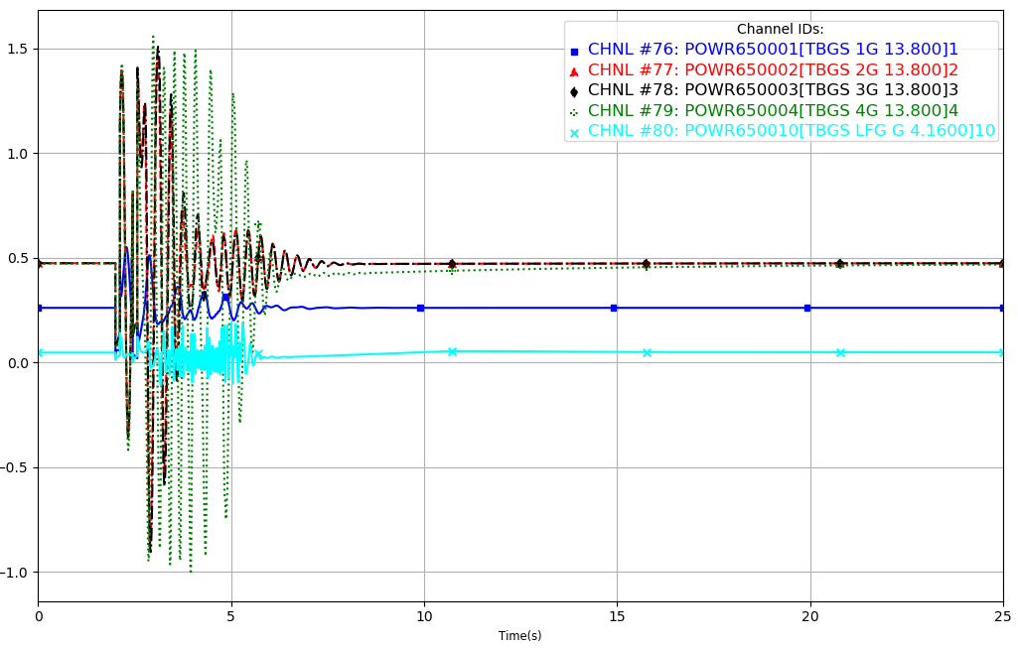

Figure 4: GROUP_FAULT_3_P1 Real Power (25SP Original Case - Reclosing Removed)
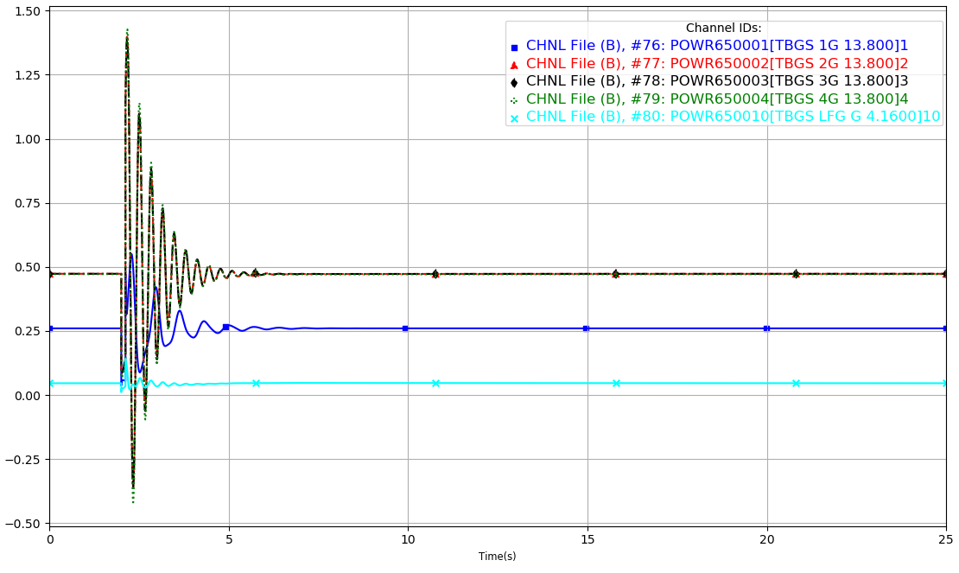
Figure 5: GROUP_FAULT_3_P1 Real Power (25SP Modification Case)
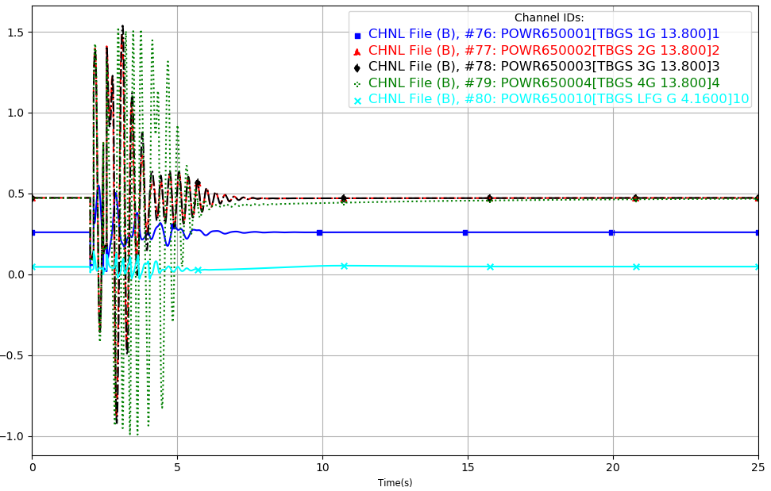

Figure 6: GROUP_FAULT_3_P1 Real Power (25SP Modification Case - Reclosing Removed)
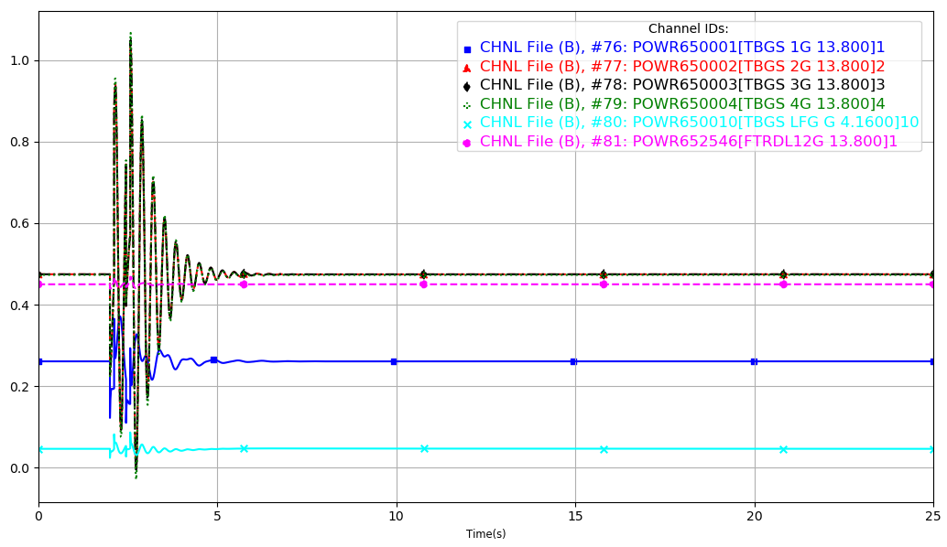
Figure 7: GROUP_FAULT_3_P1 Reactive Power (25SP Original Case)
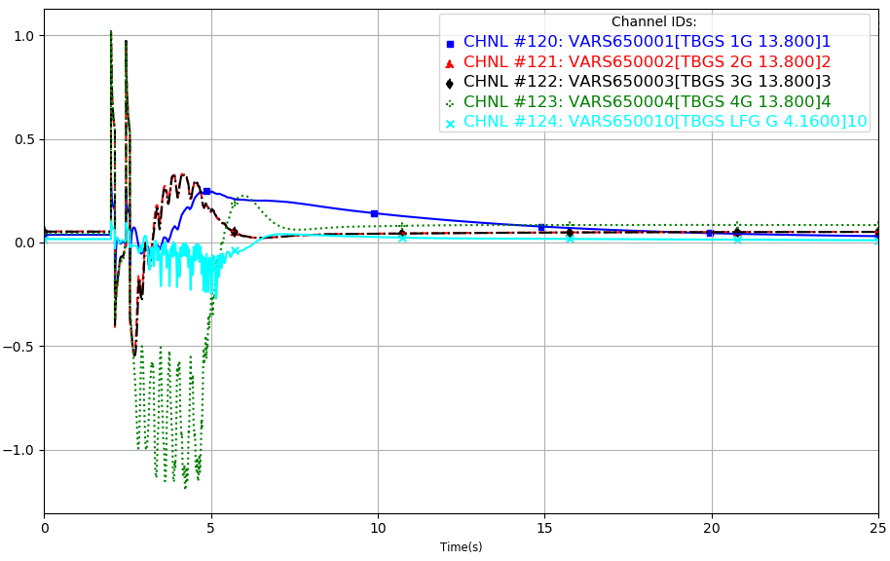
Figure 8: GROUP_FAULT_3_P1 Reactive Power (25SP Original Case - Reclosing Removed)
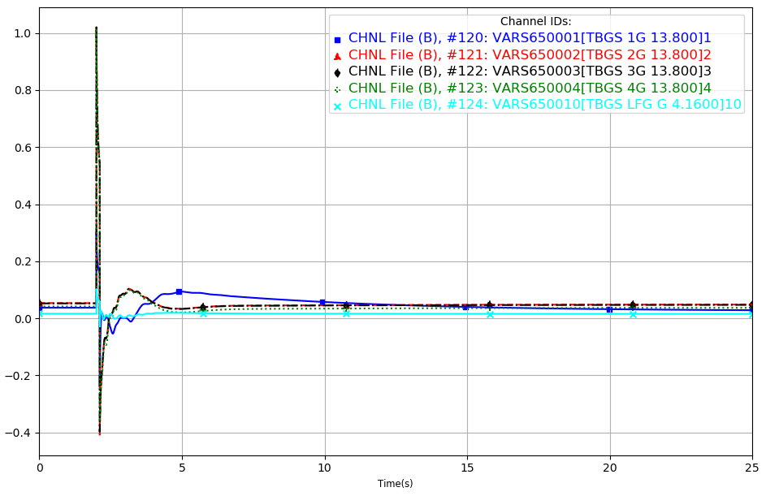
Figure 9: GROUP_FAULT_3_P1 Reactive Power (25SP Modification Case)
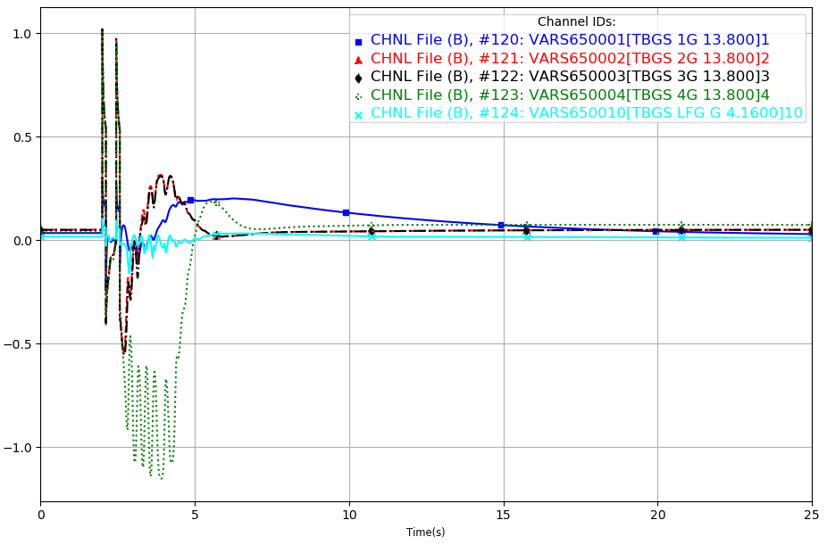
Figure 10: GROUP_FAULT_3_P1 Reactive Power (25SP Modification Case – Reclosing Removed)
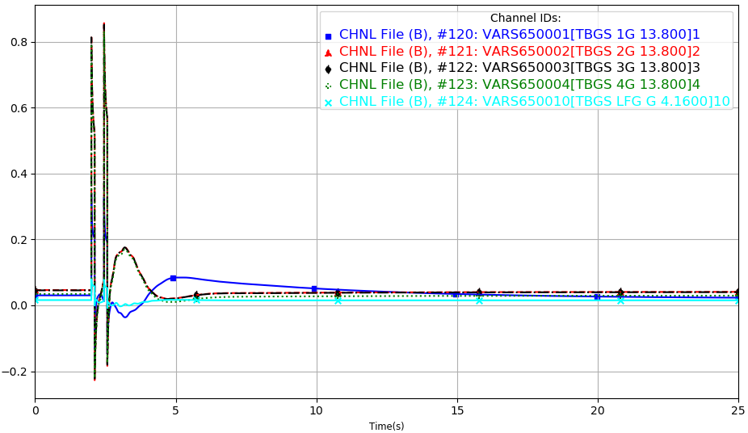
Figure 11: GROUP_FAULT_3_P1 Angle (25SP Original Case)
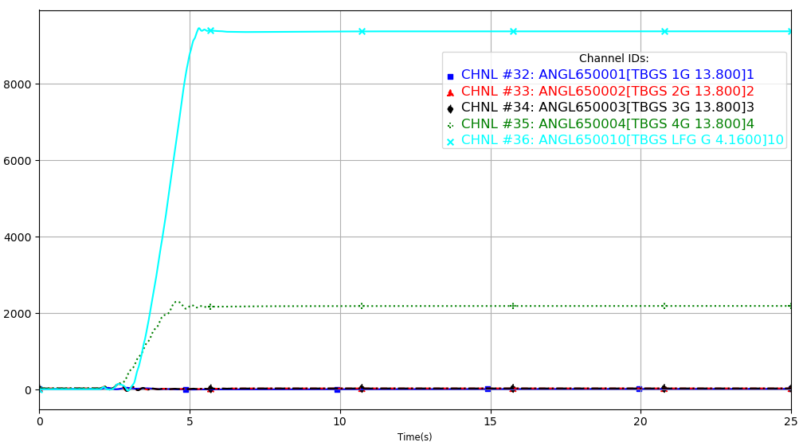

Figure 12: GROUP_FAULT_3_P1 Angle (25SP Original Case - Reclosing Removed)
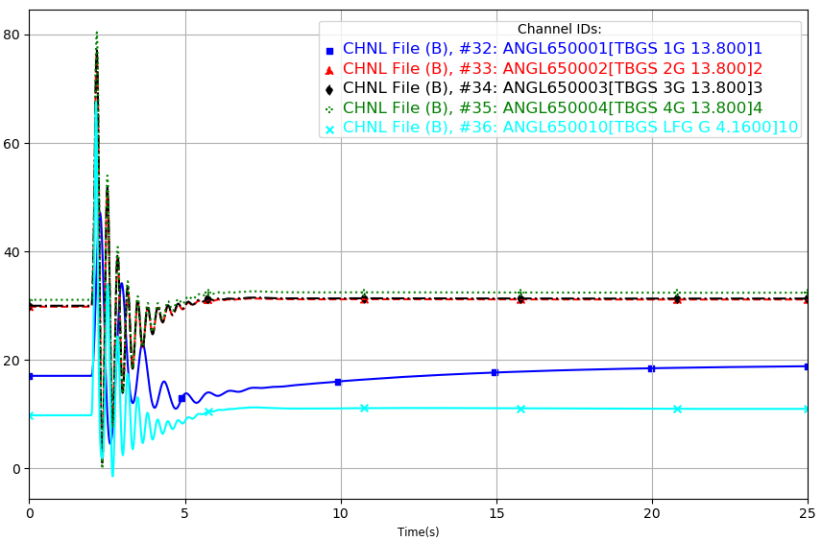

Figure 13: GROUP_FAULT_3_P1 Angle (25SP Modification Case)
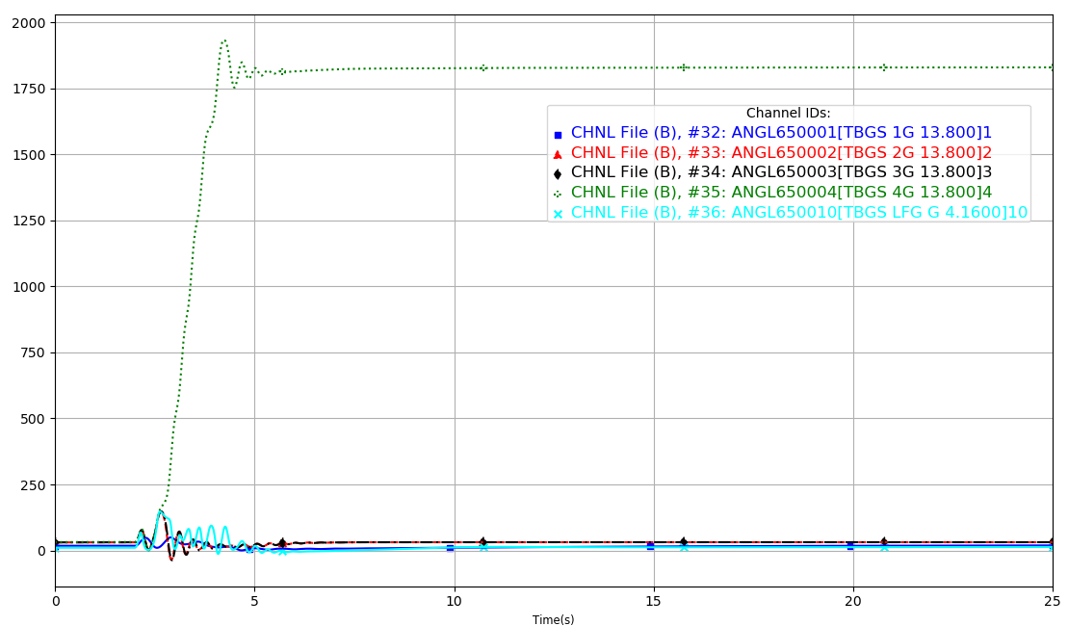

Figure 14: GROUP_FAULT_3_P1 Angle (25SP Modification Case - Reclosing Removed)
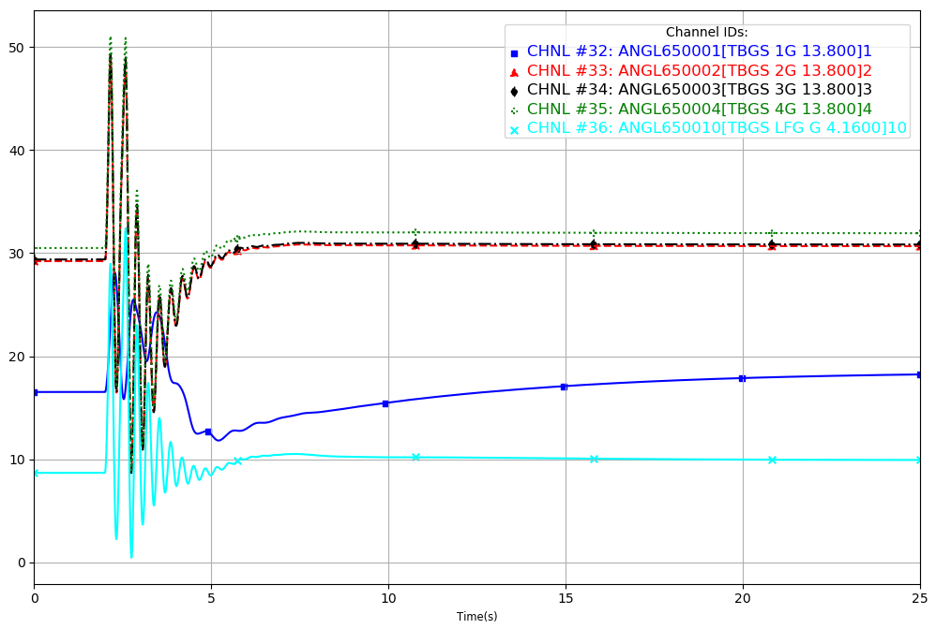
Figure 15: GROUP_FAULT_4_P1 Real Power (25SP Original Case)
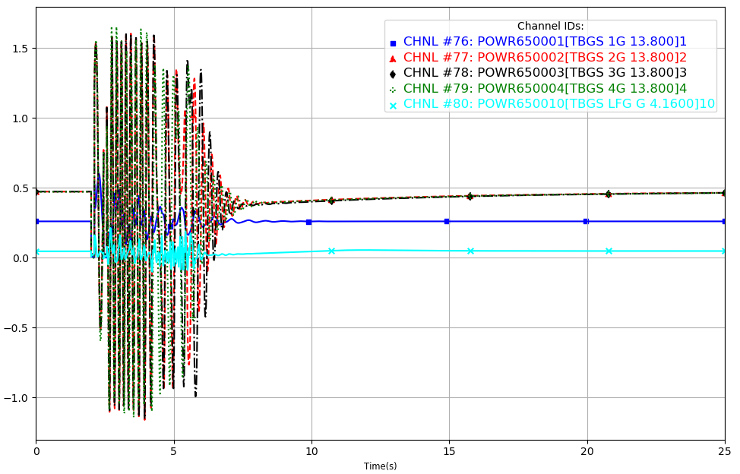

Figure 16: GROUP_FAULT_4_P1 Real Power (25SP Original Case - Reclosing Removed)
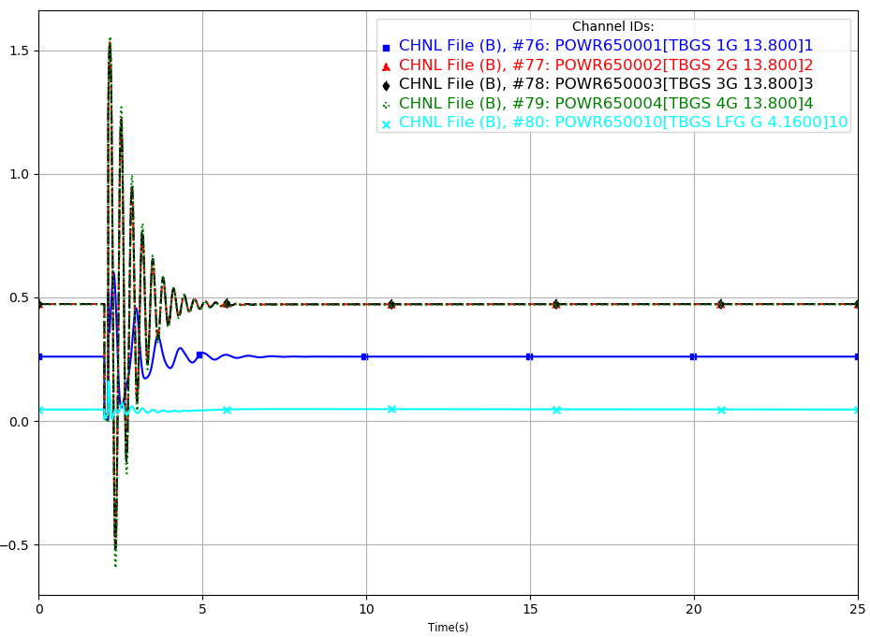
Figure 17: GROUP_FAULT_4_P1 Real Power (25SP Modification Case)
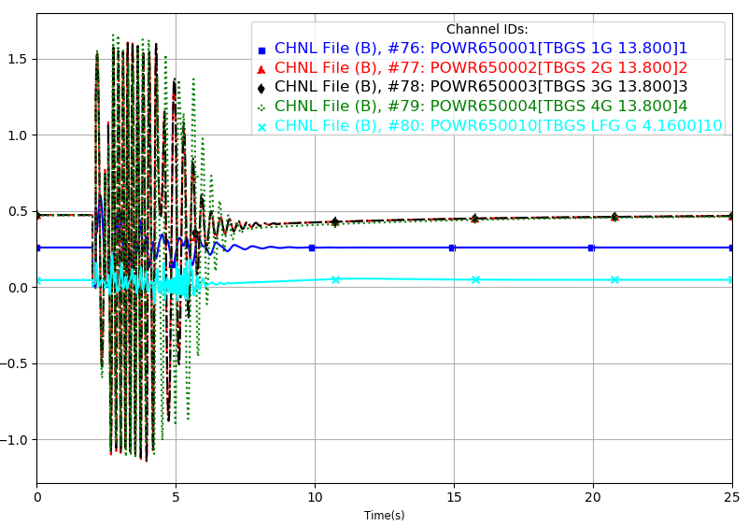
Figure 18: GROUP_FAULT_4_P1 Real Power (25SP Modification Case - Reclosing Removed)
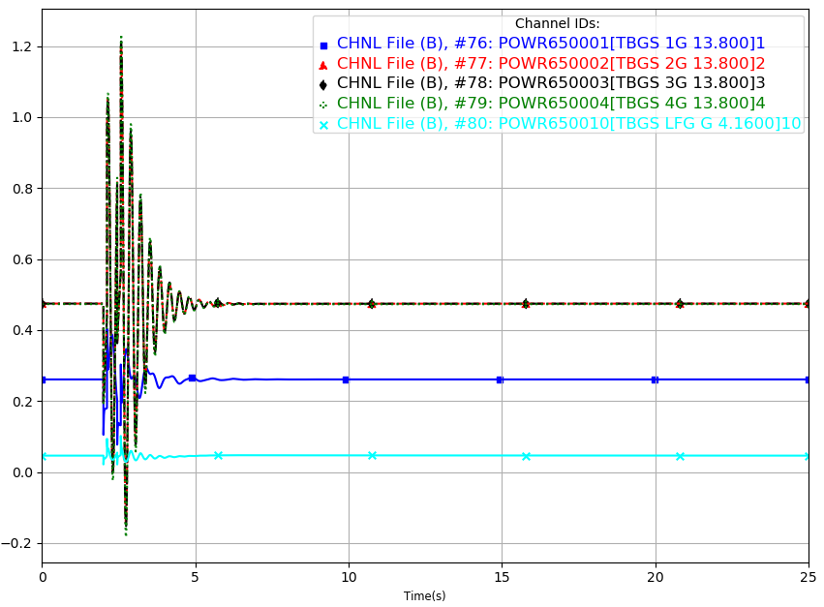

Figure 19: GROUP_FAULT_4_P1 Reactive Power (25SP Original Case)
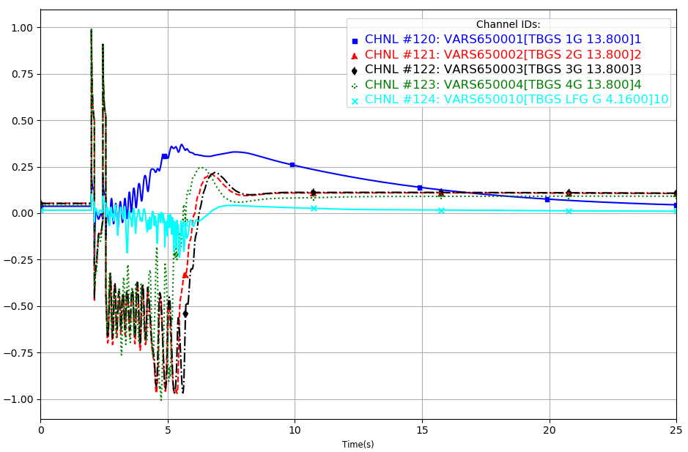
Figure 20: GROUP_FAULT_4_P1 Reactive Power (25SP Original Case - Reclosing Removed)
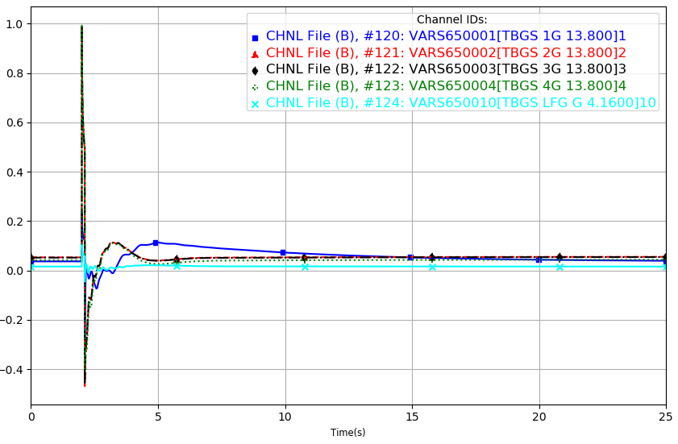
Figure 21: GROUP_FAULT_4_P1 Reactive Power (25SP Modification Case)
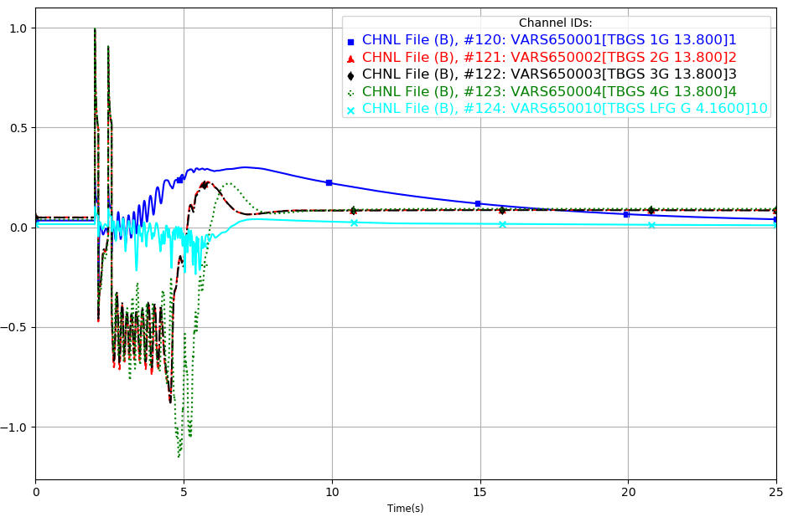
Figure 22: GROUP_FAULT_4_P1 Reactive Power (25SP Modification Case – Reclosing Removed)
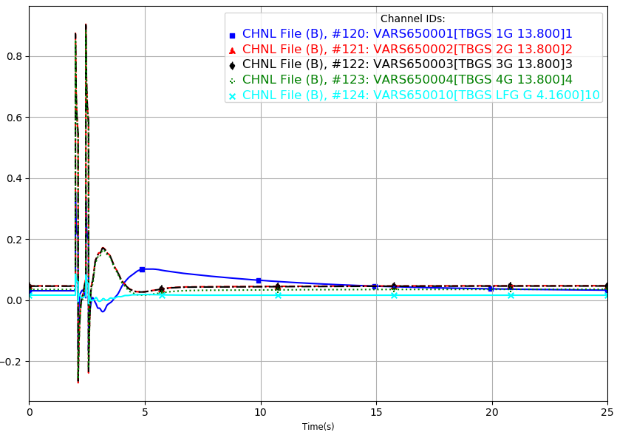
Figure 23: GROUP_FAULT_4_P1 Angle (25SP Original Case)
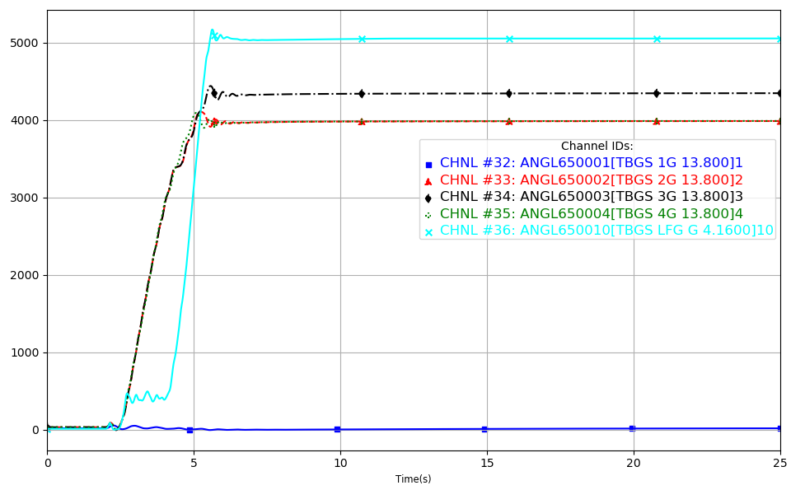
Figure 24: GROUP_FAULT_4_P1 Angle (25SP Original Case - Reclosing Removed)
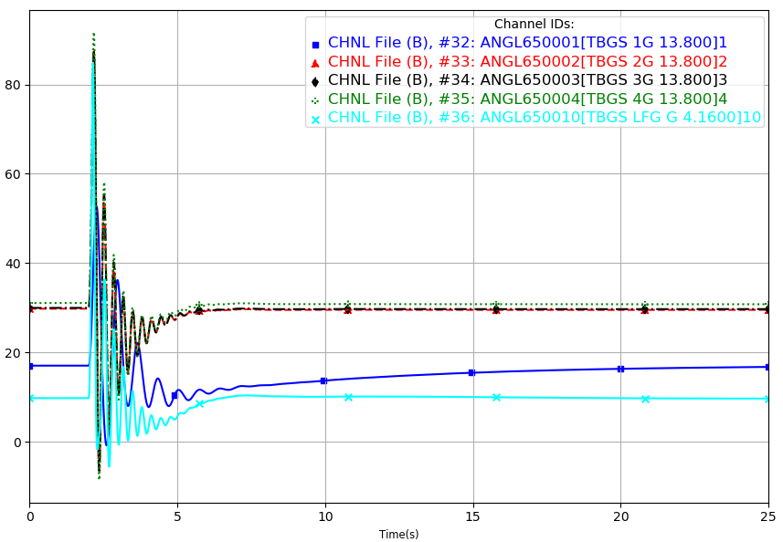
Figure 25: GROUP_FAULT_4_P1 Angle (25SP Modification Case)
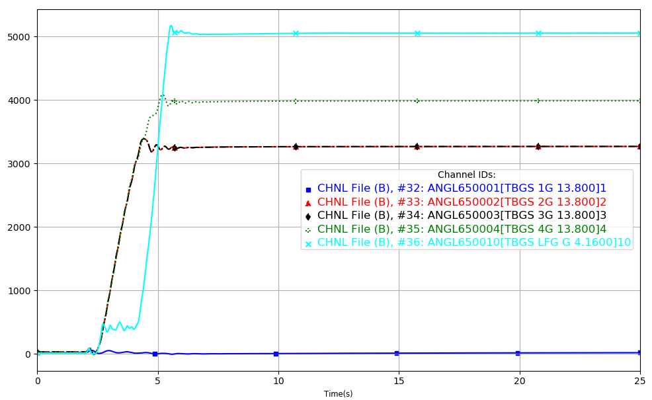
Figure 26: GROUP_FAULT_4_P1 Angle (25SP Modification Case - Reclosing Removed)
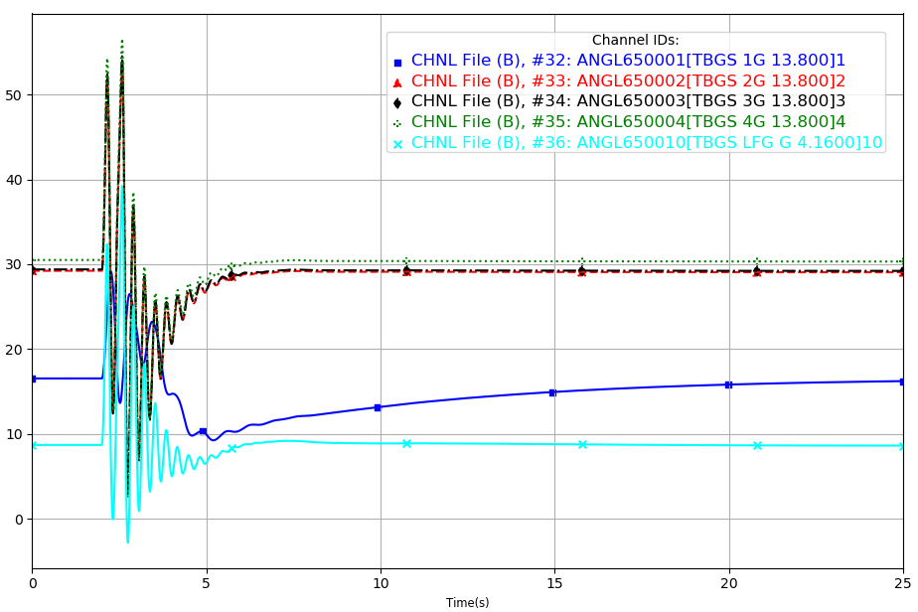
Figure 27: GROUP_FAULT_4_P1 Real Power (25WP Original Case)
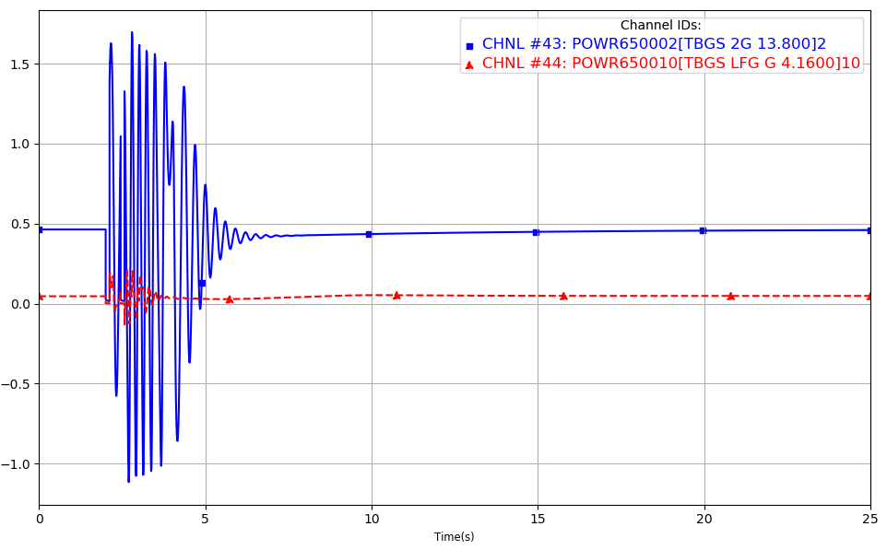
Figure 28: GROUP_FAULT_4_P1 Real Power (25WP Original Case - Reclosing Removed)
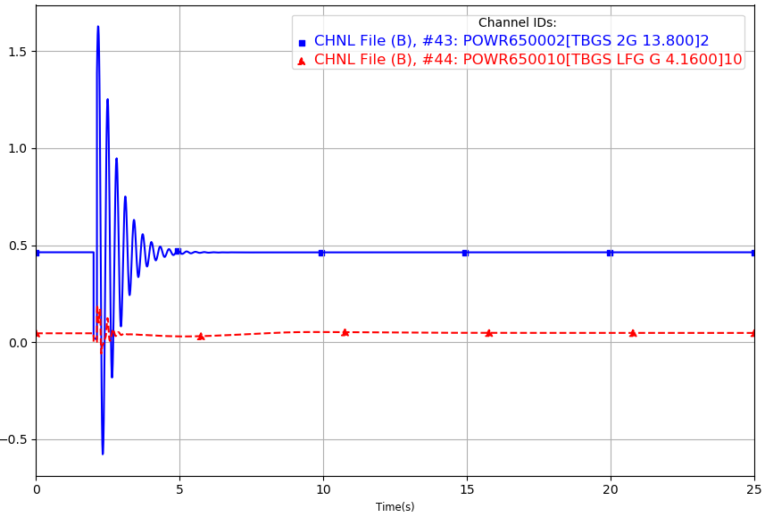
Figure 29: GROUP_FAULT_4_P1 Real Power (25WP Modification Case)
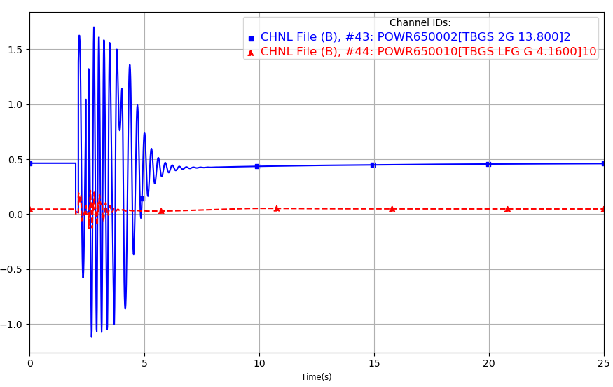
Figure 30: GROUP_FAULT_4_P1 Real Power (25WP Modification Case - Reclosing Removed)
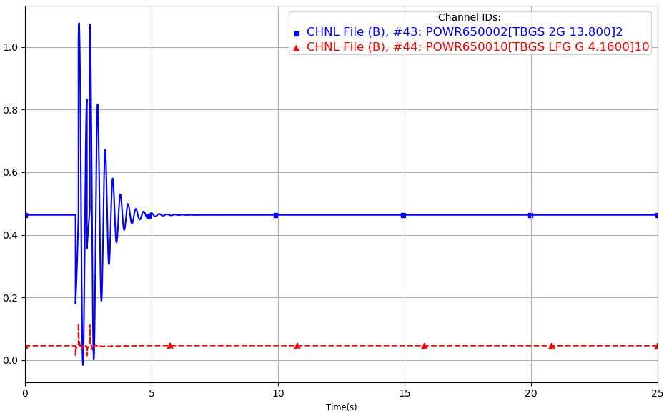
Figure 31: GROUP_FAULT_4_P1 Reactive Power (25WP Original Case)
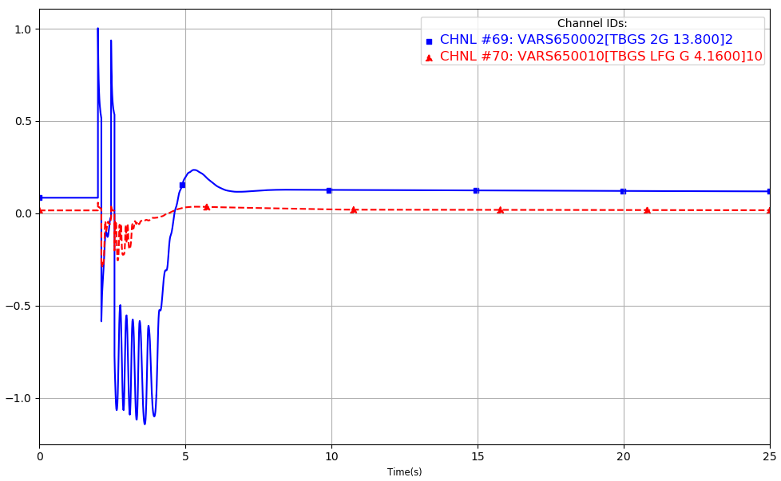
Figure 32: GROUP_FAULT_4_P1 Reactive Power (25WP Original Case - Reclosing Removed)
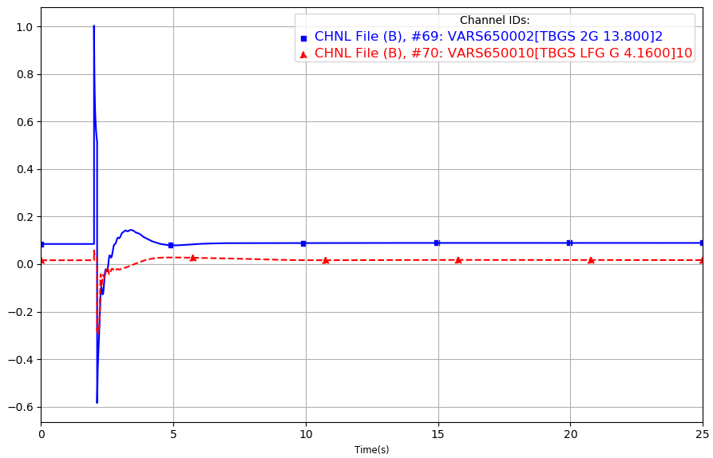
Figure 33: GROUP_FAULT_4_P1 Reactive Power (25WP Modification Case)
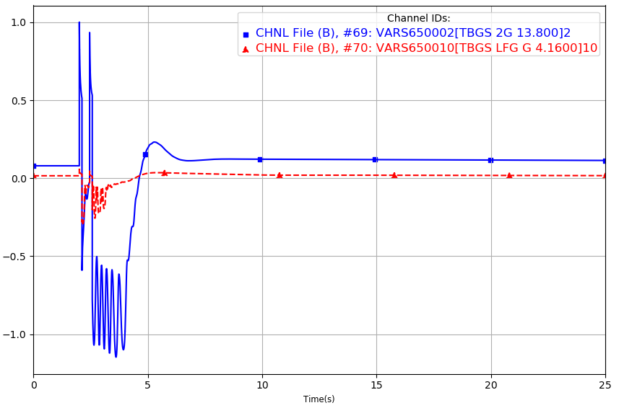
Figure 34: GROUP_FAULT_4_P1 Reactive Power (25WP Modification Case - Reclosing Removed)
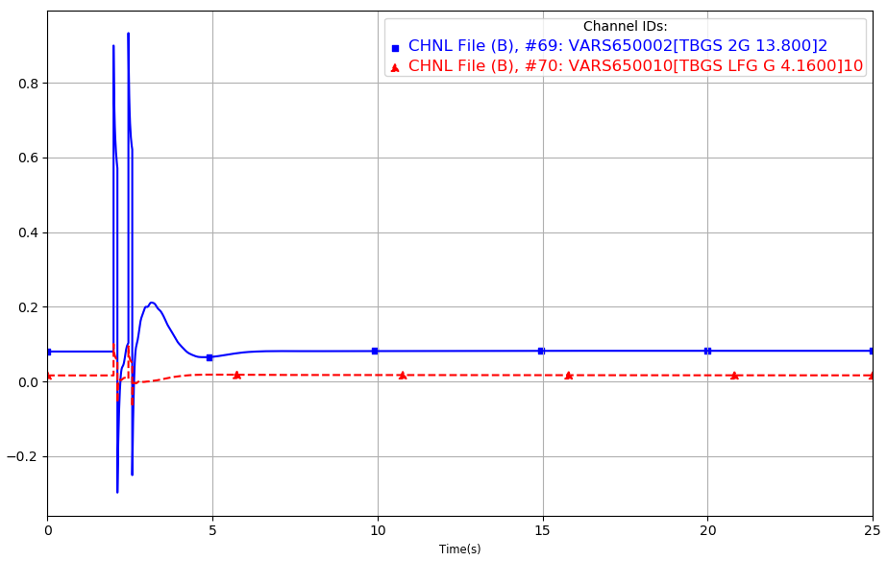
Figure 35: GROUP_FAULT_4_P1 Angle (25WP Original Case)
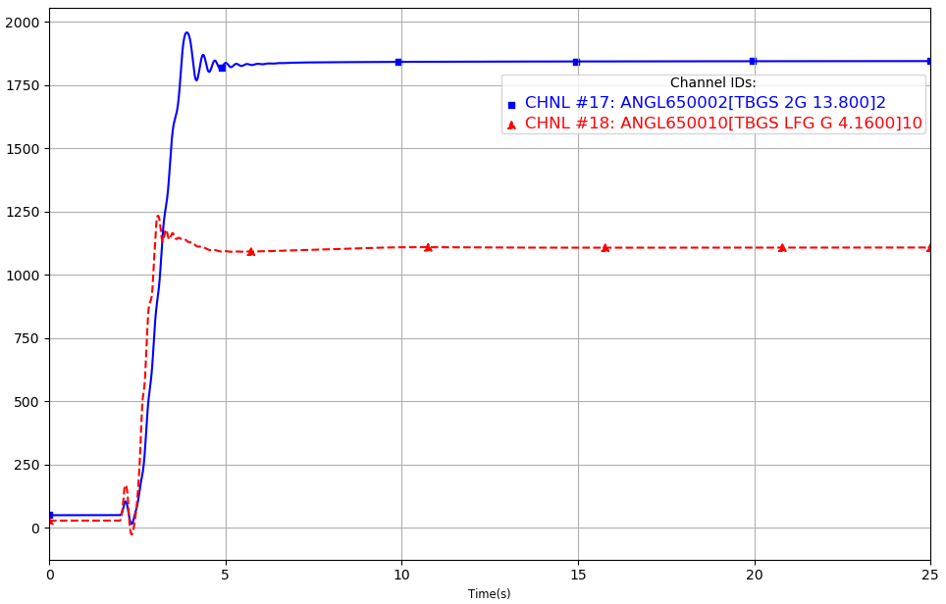
Figure 36: GROUP_FAULT_4_P1 Angle (25WP Original Case - Reclosing Removed)
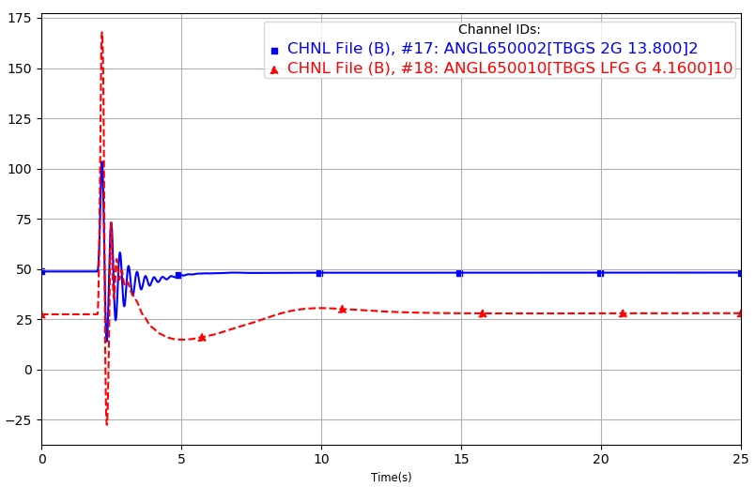

Figure 37: GROUP_FAULT_4_P1 Angle (25WP Modification Case)
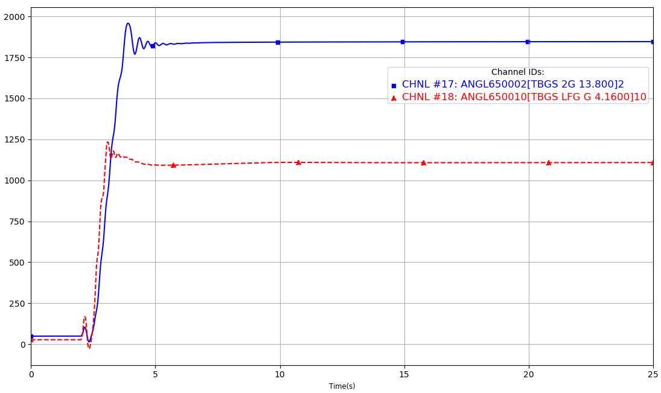
Figure 38: GROUP_FAULT_4_P1 Angle (25WP Modification Case - Reclosing Removed)
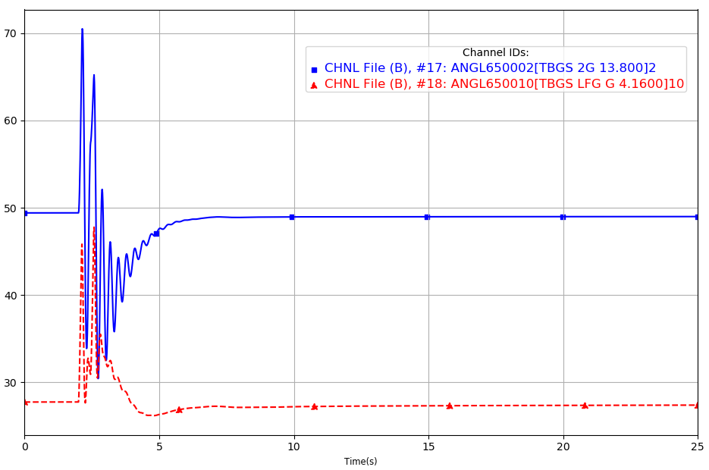

Power System Simulator for Engineering
SPP Disturbance Performance Requirements: https://www.spp.org/documents/28859/spp%20disturbance%20performance%20requirements%20(twg%20approved).pdf
Based on the DISIS-2017-002 Cluster Groups

